 | Academia da Força Aérea  Cyber Warfare A 2026/27  Test – Version {version} | 

Guidelines
- The use of any information device (phones, smartwatches, earbuds, etc.) is forbidden.
- Not following the rules may result in the test being taken away and given a total score of 0 (zero) points. Disciplinary procedures may follow.
- A cotação das perguntas está indicada em cada pergunta.
- Perguntas em que as respostas descontam está identificadas com o símbolo ZYX.
- Perguntas com o símbolo XYZ, podem ter uma ou mais respostas corretas.
- You may write whatever you want in the questions sheets.
- Only answers in the answer sheet will be graded.
- Reserve 5 minutes in the end to recheck the answer sheet.
- There is no option to correct an answer. Options:
  - answer in pencil before using the final minutes to fill the final answers;
  - write a small draft mark next to the desired bubble before using the final minutes for to fill the final answers (see Figure 1);
  - rewrite all answers in a new answer sheet.
- Sdsds

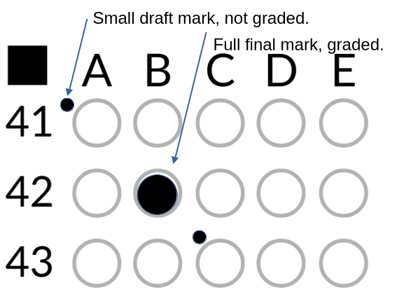Figure 1: Example of using a draft mark.
Questions
{#mcq}
Q {question_number} [{question_score} val., -{question_penalty} pen.]. {question_text}
{#options}
{option_number}. {option_text}
{/options}
-------------------------------------------------------------------------------------------------------------------------------------------------------------------------------------------------------------------------------------------------
{/mcq}

