 | Academia da Força Aérea  Cyber Warfare A 2026/27  Test – Version {version} | 

Name:  (first & last) |  | ID:  (NIP / other)

Guidelines (READ CAREFULLY)
- Accessing any external information (paper notes, phones, smartwatches, earbuds, etc.) is forbidden.
- Not following the rules may result in the test being taken away and given a total score of 0 (zero) points. Disciplinary procedures may follow.
- The score of each question is mentioned above each question. Some questions may have a penalty, other don’t. This is also mentioned above each question. Example: “Q 42 [1 points, -0 penalty]” means question 42 has a total score of 1, and has a penalty of 0 points for a wrong answer (i.e. no penalty); “Q 34 [2 points, -0.5 penalty]” means question 34 has a total score of 2 points, and has a penalty of -0.5 points for a wrong answer.
- Questions marked with the symbol {symbols.multiple}, may have one or more correct answers. The total score of the question is divided evenly for each correct answer. If there is a penalty, the penalty is applied for each wrong answer. This is to discourage random answers.
- You may write whatever you want in the questions sheets. Nothing written in the question sheets will be used for grading.
- Only answers written with pen will be considered final.
- Reserve 5 minutes in the end to recheck the answer sheet.
- There is no option to correct an answer. Alternatives:
  - answer in pencil before using the final minutes to fill the final answers with pen;
  - write a small draft mark next to the desired bubble before using the final minutes for to fill the final answers (see Figure 1);
  - rewrite all answers in a new answer sheet.

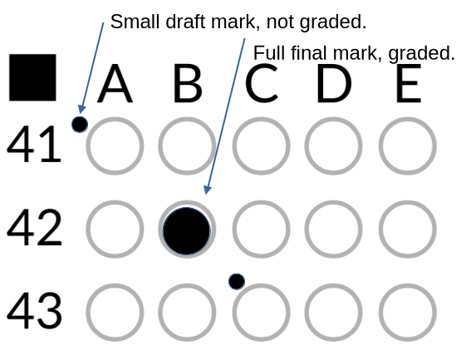
Figure 1: Example of using a draft mark.
Ubiquiti case study 🔷

This text describes a cyberattack that occurred in the past. One group of questions is related with this case study. Read it carefully. It should take you no longer than 5 minutes to read it.

In August 2018, Nickolas Sharp left a cloud engineering job at Amazon Web Services to join Ubiquiti, a US company of about 800 employees that makes routers, switches and IP cameras. He rose to lead its cloud team. His salary reached about $250,000 a year, and his access grew with his responsibility: he held root-level access to the company's entire AWS environment, and he could use a shared GitHub account with full access to every private repository. Colleagues described him as someone who liked to dramatize security problems and then fix them, to be seen as the hero. He had complained that credentials were not audited enough. As the pandemic doubled Ubiquiti's stock price and everyone worked from home, Sharp felt his raises and promotions had stopped and that the CEO kept redirecting him away from the security issues he raised.

In July 2020 he bought a 27-month Surfshark VPN subscription with his personal PayPal account. One night in December 2020, after sending a job application to a company in California, he logged into Ubiquiti's AWS environment from home with his normal work credentials. There he located the key that unlocked the company's other credentials and checked that the stored passwords worked. He logged out at 3:16 a.m. At 3:18 a.m., a session from a VPN address used the same key. It ran a single command confirming which identity it was logged in as, then left.

On December 21, he logged into GitHub with his own account and browsed the private repositories, then logged out. A minute later, he connected through the VPN, over SSH, to the shared GitHub account. Over the next hours he cloned more than 100 private repositories with their full change histories, gigabytes of company data. Partway through, his home internet failed for about 30 minutes. Although he had a VPN kill switch enabled, GitHub's logs later showed both a VPN IP and his home IP on the account.

The next day, Sharp asked a colleague whether employees could be paid through the bug-bounty program. The colleague found the question odd and saved the message. Sharp then set the AWS log retention to one day and renamed 18 sessions, including those started from the VPN, to look like DevOps colleagues'. When Ubiquiti announced suspicious activity and data exfiltration, he was called in to help investigate, and he denied ever using Surfshark.

At 4 a.m. one morning in early January 2021, senior employees received an email from an anonymous "outside hacker" demanding 25 Bitcoin (about $2 million) by January 9. The email offered details of a hidden "backdoor" into Ubiquiti's systems for another 25. A senior employee also received a copy through the Keybase chat app, with samples of the stolen data. The deadline passed unpaid. He replied "No BTC, no talk" and posted the data in a public Keybase folder, which Keybase removed at Ubiquiti's request. Ubiquiti's customer notice referred to unauthorized access to systems "hosted by a third-party cloud provider".

Investigators traced the home IP to Sharp and had him hand over his work laptop, his home router and his cameras. The footage and the laptop showed nothing. The router's logs, however, showed a second device, a MacBook, moving a volume of data that matched the theft that night. He wiped the MacBook before the FBI searched his home on March 24, 2021, and told agents someone must have used his PayPal account. He then contacted journalist Brian Krebs as an anonymous "whistleblower", claiming a catastrophic breach and a cover-up, and alerted regulators to Ubiquiti's misleading disclosures. The stock fell about 20% (roughly $4 billion) in two days. He was arrested in December 2021. In February 2023 he pleaded guilty to intentionally damaging protected computers, wire fraud and false statements to the FBI, admitting the plan was for financial gain. At sentencing he called it an unsanctioned "security drill", and was sentenced to six years.

Questions
{#mcq}
Q {question_number}{#question_symbols} {question_symbols}{/question_symbols} [{question_score} points, -{question_penalty} penalty]. {question_text}
{#options}
{option_number}. {option_text}
{/options}
-------------------------------------------------------------------------------------------------------------------------------------------------------------------------------------------------------------------------------------------------
{/mcq}

