P4 - Sales Force Automation

Project Specification



# Mestrado Integrado em Engenharia Informática e Computação

# Sistemas de Informação

## **Grupo R:** Cláudia Guedes - up201505409@fe.up.pt Cláudia Rodrigues - up201508262@fe.up.pt

## David Reis - up201607927@fe.up.pt

## Diogo Reis - up201505472@fe.up.pt

## Maria de Abreu - up201306229@fe.up.pt

## Faculdade de Engenharia da Universidade do Porto Rua Roberto Frias, sn, 4200-465 Porto, Portugal

### 28 de Outubro de 2018

# Project Overview

The aim of this project will be to provide a platform to manage and coordinate a sales force’s efforts, increasing productivity and sales.

This will be achieved through a tool that manages each sales representative’s agenda, making it easy for the representative to consult his appointments and his scheduled visits to customers’ locations.

It will also help with billing by registering and organizing sales orders and allowing the reservation of items, always taking into account the availability of the items in stock at the warehouse and updating it accordingly.

In order to be up to date with customers’ needs and status it will also be possible to consult customer profiles, keeping track of the deliveries made and of their periodicity.

To achieve these goals, Primavera ERP’s API will be used for sales management and connected to the web application, which will provide the interface.

# Functionalities and Features

|  |  |  |  |
| --- | --- | --- | --- |
| **View** | **ID** | **Name** | **Description** |
| **CALENDAR** | PANEL_005 | Calendar | Allows salesmen to see and select the desired days of a certain month, highlighting days with events planned. |
| PANEL_006 | Events | List of upcoming events scheduled to occur sorted by date if no specific day is selected. If a certain panel is expanded, that event’s detailed information will be displayed. |
| BUTTON_003 | Add event button | Allows a salesman to create and add detailed information to a new event that will be displayed on the calendar. |
| **CLIENT** | PANEL_003 | Client overview | Allows a salesman to quickly contact a client, showing his picture, name and contact information. |
| PANEL_004 | Client information | Allows a salesman to switch between information, activity and notes tabs. The information tab will have the contact’s full address, his email and possibly tags. The client’s past orders will be available for consult in the activity tab. |
| BUTTON_002 | Edit client button | Allows a salesman to edit and/or update his client’s information. |
| **MANAGE_CLIENTS** | BUTTON_001 | Create client | Allows a salesman to add a new client and his contact information and details. |
| PANEL_002 | Clients list | Allows a salesman to consult the list of all his clients and show the results of a client search. |
| **CATALOGUE** | PANEL_010 | Item list | Allows the salesman to consult a list with all the company’s products and their general information. |
| **ORDER** | PANEL_008 | Order status | This panel will display the total price of an order, its status and other relevant details like the shipping address and client name. |
| PANEL_009 | Order items | This panel will display all the items, their references, prices, quantities and costs. |
| **MANAGE_ORDERS** | BUTTON_004 | New order button | Allows salesman to create a new order by taking him to the catalogue. |
| PANEL_007 | Orders overview | Allows salesman to consult details about his latest orders such as its ID, status, date and amount. |
| **CHECKOUT** | PANEL_011 | Product cart list | Displays the list of products belonging to an order |
| PANEL_012 | Order information | This panel displays the total price of the order and the client’s address |
| **PRODUCT** | PANEL_013 | Product details | Shows the name and price of the products, as well as its technical specifications. |
| PANEL_014 | Product stock availability | Shows the stock availability information. |

# 

# Paths Diagram

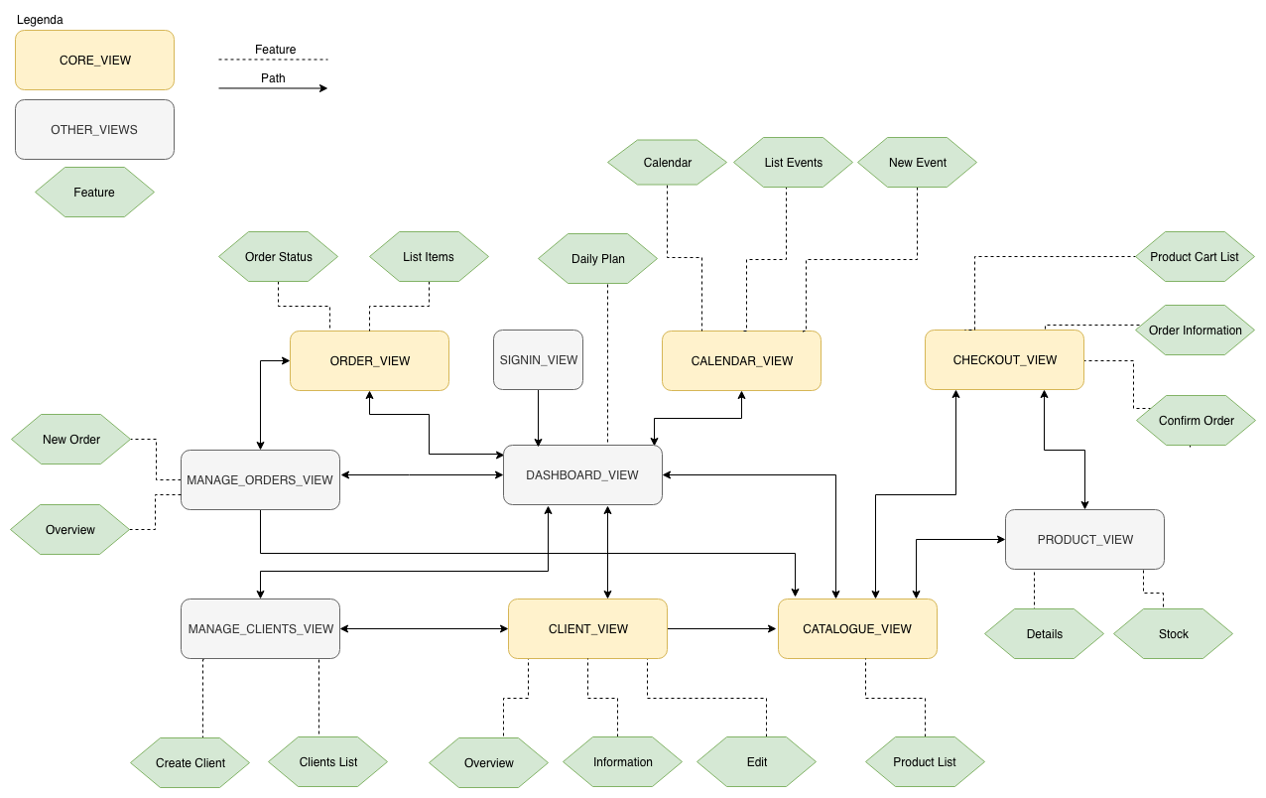

Figure 1: Paths Diagram

# Information Architecture (core views)

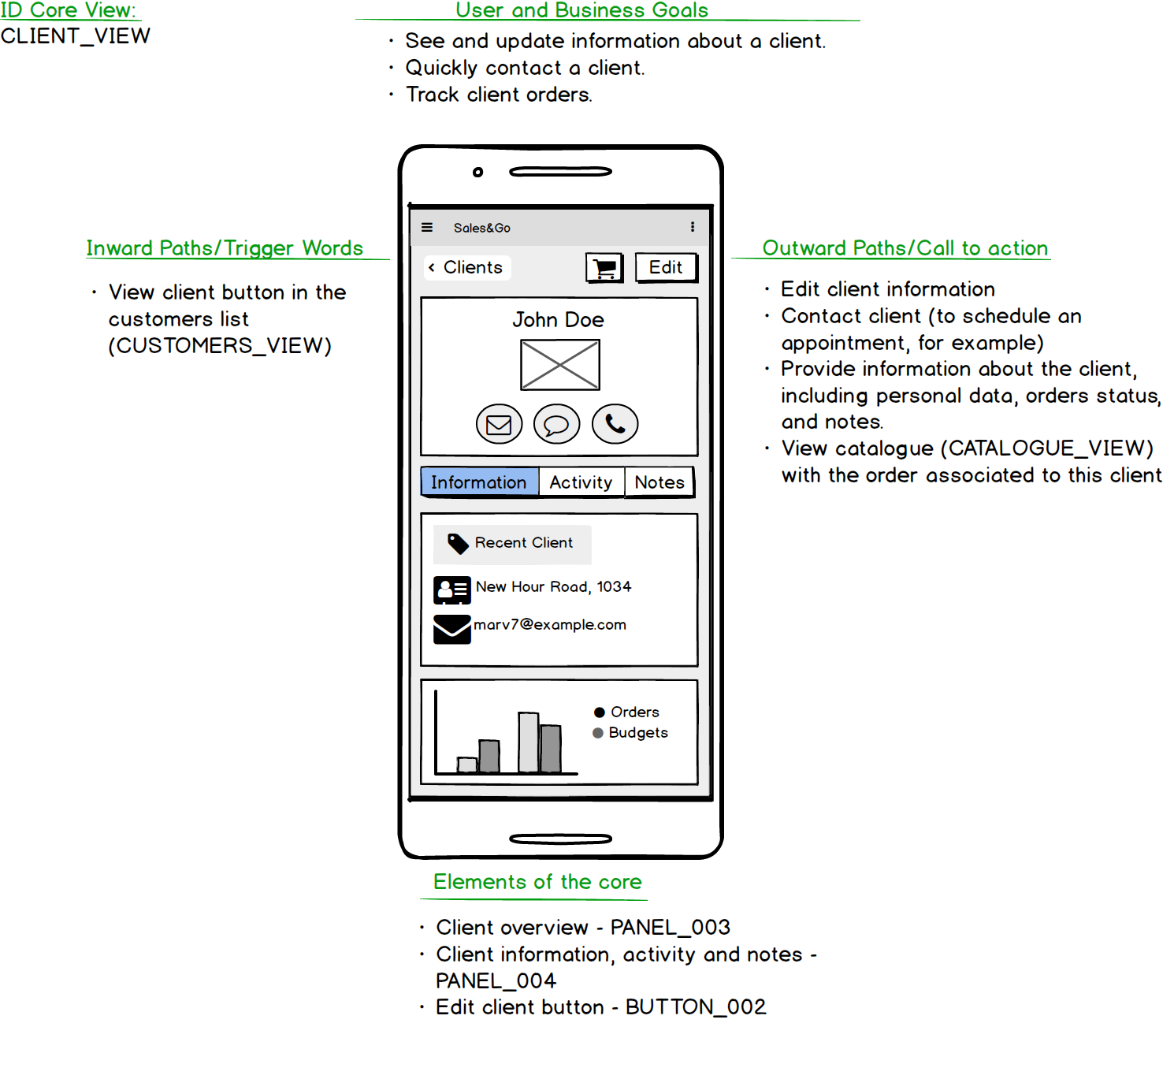

Figure 2: Core View - Client

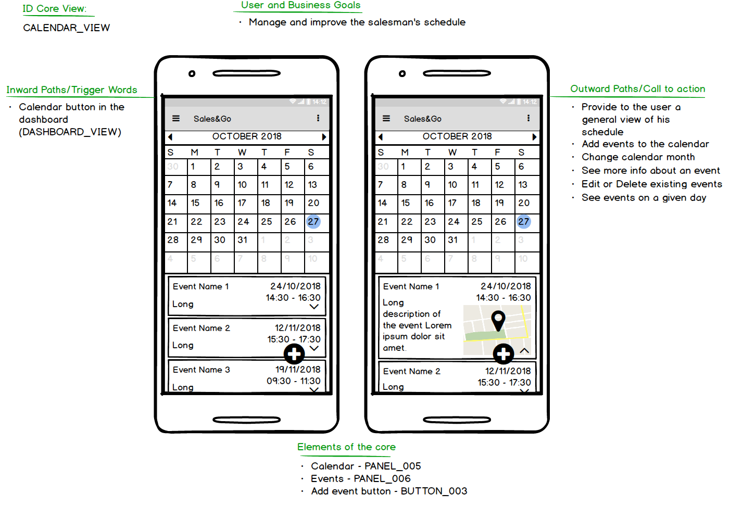

Figure 3: Core View – Calendar View

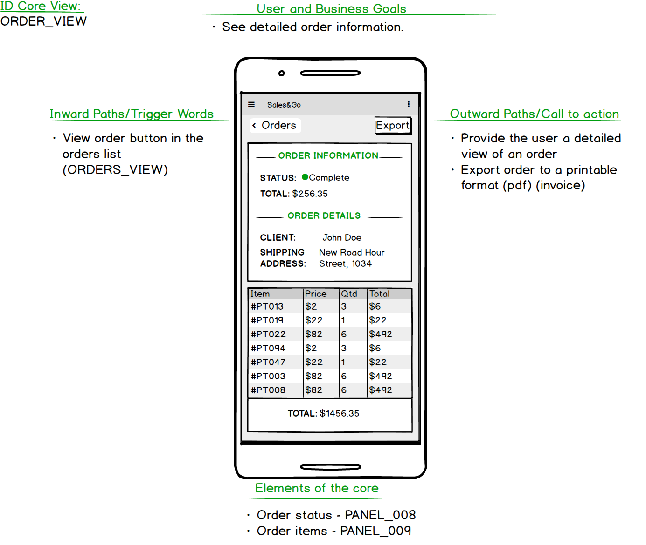

Figure 4: Core View – Order View

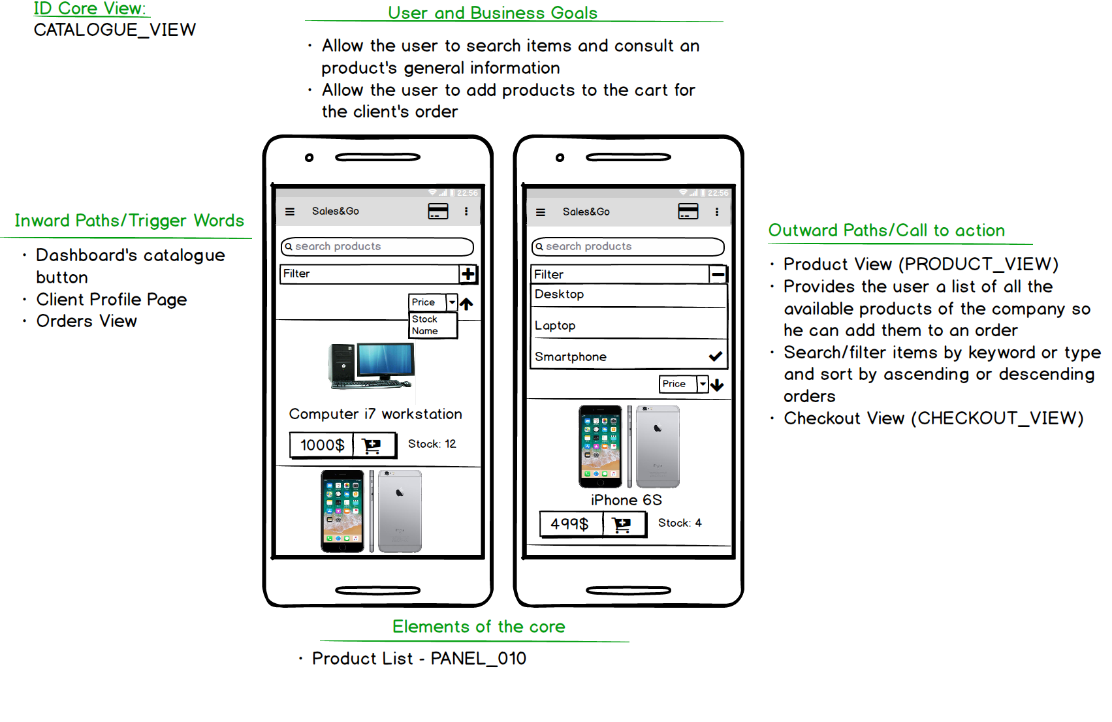

Figure 5: Core View - Catalogue

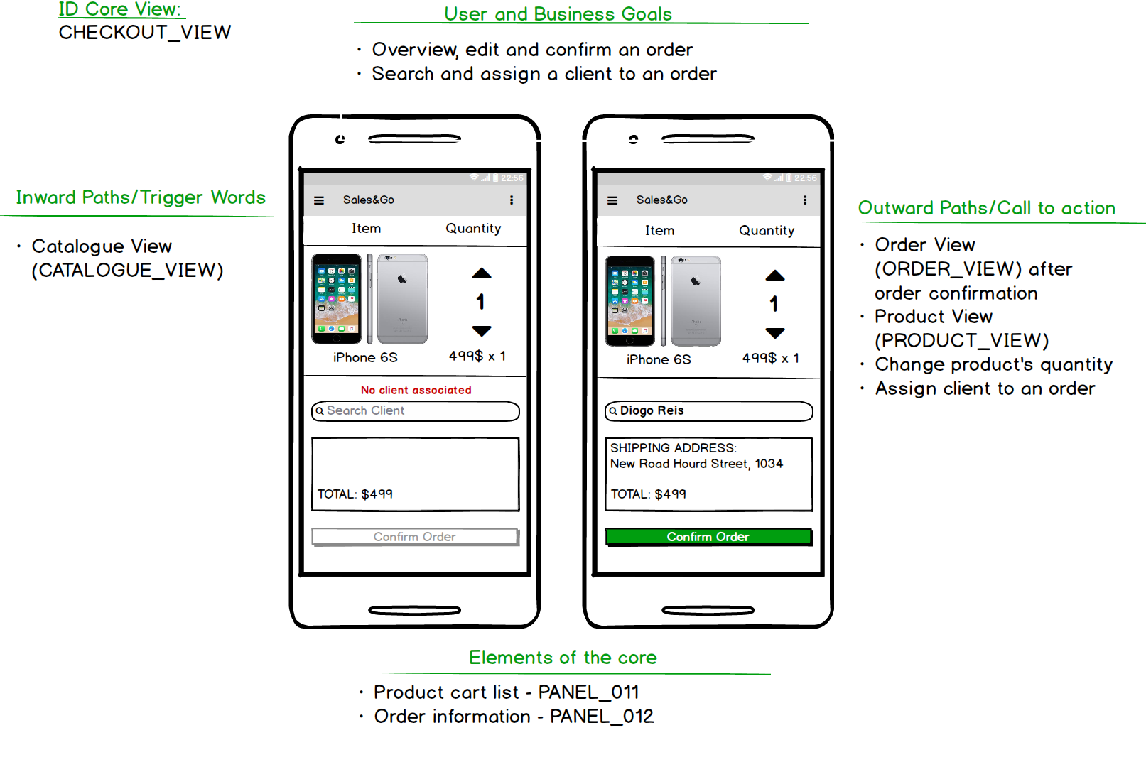

Figure 6: Core View - Checkout

# Other Views

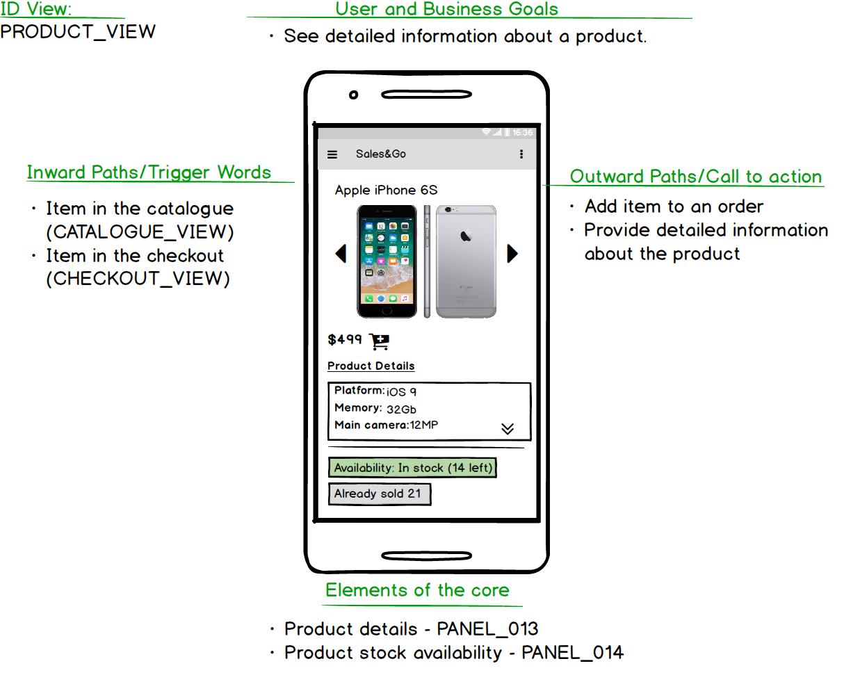

Figure 7: Product View

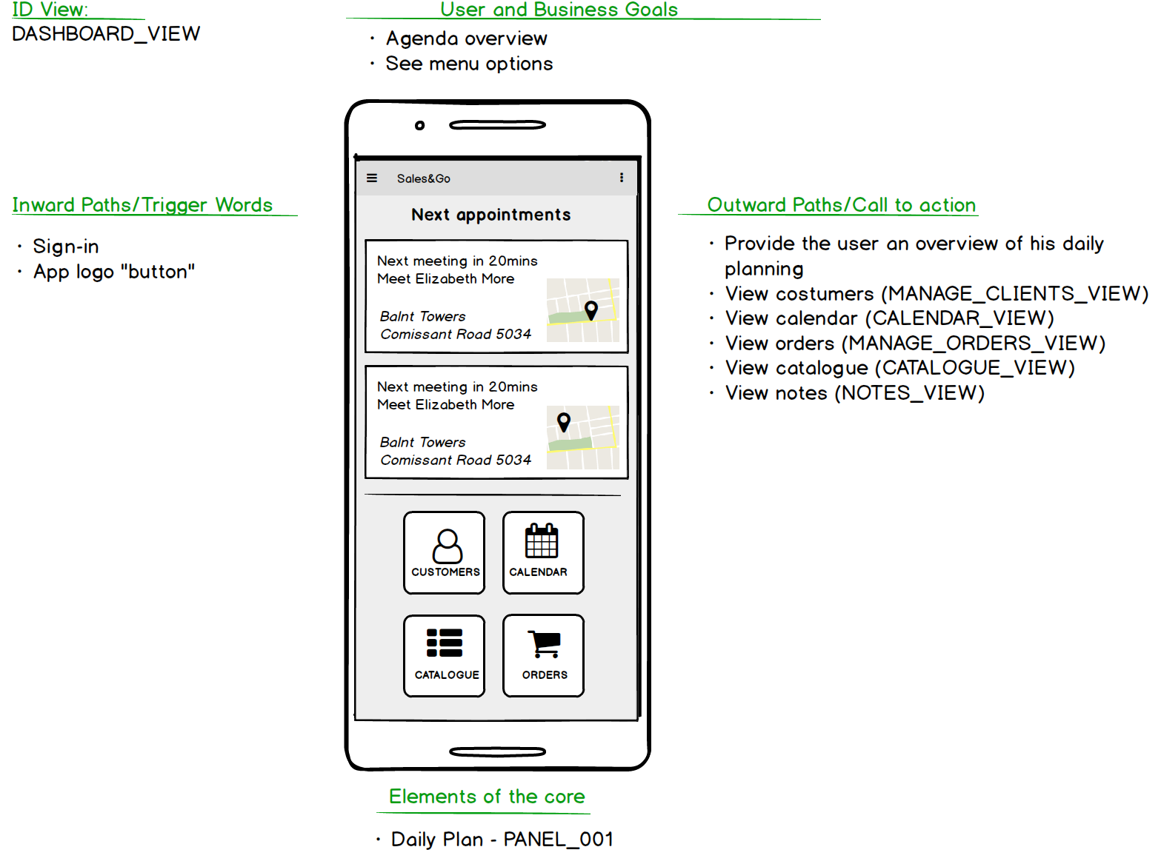

Figure 8: Dashboard

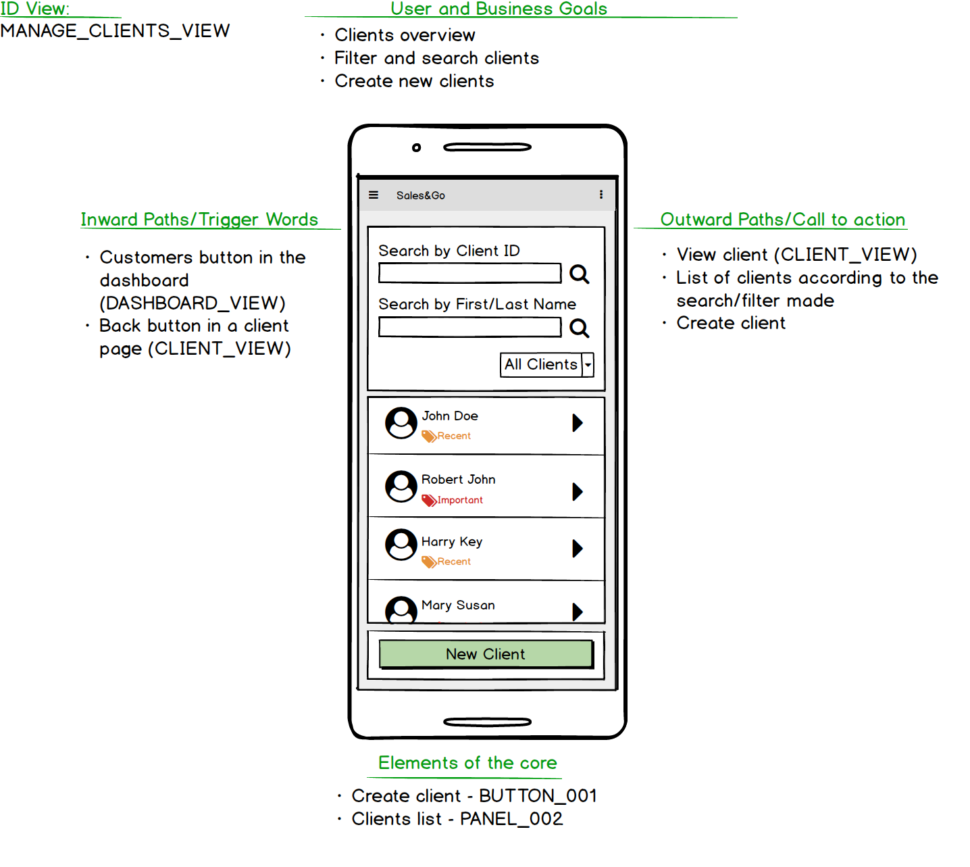

Figure 9: Manage Clients

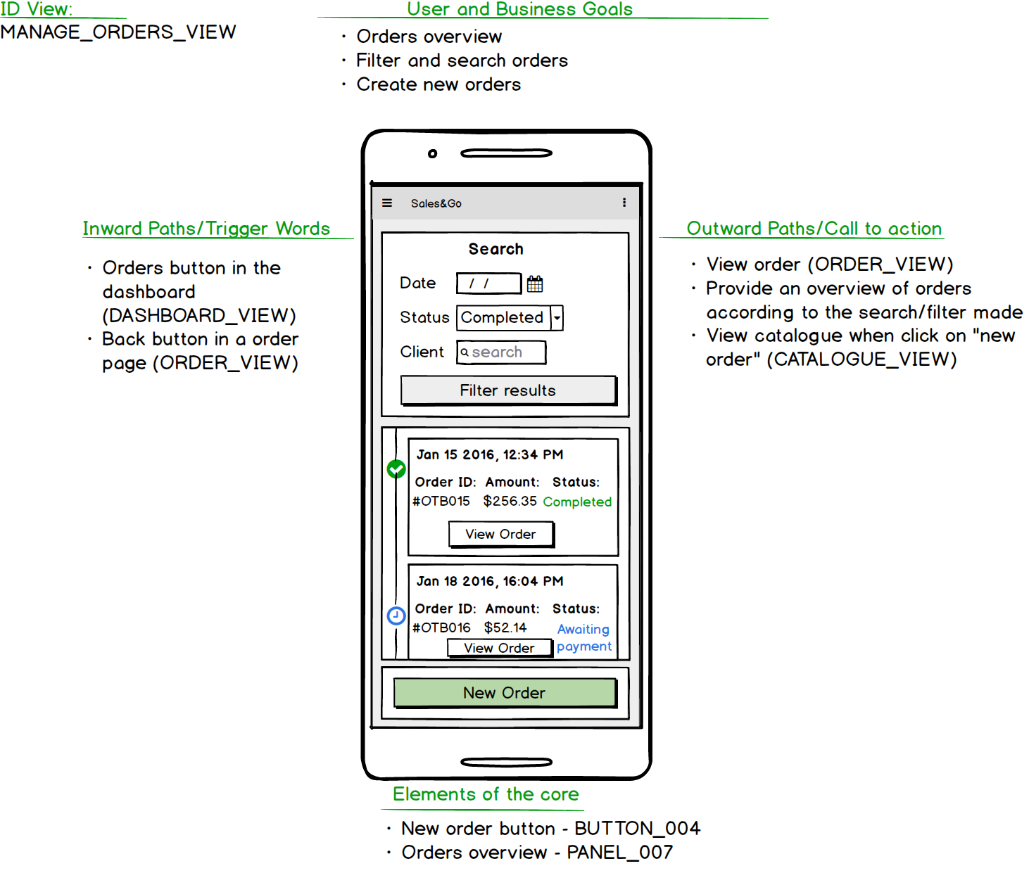

Figure 10: Manage Orders

# Project Plan - Gantt with tasks

# 

Figure 11: Feature Planning 1

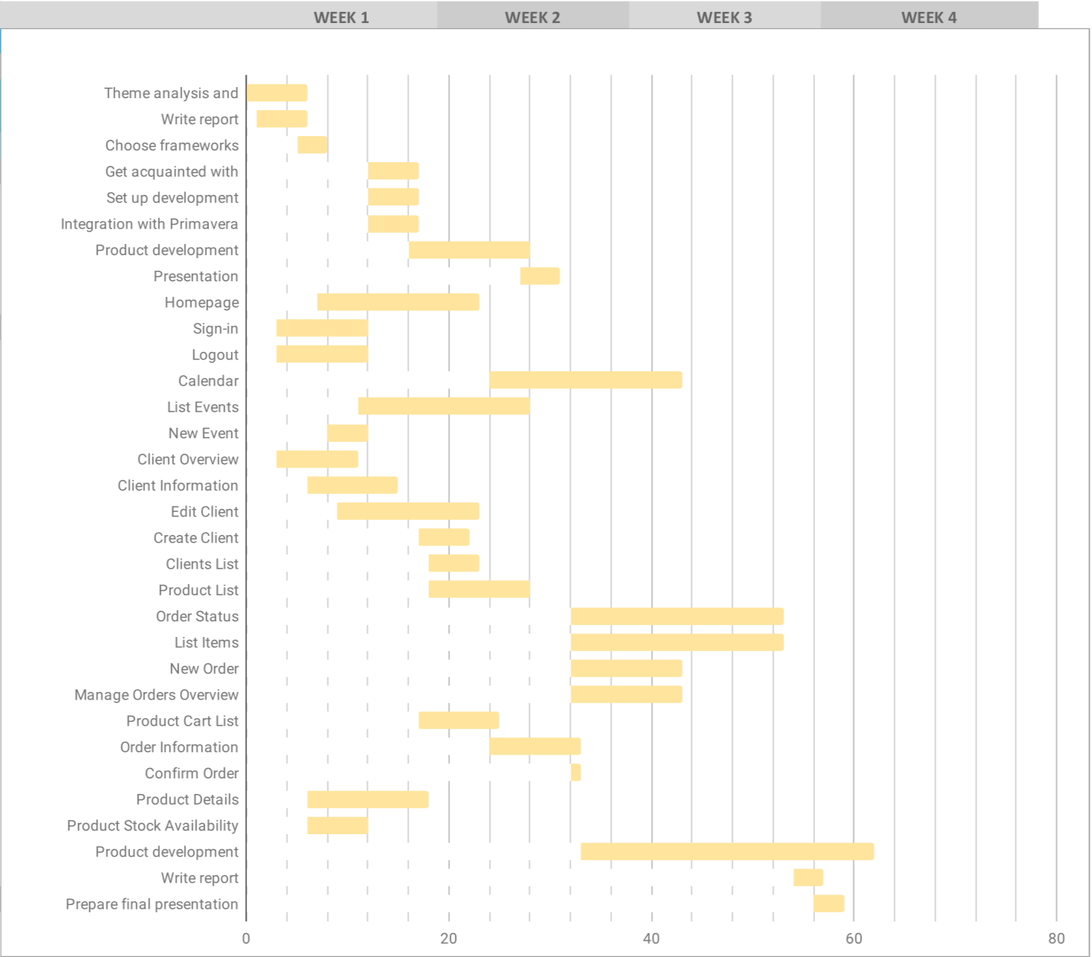

Figure 12: Feature Planning 2