Three.js Lesson 01 - Introduction

Diogo Andrade 89265, Rodrigo Oliveira 90514

Information Visualization, 2021 (MEI, University of Aveiro)

Abstract

For the first lesson on three.js in the Information Visualization class, we were tasked with learning the basics on this javascript 3D library and developing some examples, following the instructions given to us by the teacher.

# 1.2 – First example

# 1.3 – 2D Primitives



# 1.4 – Adding Color

## 

## Se não conseguir visualizar bem os triângulos, ative no material a opção side: THREE.DoubleSide. Para que serve esta opção?

The THREE.DoubleSide option makes it so that both sides of faces of the triangles are rendered.

# 1.5 – Refreshing the Viewport

## Voltando ao exemplo inicial (cubo a rodar). Visualize o exemplo e tente redimensionar a janela do navegador. O que acontece?

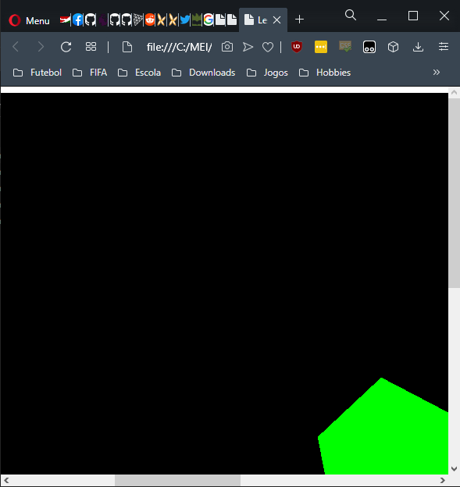When the browser is resized, the rotating cube remains in the same position and in the same size as it was in the start.

Fixed version

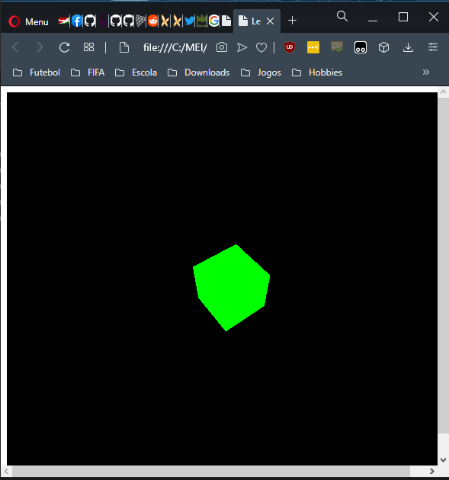

# 1.6 – Other Primitives

