Three.js Lesson 2 - Projeções, iluminação e transformações

Diogo Andrade 89265, Rodrigo Oliveira 90514

Information Visualization, 2021 (MEI, University of Aveiro)

Abstract

For the second lesson on three.js in the Information Visualization class, we were tasked with exploring the different types of cameras and perspectives, interacting with them, shading and illumination and developing some examples, following the instructions given to us by the teacher.

# 2.1 – Camera types

Perspective Camera

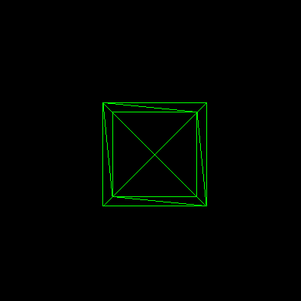

Ortographic Camera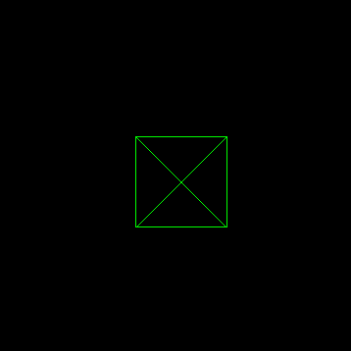

# 2.2 – Orbit control

OrbitControls

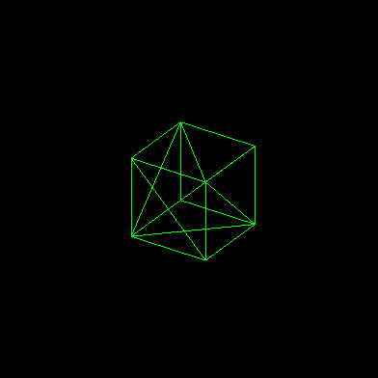

TrackballControls

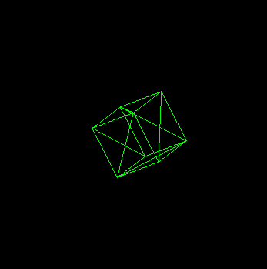

The difference between them is that when using TrackballControls, the camera does not flip when you try to look at the top or the bottom of the object, it rotates the object fully.

# 2.3 – Illumination and materials



# 2.4 – Shading

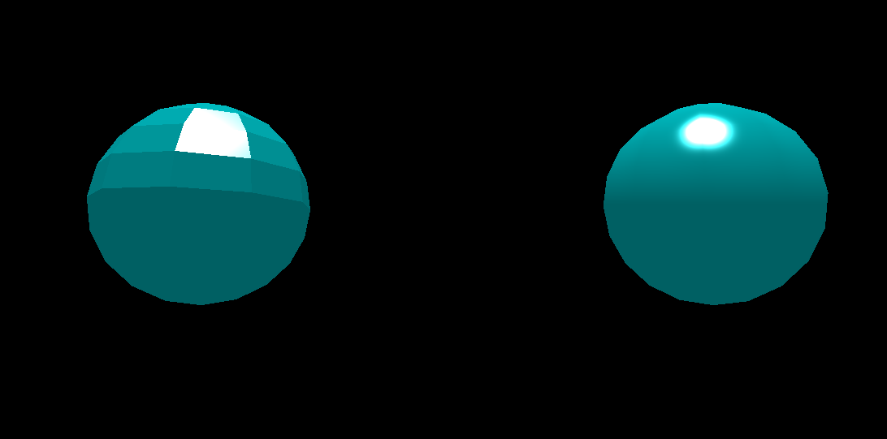

# 2.5 – Transparency

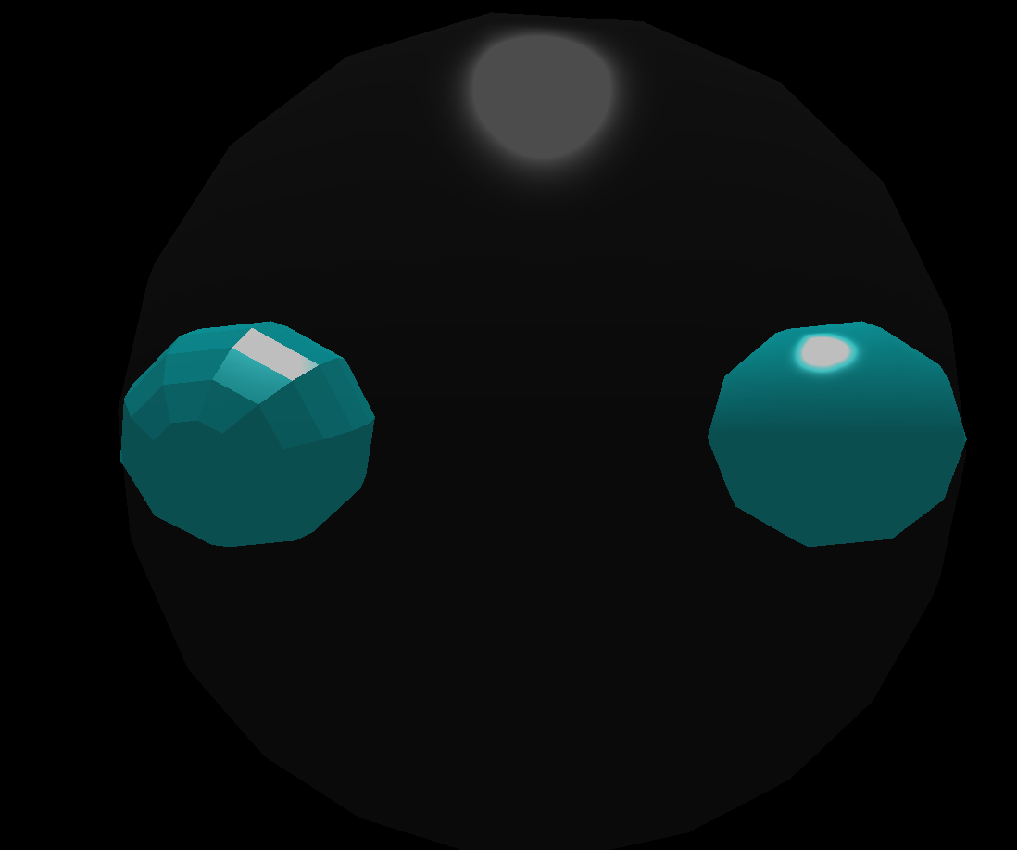

# 2.6 – Transformations (scale and rotation)



# 2.7 – Transformations (rotations)

