Three.js Lesson 3 - Textura e Interação

Diogo Andrade 89265, Rodrigo Oliveira 90514

Information Visualization, 2021 (MEI, University of Aveiro)

Abstract

For the third lesson on three.js in the Information Visualization class, we were tasked with exploring the texture features and combining them with the lighting features and keyboard interaction, developing some examples, following the instructions given to us by the teacher.

# 3.1 – Using a texture in a plane

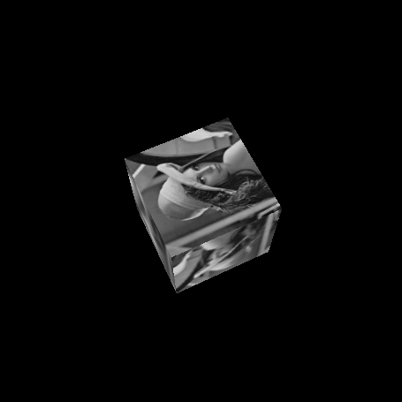

*Tente alterar o tamanho do Plano, o que acontece à textura?*

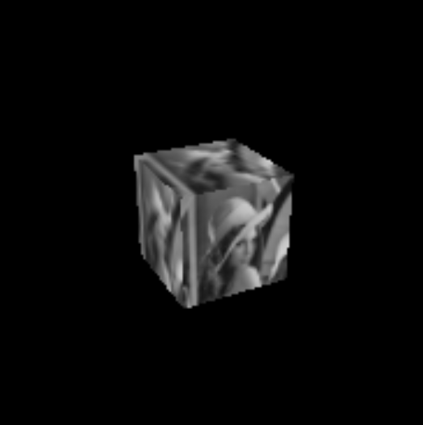

# 3.2 – Texture in a cube

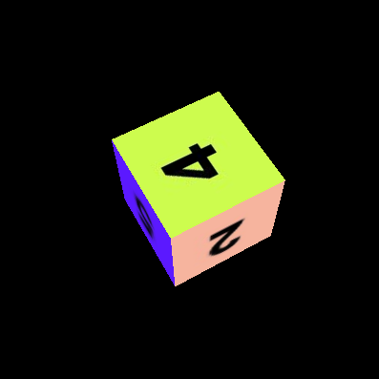

# 3.3 – Texture and illumination

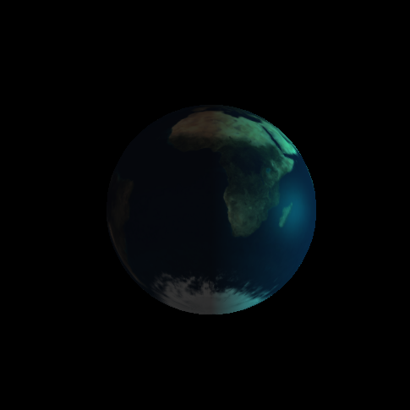

# 3.4 – Interaction

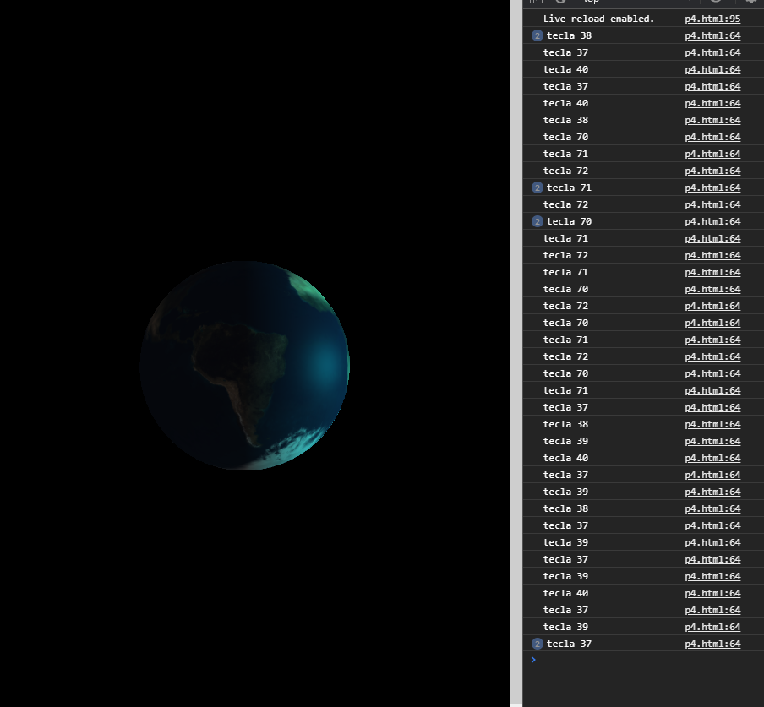

# 3.5 – Ilumination activation

Light off

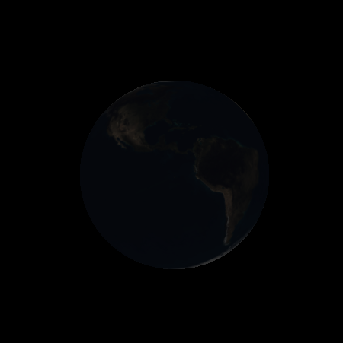

Light on

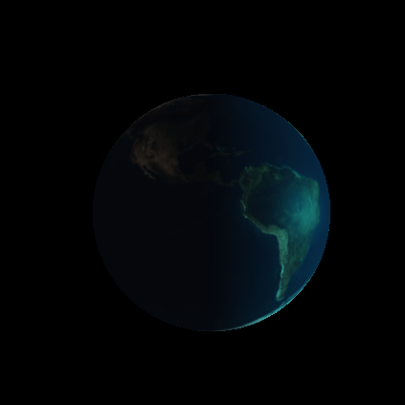

More light

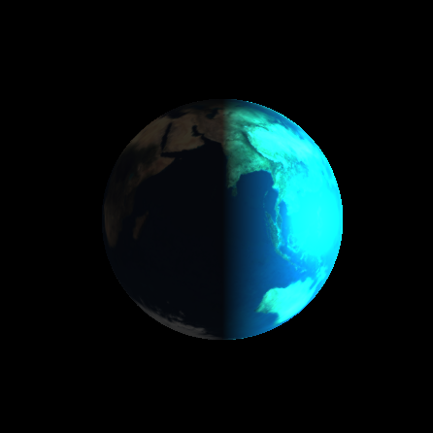

# 3.6 – Change rotation and position

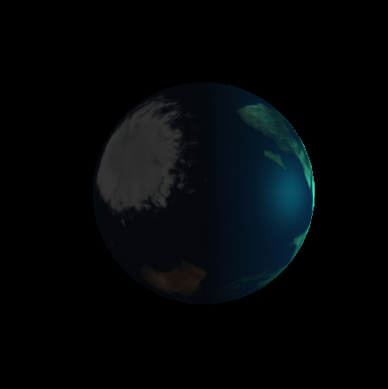

# 3.7 – Concatenation of transformations / adding a moon

