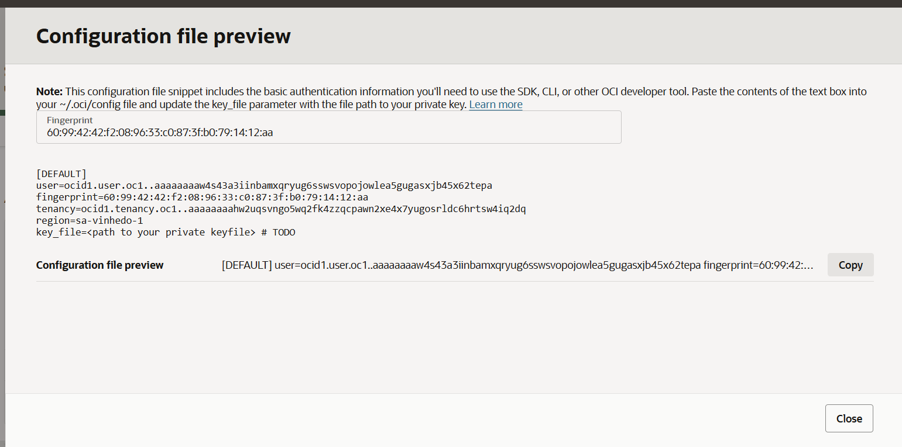

Note: This configuration file snippet includes the basic authentication information you'll need to use the SDK, CLI, or other OCI developer tool. Paste the contents of the text box into your ~/.oci/config file and update the key_file parameter with the file path to your private key. Learn more
Fingerprint
60:99:42:42:f2:08:96:33:c0:87:3f:b0:79:14:12:aa
[DEFAULT]
user=ocid1.user.oc1..aaaaaaaaw4s43a3iinbamxqryug6sswsvopojowlea5gugasxjb45x62tepa
fingerprint=60:99:42:42:f2:08:96:33:c0:87:3f:b0:79:14:12:aa
tenancy=ocid1.tenancy.oc1..aaaaaaaahw2uqsvngo5wq2fk4zzqcpawn2xe4x7yugosrldc6hrtsw4iq2dq
region=sa-vinhedo-1
key_file=<path to your private keyfile> # TODO
Configuration file preview
[DEFAULT] user=ocid1.user.oc1..aaaaaaaaw4s43a3iinbamxqryug6sswsvopojowlea5gugasxjb45x62tepa fingerprint=60:99:42:42:f2:08:96:33:c0:87:3f:b0:79:14:12:aa tenancy=ocid1.tenancy.oc1..aaaaaaaahw2uqsvngo5wq2fk4zzqcpawn2xe4x7yugosrldc6hrtsw4iq2dq region=sa-vinhedo-1 key_file=<path to your private keyfile> # TODO
Copy

[DEFAULT]
user=ocid1.user.oc1..aaaaaaaaw4s43a3iinbamxqryug6sswsvopojowlea5gugasxjb45x62tepa
fingerprint=60:99:42:42:f2:08:96:33:c0:87:3f:b0:79:14:12:aa
tenancy=ocid1.tenancy.oc1..aaaaaaaahw2uqsvngo5wq2fk4zzqcpawn2xe4x7yugosrldc6hrtsw4iq2dq
region=sa-vinhedo-1
key_file=<path to your private keyfile> # TODO

