Relatório da TP5 Sala I004

Exercício A:

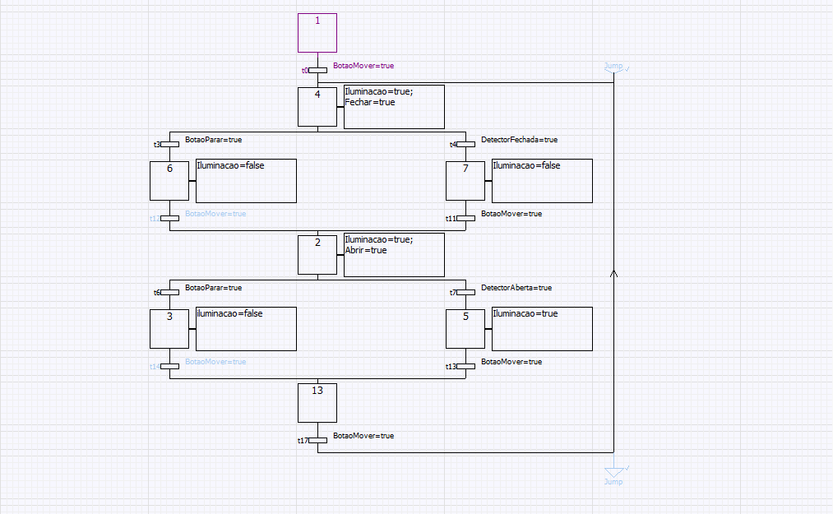

Código resultante do Grafcet:

// Grafcet Modified ...

////////////////////////////////////////////////////////////

// FEUPAutom v3.52 -

// Code Automatically Generated:14-04-2015 15:22:59

////////////////////////////////////////////////////////////

////////////////////////////////////////////////////////////

///////////// If boot => Set Initial Steps /////////////////

////////////////////////////////////////////////////////////

////////////////////////////////////////////////////////////

///////////////// Calc Fired Transitions ///////////////////

////////////////////////////////////////////////////////////

// ObjIdx=1 => Transition "t0"

// Steps Above: id=0 => X1 ;

// Steps Below: id=2 => X4 ;

t0 := X1 AND (BotaoMover=true) ;

// ObjIdx=5 => Transition "t3"

// Steps Above: id=2 => X4 ;

// Steps Below: id=3 => X6 ;

t3 := X4 AND (BotaoParar=true) ;

// ObjIdx=6 => Transition "t4"

// Steps Above: id=2 => X4 ;

// Steps Below: id=4 => X7 ;

t4 := X4 AND (DetectorFechada=true) ;

// ObjIdx=8 => Transition "t11"

// Steps Above: id=4 => X7 ;

// Steps Below: id=9 => X2 ;

t11 := X7 AND (BotaoMover=true) ;

// ObjIdx=11 => Transition "t6"

// Steps Above: id=9 => X2 ;

// Steps Below: id=7 => X3 ;

t6 := X2 AND (BotaoParar=true) ;

// ObjIdx=12 => Transition "t7"

// Steps Above: id=9 => X2 ;

// Steps Below: id=10 => X5 ;

t7 := X2 AND (DetectorAberta=true) ;

// ObjIdx=13 => Transition "t13"

// Steps Above: id=10 => X5 ;

// Steps Below: id=14 => X13 ;

t13 := X5 AND (BotaoMover=true) ;

// ObjIdx=16 => Transition "t12"

// Steps Above: id=3 => X6 ;

// Steps Below: id=9 => X2 ;

t12 := X6 AND (BotaoMover=true) ;

// ObjIdx=17 => Transition "t14"

// Steps Above: id=7 => X3 ;

// Steps Below: id=14 => X13 ;

t14 := X3 AND (BotaoMover=true) ;

// ObjIdx=19 => Transition "t17"

// Steps Above: id=14 => X13 ;

// Steps Below: id=2 => X4 ;

t17 := X13 AND (BotaoMover=true

) ;

////////////////////////////////////////////////////////////

///////////////// ReSet Steps Above fired Tr ///////////////

////////////////////////////////////////////////////////////

// ObjIdx=1 => Transition "t0"

// Steps Above: id=0 => X1 ;

// Steps Below: id=2 => X4 ;

If (t0) Then

X1:=False;

End_If;

// ObjIdx=5 => Transition "t3"

// Steps Above: id=2 => X4 ;

// Steps Below: id=3 => X6 ;

If (t3) Then

X4:=False;

End_If;

// ObjIdx=6 => Transition "t4"

// Steps Above: id=2 => X4 ;

// Steps Below: id=4 => X7 ;

If (t4) Then

X4:=False;

End_If;

// ObjIdx=8 => Transition "t11"

// Steps Above: id=4 => X7 ;

// Steps Below: id=9 => X2 ;

If (t11) Then

X7:=False;

End_If;

// ObjIdx=11 => Transition "t6"

// Steps Above: id=9 => X2 ;

// Steps Below: id=7 => X3 ;

If (t6) Then

X2:=False;

End_If;

// ObjIdx=12 => Transition "t7"

// Steps Above: id=9 => X2 ;

// Steps Below: id=10 => X5 ;

If (t7) Then

X2:=False;

End_If;

// ObjIdx=13 => Transition "t13"

// Steps Above: id=10 => X5 ;

// Steps Below: id=14 => X13 ;

If (t13) Then

X5:=False;

End_If;

// ObjIdx=16 => Transition "t12"

// Steps Above: id=3 => X6 ;

// Steps Below: id=9 => X2 ;

If (t12) Then

X6:=False;

End_If;

// ObjIdx=17 => Transition "t14"

// Steps Above: id=7 => X3 ;

// Steps Below: id=14 => X13 ;

If (t14) Then

X3:=False;

End_If;

// ObjIdx=19 => Transition "t17"

// Steps Above: id=14 => X13 ;

// Steps Below: id=2 => X4 ;

If (t17) Then

X13:=False;

End_If;

////////////////////////////////////////////////////////////

///////////////// Set Steps below fired Tr /////////////////

////////////////////////////////////////////////////////////

// ObjIdx=1 => Transition "t0"

// Steps Above: id=0 => X1 ;

// Steps Below: id=2 => X4 ;

If (t0) Then

X4 := True;

X4_T := 0;

End_If;

// ObjIdx=5 => Transition "t3"

// Steps Above: id=2 => X4 ;

// Steps Below: id=3 => X6 ;

If (t3) Then

X6 := True;

X6_T := 0;

End_If;

// ObjIdx=6 => Transition "t4"

// Steps Above: id=2 => X4 ;

// Steps Below: id=4 => X7 ;

If (t4) Then

X7 := True;

X7_T := 0;

End_If;

// ObjIdx=8 => Transition "t11"

// Steps Above: id=4 => X7 ;

// Steps Below: id=9 => X2 ;

If (t11) Then

X2 := True;

X2_T := 0;

End_If;

// ObjIdx=11 => Transition "t6"

// Steps Above: id=9 => X2 ;

// Steps Below: id=7 => X3 ;

If (t6) Then

X3 := True;

X3_T := 0;

End_If;

// ObjIdx=12 => Transition "t7"

// Steps Above: id=9 => X2 ;

// Steps Below: id=10 => X5 ;

If (t7) Then

X5 := True;

X5_T := 0;

End_If;

// ObjIdx=13 => Transition "t13"

// Steps Above: id=10 => X5 ;

// Steps Below: id=14 => X13 ;

If (t13) Then

X13 := True;

X13_T := 0;

End_If;

// ObjIdx=16 => Transition "t12"

// Steps Above: id=3 => X6 ;

// Steps Below: id=9 => X2 ;

If (t12) Then

X2 := True;

X2_T := 0;

End_If;

// ObjIdx=17 => Transition "t14"

// Steps Above: id=7 => X3 ;

// Steps Below: id=14 => X13 ;

If (t14) Then

X13 := True;

X13_T := 0;

End_If;

// ObjIdx=19 => Transition "t17"

// Steps Above: id=14 => X13 ;

// Steps Below: id=2 => X4 ;

If (t17) Then

X4 := True;

X4_T := 0;

End_If;

////////////////////////////////////////////////////////////

///////////////////// Unset all Outputs ////////////////////

////////////////////////////////////////////////////////////

Iluminacao:=False;

Abrir:=False;

Fechar:=False;

Q3:=False;

Q4:=False;

Q5:=False;

Q6:=False;

Q7:=False;

Q8:=False;

Q9:=False;

Q10:=False;

Q11:=False;

Q12:=False;

Q13:=False;

Q14:=False;

Q15:=False;

Q16:=False;

Q17:=False;

Q18:=False;

Q19:=False;

Q20:=False;

Q21:=False;

Q22:=False;

Q23:=False;

Q24:=False;

Q25:=False;

Q26:=False;

Q27:=False;

Q28:=False;

Q29:=False;

Q30:=False;

Q31:=False;

Q32:=False;

Q33:=False;

Q34:=False;

Q35:=False;

Q36:=False;

Q37:=False;

Q38:=False;

Q39:=False;

Q40:=False;

Q41:=False;

Q42:=False;

Q43:=False;

Q44:=False;

Q45:=False;

Q46:=False;

Q47:=False;

////////////////////////////////////////////////////////////

///// If step active increment MW timer of step @ %s16 /////

////////////////////////////////////////////////////////////

// ObjIdx=0 => Step "X1"

If (%s16) and (X1) Then X1_T := X1_T+1; end_if;

// ObjIdx=2 => Step "X4"

If (%s16) and (X4) Then X4_T := X4_T+1; end_if;

// ObjIdx=3 => Step "X6"

If (%s16) and (X6) Then X6_T := X6_T+1; end_if;

// ObjIdx=4 => Step "X7"

If (%s16) and (X7) Then X7_T := X7_T+1; end_if;

// ObjIdx=7 => Step "X3"

If (%s16) and (X3) Then X3_T := X3_T+1; end_if;

// ObjIdx=9 => Step "X2"

If (%s16) and (X2) Then X2_T := X2_T+1; end_if;

// ObjIdx=10 => Step "X5"

If (%s16) and (X5) Then X5_T := X5_T+1; end_if;

// ObjIdx=14 => Step "X13"

If (%s16) and (X13) Then X13_T := X13_T+1; end_if;

////////////////////////////////////////////////////////////

//////// If step active, execute its action code ///////////

////////////////////////////////////////////////////////////

// ObjIdx=0 => Step "X1" (code...)

// ObjIdx=2 => Step "X4" (code...)

If X4 Then

Iluminacao=true;

Fechar=true

End_If;

// ObjIdx=3 => Step "X6" (code...)

If X6 Then

Iluminacao=false

End_If;

// ObjIdx=4 => Step "X7" (code...)

If X7 Then

Iluminacao=false

End_If;

// ObjIdx=7 => Step "X3" (code...)

If X3 Then

iluminacao=false

End_If;

// ObjIdx=9 => Step "X2" (code...)

If X2 Then

Iluminacao=true;

Abrir=true

End_If;

// ObjIdx=10 => Step "X5" (code...)

If X5 Then

Iluminacao=true

End_If;

// ObjIdx=14 => Step "X13" (code...)

Exercício B: