**1**

**Introduction**

Improvements in computational power are supporting the birth of new fields such as Machine learning, AI, and data science. The potential contained in these fields for increased productivity and efficiency, is allowing technology to break into sectors that have been in the past very reticent to change and progress – 4th Industrial Revolution.

A good example of slow adoption of innovative technologies is the construction industry, a sector that contributes massively to several pollution indicators such as Air quality, emission of climate change gasses, and Ozone depletion [1].

Over the last two decades talk in the construction industry about new methods and solutions has been increasing, but when compared to other industries, actual implementation of these new methods has been slow. Currently the technology is making its way into the design stage, with technologies such as BIM already widely used (and mandatory in some projects) and with technologies such as Virtual&Augmented Reality and fields of Algorithmic and Computational design rapidly expanding in design practices.

Computational and Algorithmic design have the potential to become the most disruptive change in the design workflow, but currently they work very well in the concept design phase and have reduced value later in the design process as they clash with the often overly conservative design codes that are written in a way that rewards the traditional solutions and leaves little chance for innovative approaches to a design problem.

**1.1. Objectives**

This dissertation assesses the feasibility of implementing these new emerging fields past the concept design phase into the final project. The structures optimized in this dissertation are high voltage electricity pylons, this choice was made as the design process is simple enough to be developed in the time frame of the present work, when compared to other options (buildings, high rise towers, bridges, etc). Although simple in the design phase, the current design norms for such structures are quite strict when it comes to geometry, which provides the main challenge of this thesis, develop an algorithm known to produce organic shapes and make it work according to strict design codes.

If this integration proves possible, the result will be an application, with potential commercial applications, that outputs an optimized structure, reducing material usage and design time. The engineer’s function will be reduced to the initial input of information, supervise the algorithm and later the detailing of connections in the structure, overall the engineer will be freed to do more creative work.

If the integration is unsuccessful, the present work will at least provide insights about this often-conflicting relationship between current design codes and future technology, useful in the inevitable future research conducted in this field.

**1.2. Electricity Pylons**

To transmit electricity over large distances, several solutions are used, from the electricity pylons to underground cables in locations where the visual disruption of tower structures is unacceptable or the risk of power outages in wind/snow storms justifies the extra costs of this solution.

The first electricity pylons were erected in the early 1920s, initially made of wood, they have rapidly evolved to the traditional steel design we see today. Since that material change the design of lattice transmission pylons the fundamental design principles remained largely unchanged.

The lattice solution is the most common, and there are several reasons for the adoption of this solution. Lattice solutions can be applied to very small or very large towers and are often the cheapest solution when other constrains such as visual impact are not present, they can vary in shape to withstand different load conditions (figure 1.1).

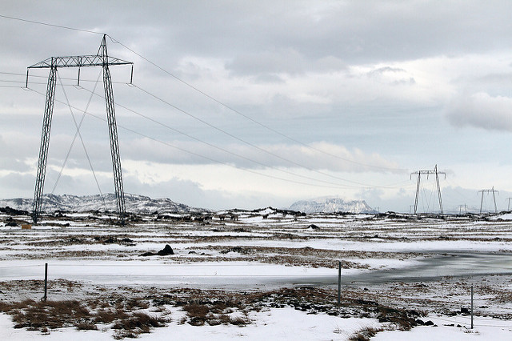

Fig. 1.1 – Power lines designed to withstand snow, Iceland

They are usually designed to make use of economies of scale, for that reason, a pylon is designed to withstand a wide range of loads present in the initial project of a new power line, this ensures that the same pylon can be used several times along the power line, reducing material waste and design time. As pylons are replicated several times, and have a relatively small size, they are one of the few structures in this field that can be tested before deployment to validate and improve the design, these tests are conducted in bespoke test benches (figure 1.2).

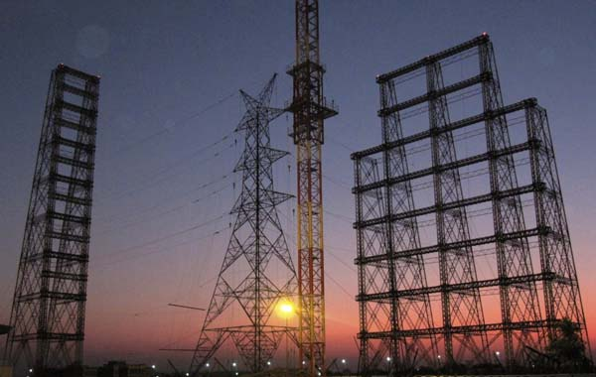

Fig. 1.2 – Test bench – India

There are also other tower solutions to transmit electricity, very high strength steel poles, have a circular hollow section, they have a reduced visual impact, are assembled faster and the base occupies less space. However, they are more expensive to build and maintain, prone to dynamic effects due to wind loads.

**1.3. Structure**

This dissertation is divided in 5 chapters, after this initial introduction, chapter 2 details the design requirements that this electricity pylons need to meet and details design assumptions that needed to be made to make possible the development of a program with a high degree of automation.

Chapter 3, starts by giving an overview of what a genetic algorithm is and proceeds to explain the key components present in these types of optimisation algorithms.

Chapter 4 presents the various components of the application developed, every component is described in detail and with some excerpts of code.

In chapter 5, the results of a case study are presented and analysed.

[1]Brown MT, Bardi E. Handbook of energy evaluation. A compendium of data for energy computation issued in a series of folios. Folio #3: Energy of ecosystems. Center for Environmental Policy, Environmental Engineering Sciences, University of Florida, Gainesville; 2001.

[2] VHSS poles