**5**

**Case Study**

In this closing chapter, the developed application will be used to design a lattice tower structure that withstands the same loads and has the same geometric constraints as the real-world model provided by Metalogalva.

In the next subchapters, the model will be presented, along with the steps taken to prepare the optimization process.

Finally results will be analysed and conclusions about real world implications will be drawn along with future development paths that could be taken to improve the application.

**5.1. Base model**

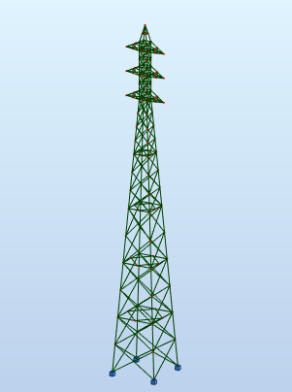

Fig. 5.1 – Base Model

The case study tower is 38 meters high, and carries 7 cables, 3 in each side and one at the tip of the tower. The distance between leg members at the base is 5 meters in both directions, each arm is 2.25 meters long and the steel used is of type S275. The model provided has a total weight of 7.612 tonnes, the distributed between the different sections is as follows:

|  |  |  |
| --- | --- | --- |
| Sections | Number | Total weight (kg) |
| CAEP 50x5  CAEP 60x6  CAEP 70x7  CAEP 100x10  CAEP 140x13  CAEP 160x15  CAEP 180x6  LP 180x180x15 | 262  44  4  4  4  4  4  8 | 1873  699  123  379  660  870  1046  1967 |
|  |  | 7616 |

Regarding loads, the base model contained hundreds of load cases. To improve the run time of the optimisation routine, the critical load cases were identified with the help of Metalogalva’s technical department, this operation allowed the application to run with only 4 critical load cases added to the self-weight of the structure. Given the way the DNA of the structure is generated this reduction of load cases adds the need of a final inspection of the output model to ensure symmetry, this is a point of further improvement of the program that will be detailed at the end of the chapter.

The following image identifies the nodes and table 5.1 details the forces applied to them in each of the four critical load cases.

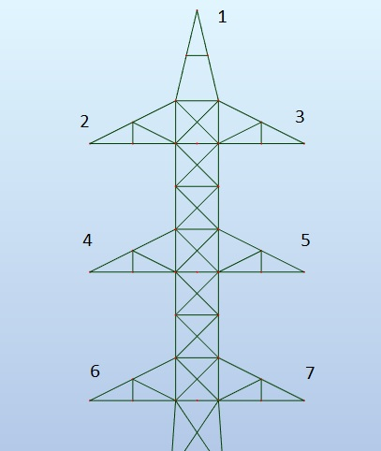

|  |  |  |  |  |  |  |  |
| --- | --- | --- | --- | --- | --- | --- | --- |
|  | Node 1 | Node 2 | Node 3 | Node 4 | Node 5 | Node 6 | Node 7 |
| LC1  (kN) | FX=13.24  FY=1.23  FZ=-3.43 | FX=24.02  FY=0.49  FZ=7.84 | FX=24.02  FY=0.49  FZ=7.84 | FX=24.02  FY=0.49  FZ=7.84 | FX=24.02  FY=0.49  FZ=7.84 | FX=24.02  FY=0.49  FZ=7.84 | FX=24.02  FY=0.49  FZ=7.84 |
| LC2  (kN) | FX=0.0  FY=12.50  FZ=-2.45 | FX=0.0  FY=29.41  FZ=-7.84 | FX=0.0  FY=22.06  FZ=-4.90 | FX=0.0  FY=22.06  FZ=-4.90 | FX=0.0  FY=22.06  FZ=-4.90 | FX=0.0  FY=22.06  FZ=-4.90 | FX=0.0  FY=22.06  FZ=-4.90 |
| LC3  (kN) | FX=1.72  FY=12.50  FZ=-2.45 | FX=2.45  FY=22.06  FZ=-4.90 | FX=2.45  FY=22.06  FZ=-4.90 | FX=2.45  FY=22.06  FZ=-4.90 | FX=2.45  FY=22.06  FZ=-4.90 | FX=2.45  FY=22.06  FZ=-4.90 | FX=2.45  FY=22.06  FZ=-4.90 |
| LC4  (kN) | FX=0.0  FY=12.50  FZ=-2.45 | FX=0.0  FY=22.06  FZ=-4.90 | FX=0.0  FY=29.41  FZ=-7.84 | FX=0.0  FY=22.06  FZ=-4.90 | FX=0.0  FY=22.06  FZ=-4.90 | FX=0.0  FY=22.06  FZ=-4.90 | FX=0.0  FY=22.06  FZ=-4.90 |

Table 5.1

**5.2. Program setup**

To configure the application to design an optimised structure to withstand the loads listed above and with similar geometrical characteristics a few steps are needed to prepare the program.

As it is a small tower (38m), the penalty function is changed to 0.15 tonnes. A list of sections needs to be provided to the GA before starting the optimisation, the sections used were:

* L50x50x5
* L60x60x6
* L70x70x7
* L100x100x10
* L150x150x15
* L180x180x16

The list has 2 fewer sections than the base model, this was done based on a previous analysis that concluded that there was no need – based on bar utilization factors and the expected optimization ratio – for two intermediate bars between the L 100 and L 180 sections. A single L 150 section was used instead of the L 140 and L160.

This reduction of available sections also allows the program to run faster as the search space is reduced however, there is a risk that the output structure still has penalties applied, that is, some bars need to have larger sections that are not available, to solve this issue a log file containing the list of bars that need to be strengthened (either by secondary bracing or larger sections) is produced for the final structure.

The load cases described in 5.1 were added using the Robot UI and for each load case the self-weight of each bar was added, this additional load is automatically updated by robot in each iteration.

**5.2. Results**

5.2.1. Post processing

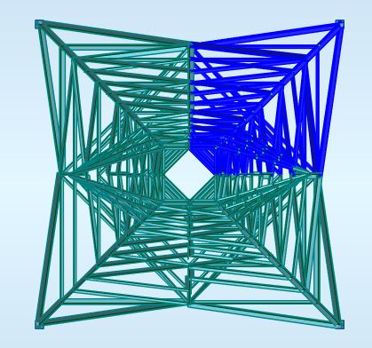

Fig. 5.3 – Plan view

Given the steps taken to reduce the number of load cases, symmetrical load cases were removed, only loads critical to the upper right quadrant (highlighted in figure 5.3) of the tower were kept. This meant the output would be a non-symmetrical structure were that upper right quadrant would need to be reproduced on the remaining three corners of the structure. In figure 5.4 the critical quadrant is displayed in isolation, next to the final symmetrical structure before any required strengthening work was performed.

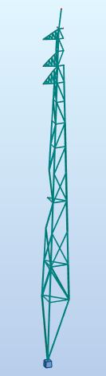 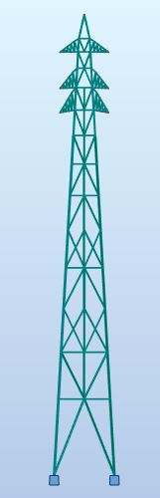 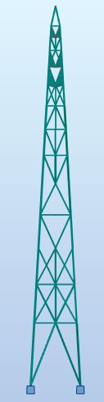

Fig. 5.4

After the symmetry operations, the log file was opened to see if any bars needed additional strengthening, in this case all the leg members were listed as well as a few bars in the middle of the structure with u/f slightly higher than 1.0. Given the locations of the elements to strengthen secondary bracing – with section L 40x40x5 – was used instead of larger sections.

Figure 5.5 details how the leg members were strengthened, a similar triangulation method was used on for the other bars.

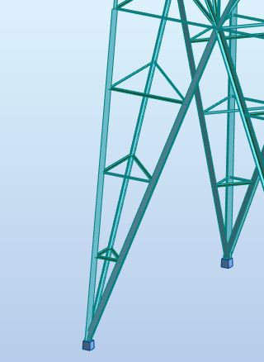

Fig. 5.5

5.2.2. Analysis

The final structure (Fig 5.6) has a total weight 6.8 tonnes, that equates to 10.5% material reduction, the weight is distributed between the different sections is as follows:

[QUADRO]

Adding to the material savings, the number of sections used is also smaller allowing for more efficient manufacturing.

Given the current concerns about sustainability the implications of savings will be analysed by CO2 emissions saved by using less steel. The national grid of the United Kingdom will be used as the data needed for the analysis is publicly available.

According to the European Strategic Energy Technologies Information System, in 2012 the European steel industry 2.3 tonnes of CO2 per tonne of steel. The report also identifies paths for improvement that could reduce this value by 70% to 0.7 tonnes of CO2 per tonne of steel. For this analysis, the best case scenario (the improvements were successfully applied to the European steel industry) will be used.

Data from the National Grid (UK) website points that there are 88000 electricity pylons in the UK and their average weight is 30 tonnes.

Using this information if a 10% reduction in material usage was applied to every pylon, 2 376 000 tonnes of CO2 could be saved on the entire grid.

To make some sense of these numbers, data from the Environment Protection Agency (US) was used to compare this emissions with other activities that equate to similar emission levels, 2 376 000 is equivalent to:

* 501 891 Passenger vehicles driven for one year;
* 11920 round trips to the moon in a passenger vehicle;
* 754 038 Tons of waste recycled instead of landfilled;
* 1 010 million litres of petrol burned;
* 600 installed wind turbines;
* Energy to power 250 000 homes for a year;
* 70 % of the yearly emissions of a coal-fired power plant.

[FALAR TO CASO DE ESTUDO EXTRA]

**5.3. Future work**

This first version of the program validated the use of genetic algorithms to automate to a certain degree the design of optimised lattice tower structures, returning gains in productivity and material efficiency. During development and testing, some points to improve in a future iteration of the software were also identified.

The Genome class, responsible for the DNA generation should be updated to ensure symmetry of the structure even when loads are reduced, as they were in the case study, to its most critical loads for a specific quadrant. This would shorten the execution time of the optimisation by reducing the number of load cases applied in the structure (by removing the symmetrical LCs), ensuring the output structure does not need the human operations to re-establish symmetry of the solution. This could be implemented by defining a master quadrant, from where every bar in the remaining three corners of the structure would inherit its properties, the same should also be applied to the node elements.

When scaling up to optimise larger structures a constraint in the Robot API was identified, the calls needed to update bar properties between each individual evaluation take too much time when compared to other calls such as the ones responsible for running and retrieving results from the FE analysis, in fact when the bar count increases above a certain point the communications between the program and Robot are slow enough to make the application stop responding. In a future version, changing the Robot_call class to work with another FEM package such as OpenSees or Oasys GSA will deliver higher performance and will enable more complex optimization problems to run.

Finally, to address the need for human intervention to read the log file and add secondary bracing to the model, a future academic work could test the implementation of a neural network to read input from that file and the structure, and automatically apply the needed bracing elements.

https://setis.ec.europa.eu/related-jrc-activities/jrc-setis-reports/energy-efficiency-iron-and-steel-industry-technology