1. Install requirements  
  
  
2. Main code execution with data  
  
  
User is admin  
  
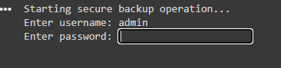  
  
password is: password123  
  
End result:  
