Shortcut Mail Integration - Program details.

Document history and versions
Version | Date | Edited by | Changed sections | Reason for change
1.0 | 15/06/2020 | Sagar Khade | - | NEW

Description:
New GEOS Addin in Outlook, so that it is easier for sales people to create new opportunities and activities directly from Outlook.
Prerequisite:
- Outlook should be installed.
- Geos Workbench should be installed as we are using same setting than Geos Workbench.
IMPORTANT NOTE:
- Use one application at a time to avoid errors.
- Some time Addin is delay loading with showing message in 1 Working with OUTLOOK GEOS addin in point 7
Installation Process:
1) Copy installation folder to local directory
- It is compulsory to copy installation folder to local directory.
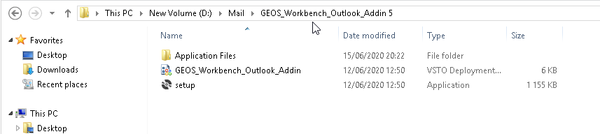
2) Start installation
- Double click on setup file and start installation and click on install.
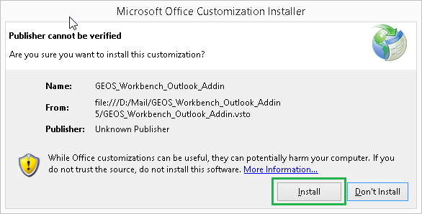

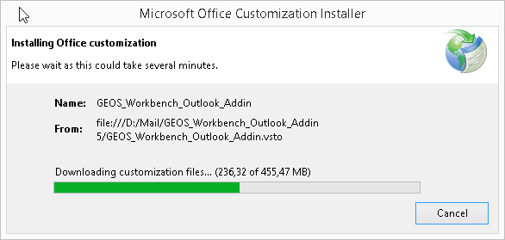
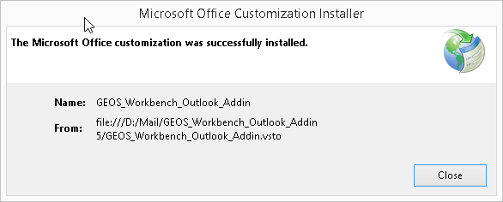
3) Close the window.
- The outlook addin was successfully installed.
- Close the window.

Working with OUTLOOK GEOS addin

This setting.xml is contain setting for saving .csv file and other details required for the program to get the data of employee.
- Open Microsoft outlook.
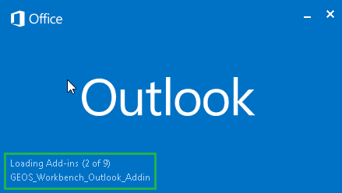
- GEOS_Workbench_Outlook_Addin - loading.
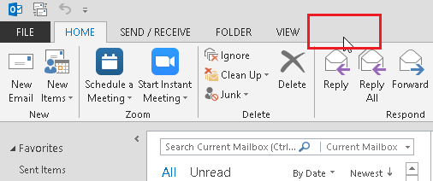
- GEOS - Search for GEOS tab.

- Information – If GEOS tab is not shown then the GEOS addin is not loaded by outlook. In this case try this option.
  - Files -> Information -> Slow and Disabled COM addins
If GEOS addin is loaded then ignore this option.

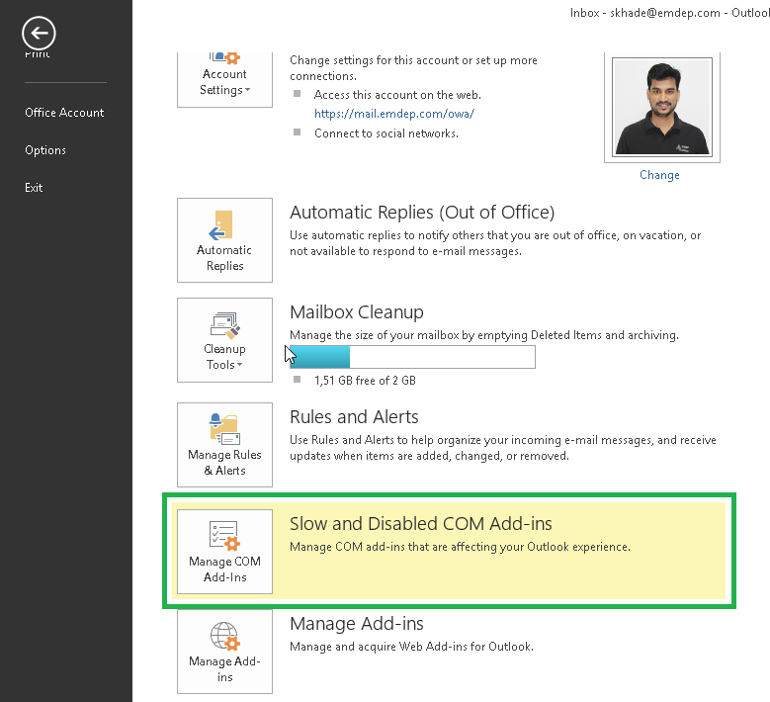

- If addin is disabled then enable it.
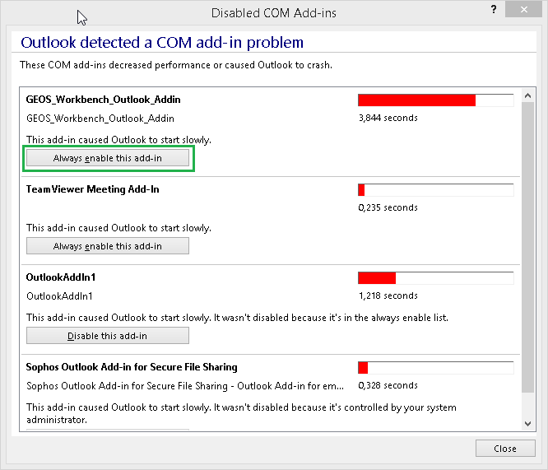
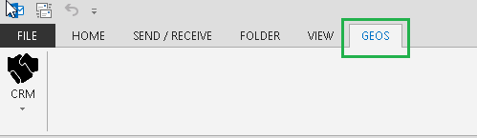
- GEOS Menu - Now you will see GEOS menu in outlook.

- Sometimes the Geos tab is delayed by following screen
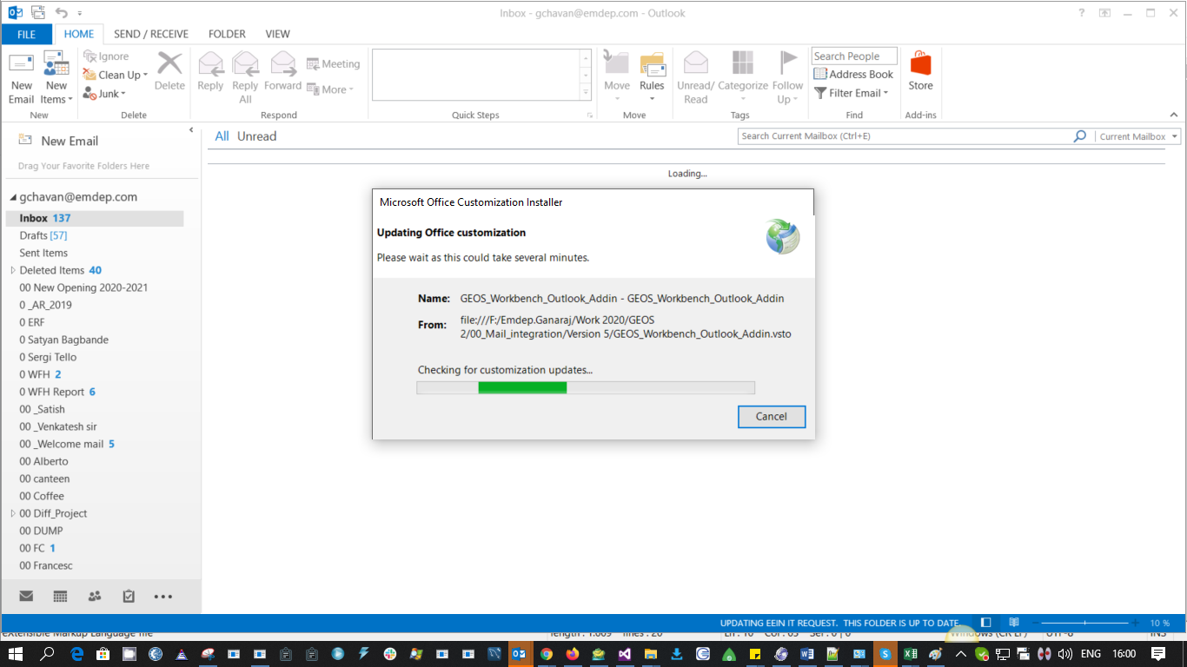

2 Available options in CRM menu.

There are multiple options from CRM module are available.
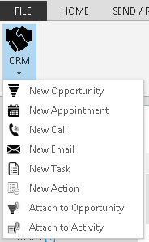
User can selected any one of this option.
Note: It is mandatory to select one email from inbox to use these options from CRM

1) New Opportunity:
This option will work same like CRM new opportunity without entering in Geos Workbench. Some fields are automatically filled on selected email information. Group and plant automatically loaded on receivers email address.
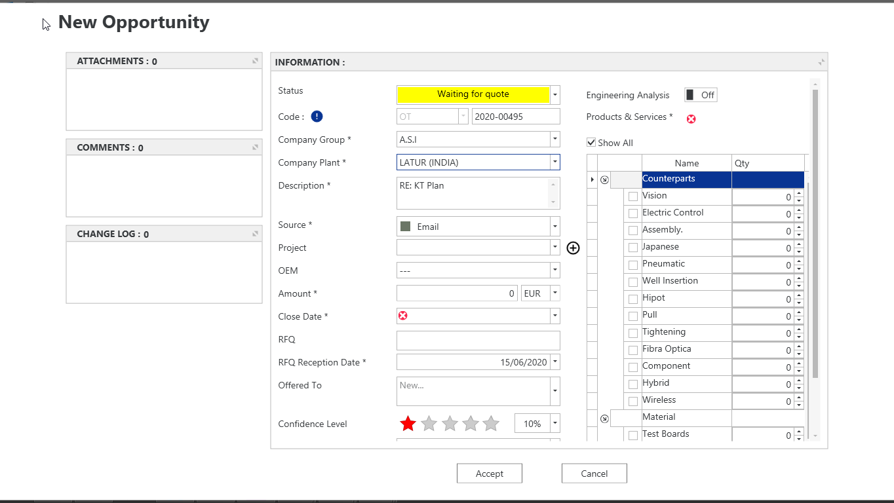

2) New Appointment:
Clicking on new Appointment option a new window will be prompted in order to let the user create new Appointment activity in GEOS without entering to GEOS Workbench.
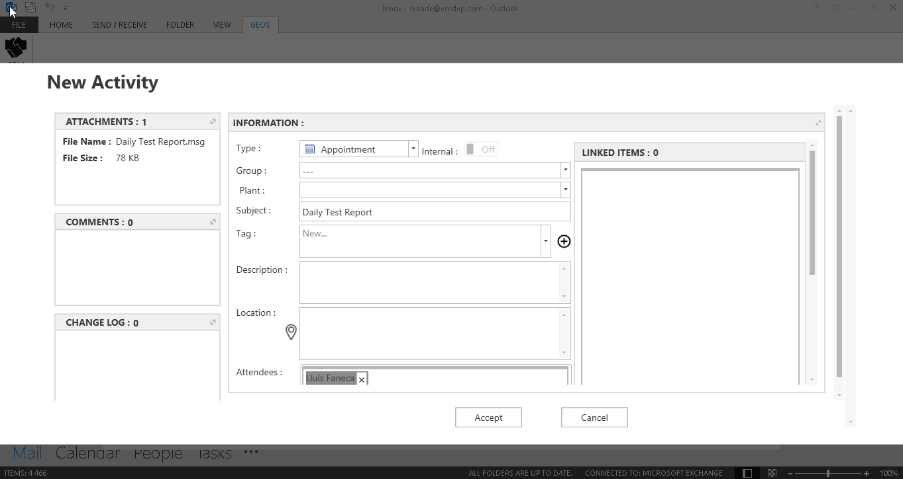
3) New Call:
Clicking on new Call option a new window will be prompted in order to let the user create new Call activity in GEOS without entering to GEOS Workbench.
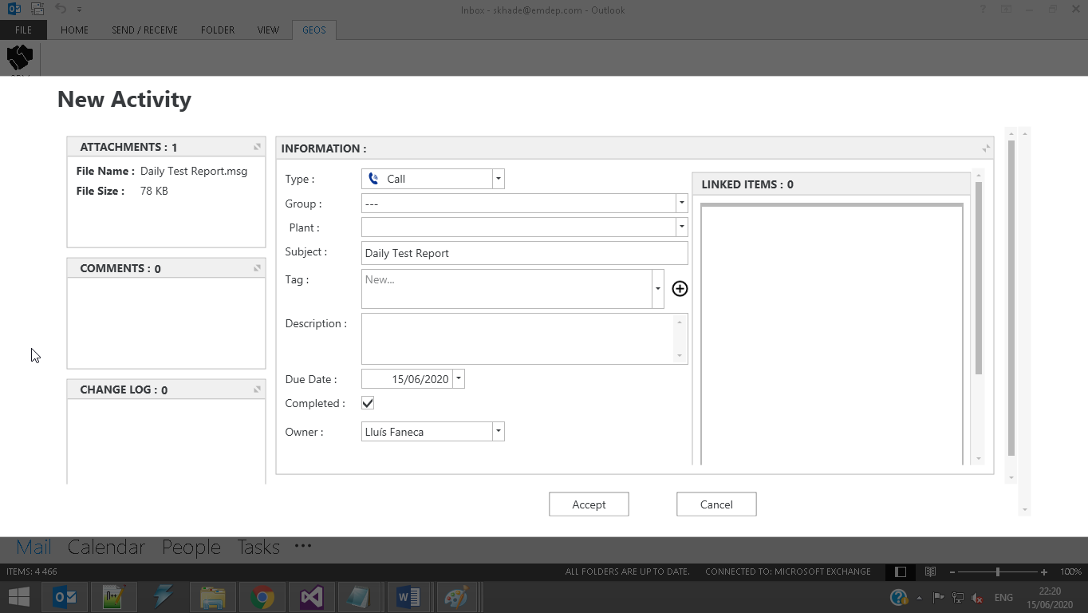
4) New Email: Clicking on new Email option a new window will be prompted in order to let the user create new Email activity in GEOS without entering to GEOS Workbench.
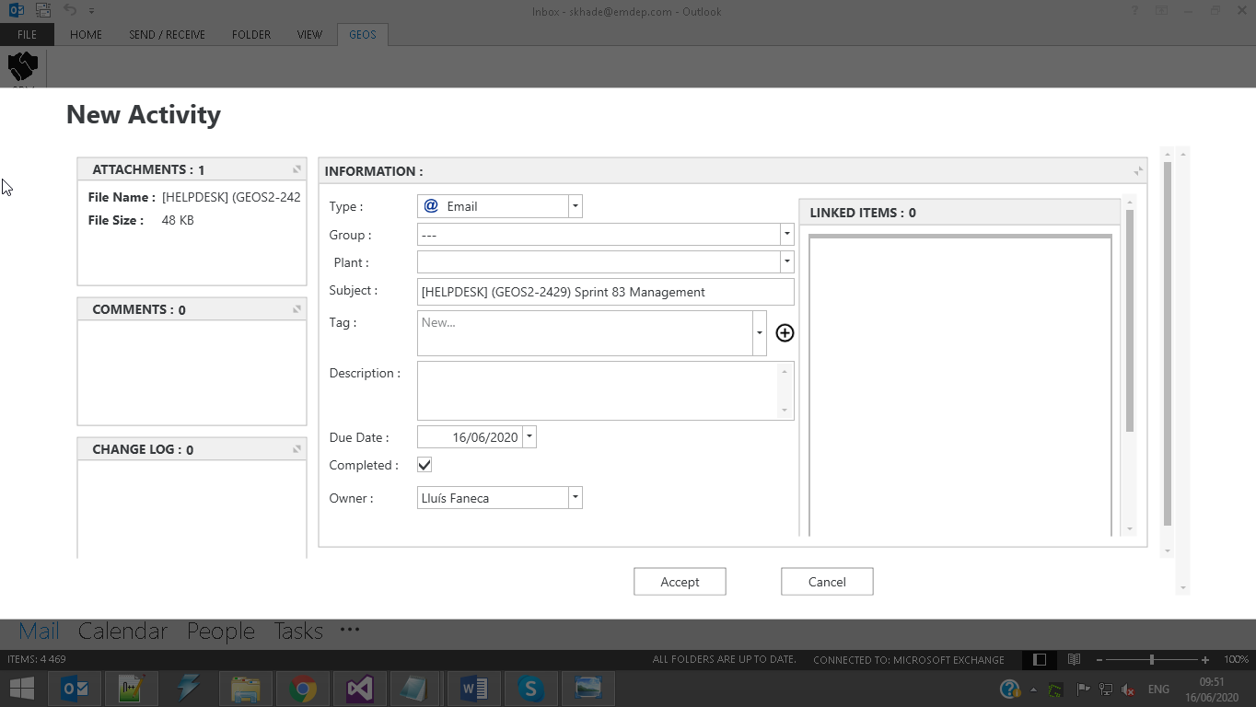
5) New Task:
Clicking on new Task option a new window will be prompted in order to let the user create new Task activity in GEOS without entering to GEOS Workbench.
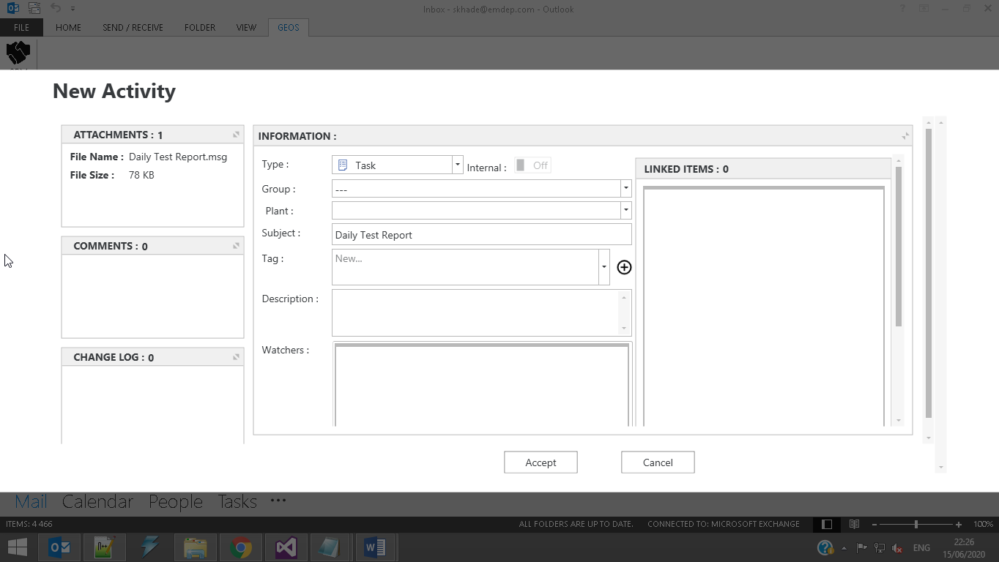
6) New Action:
Clicking on new Action option a new window will be prompted in order to let the user create new Action in GEOS without entering to GEOS Workbench.
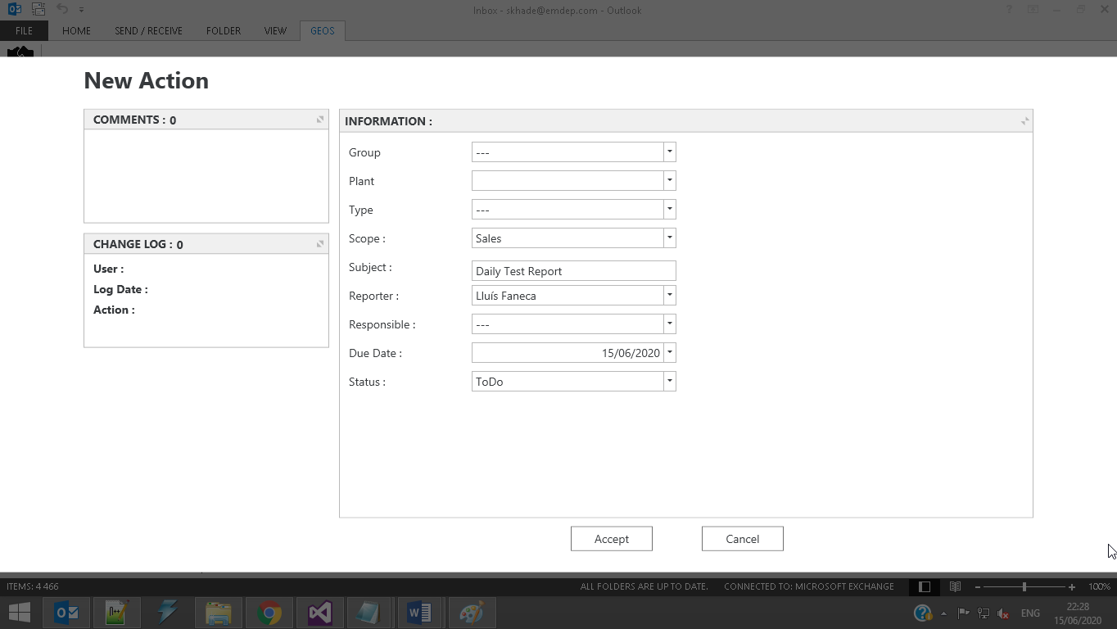
7) Attach to Opportunity:
Clicking on this option a new window will be prompted in order to let the user attach the current email to some of the existing opportunities in GEOS.
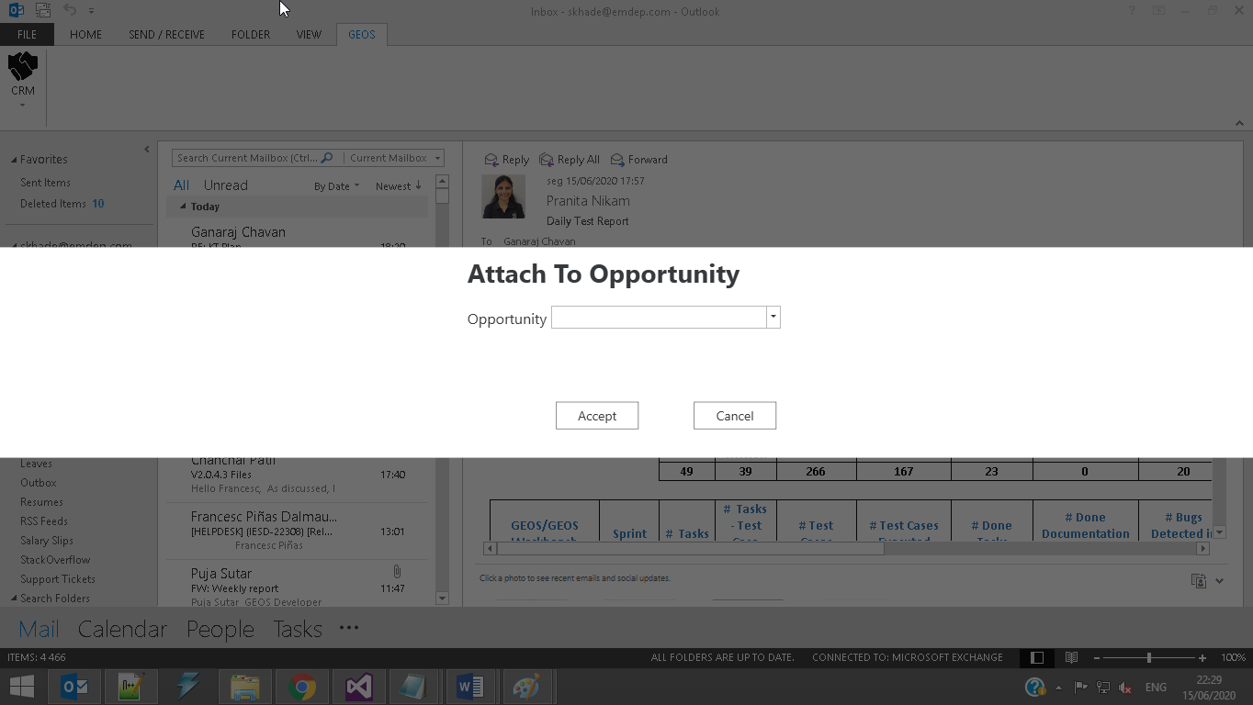

8) Attach to Activity:
Clicking on this option a new window will be prompted in order to let the user attach the current email to some of the existing activities in GEOS.
