1. **Introduction**

Today’s increasing use of smart mobile devices[1] for application-based online content access and growing demand for reliable and ubiquitous Internet connectivity poses challenges to Internet and content providers. Cellular providers are looking for offloading opportunities due to increasing load on their networks[2], whereas content providers increasingly adapt Content Delivery Network (CDN) solutions to provide a seamless user experience for their customers. In parallel, there is a growing paradigm of Information-Centric Networking (ICN)[3], both in research and industry, which addresses the data-centric evolution of the Internet. Motivated by the above trends and challenges as well as the ICN movement, this project proposes a mobile, application-aware, device-to-device (D2D) content delivery scheme.

Such a scheme aims to utilize existing and emerging radio and discovery technologies, such as Wifi-Direct, to allow for the effective dissemination of content between individual mobile devices with common applications, as opposed to direct downloading of content by each individual device. A successful implementation of this scheme could potentially decrease load on Internet and content providers, enhance user experience by reducing the dependency on Internet connectivity and online download times, and open doors for application development, which takes advantage of the application-aware nature of the scheme.

1. **Objectives and Previous Works**

The aim of this project was to assess the feasibility of the proposed scheme. As such, the following objectives were defined at the start:

* Explore related work and existing technologies applicable to the implementation of the scheme.
* Design the protocols for the prototype scheme to be implemented in a suitable simulating environment.
* Design the simulation scenario to model a real-world emvironment.
* Select the key parameters to study and evaluation metrics for assessment.
* Run multiple simulations and extract results for evaluation.

In recent years there have been a number of proposed communication architectures designed for mobile, opportunistic environments, such as the Delay Tolerant Network (DTN) architecture[4]. Many of these are not data-centric or application aware, however, and focus on providing a reliable communication service in environments with common disruptions and delays. One of the recent architectures most similar to the proposed scheme is a peer-to-peer (P2P) opportunistic and content-centric network architecture[5]. This middleware architecture shares the aims of allowing content dissemination between mobile devices in an information-centric manner. One of the key differences between the above architecture and the proposed scheme is that the former assumes simple and information-agnostic discovery mechanisms based on common radio technologies (such as Bluetooth and standard Wifi). These can often be inefficient and energy consuming (especially with Wifi technologies as shown in previous research[6] and simulations from this project), which is an important consideration in the context of modern mobile devices.

There have since been developments in this field in both research and industry. Information-Centric Connectivity (ICCON)[7] is a recently proposed scheme aimed at making connectivity decisions information-aware at the link layer (for example by advertising content profiles in the SSID of a wireless network). On the other hand, Wifi-Aware[8] is a new scheme developed in 2015 to make D2D discovery both application-aware and energy efficient. Thus, these emerging technologies further motivate to model an application-aware discovery mechanism in the proposed scheme.

1. **Methodology**

To evaluate the feasibility of the proposed scheme a network simulator was extended to implement the required scenarios and protocols. The simulator chosen was ‘The ONE’– a discrete event simulator for opportunistic network environments[9]. The simulator is capable of generating node movement using various models, routing messages between nodes using different DTN routing schemes and provides interfaces for application level extension and extraction of various network statistics.

The scenario chosen for assessment was a busy city environment with a fixed population of users carrying a mobile device capable of D2D connectivity and multiple application support. Thus, each user was modelled as a mobile network node. Application-specific content updates would then be generated periodically (e.g a news application could update its content every hour). A fixed proportion of the population were assumed to be Source nodes. These nodes modelled users with ubiquitous Internet connectivity, which received content updates for each application by a traditional download via a cellular Internet connection. As opposed to all users receiving content updates for each application in the same traditional way, the smaller proportion of Source nodes would opportunistically disseminate the content updates to all other Destination nodes throughout a simulation. The simulator was extended to implement the application-aware scheme, which is described in more detail below.

Whenever a Source node is in range with another node it will first check for matching applications, and if found the content will be compared. If the discovered node has out of date content the Source node will push the update via a direct message to the Destination node. These messages will also be prioritised by application popularity. If relaying is enabled the Destination node will become a Relay node upon receiving a successful update either for a fixed time or until it transmits one successful update, depending on the preferred settings. During this time, a Relay node will effectively act as a temporary Source node in order to increase the probability of disseminating the content to potential nearby Destination nodes with out-of-date content. It is assumed that nodes support a discovery mechanism such as ICCON or Wifi-Aware and are thus content-aware during the discovery process.

The simulator was also extended to implement additional functionalities. A basic application module was designed to generate periodic content updates and support the above scheme. The application would receive all messages from the network layer, update local content appropriately, control relay states and generate update messages to discovered nodes if necessary. Upon initialization, applications would be assigned to all users randomly, following a Zipf popularity distribution. Nodes were also extended to model users checking their application at certain average time intervals, randomized by a Poisson process. This was used to keep track of user ‘satisfaction’ levels throughout a simulation, where a satisfied user would contain the most up-to-date content when checking an application. Other interfaces were extended to record statistics such as the number of updates generated and exchanged throughout a simulation. Finally, an application-agnostic content flooding scheme was implemented in the simulator for comparison. In this scheme, Source nodes generate update messages for all local applications to nearby nodes irrespective of whether they are out-of-date or even contain the same applications. In turn, if relaying is enabled, Relay nodes hold on to received updates and disseminate them regardless of what application they belong to.

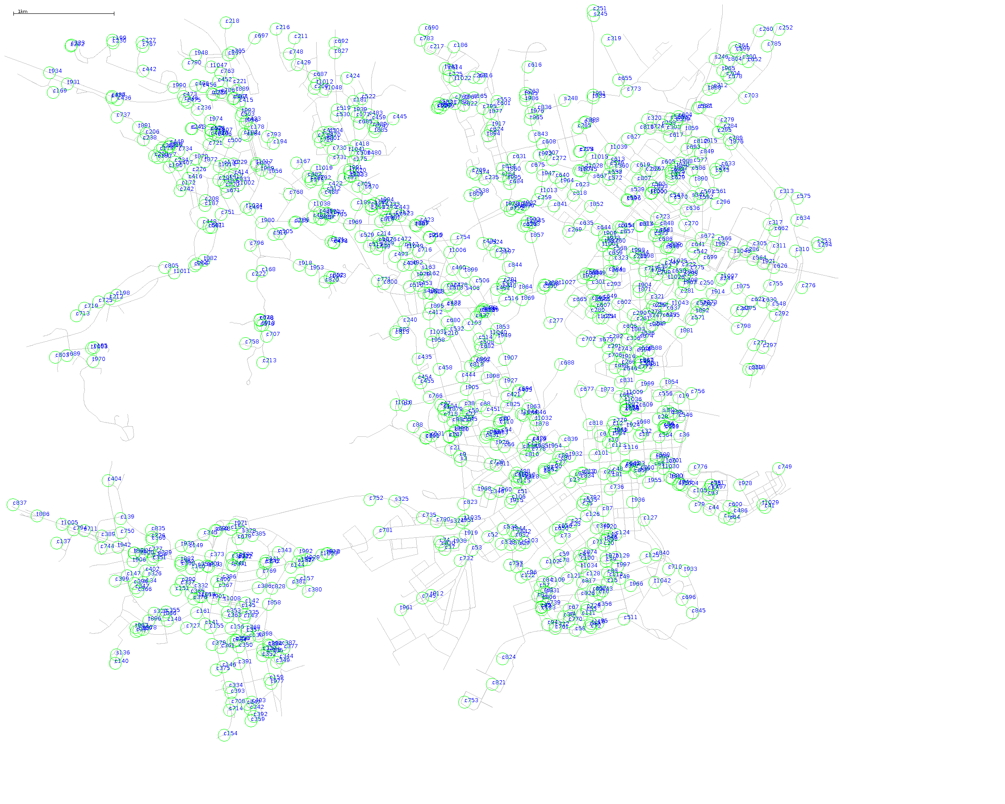

The city environment supported by the simulator was a map of Helsinki (Fig 1). To simulate a city population certain movement models were selected and configured. The majority of nodes were assigned a ‘working day’ movement model, which allowed them to travel to designated office spaces on the map, either by car or public transport routes, and travel for other evening activities later in the simulated day. A small portion of users were bus drivers on designated bus routes and the remaining users modelled tourists, which walked freely around the city and often aggregated in certain map points designating popular touristic attractions.

Fig 1. A zoomed in snapshot of a simulation in Helsinki city centre.

1. **Results and Discussion**

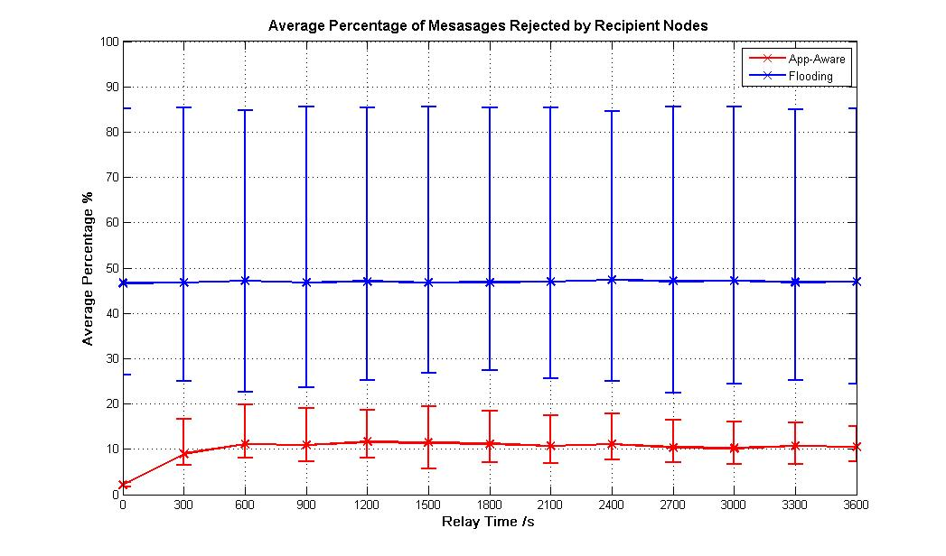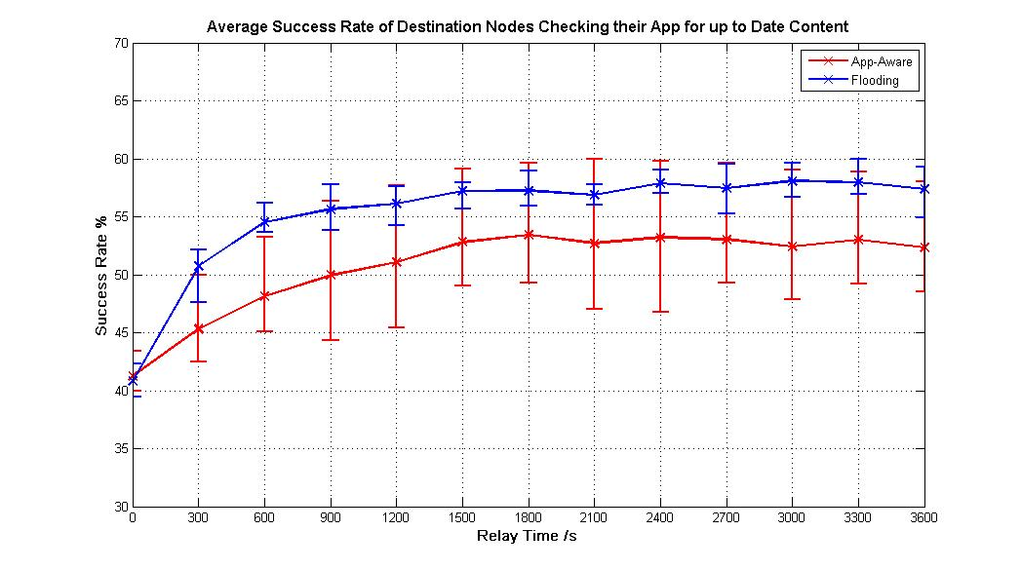

Fig 3. A comparison of message overhead for two schemes.

Fig 2. A comparison of user satisfaction rates for two schemes with varied Relay times.

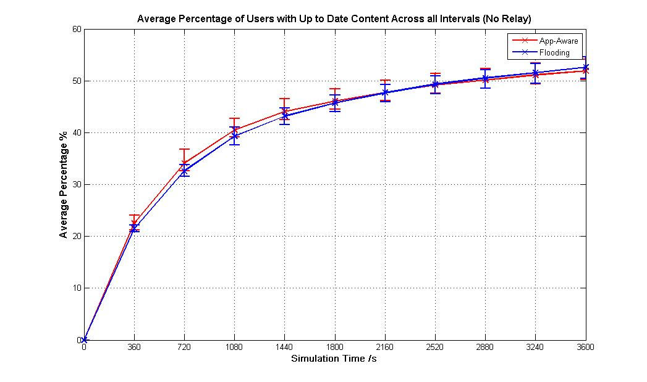

Fig 4. Change in average percentage of users with up-to-date content within one update interval for two schemes

Multiple scenarios were simulated while varying different parameters, however, only one is discussed in this short report. Figures 1-3 show some results for a scenario were the relaying times were varied for both schemes. Both scenarios simulated 12 hours in the same city environment. The total population consisted of 1050 nodes (18 buses, 832 office workers and 200 tourists), 50 of which were assigned to be Source nodes. All 18 bus drivers, being the most mobile nodes, were Source nodes with the remaining 32 being comprised of office workers. Given the potential of Wifi-Aware, the wireless radios of all nodes were modelled as ideal Wifi-Direct radios with a signal range of 60m and a speed of 200Mbits/s. A total of 10 unique applications was distributed amongst nodes upon initialization. All applications generated periodic content updates (1MB in size) in one hour intervals. All results are averages across all 10 applications with the upper and lower bounds of the bars corresponding to the maxima and minima for a particular application.

Figure 2 presents the average success rate of users checking their applications by the end of the simulation for both the proposed application-aware scheme and application-agnostic flooding scheme. A user is considered satisfied if the most up-to-date content is found upon checking an application. Lowest success rates are observed with no relaying enabled, allowing the dissemination of updates only directly from Source nodes. Both schemes lead to a satisfaction rate of about 41% amongst Destination nodes. As relaying is introduced with increasing times, the average success rate increases and saturates at about 53% for the app-aware scheme with 30 min relaying and at about 58% for the flooding scheme slightly earlier. Although flooding results in a 5% increased average success rate with relaying, the upper bound results of the app-aware scheme reached the same maximum rate of about 60% as the flooding upper bound. In fact, the upper bound of the app-aware scheme consistently corresponds to the most popular application in the environment (contrary to that of the flooding scheme), indicating the effect of message prioritization by popularity. In addition, the 5% increase comes at the expense of an almost 50% higher average message rejection percentage (Fig 3) due to a large overhead of unwanted message transmissions in the flooding scheme. In fact, the upper bound results of about 85% rejection consistently correspond to the most popular application with the greatest volume of unwanted messages. This could result in large traffic and energy costs for users.

In general, both schemes would require relaying to achieve success rates above 50%. Although the results are promising and indicate a functional scheme, they may seem low at first. There are a number of reasons for this. Firstly, less than 5% of the population are Source nodes in this scenario and yet achieve substantial success rates. Already less than 50% of the remaining population would require to actively download the up-to-date content. The lower satisfaction rate can be attributed to the sparsity of users (only 1050 users in 80 ${km}^{2}$ area) as well as the users who remained immobile at the outskirts of the city and never came in contact with others. In addition, users may often check their applications shortly after a new application update is generated and before it can be disseminated. In fact, figure 4 shows that on average less than 20% of Destination nodes received the updated content within 5 minutes of a new update. Preliminary scenarios in a smaller but denser environment have shown higher satisfaction rates up to 80% and other scenarios with limited bandwidth have shown the app-aware scheme outperform flooding.

1. **Conclusion**

In summary, the project lead to positive and promising results, which should motivate further investigation and development of the application-aware D2D content delivery scheme. Future improvements and investigations could include extending the scheme to allow dynamic Source node assignment to maximize results, modelling other environments such as crowded festivals, recording real-world mobility patterns as opposed to using movement models and even testing a prototype scheme with available technologies on mobile devices.

**References**

1. "Cisco Visual Networking Index: Global Mobile Data Traffic Forecast Update, 2011–2016, " white paper by Cisco, Feb. 2012, http://www.cisco.com/en/US/solutions/collateral/ns341/ns525/ns537/ns705/ns827/white_pap er_c11-520862.pdf, accessed March 2016.
2. A. Aijaz et al., "A survey on mobile data offloading: technical and business perspectives," in IEEE Wireless Communications, April 2013.
3. G. Xylomenos, C. Ververidis, V. Siris, N. Fotiou, C. Tsilopoulos, X.Vasilakos, K. Katsaros, and G. Polyzos, “A survey of information-centric networking research,” Communications Surveys Tutorials, IEEE, vol. 16, no. 2, pp. 1024–1049, 2014.
4. V. Cerf, S. Burleigh, A. Hooke, L. Torgerson, R. Durst, K. Scott, K. Fall, and H. Weiss. “Delay-Tolerant Networking Architecture.” RFC 4838, April 2007.
5. Ólafur R. Helgason , Emre A. Yavuz , Sylvia T. Kouyoumdjieva , Ljubica Pajevic , Gunnar Karlsson, “A mobile peer-to-peer system for opportunistic content-centric networking”, Proceedings of the second ACM SIGCOMM workshop on Networking, systems, and applications on mobile handhelds, August 2010
6. Sacha Trifunovic , Andreea Picu , Theus Hossmann , Karin Anna Hummel, “Slicing the battery pie: fair and efficient energy usage in device-to-device communication via role switching”, Proceedings of the 8th ACM MobiCom workshop on Challenged networks, September 2013
7. K. V. Katsaros, \V. Sourlas, I. Psaras, S. Rene and G. Pavlou, ``Information-Centric Connectivity,'' submitted in IEEE Communications Magazine (Communications, Caching and Computing for Content-Centric Mobile Networks issue), 2016.
8. WI-FI Aware Scheme, 2016. Available from: <http://www.wi-fi.org/discover-wi-fi/wi-fi-aware>, accessed July 2016
9. The Opportunistic Network Environment Simulator, 2016. Available from: https://akeranen.github.io/the-one/ , accessed June 2016