**Hicham Dioury (01198781)**

**CPSC – 4210 –Project**

**December 9, 2020**

**Dr. Robert Benkoczi**

**I) Planning of a simple sensor network using X-bee modules.**

I consider the fridge temperature as an important factor to monitor , my thought would be to use a sensor in different area on the fridge using a temperature sensor such a DHT11 and an ad-hoc network with X-bees and an Arduino.

802.15.4 firmware is used to transmit data in a point-to-point, peer-to-peer topology with Carrier-sense multiple access with collision avoidance.

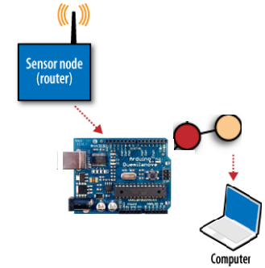 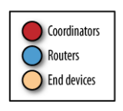

The DH11 library : <https://www.arduino.cc/reference/en/libraries/dht-sensor-library/>

I’ve placed my system in three different areas:

-A bottom shelf towards the back

- The Upper/Middle shelve

- The Bottom drawer

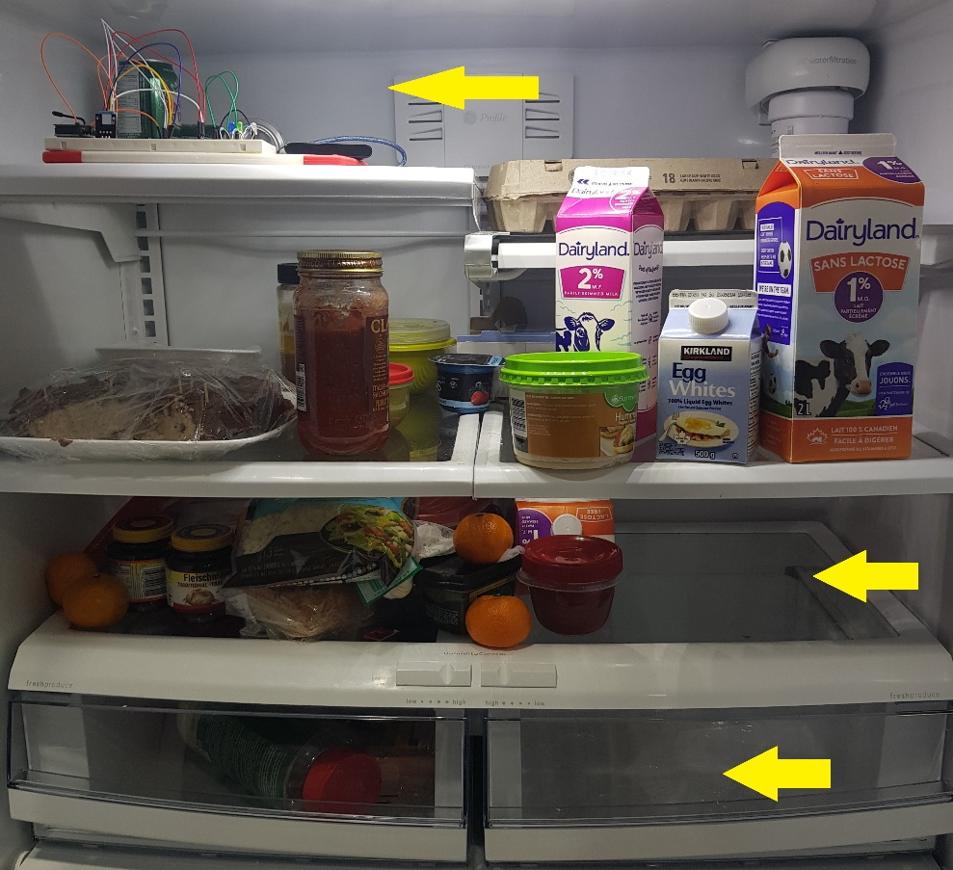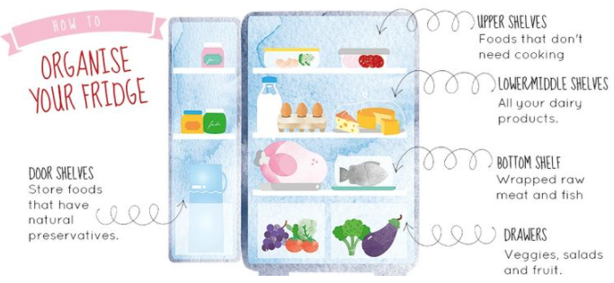

1. At the bottom shelf towards the back, the Coldest part of the fridge, a 0-degree zone is more suitable for meat and fish, on the bottom shelf towards the back the temperature should be the lowest.

Currently, my sensor is at the Bottom Shelf, it indicates at first 5.50 °C:

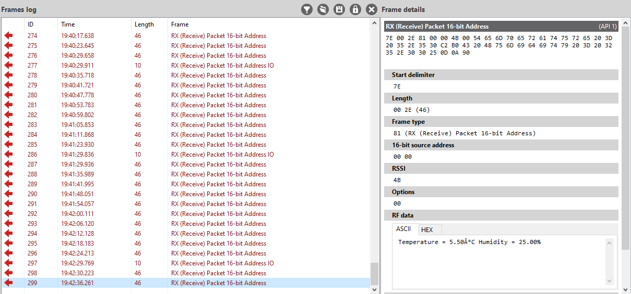

After 30 minutes, as expected on the bottom shelf towards the back the temperature went down to 3.50 °C

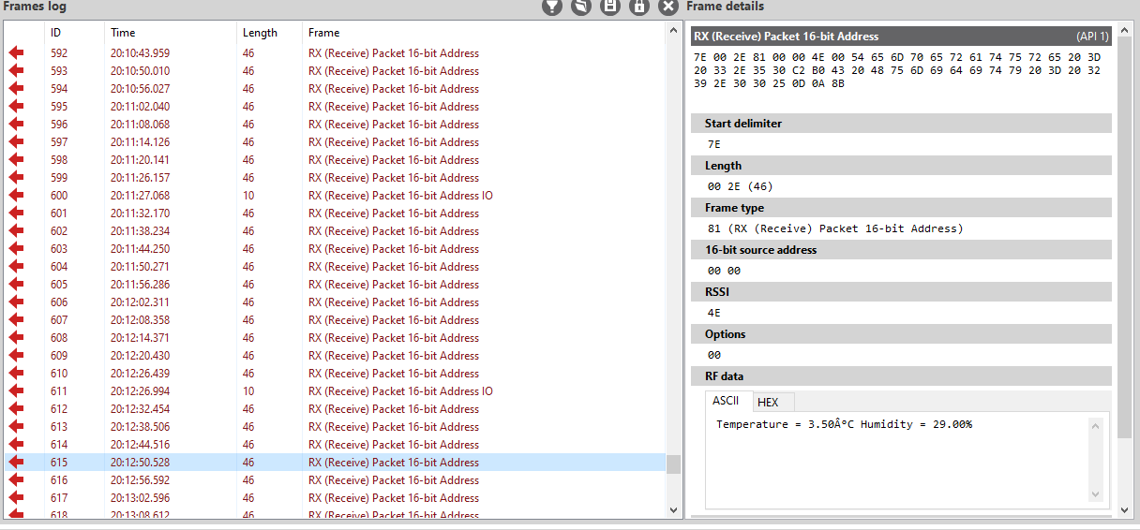

The coldest part in my fridge after a day, is hovering between Celsius 2 and 2.1 degree Celsius

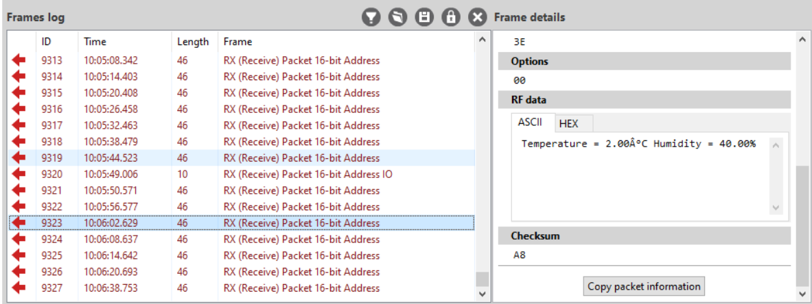

1. At the Upper/Middle shelve, I believed that the temperature is slightly higher than the Bottom Shelve so I think it should be at first around 6 °C or less. I hoped that my sensor can detect a faintly difference .

At 21:14 I moved the sensor on the top shelve:

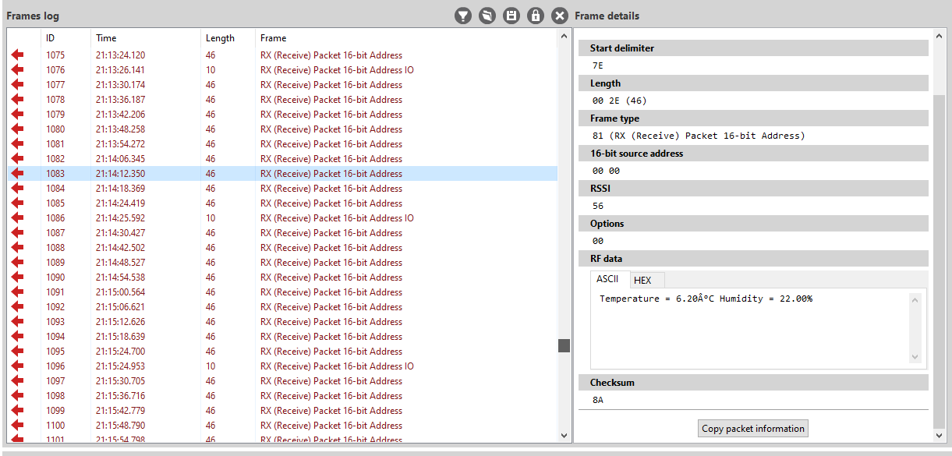

At 9:45 It never went lower than 4 °C

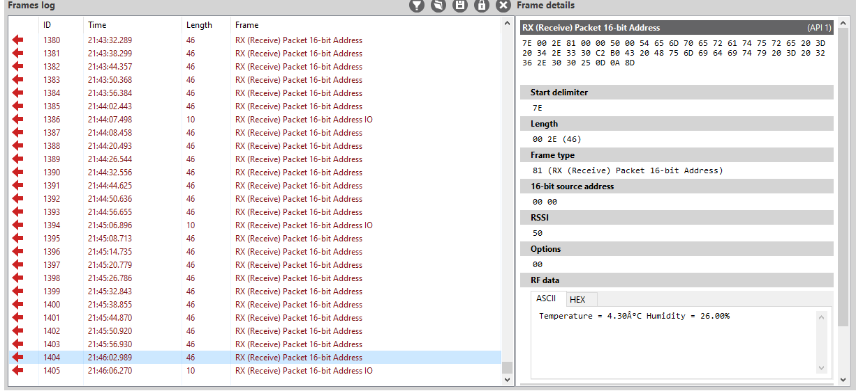

After opening my fridge, my blue LED was one since 4.30 < 5 but my temperature at 21:51 is 7 °C.

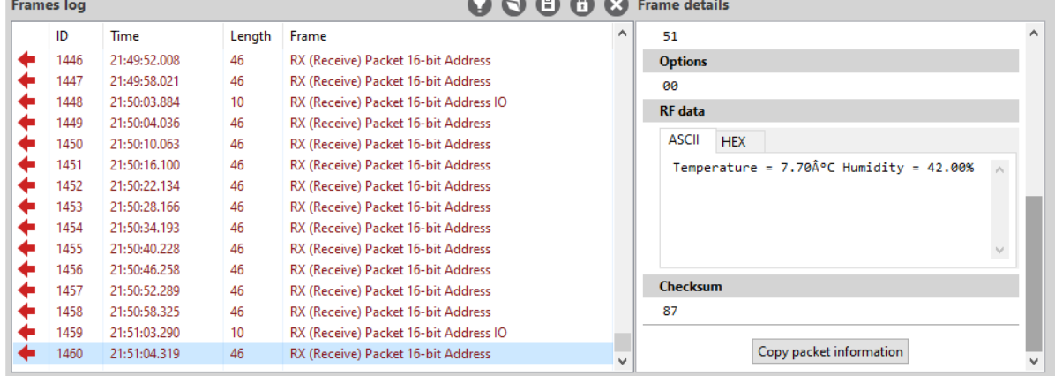

From 4 am to 8:38 am at the upper shelve, it went down at 3.30°C then up again 4.20 °C

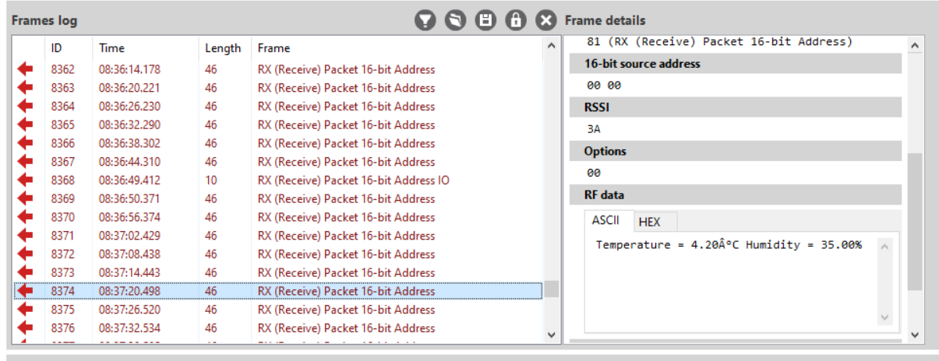

1. The bottom drawer is where vegetables and fruit should be kept, the humidity is adjustable, the humidity should be High humidity for leafy greens, beans, cucumbers, asparagus, broccoli and celery; medium humidity for things like tomatoes and citrus fruits; low humidity for garlic, onions and squash., currently at 36%

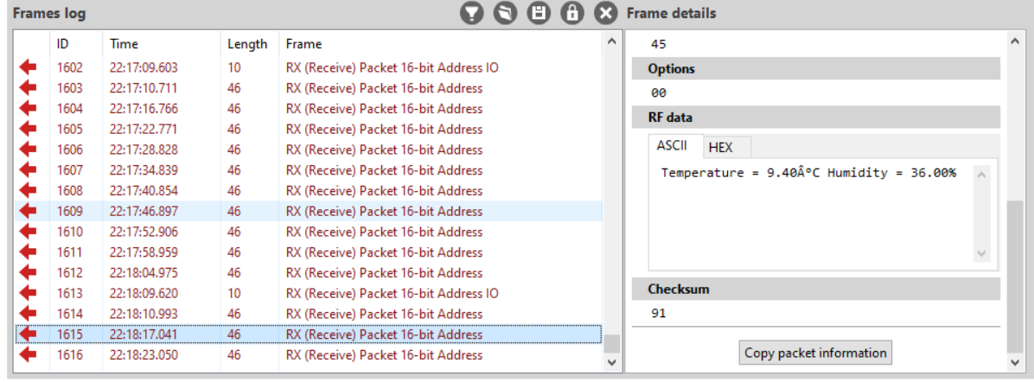

After changing the humidity, it went up to 49%

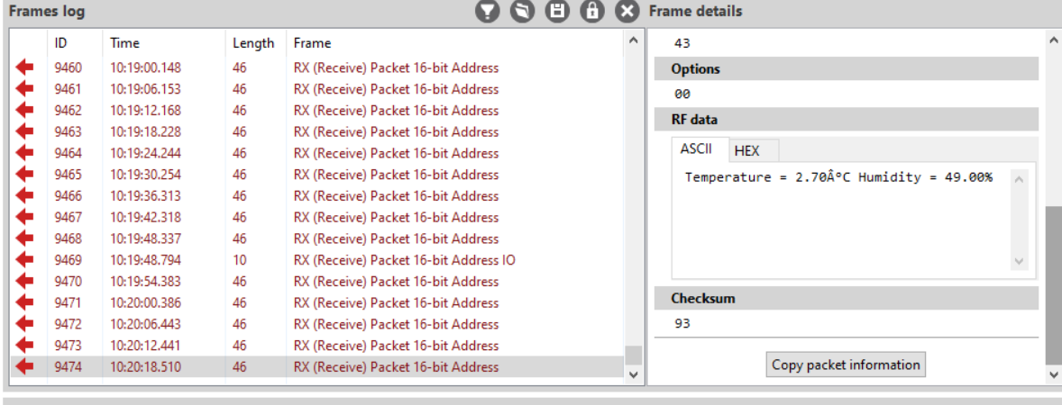

Then one of the highest values 80%

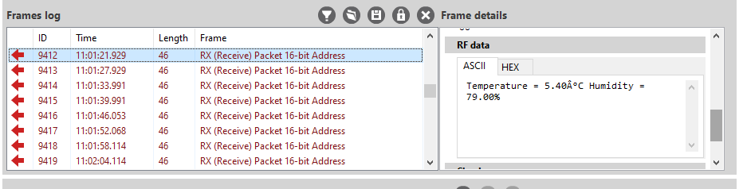

**II) An application to the real world.**

On our everyday life, we spend a huge amount of our money to buy groceries, I believe making sure of the right fridge temperature is essential so that the food don’t go bad. Temperature in many environment can have a big impact, like the transportation of a covid-19 vaccine.

**III) Deployment of a simple sensor network using X-bee modules**

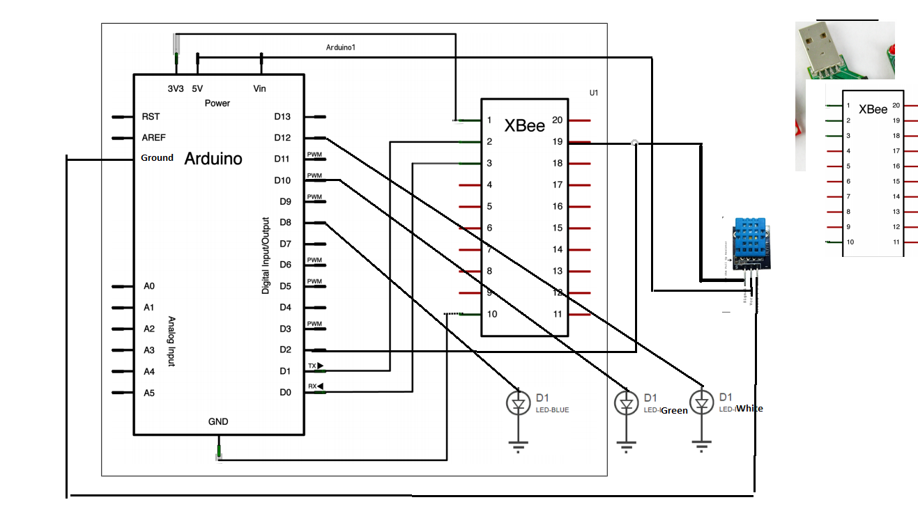

My settings were correct from the previous checkpoint, and the system is working so I kept them

|  |  |
| --- | --- |
| Coordinator  Pin1->3.3∨  Pin10->Ground  Pin2 Tx->Rx  Pin3 Rx->Tx  Pin19-> Digital Input [3]  Channel:B  PANID:similar  DH:0013A200  DL:otherXBee  MY:0  CE: enable  AT mode: API disabled [0]  DH:0013A200  DL: XXXXXX | Endpoint  Pin1->3.3∨  Pin10->Ground  Channel:B  PANID:similar  DH:0  DL:0  MY: FFFF  Pin2 Tx->Rx  Pin3 Rx->Tx  Pin19-> Digital Input [3]  CE: enable  API enabled [1]  DH:0013A200  DL: XXXXXX |

VI) Advancement from the checkpoint to the final project

I added 3 different LED and changed my code so that the LED turn on specific temperature and humidity.

The previous program had a small delay, so I increased the delay at the start and the end of my code

delay (3000);

To troubleshoot, I first turned them all to HIGH (videos available on the link)

At different times, I had different settings, one with only humidity <= 20, before adjusting my code and my internal fridge humidity

