NetShop user guide
What is NetShop?

Netshop is an online store that has been developed so users can buy cars quickly and easy. This user guide will provide useful information to navigate through this internet store.
Main page
NetShop provides you with options to:
1) Choose one of available the car manufacturers.
2) Choose one of the advertisements.
3) Place an order.
4) Provide us with feedback.
5) Find our contact information.

Placing an order
First you are located in main page. You have to choose one of the available car manufacturers by clicking on logo .
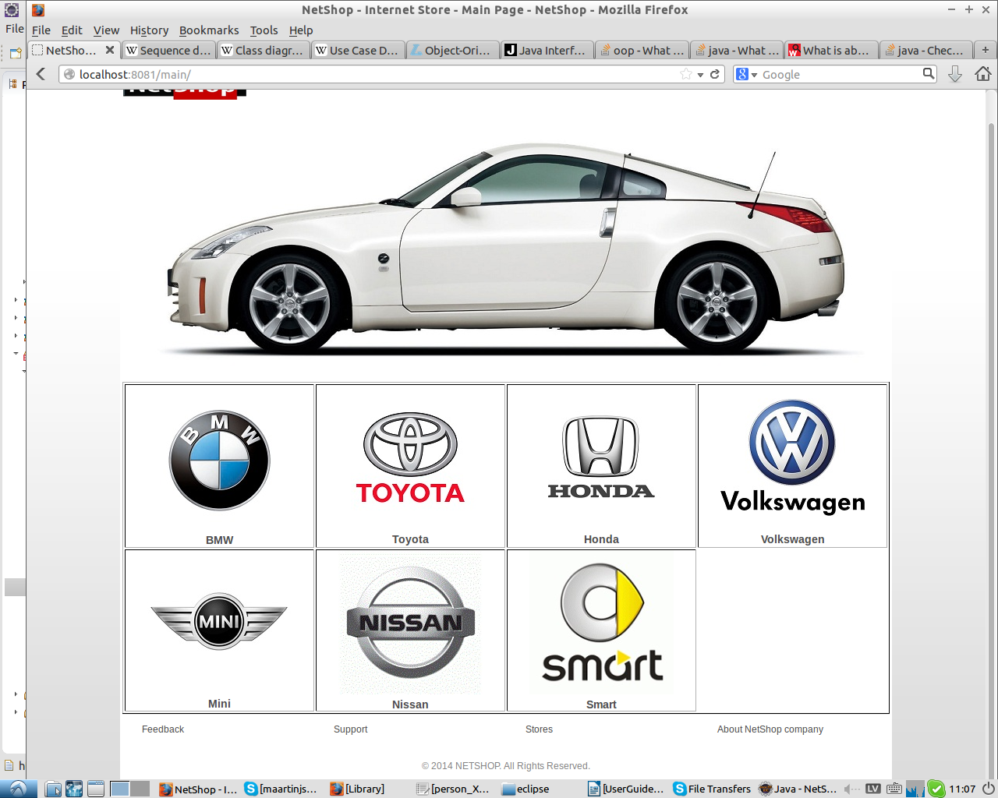

Then you have multiple selection of models you can choose from. You can select model by clicking on the name, for example- BMW X1..
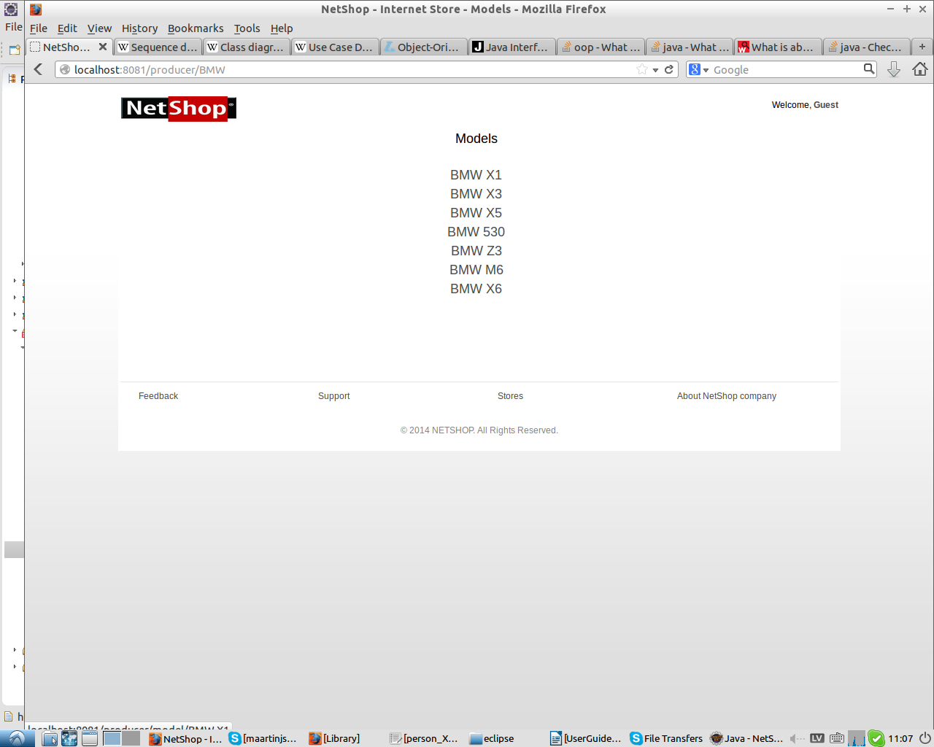
Next page displays all advertisements for model you have choosen. You can select an advertisment by clicking on it.
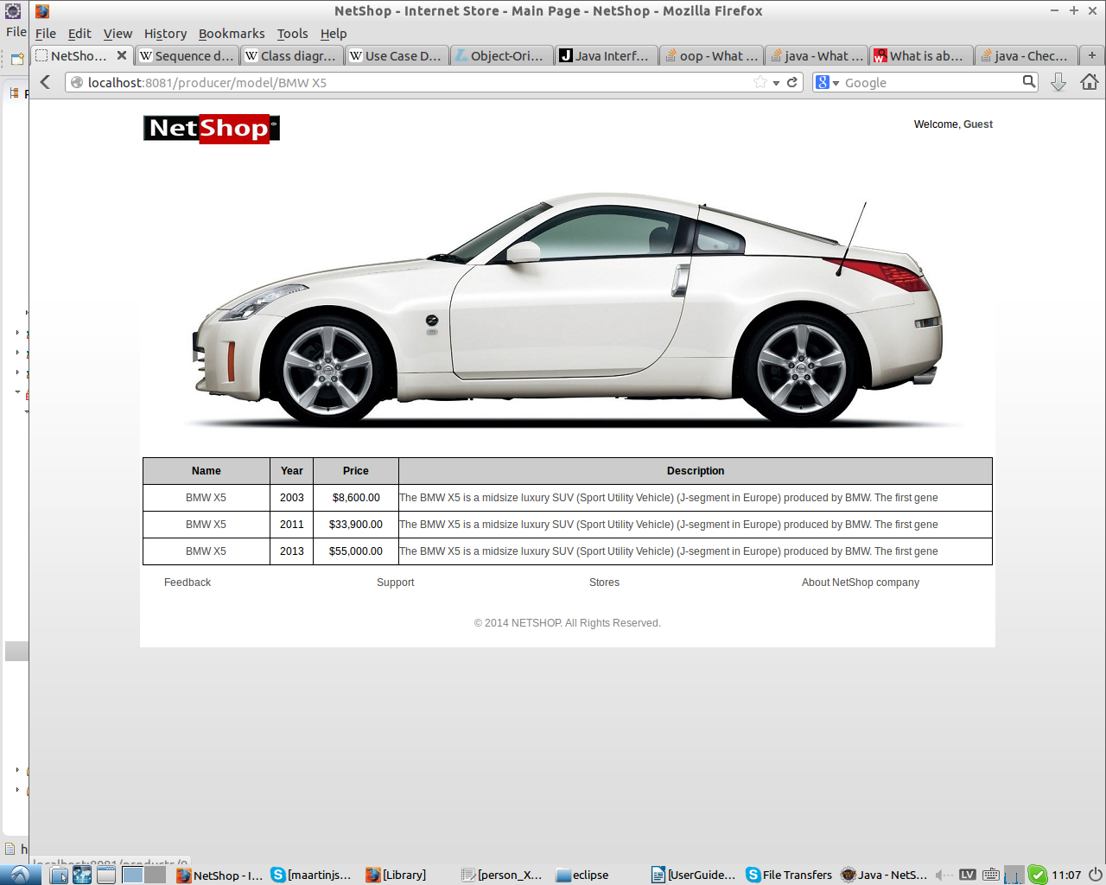

Once you have selected advertisement of your choice you can learn about the car. On the left side you can see picture of the car and on the right there is information about it. You can press back which will take you a step back or buy.
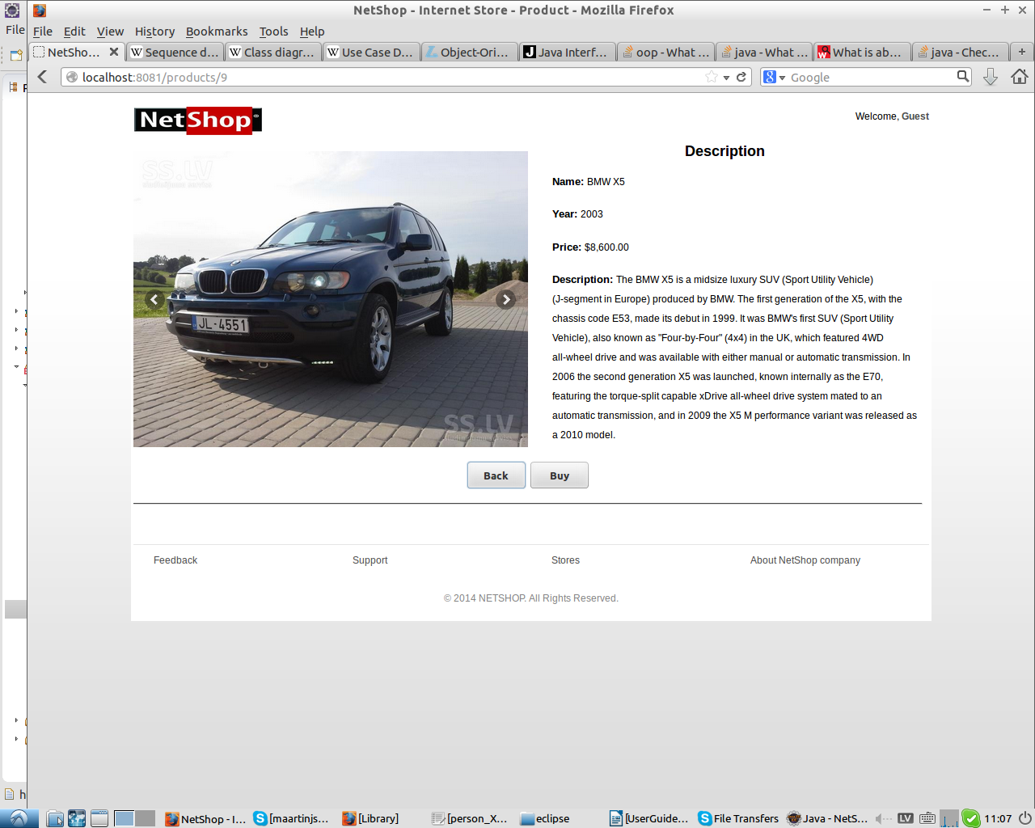
If you press buy you are presented with a registration form. You have to fill out your name, surname and login and password of your choice. Please note that all fields must be filled out.
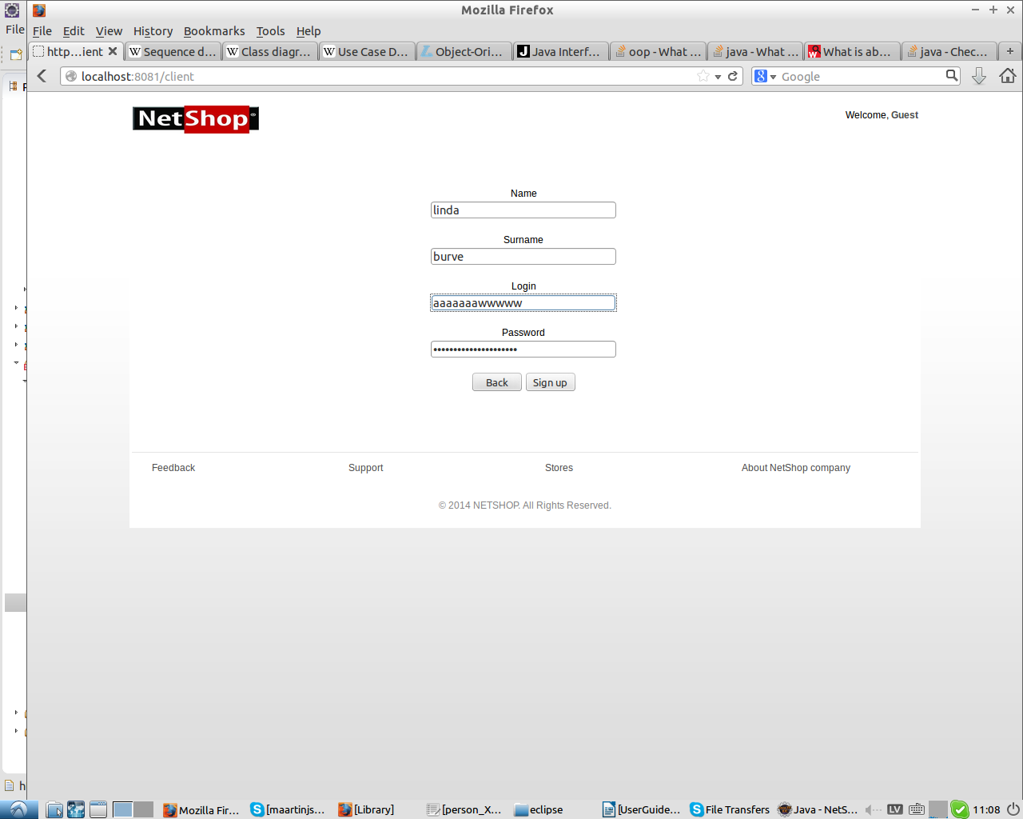
When you have filled out all required fields you are taken to next page so you can confirm your purchase. You can see description of the car again.
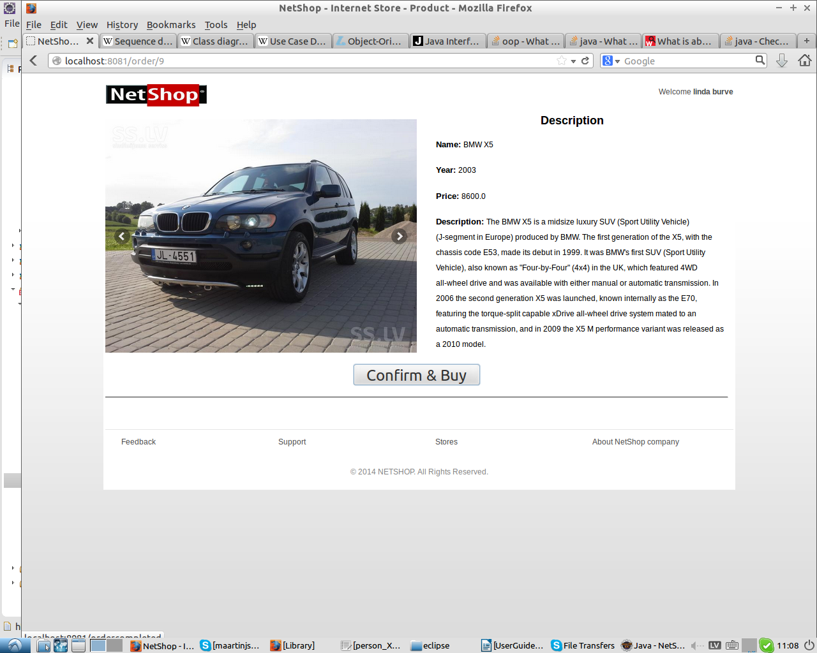
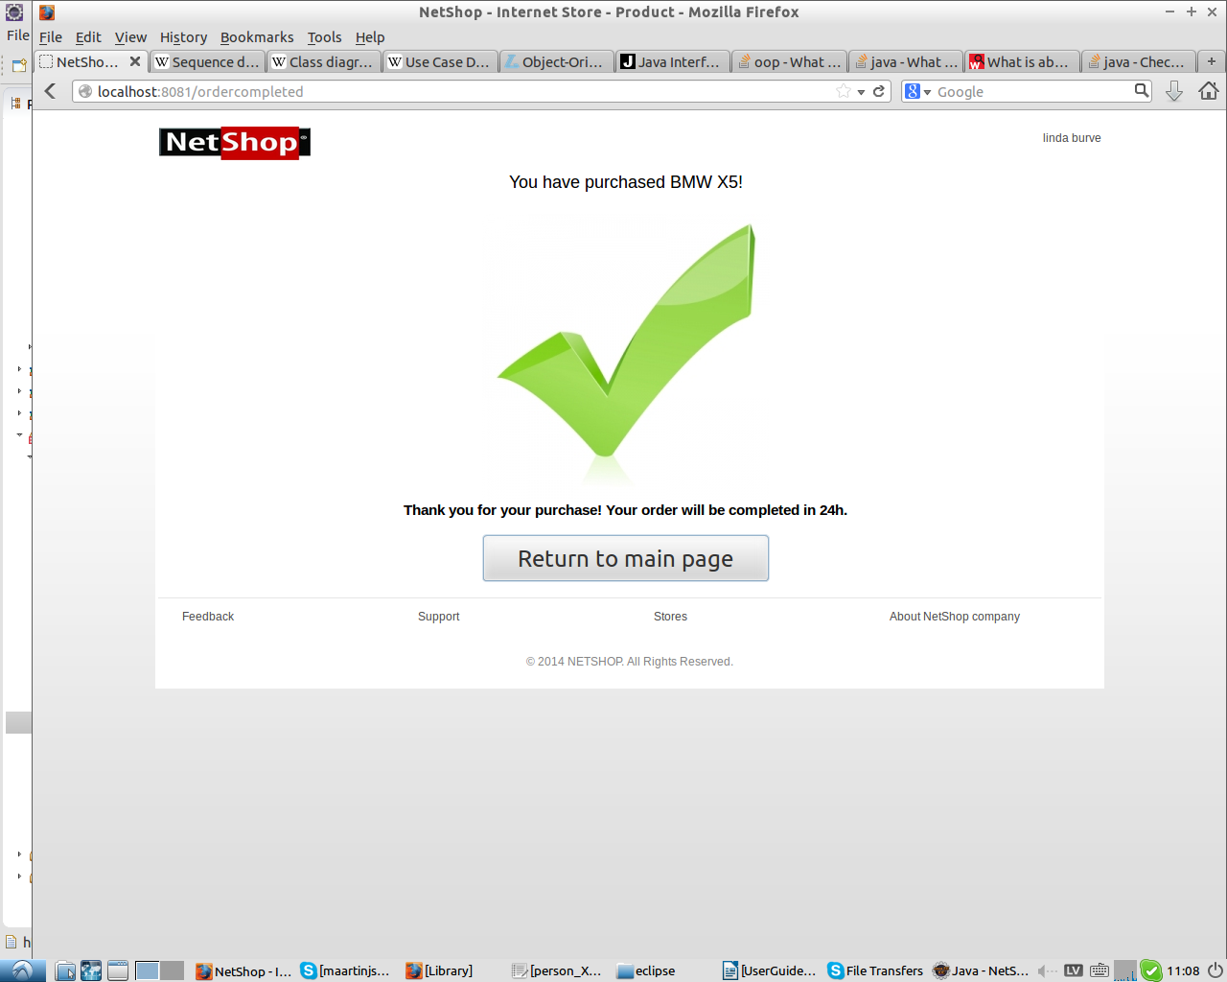
When you receive confirmation that order is complete you will see this page and you can return to main page and place your next order.
Information about registering

Please note that if “All fields must be filled out” alert appears you have not filled or more fields. To complete registration and place your order you have to fill all of the required fields. Information required includes- name, surname, username and password.
After alert is displayed page will refresh and all the fields will be empty.

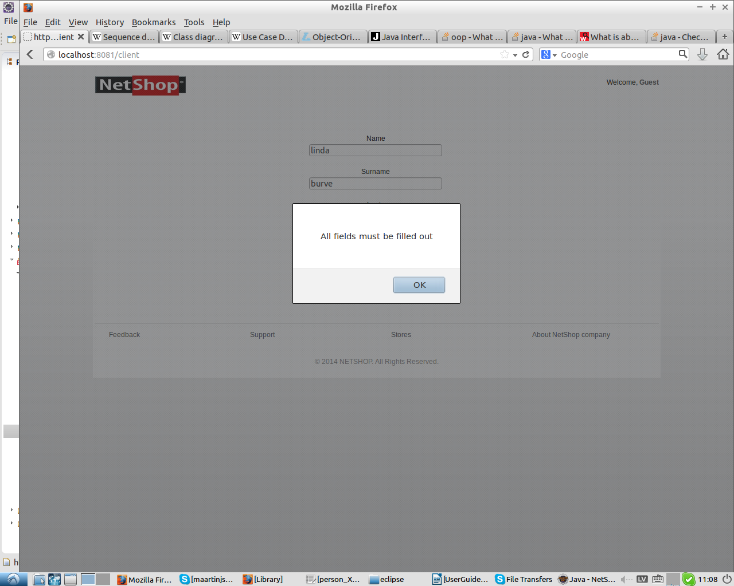

Additional information

If you have a wish to see additional information like “about” or provide feedback see bottom of the page.
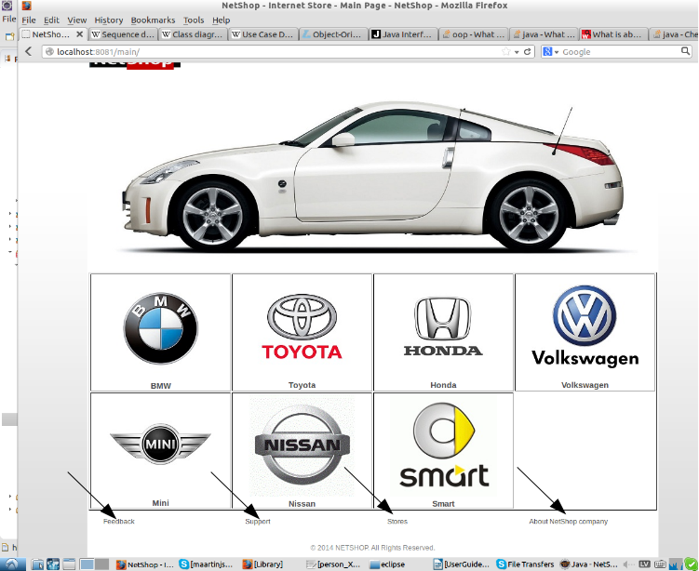
To provide feedback click feedback on the bottom of the page, add your first name, comment and click submit.
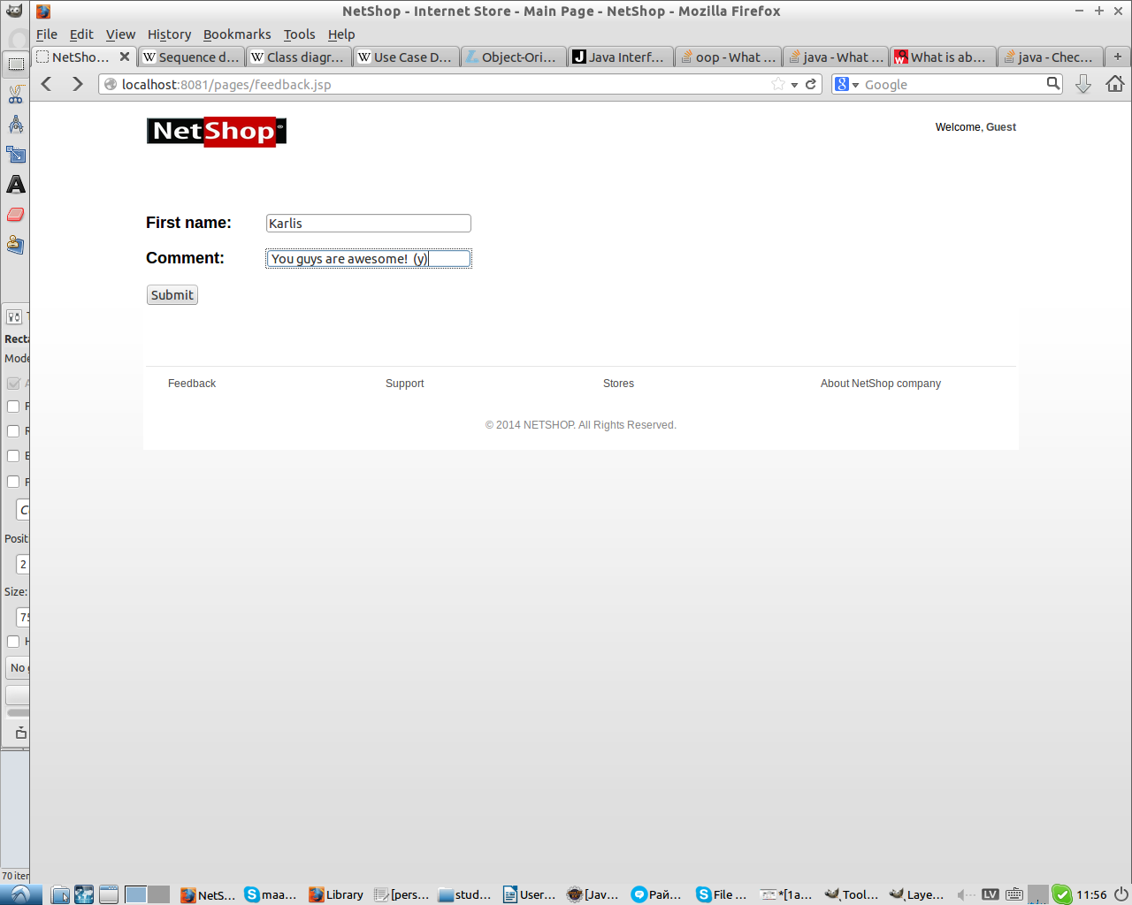
Support
If you have any questions or need to contact contact us via phone- +26700061 , or visit our office in Raina bulvaris 19, Riga. We are open from Monday to Friday 9.00-17.00.

