Contents

ITECH2003: Web Design Document 1

Contents 1

1. Overview 2

1.1. Description 2

1.2. Highlights 2

1.3. Target Audience 2

2. Site Content & Structure 3

2.1. Navigation Scheme 3

2.2. Content Inventory 4

3. Content Design 5

3.1. Page Layout 5

3.2. Wireframes 5

4. Visual design 10

4.1. Home Page Mock-Up 10

4.2. Colour Scheme 10

4.3. Typography 10

5. References 11

1. Overview

1.1. Description

My personal website is called full stack programmer. My advantage in choosing this career is that I majored in computer science in college, and I am good at computer programming, user experience design, project management and so on. These skills are typical of a full-stack developer. My career ambition is to use code to create a better future.

A detailed introduction to all the interfaces on my website:

I design the first interface of the website is my career and ambitions, the second page is the introduction of several other page content summary, users can click the link to jump to any page, he wants to see the third page of website is my name, and contact me, including my email address, phone number, etc. The fourth screen details the main work of a full-stack engineer, the fifth screen is the books I read about C, the sixth screen is the books I read about JAVA, the seventh page is the photos of my life, and the eighth page is the comments of some people who have visited my page.

1.2. Highlights

The website uses a grid layout as a whole. The reason for choosing it is that it conforms to a certain responsive design and is convenient to use. No matter what screen changes, it can be easily adapted. CSS grid layout introduces a two-dimensional grid layout system that can be used to lay out the main area layout or small components of a page。

I designed the page to move the mouse cursor around to get detailed links for each navigation category, which is the first level of the second type of navigation. It can improve the user experience, smooth sliding animation can improve the aesthetic of the whole page

My web page with a lot of bright color, can make people bright, and put a lot of pictures to match the text, will not let people feel boring

1.3. Target Audience

My site mainly for software development company, and the same with my professional software development company can browse my website link and hire me, and I the same person can communicate with my problems in the process of writing code, browse my website about people age between 20 to 40 years old, and are subject to certain education, Learn about the full stack Engineer career2. Site Content & Structure

2.1. Content Inventory

|  |  |  |
| --- | --- | --- |
| Page | 内容类型 | 标签 |
| All | Image  text | My virtual avatar  Navigation link  Home[contact,guest-messages] Code[java,c] school[article,Life is instantaneous] |
| Home | Image  Text | Career pictures  Career introduction |
| Contact me | Text  Form | My contact information  User's information form |
| Article(1) | text | Article List |
| Article(2) | Text | Article Details |
| JAVA | image | code snippet |
| c | image | code snippet |
| Guest messages | Image  Text  text | User's comments |
| Life is instantaneous | Image  Text | Life pictures  brief introduction |

2.2. Navigation Scheme



This is my navigation map. As you can see, it is a simple design. You can move the mouse cursor to get detailed links of each navigation category. It is a first level navigation of class II navigation. It can improve the user experience,Smooth sliding animation can improve the overall page aesthetics of the page

3. Content Design

3.1. Page Layout

The website uses a grid layout as a whole. The reason for choosing it is that it conforms to a certain responsive design and is convenient to use. No matter what screen changes, it can be easily adapted. The minimum screen I set is 390px, which is my mobile screen. I think it can also serve most screens. The browser tested is Chrome

3.2. Wireframes

* 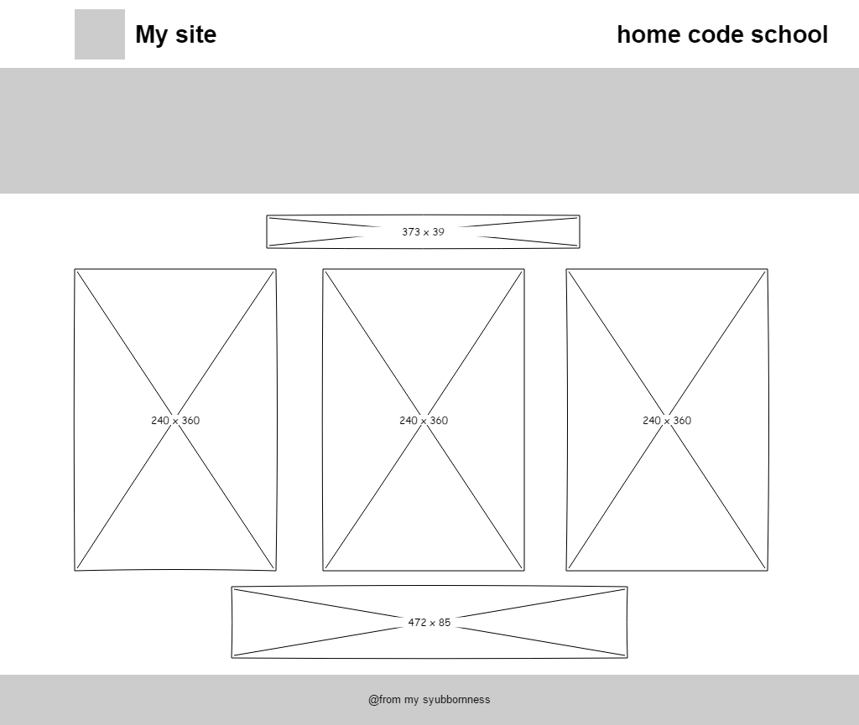
* 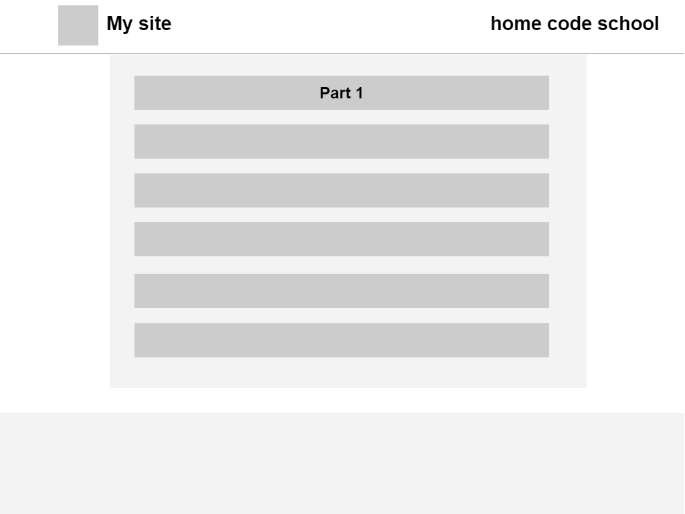
* 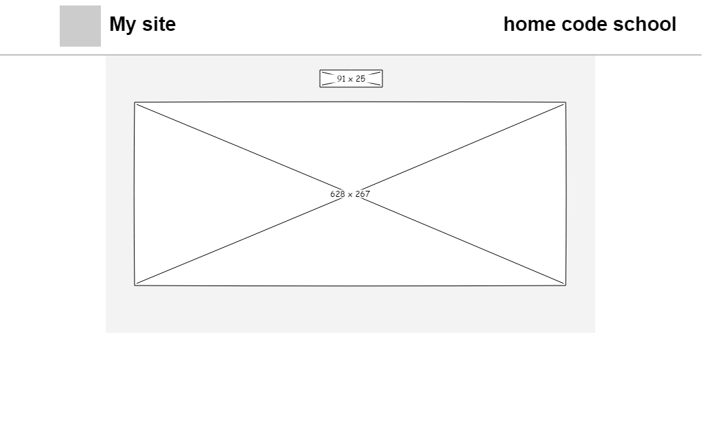

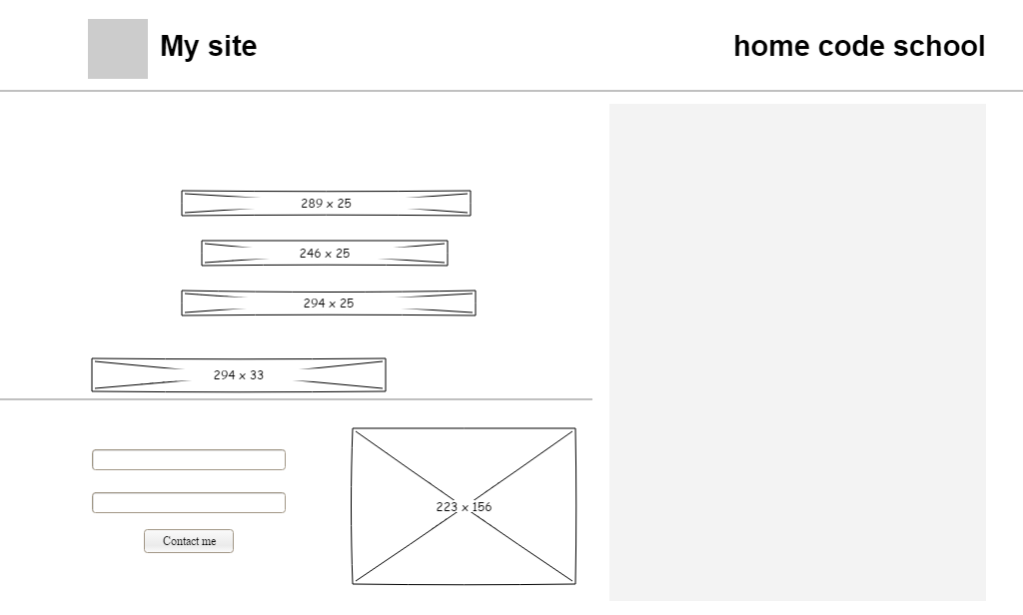

* 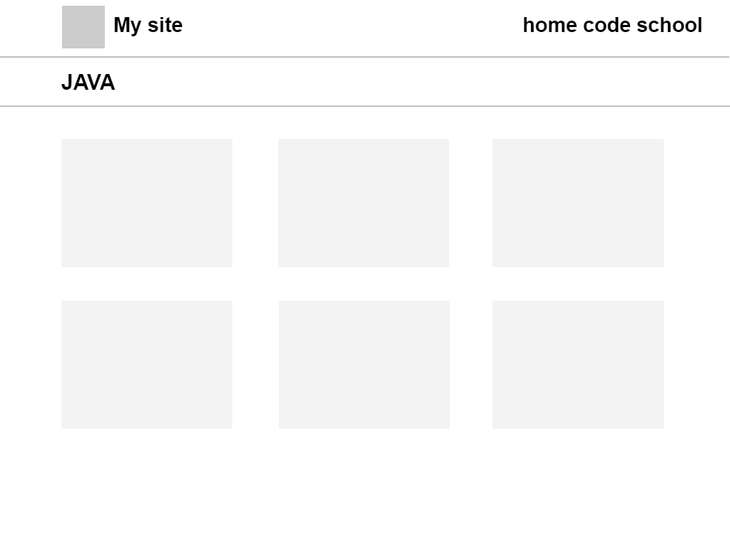
* 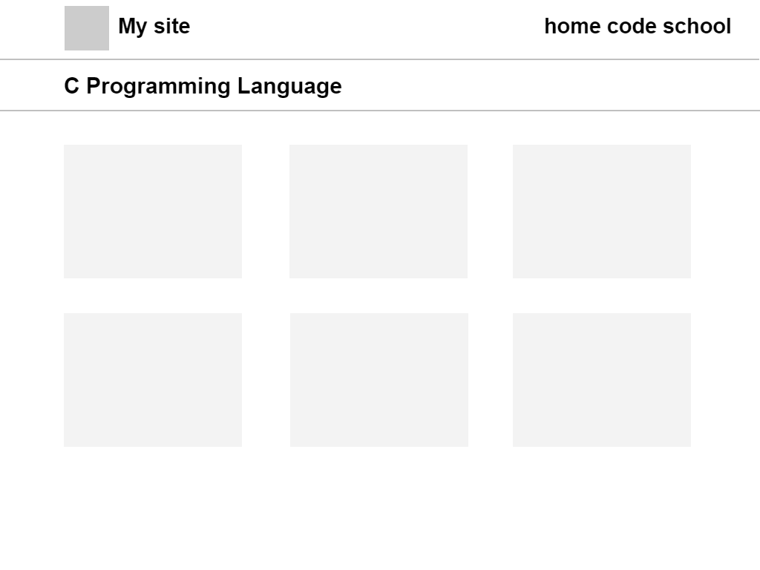
* 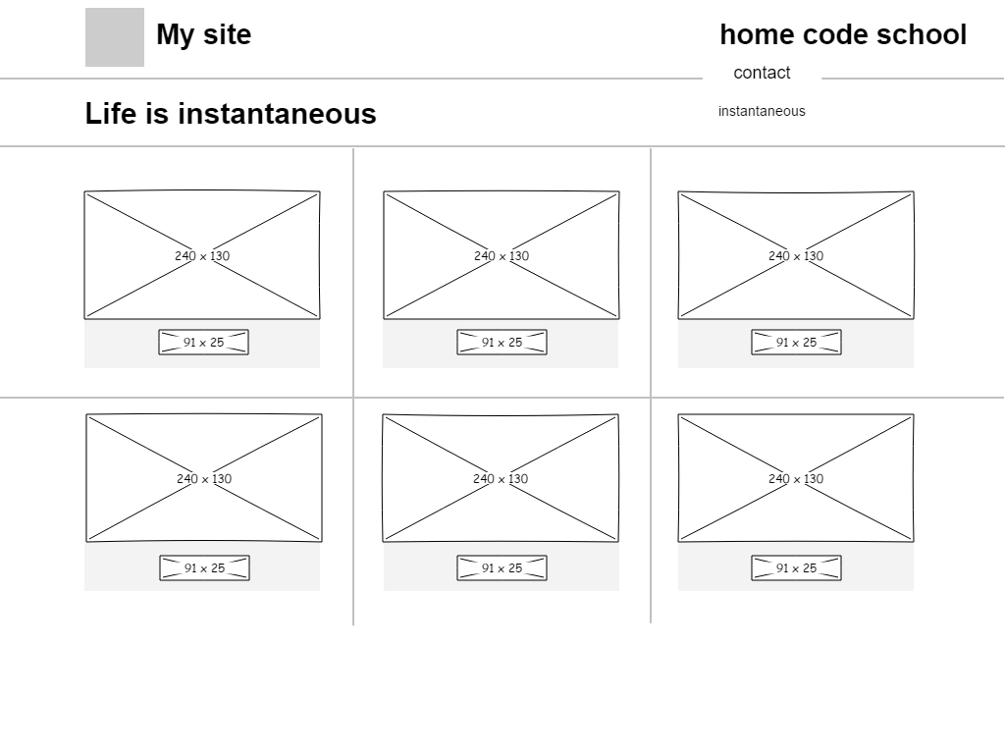
* 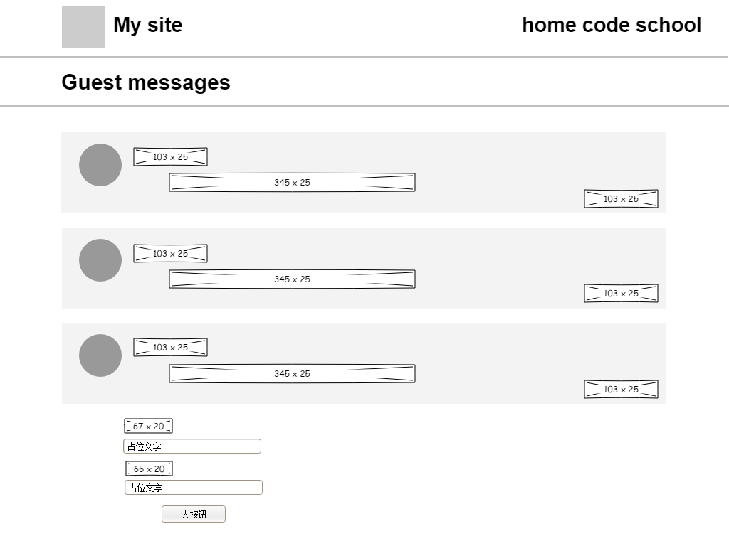

4. Visual design

*(Visual Design was discussed in* ***Lecture’s 4, 5 and 6****)*

4.1. Home Page Mock-Up



4.2. Colour Scheme

|  |  |  |
| --- | --- | --- |
| **#000** |  | Set off the power of words |
| **#fff** |  | White is bright, clean, cheerful, simple, elegant and chaste. It has no strong personality |
| **#71A0F1** |  | Have bright spots |
| **#A44343** |  | Think of soil, earth, nature and simplicity. It gives a feeling of reliability. |
|  |  |  |

4.3. Typography

|  |  |  |  |
| --- | --- | --- | --- |
| headline |  | 36px,Source-Han Sans CN | emphasize |
| Content |  | Source Han Sans CN,  18px | Can highlight content |
| footer |  | Source Han Sans CN,  14px | Fade out the page |
| navigation |  | YouSheBiaoTiHei  24px | Beautiful navigation font |
|  |  |  |  |

5. References

Sklar, J. (2012). *Principles of web design* (5th ed..). Course Technology Cengage

Learning.

Sklar, J. (2009). *Principles of web design* (4th ed..). Course Technology.

Grannell, C., Sumner, Victor, & Synodinos, Dionysios. (2012). *The essential guide to HTML5 and CSS3 Web design*. friends of ED ; Distributed to the book trade worldwide by Springer Science+Business Media.