Contents

ITECH2003: Web Design Document 1

Contents 1

1. Overview 2

1.1. Description 2

1.2. Highlights 2

1.3. Target Audience 2

2. Site Content & Structure 3

2.1. Navigation Scheme 3

2.2. Content Inventory 4

3. Content Design 6

3.1. Page Layout 6

3.2. Wireframes 6

4. Visual design 9

4.1. Home Page Mock-Up 9

4.2. Colour Scheme 9

4.3. Typography 9

5. References 10

1. Overview

1.1. Description

The name of this web page is: Dream of becoming a ui designer.

Blurb: As a ui designer, I will devote myself to optimizing the interface effect and enhancing the user experience.

My professional revenge is to be a ui designer, including my learning experience, contact information.

The first interface introduced my career and my dream;

The second interface includes my blog;

The third interface describes my contact information. You can contact me through the website, etc.

I put six books in the fourth interface, which is related to ui design;

The fifth interface describes my learning experience in order to know me better.

In the sixth and seventh interfaces, I put my personal design in order to know my strength in ui design.

At the last interface, I imagined my future and my plan for future development.

1.2. Highlights

The web page uses a grid layout. The advantage of grid layout lies in its integration, and I think it can highlight the theme of web pages. And three breakpoints are set, which can better match different screen sizes. Show hidden pictures through JavaScript to give users better interactivity. By using responsive design, users can have a better seamless experience and improve the usability of the website.

1.3. Target Audience

Fishel, Cynthia experts said that if all the content created by the company for the Web reaches a specific target audience, the company's effect will be much higher. For the profession of ui designer, the target audience should be companies and individuals who have the need to beautify web pages and make beautiful web pages.

Therefore, I think that the audience of my web page should be companies and enterprises that want to beautify my web page and people who have a demand for personal web pages. Enterprises may be newly developed enterprises that want to do publicity and other purposes.

2. Site Content & Structure

2.1. Content Inventory

|  |  |  |
| --- | --- | --- |
| *Page* | *Content type* | *label* |
| *All pages* | *Text,*  *button* | *Navigation link(*  *Blog,contact me books,Educational experience,wanliRoad*  *Hoppy,Ui)* |
| *Home* | *Image*  *text*  *text*  *button* | *My avatar*  *My profession*  *My self-introduction*  *Navigation different from other pages* |
| *Contact me* | *Image*  *Text link*  *Button*  *From*  *\Submit button* | *My Photo*  *Contact my title, my email address and mobile phone number.*  *Fill in the mailbox*  *Fill in the mobile phone number*  *Submit from form* |
| *Blog* | *Text*  *text* | *time*  *content* |
| *books* | *Image*  *text* | *Book cover*  *title* |
| Educational experience | *Text*  *text* | *School*  *Learning content* |
| *Wanli Road* | *text*  *picture* | *Place of travel*  *Photo* |
| *hobby* | *text*  *picture* | *My hobby*  *Instantaneous photos and achievements* |
| *UI* | *picture* | *----* |

2.2. Navigation Scheme

This is my navigation map. Through sticky positioning, I intuitively displayed seven web links to website visitors (home, blog, contact me books, experience, wanli Round, future); First level navigation

I placed it on the left side of the page to highlight the theme of the website, and the blue color matching is also used. The navigation link button is made into a card shape, and even if it is placed randomly, it can clearly feel that it is a navigation (such as the navigation layout I made on the homepage of the website When the navigation link gets the focus, it will have a dynamic effect to prompt the user. navigation link gets the focus, it will have a dynamic effect to prompt the user.

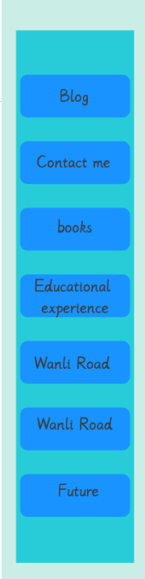

3. Content Design

3.1. Page Layout

I use grid layout. The advantage of grid layout lies in its integration. It is convenient for users to obtain information on the website and highlight the theme of the website. Grid layout is convenient for responsive design. I set three breakpoints in total, which can adapt to most screen sizes, 375px, 780px, 1200px,Fonts of different sizes will change accordingly, perfectly matching the screen.

**3.2. Wireframes**

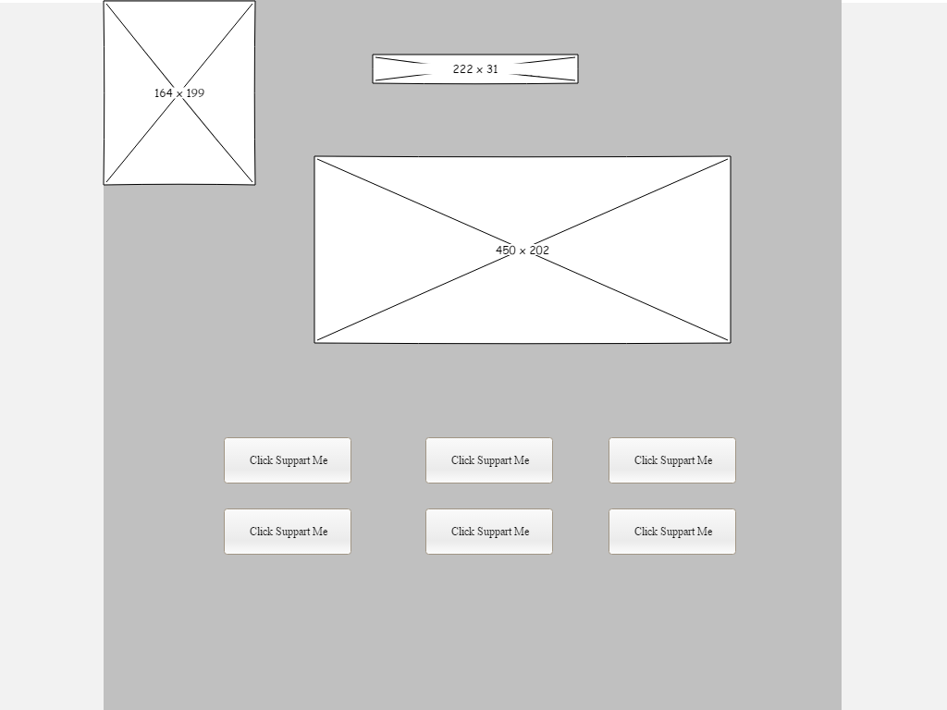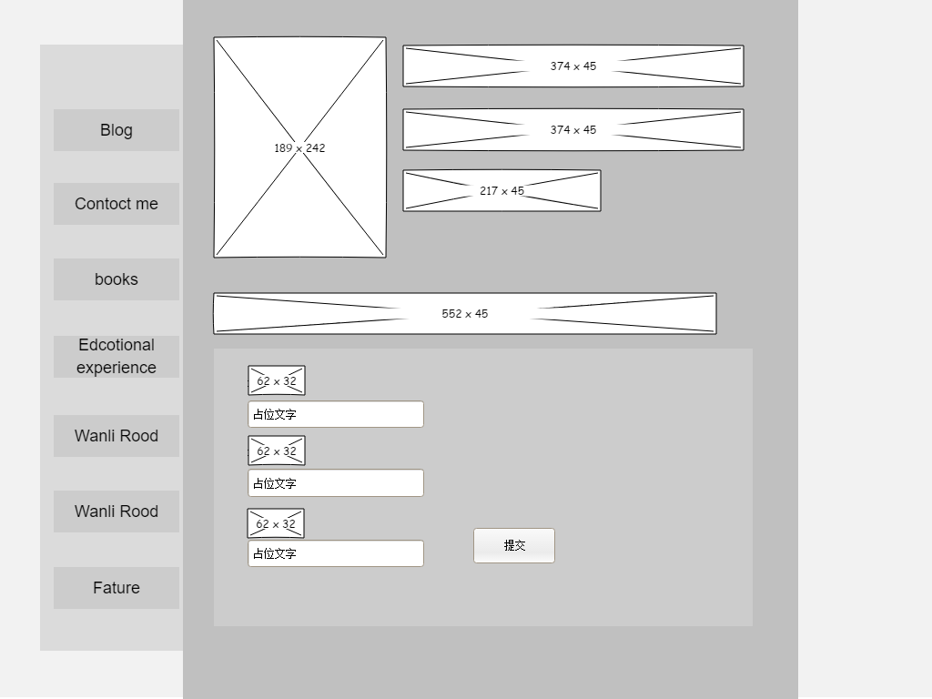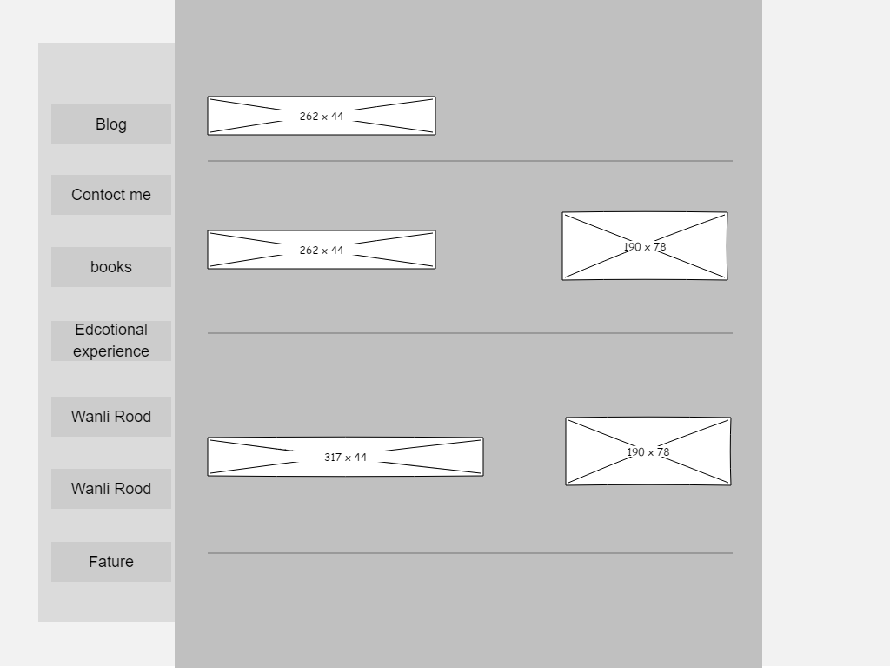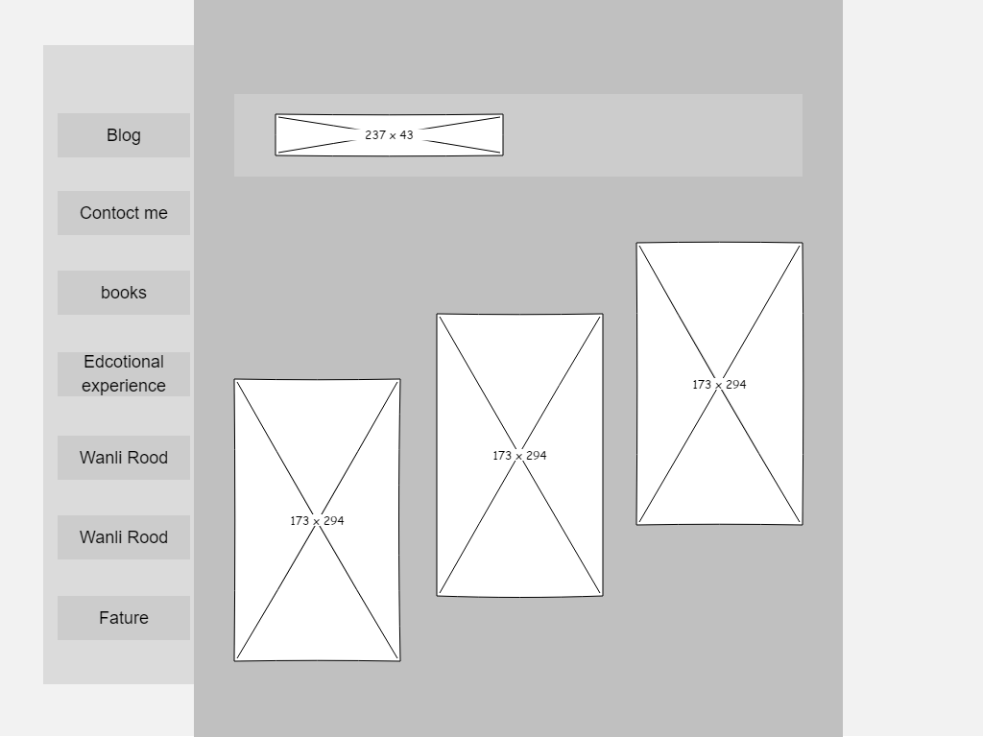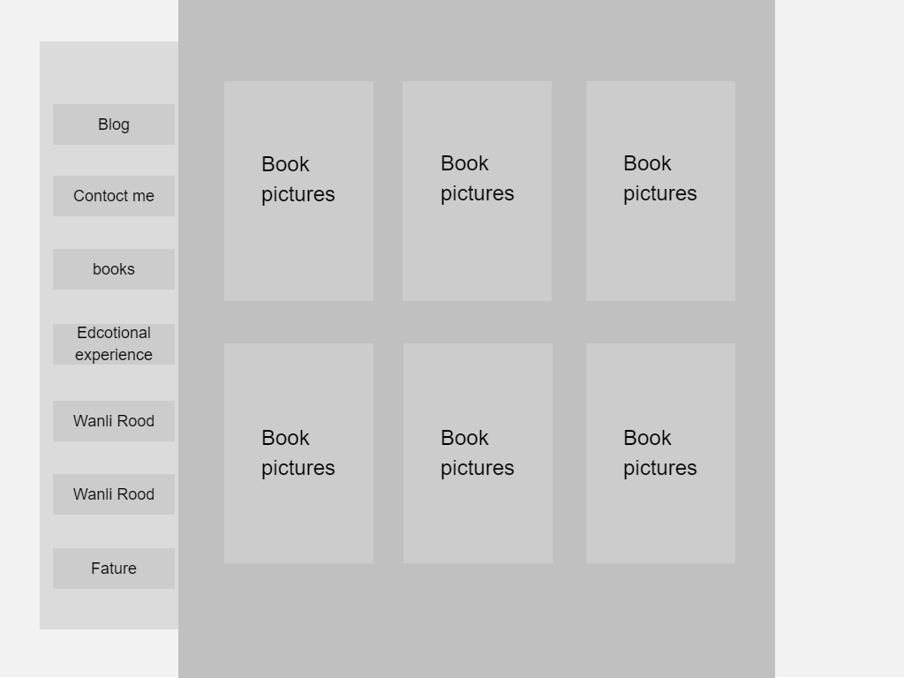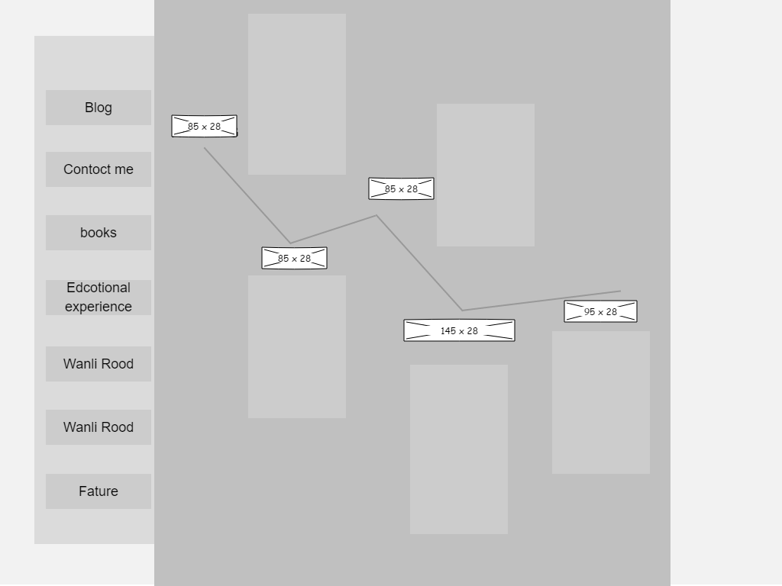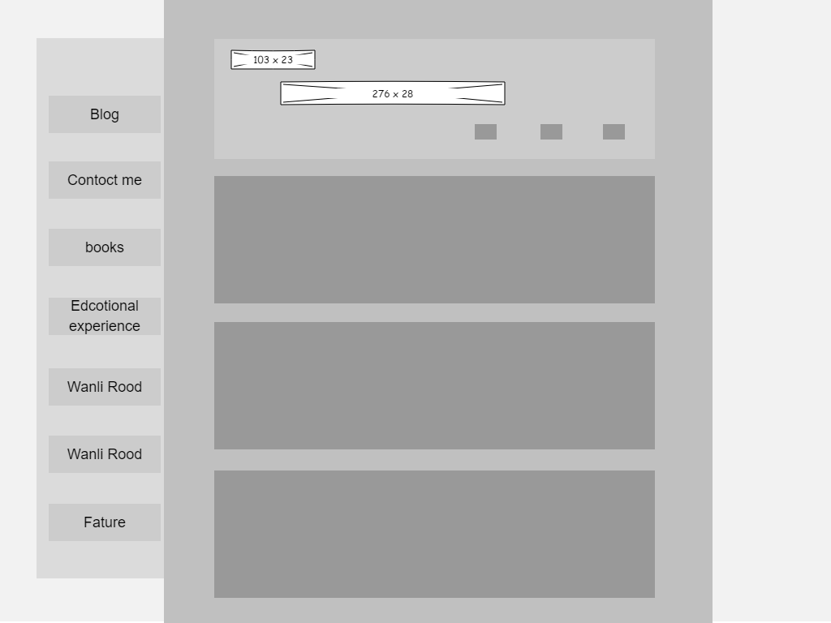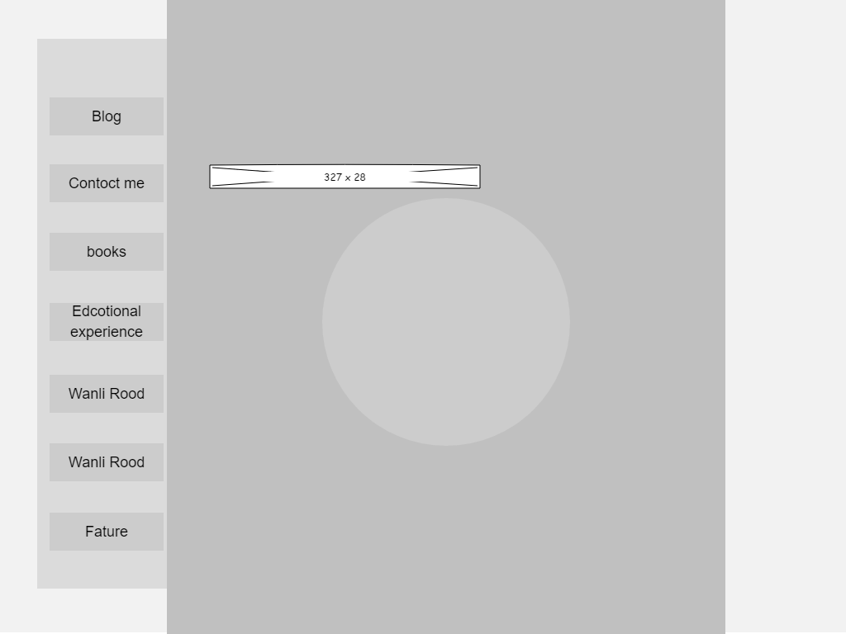

1. Visual design

4.1. Home Page Mock-Up

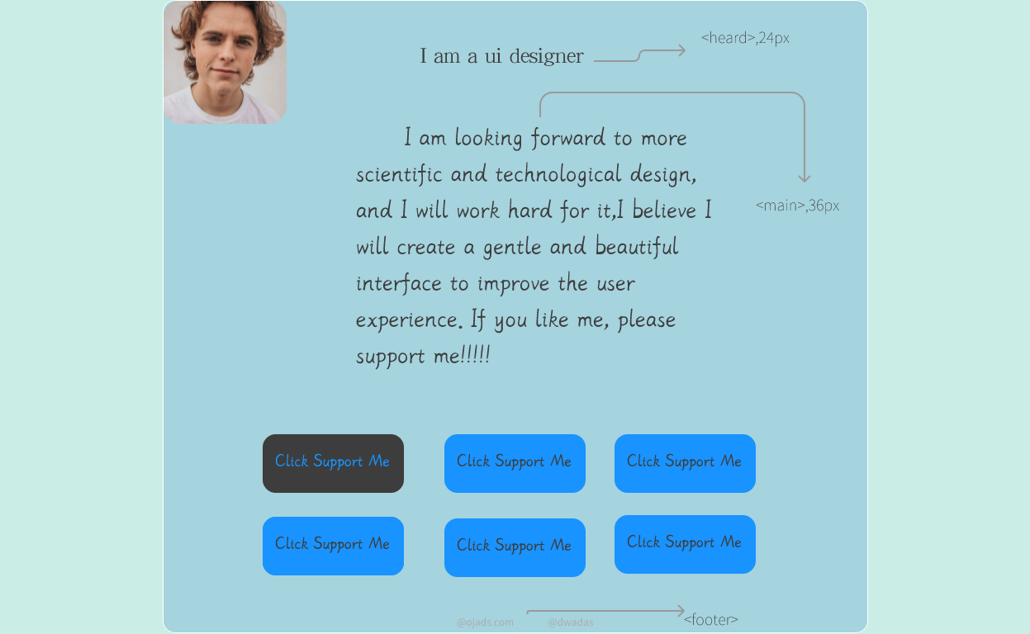

4.2. Colour Scheme

#1993FF 

#3D3D3D  Form contrast

#CAEEE6 

#27CCD8 

**Use nearly similar colors to highlight the sense of technology of ui designer**s

4.3. Typography

|  |  |  |  |  |
| --- | --- | --- | --- | --- |
| title | YRDZST | 36px |  | Bold,,ompact |
| content | YRDZST | 24px |  | beautiful |
| Navigation | YRDZST | 24px |  | Fashionable and interesting |
| content | Source Han Sans CN | 24px |  | Show the formality of blog content |

5. References

Cabrera, J. (n.d.). *Modular Design Frameworks*. Apress. <https://doi.org/10.1007/978-1-4842-1688-0>

Fishel, C., Donatone, F., & Mathewson, J. (2010). *Audience, relevance, and search: targeting Web audiences with relevant content*. IBM Press.