DESIGN AND ANALYSIS OF ALGORITHMS (24CCT301)
Assignment 2: GUI-Based Algorithm Implementation
Campus Route Finder
All-pairs shortest paths and help desk placement using the Floyd-Warshall algorithm
Name | Dion Boby
Roll number | 10
Department | Computer Science and Engineering (Cyber Security)
College | Amal Jyothi College of Engineering (Autonomous), Kanjirappally
Batch | 2024–2028
Algorithm | Floyd-Warshall (dynamic programming)
Source file | campus_route_finder.py (Python 3, Tkinter)

1. Problem Statement
A campus has several buildings joined by walking paths of known length. Students and staff need two answers. First, the shortest walking distance between any two buildings, together with the actual route. Second, the best building for a shared facility such as a help desk, meaning the building with the smallest total walking distance to all other buildings.
Running a single-source algorithm once per building repeats work. An all-pairs method builds one distance table and answers every query from it. This project implements that method with a graphical interface that shows how the table is built, one step at a time.

Objectives
- Apply Floyd-Warshall to a realistic problem (campus navigation and facility placement).
- Let the user enter buildings and paths, and view results in a graphical interface.
- Visualise every stage of the algorithm on a map and in the distance matrix.
- Explain the algorithm and analyse its time and space complexity.
- Test the application with normal inputs and boundary cases.

2. Algorithm Selected and Originality
The selected algorithm is Floyd-Warshall, a dynamic programming method for all-pairs shortest paths. The application context (campus route finder with help desk placement) is the author’s own. The program was written from scratch in Python 3 as a single file that uses only the standard library (Tkinter for the graphical interface), so nothing needs to be installed.
Features beyond a plain implementation: step-by-step animation with pivot highlighting, a log of every improved distance, route reconstruction between any two buildings, ranking of buildings for the help desk, support for one-way and two-way paths, and detection of negative cycles.

3. Algorithm Explanation

3.1 Idea
Let D[i][j] be the shortest known distance from building i to building j. Initially D holds only direct path lengths, with 0 on the diagonal and infinity where no direct path exists. The algorithm then allows the buildings to be used as stop-overs one at a time. After pivot k has been processed, D[i][j] is the shortest distance that uses only the first k buildings as intermediate stops. The recurrence is:
D_k[i][j] = min( D_(k-1)[i][j] , D_(k-1)[i][k] + D_(k-1)[k][j] )

3.2 Pseudocode
FLOYD-WARSHALL(V, edges)
for i in 0..V-1: for j in 0..V-1: D[i][j] = INF; next[i][j] = none
for i in 0..V-1: D[i][i] = 0; next[i][i] = i
for each edge (u, v, w): D[u][v] = min(D[u][v], w); next[u][v] = v
(also v to u if paths are two-way)
for k in 0..V-1: // pivot building
for i in 0..V-1:
for j in 0..V-1:
if D[i][k] + D[k][j] < D[i][j]:
D[i][j] = D[i][k] + D[k][j]
next[i][j] = next[i][k]
if any D[i][i] < 0: report negative cycle
return D, next

3.3 Route reconstruction
The next matrix stores the first building to walk to on the best route from i to j. To print a route, start at i and keep moving to next[u][j] until j is reached. This takes at most V steps.

3.4 Best help desk location
For every building i that can reach all others, the total distance is the sum of D[i][j] over all j other than i. The building with the smallest total is suggested. If some building cannot reach all others (disconnected paths), no single best location exists and the program reports this.

3.5 Worked example from the sample campus
- Before pivot Library, Gate and Canteen have no known route (infinity). When Library is the pivot, the program finds Gate → Library → Canteen = 200 + 80 = 280 m and updates D[Gate][Canteen] from infinity to 280.
- After all pivots, the shortest Gate to Lab route is Gate → Admin → CSEBlock → Lab with a length of 120 + 150 + 60 = 330 m, shorter than going via the Library (200 + 100 + 60 = 360 m).

4. Complexity Analysis
Part of the program | Time | Extra space
Initialising D and next | Θ(V²) | Θ(V²)
Triple loop over k, i, j | Θ(V³) | none beyond D and next
Negative cycle check (diagonal) | Θ(V) | none
Route reconstruction (per query) | O(V) | O(V) for the route
Best location ranking | Θ(V²) | O(V)
Whole algorithm | Θ(V³) | Θ(V²)

The three nested loops each run V times and the work inside is constant, so the time is Θ(V³). This holds for the best, average and worst case because the loops do not depend on the number of paths E or on the input values. The two V × V matrices D and next give Θ(V²) space.
For comparison, running Dijkstra’s algorithm from every building costs O(V · E log V) with a binary heap, which is better on sparse graphs. Floyd-Warshall is simpler, works with negative edge weights, and is competitive on dense graphs.
Note on the visualisation: to allow stepping backwards, the program stores a copy of the matrix after each pivot, which uses O(V³) memory. This is a cost of the animation, not of the algorithm. The interface limits the input to 12 buildings.

5. GUI Design
The application is a Python desktop program built with Tkinter. It has five areas:
- Enter paths. A text box takes one path per line in the form Building1 Building2 Distance (metres). A check box chooses two-way or one-way paths, and a drop-down loads ready-made test cases.
- Campus map. Buildings are drawn as circles and paths as lines labelled with their length. The current pivot building is highlighted, and a requested route is drawn in red. A message line and a step log explain each step.
- Distance matrix. Shows D after each step. The pivot row and column are shaded, and cells that just improved are shown in green.
- Find a route. Select two buildings to see the shortest route and its length, drawn on the map.
- Best help desk location. A ranking of all buildings by total walking distance.
Controls: Build, Back, Step, Run all and Reset. Invalid input produces a clear error message instead of failing silently.

Program structure
- read_paths(data) reads and validates the input lines.
- floyd_warshall(n, edges, two_way) runs the algorithm and records the matrix after every pivot, together with the next-hop matrix.
- route(nxt, a, b) rebuilds the shortest route between two buildings.
- build, step, back, run_all, reset, show_route, show, draw are the interface functions: they control the steps and update the matrix, step log, map and ranking.

6. GUI Screenshots
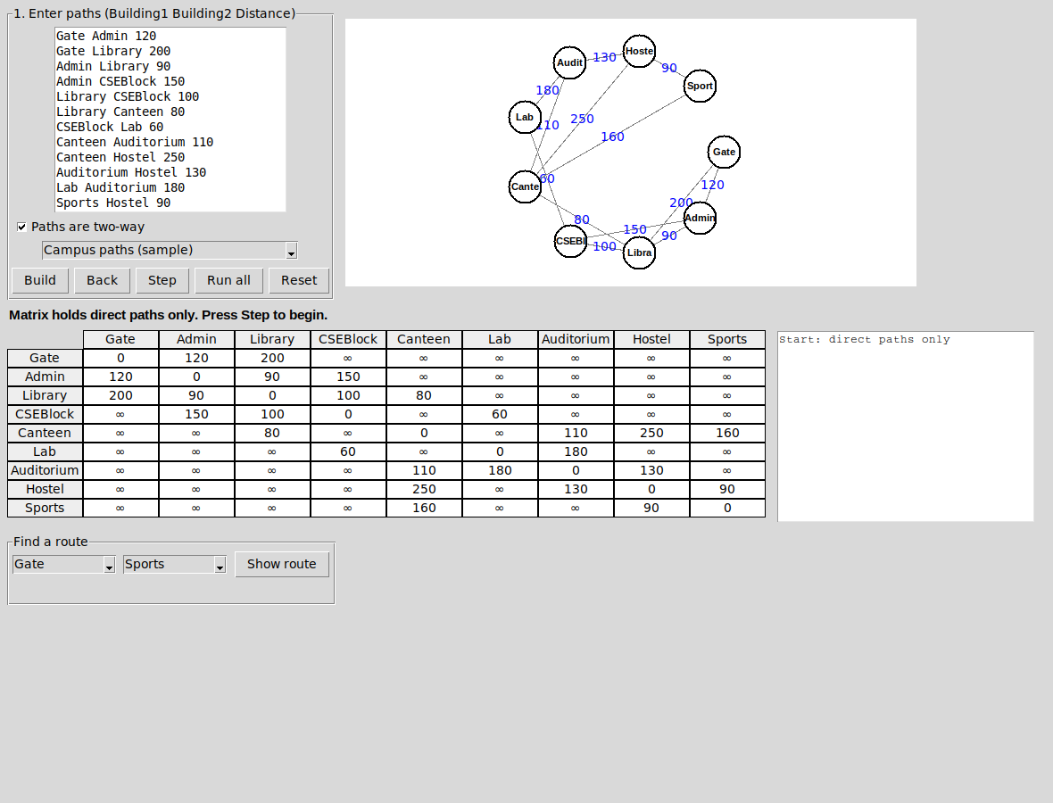
Figure 1: Application after Build, showing the sample campus before any step.
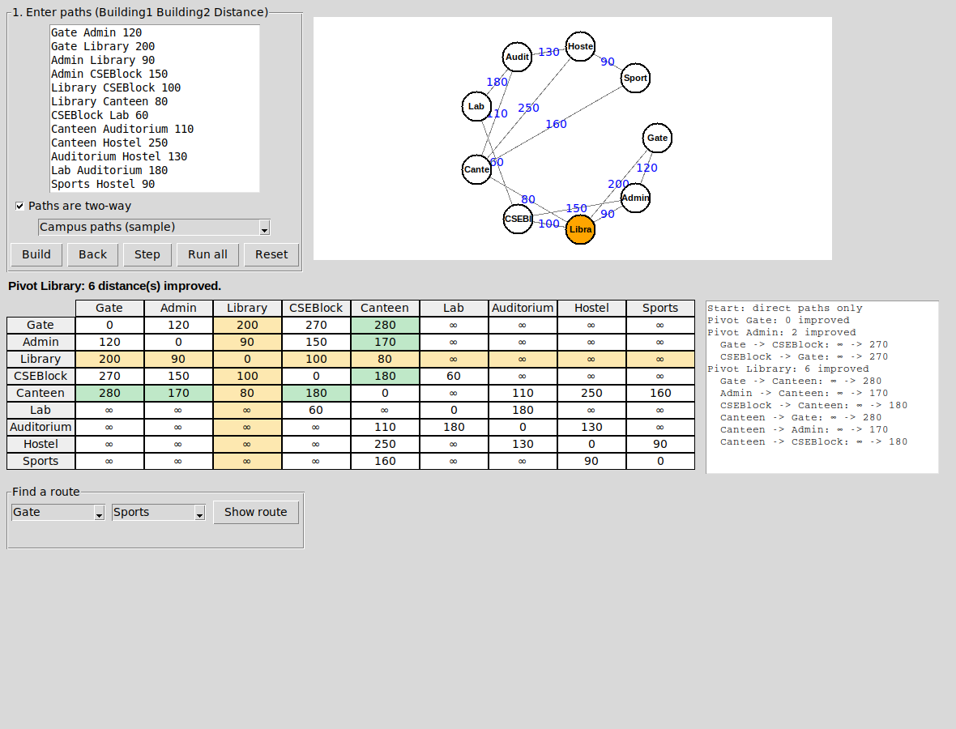
Figure 2: Step with Library as pivot. Six distances improve (green cells), including Gate to Canteen.
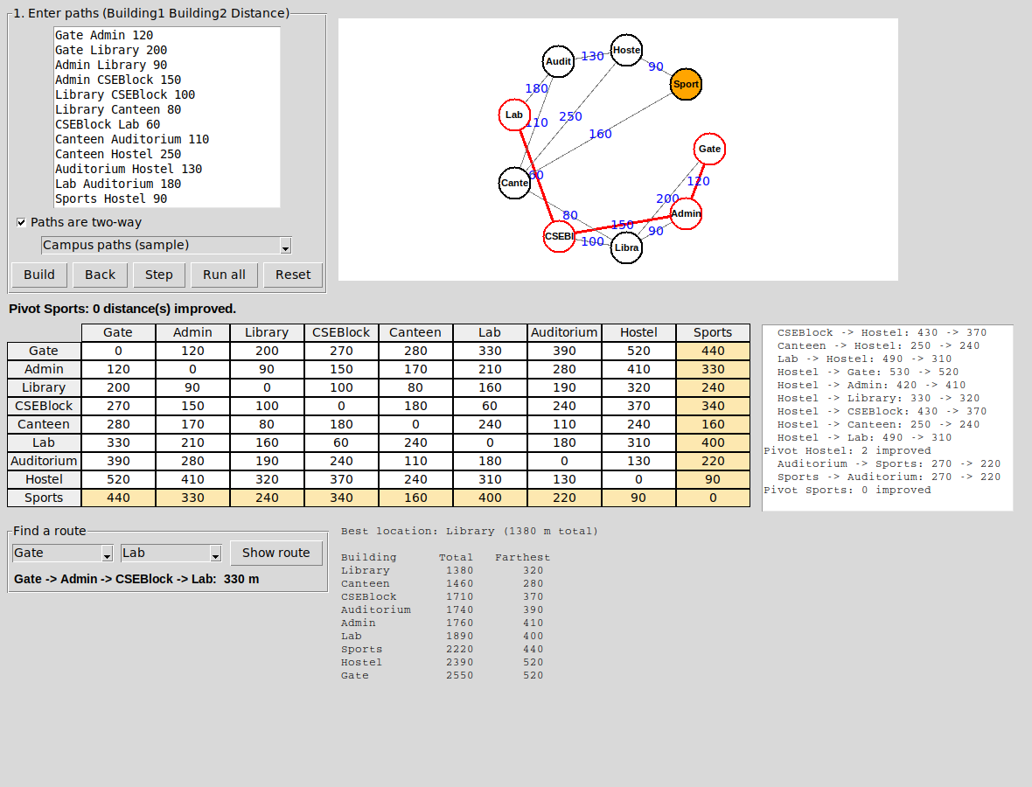
Figure 3: Final state. The shortest route from Gate to Lab (330 m) is drawn in red, and Library is the best help desk location with 1380 m.

7. Testing and Results
The application was tested with the sample campus and with boundary cases. Each case can be loaded from the drop-down list in the application.
ID | Test case and input | Expected result | Observed result | Status
T1 | Sample campus: 9 buildings, 13 two-way paths | Gate to Lab 330 m; best location is Library | Gate → Admin → CSEBlock → Lab = 330 m. Gate → Hostel = 520 m via Library, Canteen, Auditorium. Library best with 1380 m total. | Pass
T2 | Single path (A B 5), two-way | D[A][B] = D[B][A] = 5; no step improves anything | Matrix 0 5 / 5 0; no improvements; A and B tie at 5 m total | Pass
T3 | Disconnected: A–B 4 and C–D 6 | Distances between the two groups stay infinity; no single best location | Cross distances remain ∞; message says no single best location exists (Figure 4) | Pass
T4 | One-way paths: A→B 2, B→C 3, C→A 4, A→C 9 | A to C improves from 9 to 5 via B; B to A = 7; C to B = 6 | Matrix 0 2 5 / 7 0 3 / 4 6 0; best location A with 7 m total (Figure 5) | Pass
T5 | Negative cycle: A→B 1, B→C −3, C→A 1 | Negative cycle detected | Diagonal becomes −1; warning shown; routes and ranking disabled (Figure 6) | Pass
T6 | Empty input | Error message, no crash | “Add at least one path.” (Figure 7a) | Pass
T7 | Invalid distance: A B x | Error message with line number | “Line 1: the distance must be a number.” (Figure 7b) | Pass

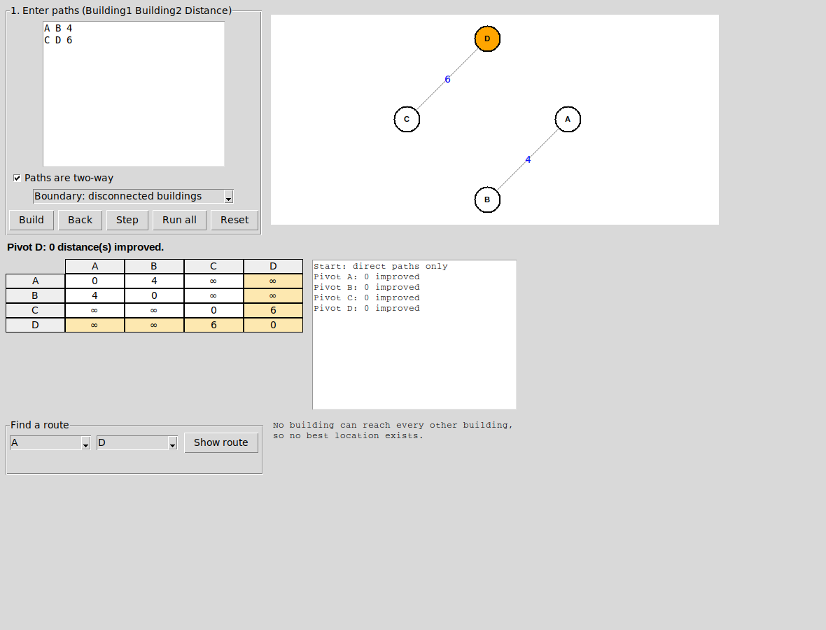
Figure 4: Test T3, disconnected buildings. Cross distances stay infinity and no single best location exists.
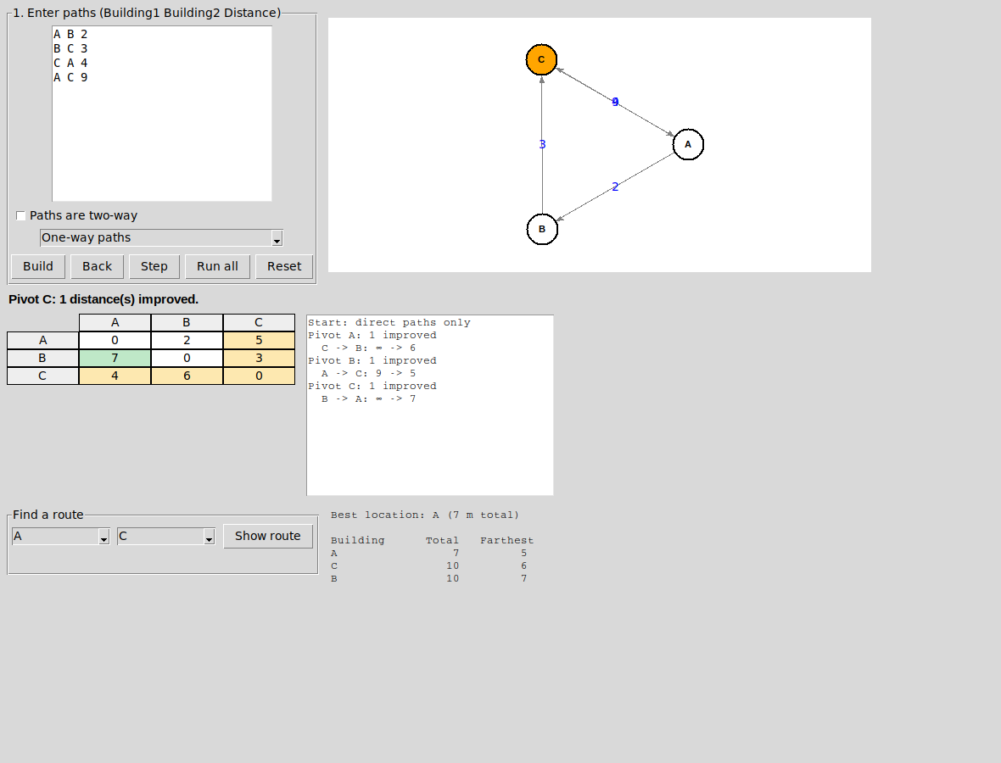
Figure 5: Test T4, one-way paths. The matrix is not symmetric.
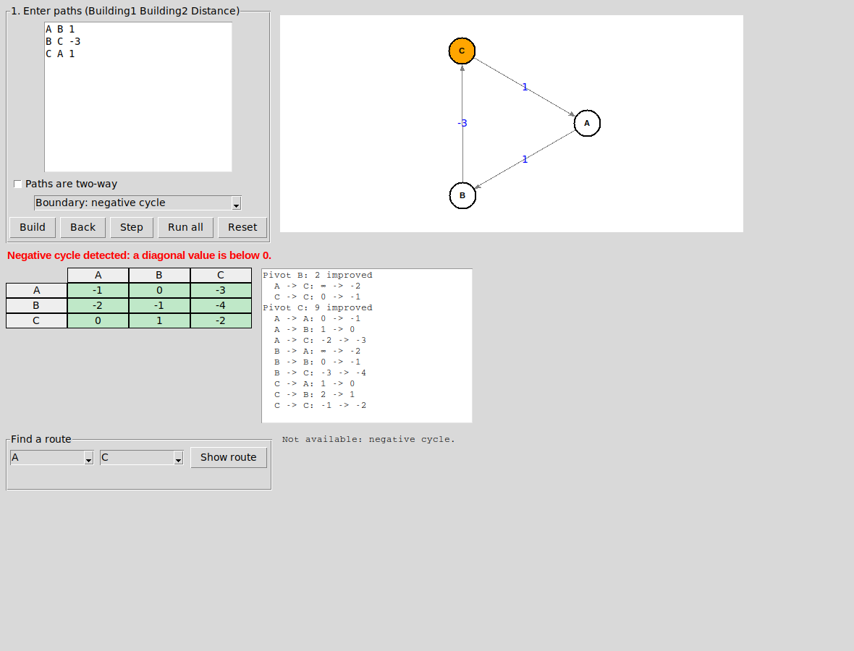
Figure 6: Test T5, negative cycle detected from a negative diagonal value.
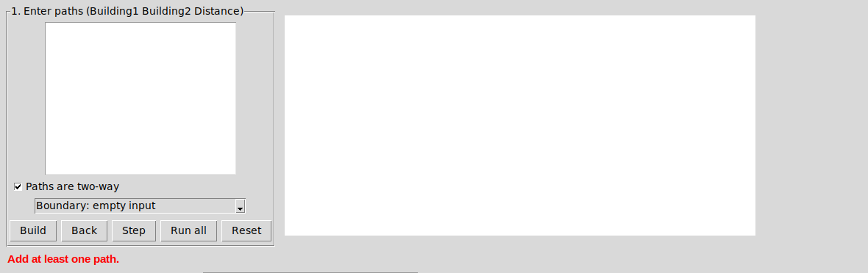
Figure 7(a): Test T6, empty input shows an error message.
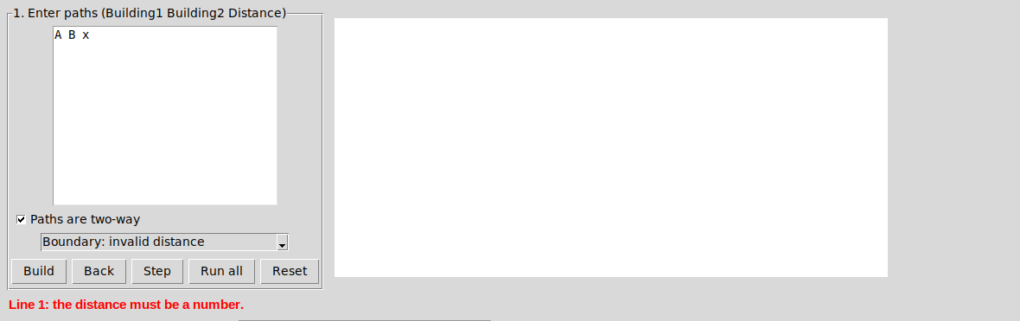
Figure 7(b): Test T7, invalid distance shows an error message with the line number.

8. Conclusion
The Campus Route Finder applies Floyd-Warshall to a practical problem and makes the algorithm easy to follow by showing the pivot building, the improved distances and the matrix at every step. It runs in Θ(V³) time and Θ(V²) space, and it handled all normal and boundary test cases correctly, including disconnected graphs, one-way paths and negative cycles.

Appendix: How to Run
- Install Python 3 (Tkinter is included with the standard Windows and macOS installers; on Linux run: sudo apt install python3-tk).
- Open a terminal in the folder that contains the file and run: python campus_route_finder.py
- Pick a case from the drop-down list or type paths in the text box, then press Build. The window is about 1180 × 900 pixels, so maximise it on smaller screens.
- Press Step to move through the pivots, or Run all to see the final result. Use Find a route to see any shortest route.

