Table of Contents

Document Version 2

1. Purpose 3

1.1. Intended Audience 3

1.2. Intended Use 3

1.3. Scope 3

1.4. Definitions and Acronyms 3

2. Overall System Description 4

2.1. Use Case Diagrams 4

2.2. System Architecture 5

2.3. Functional Requirements 6

2.3.1. Library Selection 6

2.3.2. Book Selection and Resservation 7

2.3.3. User Account Management 7

3.1. Non-Functional Requirements 8

3.1.1. Non-Functional Requirement xxxx 8

4. Software Architecture 8

4.1. Static Software Architecture 8

# Document Version

|  |  |  |  |  |
| --- | --- | --- | --- | --- |
| No | Update | Name | Date | Version |
| 1. | Initial version |  |  | 1.0 |

# Purpose

## Intended Audience

This SRS document describes the System Requirements and Software Design for an IoT Coffee maker and the target audience are System and Software Engineers working on the development of this project.

## Intended Use

The SRS defines the overall System Architecture and Requirements as well as the Software Architecture and Design. This document is also contains the definition of the System Requirements which shall be used as the input for System Test cases and Software Unit Test cases.

## Scope

## Definitions and Acronyms

|  |  |
| --- | --- |
| **Acronym** | **Description** |
| IR | Infra Red |
| LED | Light Emitting Diode |
| NFC | Near Field Communication |
| SW | Software |
| HW | Hardware |

# Overall System Description

## Use Case Diagrams

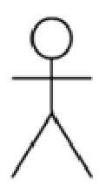

Library Patrons



Library

## System Architecture

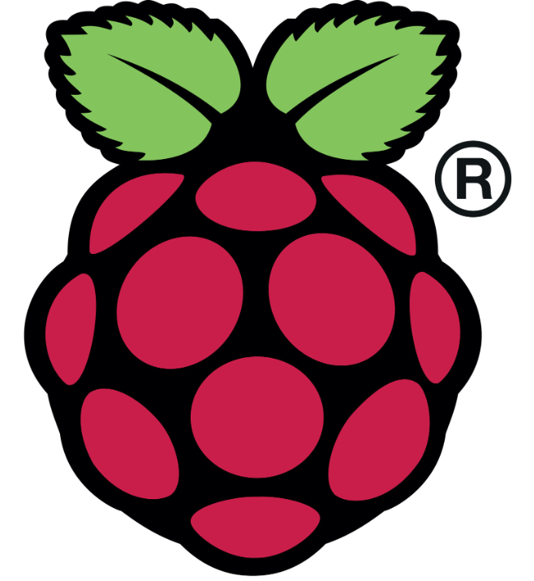

DC Motor

Servo Motor

RFID Card Reader

LCD

I2C

**Raspberry Pi Development Board**

Camera

## Functional Requirements

### Library Selection

There should be a main home screen providing any user options of whether where the user wants to access.

|  |  |
| --- | --- |
| **REQ_ID** | **Requirement** |
| REQ-01 | Users shall be able to select the library branch from which they wish to borrow books. The main menu with the text below shall be displayed on the LCD screen:  Line 1 = “Select branch”  Line 2 = “Exit app” |
| REQ-02 | In the main menu defined in REQ-01, if the option “Select branch” is selected on the keypad, then the following menu shall be displayed on the LCD screen  Line 1 = “Library 1”  Line 2 = “Library 2” |
| REQ-03 | In the main menu defined in REQ-01, if the option “Exit app” is selected, the LCD should be turned off. |

### User Account management

In the event if the user would like to borrow books or return book, this function is to get the user information and verify the user (Strictly only using NRIC or SP student card)

|  |  |
| --- | --- |
| **REQ_ID** | **Requirement** |
| REQ-04 | In the page where is defined in REQ-02, the users will be brought to a page to provide their identification for whichever option being chosen. The LCD shall display:  Line 1= “Scan your IC”  Line 2=” Type your IC no.” |
| REQ-05 | If the option “Scan your IC” is selected, the camera shall turn on, allowing the users to put their cards under to scan. |
| REQ-06 | If the option “Type your IC no.” is selected, the users shall be able to type down numbers |
| REQ-07 | If any of the processes is done successfully in 05 & 06, there shall be a reminder displayed on the LCD screen showing a tick. |
| REQ-08 | Else if, there will be reminder telling the users there’s error verifying themselves. |

### Book Selection and Reservation

This function will be able to help the users identify the books through the book barcode or number for tracking purposes.

|  |  |
| --- | --- |
| **REQ_ID** | **Requirement** |
| REQ-09 | The main menu of library with the text below shall be displayed on the LCD screen:  Line 1 = “Borrow”  Line 2 = “Return” |
| REQ-10 |  |
| REQ-11 | If the option “Borrow” is selected above, the camera shall turn on for the users to scan the barcodes on books. |
| REQ-12 | If the option “Return” is selected in REQ-09, the respective names for the books being lent out would display on the LCD screen.  Line 1= “BOOK1”  Line 2= “BOOK2” |
| REQ-13 | The camera shall turn on for the users to scan and verify the respective codes of the books |
|  |  |

## Non-Functional Requirements

### Non-Functional Requirement xxxx

Add short description here …

|  |  |
| --- | --- |
| **REQ_ID** | **Requirement** |
| REQ-xx |  |
| REQ-xx |  |

# Software Architecture

## Static Software Architecture

The Software Architecture defines the various Software Components that are developed to realize the implementation of the system requirements.

**PowerMgt**

**HMI**

**Application Layer**

**Hardware Abstraction Layer (HAL)**

**ADC**

**USonic**

**NFC**

**Servo**

**RainSens**

**BlackCoffee**

**HotWater**