**Topics: Normal distribution, Functions of Random Variables**

1. The time required for servicing transmissions is normally distributed with *μ* = 45 minutes and *σ* = 8 minutes. The service manager plans to have work begin on the transmission of a customer’s car 10 minutes after the car is dropped off and the customer is told that the car will be ready within 1 hour from drop-off. What is the probability that the service manager cannot meet his commitment?
2. 0.3875
3. 0.2676
4. 0.5
5. 0.6987

**A]**

X=50,

Mean, *μ* = 45

Std, *σ* = 8



1. The current age (in years) of 400 clerical employees at an insurance claims processing center is normally distributed with mean *μ* = 38 and Standard deviation *σ* =6. For each statement below, please specify True/False. If false, briefly explain why.
2. More employees at the processing center are older than 44 than between 38 and 44.
3. A training program for employees under the age of 30 at the center would be expected to attract about 36 employees.

**A]**

A.More employees at the processing center are older than 44 than between 38 and 44.

A] **False**

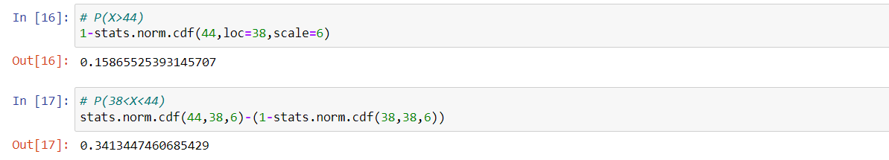

0.15865 < 0.34134

B. A training program for employees under the age of 30 at the center would be expected to attract about 36 employees.

A] **True**



1. If *X1*~ *N*(μ, σ2) and *X*2 ~ *N*(μ, σ2) are *iid*normal random variables, then what is the difference between 2 *X*1 and *X*1 + *X*2? Discuss both their distributions and parameters.

**A]**

1. If *X1* is normally distributed then 2*X*1 is also normally distributed and 2X1 is larger scale of *X1*.
2. *X1* and *X2* are normally distributed and their associated sum and samples are exactly normal with suitable parameters.
3. Let X ~ N(100, 202). Find two values, *a* and*b*, symmetric about the mean, such that the probability of the random variable taking a value between them is 0.99.
4. 90.5, 105.9
5. 80.2, 119.8
6. 22, 78
7. 48.5, 151.5
8. 90.1, 109.9

**A]** Probability of the random variable taking a value between them is 0.99.

Mean = 100, Std=20 

1. Consider a company that has two different divisions. The annual profits from the two divisions are independent and have distributions Profit1 ~ N(5, 32) and Profit2 ~ N(7, 42) respectively. Both the profits are in $ Million. Answer the following questions about the total profit of the company in Rupees. Assume that $1 = Rs. 45
2. Specify a Rupee range (centered on the mean) such that it contains 95% probability for the annual profit of the company.
3. Specify the 5th percentile of profit (in Rupees) for the company
4. Which of the two divisions has a larger probability of making a loss in a given year?

**A]**

1. 95% of the probability lies between 2 times standard deviation away from the mean

Profit = (5+7, 32+ 42)= (12, 52)

Mean = 12, Std = 5

[12-(5*2), 12+(5*2)] = [$2, $22] = [2*45, 22*45]

= [₹90M, ₹990M]

1. From the Z-table, 5th percentile is -1.645.

Using Z score formula:

X = µ+Zσ

= 12+(-1.645*5)

X = $3.775 = 3.775*45 = 169.875

5th percentile of profit is ₹169.875M

1. The 1st division has a higher probability of making a loss compared to 2nd division

