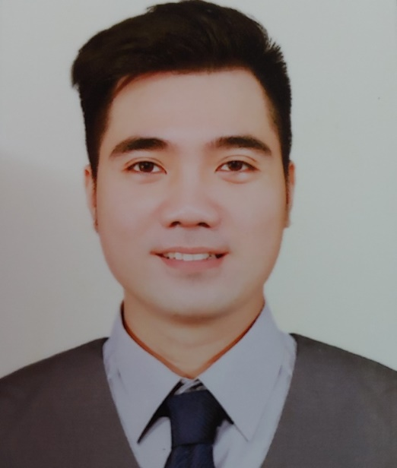B

* **09/2020 – 02/2021: SUPERVISOR – BEP NHA THANH COFFEE SHOP**

Recruitment, training, shift assignment, create new drink  
Solve problem, propose solution, daily report…

* **10/2018 – 03/2020: RECEPTIONIST (BUSINESS LOUNGE TSN INT. AIRPORT) – SOUTHERN AIRPORTS SERVICES JSC. (SASCO)**

Welcome, Check-in, Guide and Support Customer  
Solve problem, Record and Report…

* **04/2018 – 08/2018: OWNER OF A SMALL F&B SHOP**

Selling some fast food and beverage…

* **03/2016 – 03/2018: WAITOR (AIDA CRUISE SHIP) - HUNG VUONG IMPORT EXPORT SERVICE AND TOURISM STOCK COMPANY (ISALCO)**

Working in the restaurants on AIDA Cruise ship in EU…

* **09/2015 – 02/2016: SALESMAN – GOLDEN APPLE DISTRIBUTOR**

Introduce products, promotion, benefits…to customer  
Record and report the feedback of customer  
Planning, Analysis, Implement, Checking, Solve problem…

**WORKING EXPERIENCE**

* **2010-2014** Bachelor of Industrial University of Ho Chi Minh City

Major: Business Administration

* **Second language:** English (Toeic 600)
* **Office IT Cetificate:** B

**EDUCATION**

* **Date of birth** 18/07/1992
* **Gender** Male
* **Tel** 0906120028
* **Email** [n.d.anhhuy92@gmail.com](mailto:n.d.anhhuy92@gmail.com)
* **Address** 781/30 Le Duc Tho Street,   
   Ward 16, Go Vap District,   
   HCMC

**CONTACT**

**NGUYEN ĐINH ANH HUY**

**CAREER OBJECTIVE**

- Working in a professional, dynamic and competitive environment where I can develop skills to contribute the company.

- Willing to learn and improve myself in order to adapt working inquiries.

- Take all my advantages, knowledge and skills to bring the value to the company I work for.

**PERSONAL SKILLS**

. Good communication

. Customer consulting and negotiating

. Independent work

. Work in group

. Fast learning

. Customer care mindset