**Cop 2271: Introduction to Computation and Programming Assignment#4**

**Possible Points: 50**

**Problem 1 (10 pts):**

1. Ask the user to enter a value between 1 and 100.
2. If the value is out of the range, print **“Invalid input”**
3. Take the number entered and %4, make sure to store it as a variable.
4. If the variable is equal to 0, print **“You won!”**
5. If the variable is equal to 1 or 2, print **“It is a tie!”**
6. If the variable is equal to 3, print **“You lose!”**
7. Make sure if, else if and else are used. Here are some sample runs:

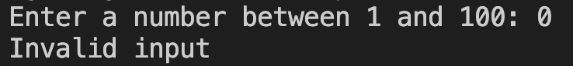

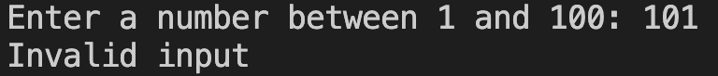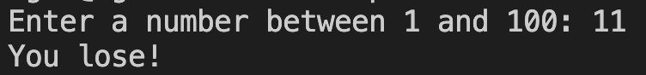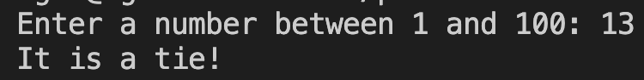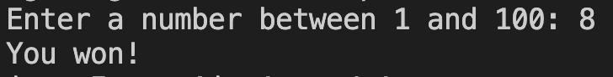

**Problem 1 Code Output:**

**Problem 2 (12.5 pts):**

1. Ask the user to enter a lowercase letter.
2. If the letter is equal to **‘a’, ’e’, ’i', ’o’**, or **‘u’** print “You have entered a vowel.”
3. If the user entered the letter **‘y’** print “You may have entered a vowel.”
4. Otherwise, print **“You have entered a consonant”**
5. You can use individual if/else if/else statements. Bonus: if you use compound logic instead you can earn 5 bonus points.

Here are some sample runs:

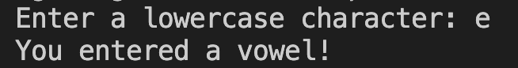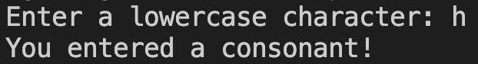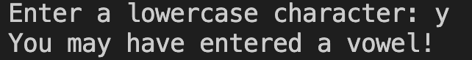

**Problem 2 Code Output:**

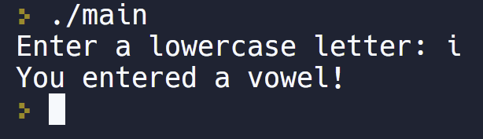

**Problem 3 (12.5 pts):**

1. Ask the user to enter two characters, store each to different variables.
2. Using a while loop, start at the lowest character entered and print all characters between the two characters entered.
   1. You may include the two characters that were entered if you wish. Here is a sample run:

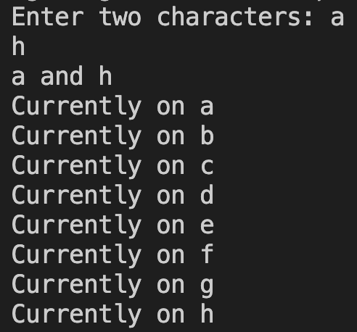

**Problem 3 Code Output:**

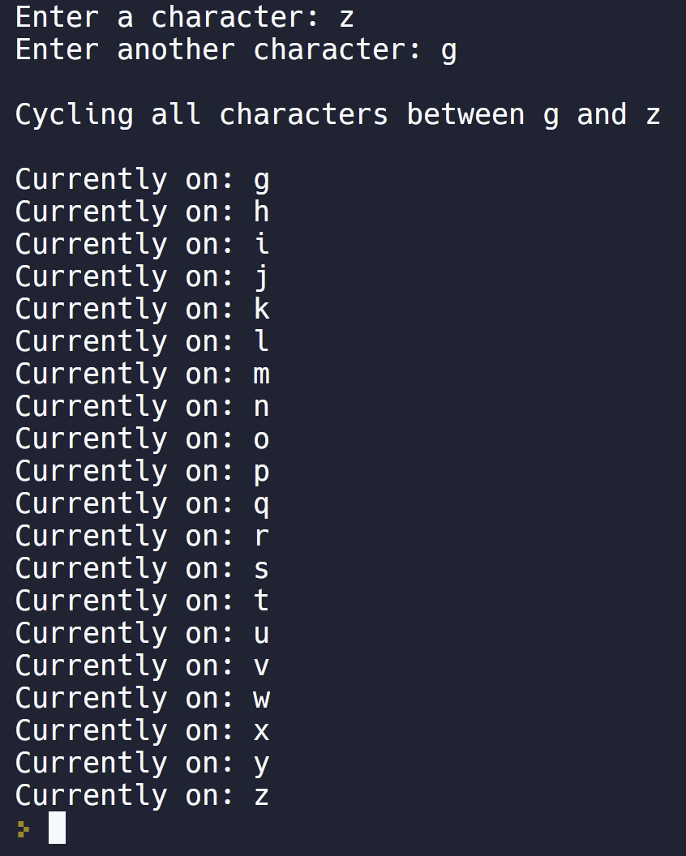

**Problem 4 (15 pts):**

1. Using a while (or do-while) loop, and if/else, prompt the user to enter a number between 1 and 4.

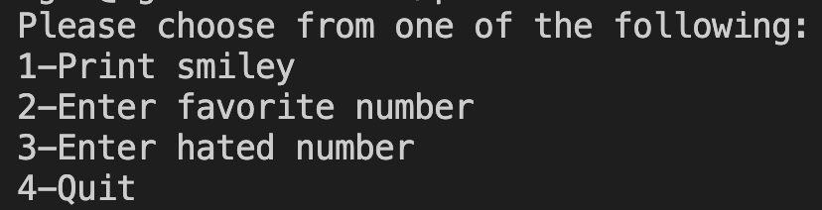

1. 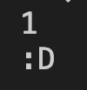If the user enters 1, print an ASCII smiley face.
2. If the user enters 2, prompt the user to enter their favorite number, then store the number in a variable.
   1. If the user has already entered their least favorite number provide the results of the two numbers summed together in a meaningful message.

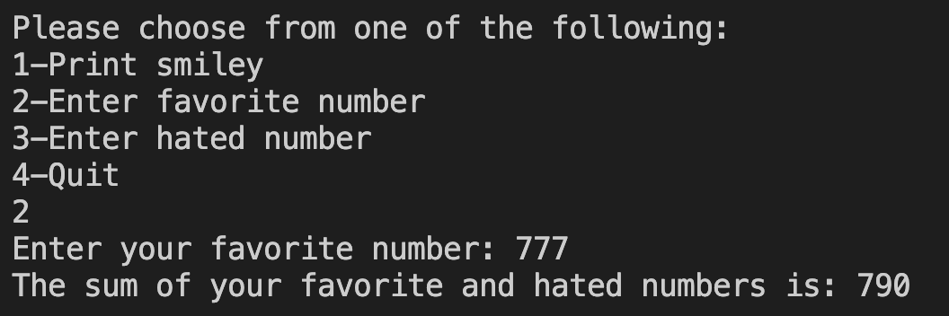

1. If the user enters 3, ask them to enter their least favorite number between 1 and 100. Store the value in a variable.
   1. If the user has already entered their favorite number provide the results of the two numbers summed together in a meaningful message.

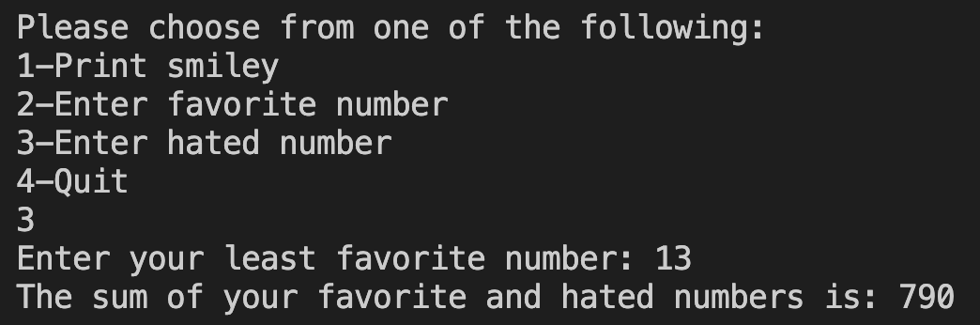

1. If the user enters 4, then quit the program (exit the while loop).
2. Should the user enter an invalid option, print a message asking the user to enter a valid option. (Do not leave the loop).



**Problem 4 Code Output:**

