Problem 1:

State whether the following statements are true or false. If false explain why.

1. An expression containing **&&** is true only if one of its operands is true.

False, && expression is only true if both operands are true

1. An expression containing **||** is false only if both of its operands are false.

True

1. Not having the default case in the **switch** selection statement is a syntax error.

False, the default case may be omitted

1. The expression **!(x < y)** is true if (**x >= y)**.

True

1. The **break** statement is always required for each case in **switch** statement.

False, break is not required but will change the logic of the statements

(5 points)

Problem 2: (10 points)

Using **for** loop, write a C program to find the sum of all numbers divisible by 5 between 1 to *n* inclusively. *n*

should be entered by the user. For example: If 29 was entered the sum is 75. (5 + 10 + 15 + 20 + 25). Here is a sample run:

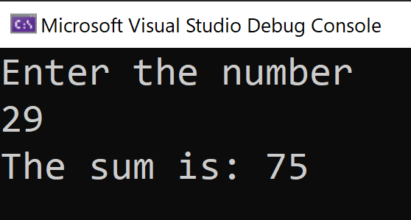

Note:

1. Provide your source code (.c) file (as a separate file).
2. Provide snapshots of all your results after running your code. Use a word or pdf file to show your results.

Code output:

Problem 3: (10 points)

Redo Problem 2 using the do…while iteration statement. Note:

1. Provide your source code (.c) file (as a separate file).
2. Provide snapshots of all your results after running your code. Use a word or pdf file to show your results.

Code Output:

Problem 4: (7.5 points)

What is the number of iterations in the following do...while loop? (Show the values of *a* and

*b* at each iteration).

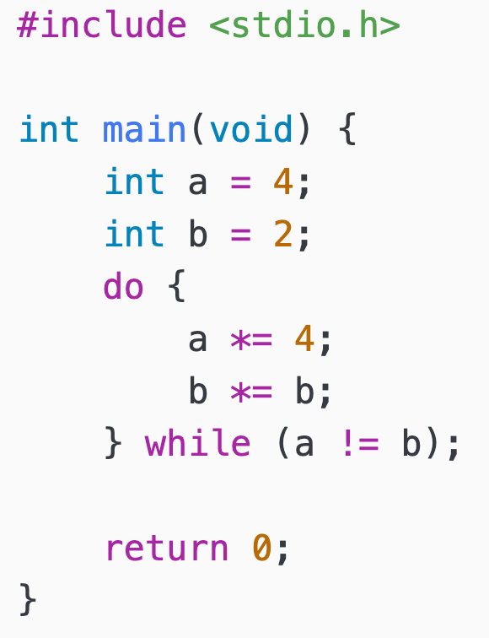

|  |  |  |
| --- | --- | --- |
| Num iterations | a | b |
| initialize | 4 | 2 |
| 1 | 16 | 4 |
| 2 | 64 | 16 |
| 3 | 256 | 256 |

3 iterations

Problem 5: (17.5 points)

An online retailer sells five different products whose retail prices are shown in the following table:

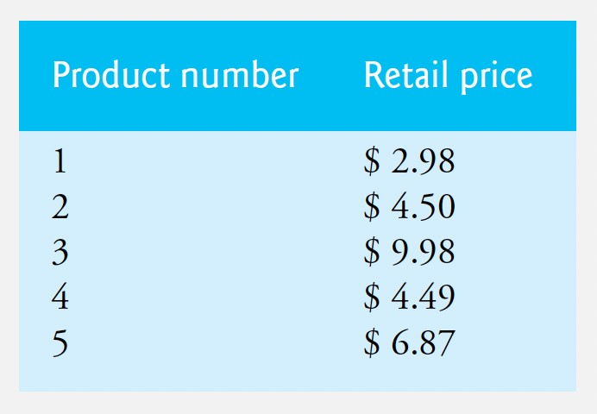

Write a program that reads a series of product numbers.

Your program should use a sentinel-controlled loop and **switch** statement to help determine the retail price for each product. The program should provide an error message if the invalid product number was entered. Your program should calculate and display the total retail value of all products sold last week.

Here is a sample run:

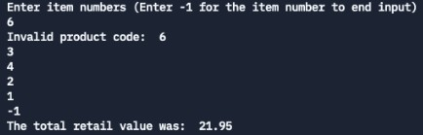

Note:

1. Provide your source code (.c) file (as a separate file).
2. Provide snapshots of all your results after running your code. Use a word or pdf file to show your results.

Code output:

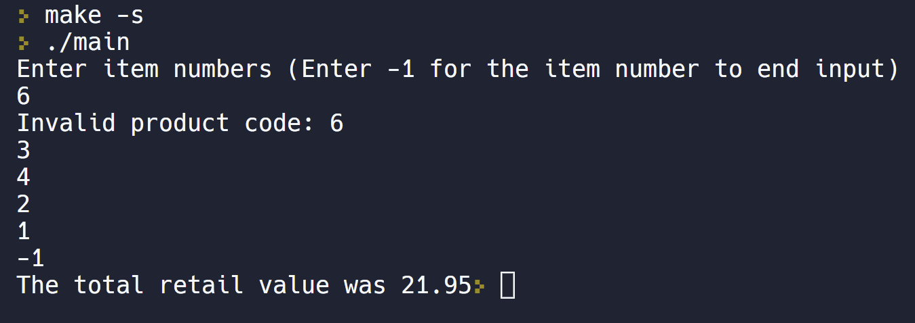

Problem 6: (5 points bonus)

1) Write a C program that will print a table of conversions from degrees Celsius to degrees Fahrenheit. The degrees Celsius conversion table has Celsius values from −50◦C to +50◦C with increment of 1◦C.

𝑇 = 9.0 ∗ 𝑇 + 32

! 5.0 "

The output of the program should follow the exact format showed below. You should specify columns width, justification, and signs.

Here is a sample run:

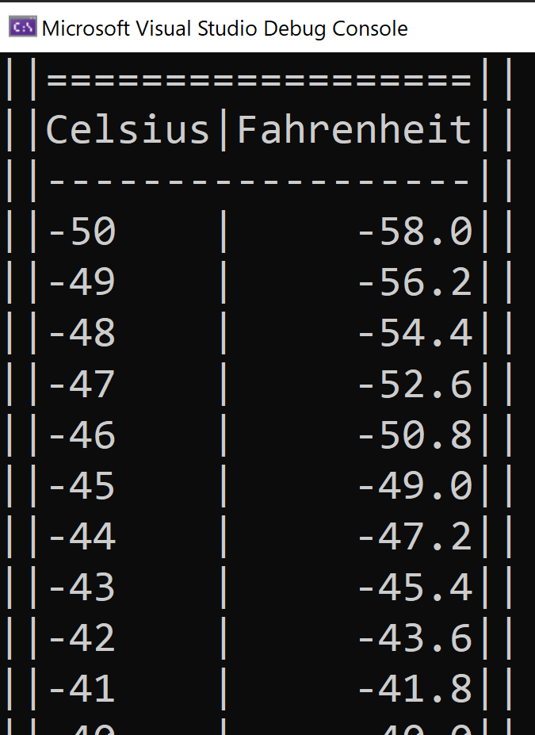

Note:

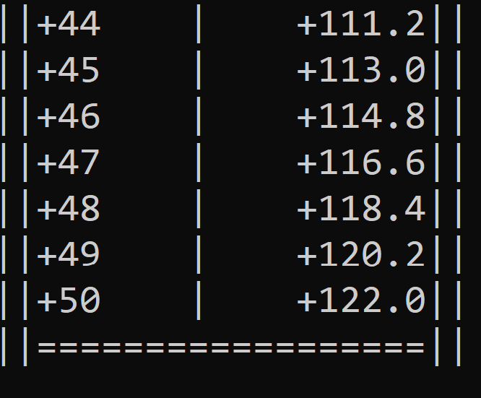

1. Provide your source code (.c) file (as a separate file).
2. Provide snapshots of all your results after running your code. Use a word or pdf file to show your results.

Code output:

