Assignment 9: Advanced Array Concepts

# Assignment Description:

This assignment will cover advanced concepts of arrays. Please review your class notes, slides and textbook to ensure you understand the necessary concepts.

**YOU MAY NOT USE cstring OR string.h FOR THIS LAB!**

You may use scanf(“%s”,charArray) , gets and printf.

# Program 1 (12.5 pts):

You will write a function called myStringLen. It will take in a single char array. You can assume adequate space has been allocated to it. You will iterate through the array and count how many characters are preset (white space included) until you reach a null character (‘\0’). You will return the number of characters found (not including the null character).

Use “gets” to populate a char array in main and call this function. Print the size in main. Example output (Prompt does not have to be exact):

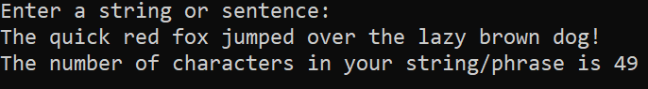

**Submit a screen shot of your output and the source code (.c file)!**

**Code output screenshots:**

# Program 2 (12.5 pts):

You will write a function called myStringCmp. It will take two character arrays. You may assume that there is enough space allocated for each array. Iterate through the arrays and compare each character.

* If the characters are the same until you reach a null character ‘\0’ you will return a 0.
* If the first char array would come before the second in the dictionary you will return a negative number.
* Otherwise, you will return a positive number.

**Submit a screen shot of your output and the source code (.c file)!**

**Code output screenshots:**

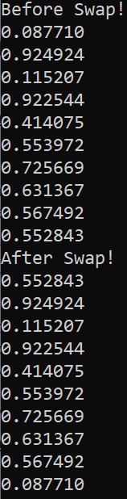

# Program 3 (12.5 pts):

Create a function called printArray that will take the float array and size as parameters. The function will then print out all the elements of the float array.

Create another function called mySwap. This function will take in a float array, the size of the float array, and the two indexes you wish to switch. The function will then swap the values at the two indexes specified.

In Main, you will create a float array of size ten and populate it with random numbers between 0 and 1 (Use a for loop). You will then print the array, call mySwap, pass in 0 and 9 for the indexes, and then print the array a second time.

* *Hint: use RAND_MAX instead of INT_MAX.*

**Submit a screen shot of your output and the source code (.c file)!**

**Code Output Screenshots:**

**

# Program 4 (12.5 pts):

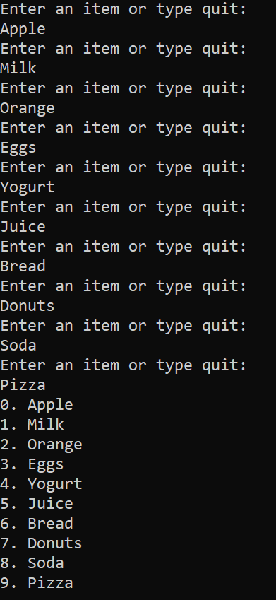You do not need to create a function for this program. You will create a 2D array of chars called shopping list. The first dimension of the array will be size 10, and the second dimension of the array will be size 80.

Ask the user what items they need to purchase at the store. Record each entry into the consecutive element of the 2D array.

Use scanf(“%s”…) for the input.

If the user inputs “quit”, or if the user enters 10 items, then stop asking the user for items and print out the shopping list in a nicely formatted way.

*Hint: Remember myStrCmp you wrote earlier!*

*Hint 2: You should read the string into a temporary char array, check to make sure it is not “quit” then do a deep copy into the final list (Do not forget to add*

*\0 as the last letter).*

**Submit a screen shot of your output and the source code (.c file)!**

**Code Output Screenshots:**

