“Karawang Timur District in Figures 2025” is a publication series intended for the public, containing statistical data tables derived from secondary sources—including local government agencies, as well as other public and private institutions—located within Karawang Regency, specifically in the Karawang Timur District area.
We acknowledge that this publication may still have shortcomings; however, we are continuously striving to improve and refine its scope, quality, and presentation, with the aim of fully meeting the needs of data users.
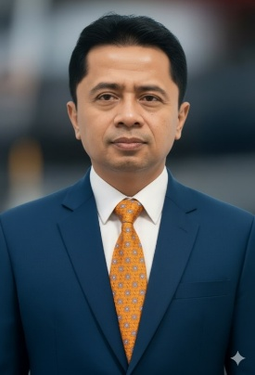
We extend our gratitude to all parties who have contributed to the completion of this publication. Suggestions and constructive criticism are highly welcome to help improve future editions.

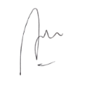
Karawang, September 2025
Head of Statistics of Karawang Regency

Ari Setiadi Gunawan

