RuleKit
An Architecture for Logically Faithful Policy Adjudication via LLMs

The Gap
Policies — administrative rules, regulations, clinical guidelines, contractual terms — describe what an institution will do given the facts of a case. Adjudicating a case under a policy means reading the policy, identifying its requirements, determining which requirements the case satisfies, and producing the determination the policy specifies.
This is a reasoning task institutions perform at scale. Health plans adjudicate prior authorizations. Banks adjudicate billing disputes. Government agencies adjudicate benefits eligibility. Each adjudication applies a fixed policy to a varying case and produces a determination.
Large language models can read policy text and reason about cases described in natural language, which makes them attractive substrates for adjudication automation. The problem is that LLM reasoning is not auditable. An LLM that produces "approved" for a case provides no structured trace of which policy requirements it considered, which it deemed satisfied, which were partial, which it might have overlooked. The institution cannot tell whether the adjudication was correct.
The gap is between three things institutions need:
- Determination correctness. The system produces the same determination a qualified human reviewer would.
- Determination explainability. The system can show the reviewer the reasoning path: which atomic claims about the case were established as true, false, or unknown, and how they combined under the policy’s logical structure to produce the determination.
- Adjudication consistency. The system produces the same determination for the same case across runs and across slight variations in case description.
Direct LLM-as-judge approaches deliver none of these reliably. Hand-coded rule engines deliver correctness and explainability for the policies their authors anticipated but cannot scale across the volume and variety of institutional policy. The gap is for an architecture that uses LLMs where they are reliable — extracting structure from natural language — and uses deterministic machinery where reliability is required — composing and evaluating logical structures.
RuleKit is an architecture for this gap.
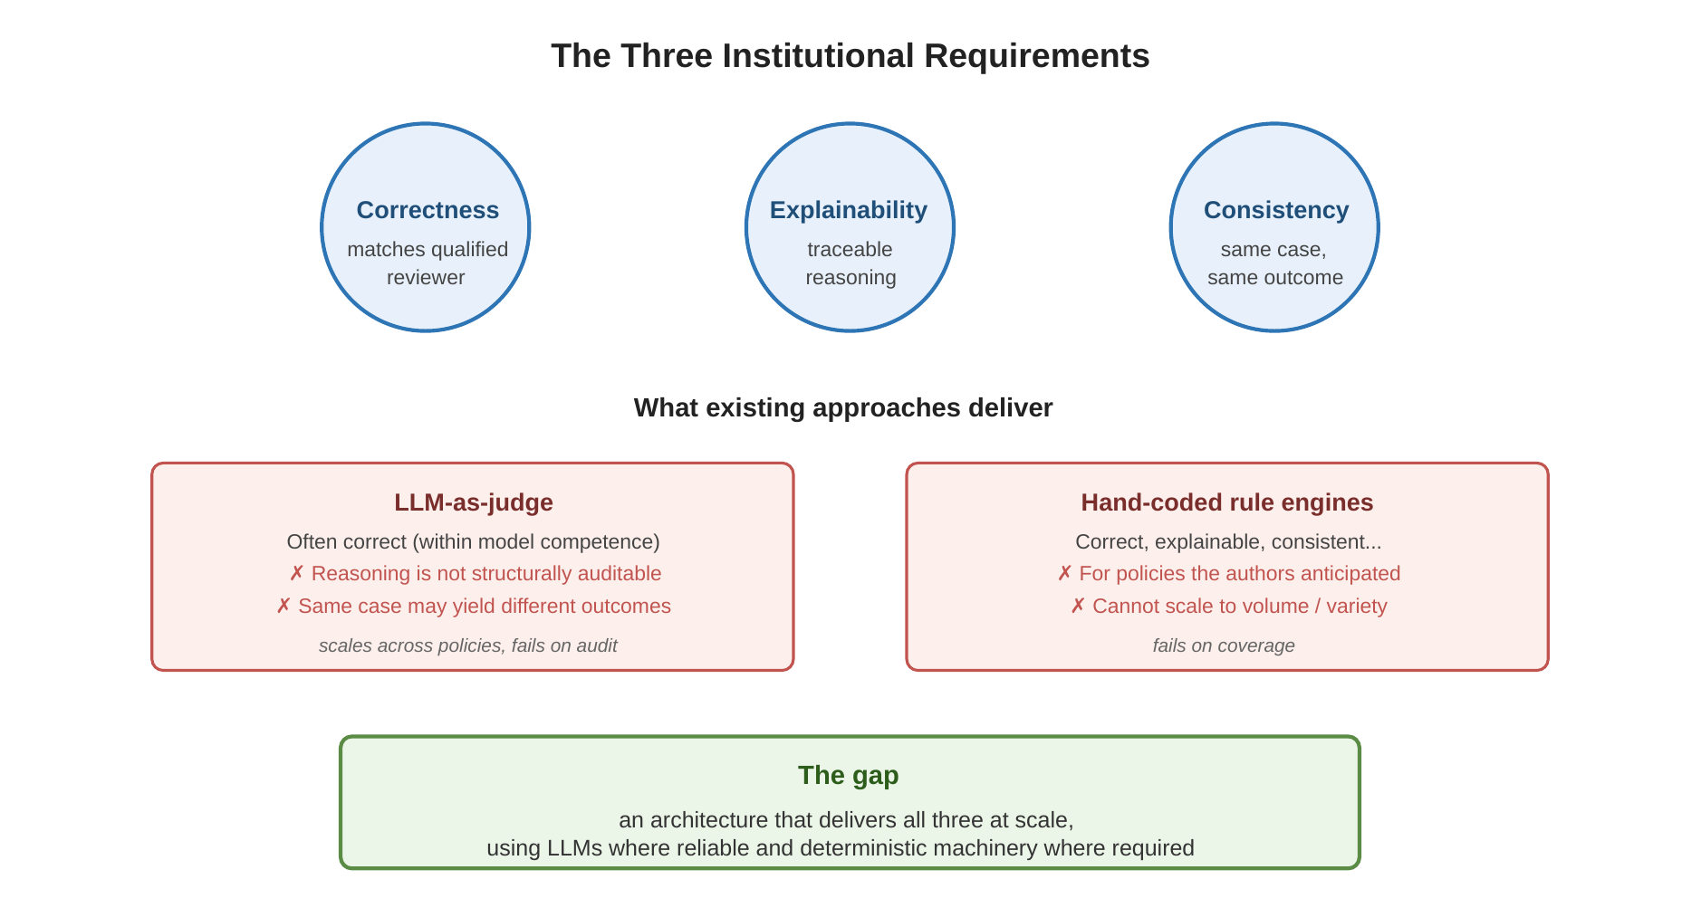
Figure 1. The three institutional requirements. Existing approaches deliver some but not all.

The Proposal
The core proposal is to separate the policy from the case, and to separate the LLM’s role from the logic engine’s role.
A policy is a slow-changing artifact. It is published once, perhaps amended occasionally. Its meaning is institutional: the institution reads it the same way across all cases. Adjudication of any specific case applies the policy’s fixed reasoning structure to that case’s specific facts.
The proposal:
For each policy plus an institutional declaration of what determinations the policy yields, build — once — a directed acyclic graph (DAG) of logical operators over atomic propositions. The DAG is the policy expressed as a formal logical model. The institution declares the determinations; the LLM extracts atoms and operators from the policy text; the DAG is the artifact.
For each case, map the case’s evidence to a fact bundle — an assignment of truth values (true, false, undetermined) to the DAG’s atoms. The mapping respects the evidence available: atoms the evidence supports become true, atoms the evidence contradicts become false, atoms the evidence does not address become undetermined.
Evaluate the DAG against the fact bundle using three-valued (Kleene) logic. The output is the determination the policy specifies for this case, paired with an evaluation trace.
This decomposes the problem into stages with different reliability requirements:
- The policy-to-DAG build is slow, expensive, audited, and version-controlled. It happens at policy-publication or policy-revision time. Errors here are identified and fixed by domain experts before the DAG is deployed.
- The evidence-to-fact-bundle mapping is per-case. It is the substrate that bridges the institution’s data systems to the DAG’s atoms. The mapping is deterministic given the same evidence, and its correctness is testable by comparing its output to a known-correct bundle.
- The fact-bundle-to-determination evaluation is purely logical. Same bundle, same DAG, same determination. The evaluation produces a trace showing exactly which atoms drove the outcome and which were irrelevant. The trace is auditable in the sense an institutional reviewer needs.
The LLM is doing what it does well: reading natural language text and identifying its logical structure. The engine is doing what it does well: deterministic three-valued evaluation. The institution is doing what only the institution can do: declaring what determinations the policy must yield.
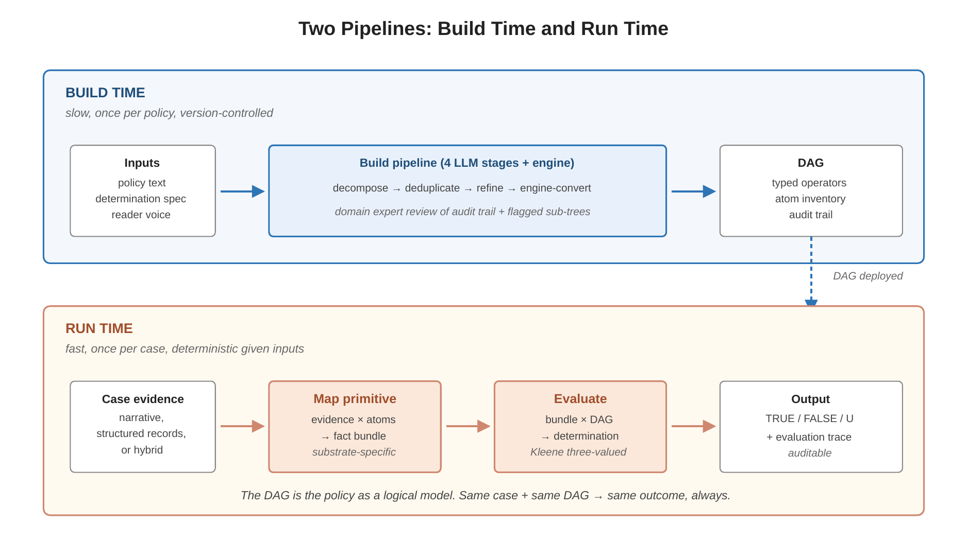
Figure 2. The two pipelines. Build runs once per policy; Map + Evaluate runs once per case.

The Design

Inputs and outputs
The build process takes three inputs:
- A policy text (a section of legal, regulatory, clinical, or administrative drafting; tens of paragraphs in length).
- A determination spec declared by the institution. A YAML or JSON document naming each determination the build must produce, its polarity (positive, negative, neutral), and its relationship to other determinations (for instance, denial as the structural complement of approval).
- A reader voice: a brief description of the role from which the policy should be read (an experienced medical reviewer, a credit-card dispute adjudicator). The voice scopes the LLM’s interpretation.
The build produces:
- A DAG: each node is either a leaf atom or a logical operator (AND, OR, NOT, AT-LEAST-N) over child nodes. Each declared determination corresponds to a root node. Sub-trees are shared across roots wherever the policy’s requirements overlap.
- An atom inventory: each atom has a stable identifier, a natural-language statement, and a source span citing the policy text.
- An audit trail: per-stage record of LLM calls, prompts, responses, and any refinement operations applied.

The build pipeline
The build runs four LLM-driven stages plus a deterministic engine-conversion stage.
Stage 1 — Decomposition.
For each declared determination, recursively decompose. Each LLM call takes one claim (the determination, or a sub-claim from an earlier step) and returns either a leaf node (the claim is atomic) or an internal node (the claim is composed of sub-claims joined by a named operator: AND, OR, NOT, or AT-LEAST-N). The recursion terminates when every leaf path reaches an atomic claim. Each LLM call is small: one claim in, one local decomposition out. The full tree emerges from the recursion; no single LLM call composes the whole tree.
Atomicity — what distinguishes a leaf from a composed claim — is specified by examples in the decomposition prompt. The examples teach two principles: the policy’s drafting structure tends toward decomposition; the evidence’s structure (claims that always co-evaluate from the same source) tends toward keeping together.
Stage 2 — Deduplication.
After decomposition produces a separate tree for each determination, a single LLM call identifies semantically equivalent atoms across all trees. Equivalence groups are assigned shared atom identifiers; the previously-separate trees now share nodes by reference. The output is a DAG, not a forest of trees. Shared atoms are the structural realization of policy-level overlap.
Stage 3 — Refinement.
Decomposition produces trees with predictable classes of redundancy: leaves that summarize what their siblings already decompose, sibling sub-trees that are functionally equivalent, low-confidence inferred sub-trees that may not reflect the policy. A single LLM call per determination identifies refinement operations (drop a child, merge equivalent children, flag a suspicious sub-tree for human review). Deterministic code applies the drop/merge operations and simplifies the resulting tree bottom-up.
Stage 4 — Engine conversion.
The refined DAG specs are converted to engine nodes (typed AND, OR, NOT, AT-LEAST-N nodes) ready for Kleene three-valued evaluation. Each engine node carries metadata: the source span from the policy, the surface label preserving the original drafting, the provenance (transcribed from the policy, structurally implied, inferred), and confidence levels for inferred nodes. The determination spec separates determinations that need their own DAG from determinations that are structural complements; the latter are handled deterministically as NOT-nodes around the linked determination’s tree.
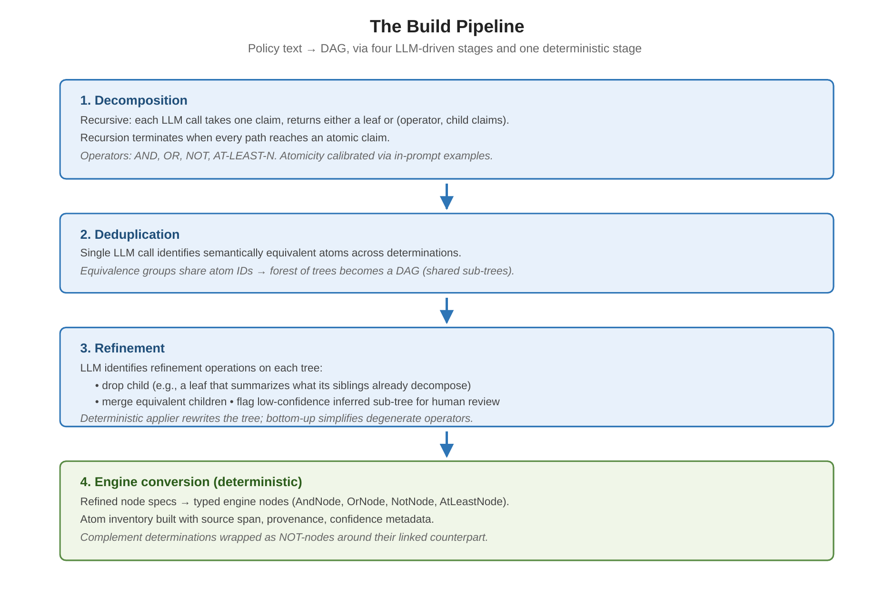
Figure 3. The build pipeline. Four LLM stages followed by deterministic engine conversion.

Run-time evaluation
The run-time pipeline is the Map primitive followed by the Evaluate primitive.
The Map primitive is the morphism from evidence space to fact-bundle space. Given a body of evidence and the DAG’s atom inventory, Map produces a fact bundle: each atom assigned a Kleene truth value.
Different evidence types call for different substrate implementations. A narrative substrate uses an LLM call to bind a case description against the atom inventory — for each atom, decide whether the description supports, contradicts, or fails to address the claim. A structured substrate uses lookups and predicates against the institution’s data systems. A hybrid substrate dispatches per atom type. The substrate is the architectural boundary between the institution’s evidence infrastructure and the DAG’s atomic vocabulary.
The Evaluate primitive takes a fact bundle and the DAG and produces a determination plus a trace. Three-valued Kleene logic governs the propagation: AND is true when all children are true, false when any child is false, otherwise undetermined; OR is the dual; NOT inverts polarity preserving undetermined; AT-LEAST-N is true when at least N children are true, false when fewer than N could ever be true, otherwise undetermined. The trace shows each operator’s result and each leaf’s value — the audit artifact an institutional reviewer can inspect.
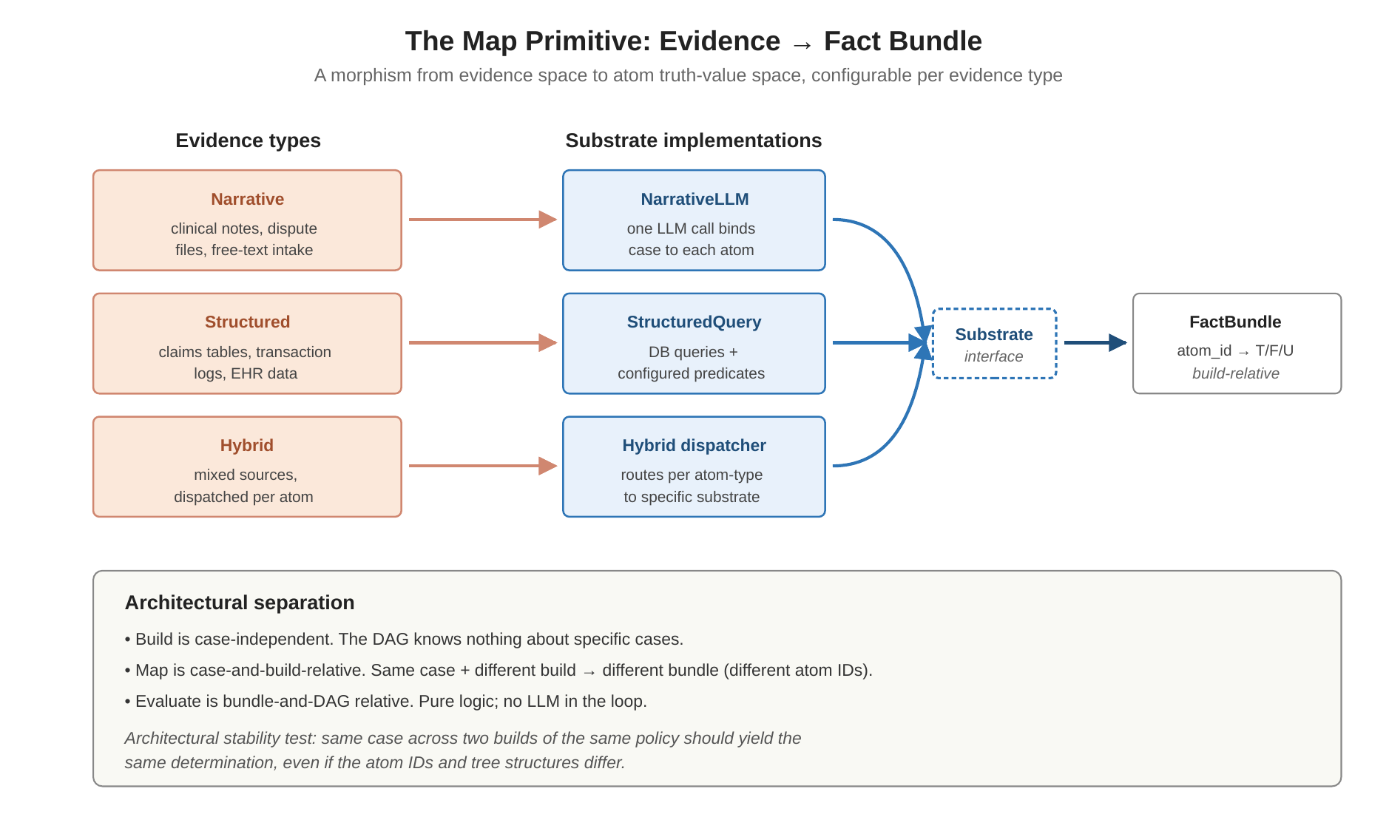
Figure 4. The Map primitive. Substrate implementations bridge evidence to atoms.

Testing
The architecture supports three test paths, each diagnosing a different class of failure:
Pure tree test.
A bundle authored against the DAG’s atoms (every atom assigned a concrete truth value) is run directly through the engine. If the resulting determination matches the case’s expected outcome, the tree is operationally correct for this scenario. If not, the tree has a structural bug; the trace identifies the offending sub-tree.
Map binding test.
A narrative case description is bound to a fact bundle by the Map primitive. The result is compared to a known-correct bundle. The comparison identifies which atoms Map bound incorrectly. The failure mode is a Map error, not a DAG error.
Sensitivity / degradation analysis.
Starting from a known-correct bundle, atoms are progressively dropped to undetermined. The determination’s outcome is tracked across the degradation. The output is a per-atom sensitivity report: which atoms are load-bearing (their undetermination shifts the outcome) versus robustness margin (their undetermination is absorbed). The cumulative degradation curve shows how the system handles increasing evidence sparsity.
These tests separate diagnostic concerns that a unified pass/fail metric would conflate. A failed pure-tree test indicts the DAG. A passed pure-tree test combined with a failed Map test indicts the Map. A passed Map test combined with a high load-bearing atom count indicts the case documentation rather than the system.

What the architecture commits to
The architecture commits to a specific division of labor:
- The institution declares determinations. The LLM does not invent determinations. The build produces exactly the determinations the institution names.
- The policy provides atoms, operators, and structure. The LLM extracts these from the policy text. The institution does not author atoms in advance; the policy specifies its own evidence vocabulary.
- The engine evaluates. The DAG is the policy’s logical model; the engine is a deterministic substrate over that model. Same bundle, same DAG, same outcome — always.
- The substrate is configurable per evidence type. Narrative evidence uses LLM-driven binding; structured evidence uses lookups; institutions with hybrid evidence dispatch per atom type. The substrate interface is small and stable.

A Worked Result: PA Standard Approval
The architecture has been exercised end-to-end on a prior-authorization clinical guideline (cervical spinal surgery, Section 2 medical-necessity criteria). The build pipeline produced a DAG of 55 atoms across two determinations (approval and its structural complement, denial). The refinement stage applied six operations (dropping redundant summary atoms and merging duplicate sibling sub-trees) and raised four flags for human review (including a medium-severity flag on an inferred "second qualifying agent" construct).
For a standard-approval scenario — radiculopathy at C5-C6 with full conservative treatment and complete physician documentation — the narrative case description was bound to a fact bundle via the Map primitive. The bundle, evaluated through the DAG, produced the expected determination: approval TRUE, denial FALSE.
Sensitivity analysis on this bundle revealed structure worth reporting.
Twenty atoms are load-bearing.
Dropping any one of these twenty atoms to undetermined shifts the determination from TRUE to UNDETERMINED. They map precisely to the policy’s required elements for the standard pathway: nerve root compression with imaging correlation; MRI within six months showing structural pathology at the proposed surgical level; six weeks of supervised physical therapy with documented outcomes directed at the cervical condition; at least two pharmacotherapy classes (NSAID, neuropathic agent) each trialed for at least four weeks; one interventional treatment (cervical epidural steroid injection); and the four physician-documentation atoms (attestation of conservative treatment, clinical rationale, functional limitations, risks and alternatives statement).
Thirty-five atoms are non-load-bearing.
Dropping any one of these does not shift the determination. They fall into three robustness categories: atoms about the unused alternative pathway (myelopathy exception); alternative atoms within satisfied disjunctions (the CT myelogram branch is unused because the case used MRI); and OR-redundant evidence within a category (any one of pain, numbness, or weakness suffices to satisfy "radicular symptom present").
The cumulative degradation curve has a sharp inflection.
Atoms dropped in non-load-bearing-first order leave the determination at TRUE through steps 1 and 2 (the first two radicular-symptom atoms — pain and numbness — can both be lost while weakness remains, and the OR over the three symptoms is still satisfied). At step 3, when the third radicular-symptom atom is dropped, the OR can no longer evaluate TRUE, the qualifying-diagnosis branch collapses to UNDETERMINED, and the determination follows. From step 3 onward the determination remains UNDETERMINED through the remaining 52 drops.
This is the kind of structural diagnostic the architecture exists to support. The load-bearing set is interpretable to a domain reviewer; the robustness margin is identifiable; the inflection point is explained by a specific OR in the tree. A medical reviewer can audit the build by inspecting the load-bearing set against the policy’s requirements: the twenty atoms map to the requirements one expects, in the structure one expects.
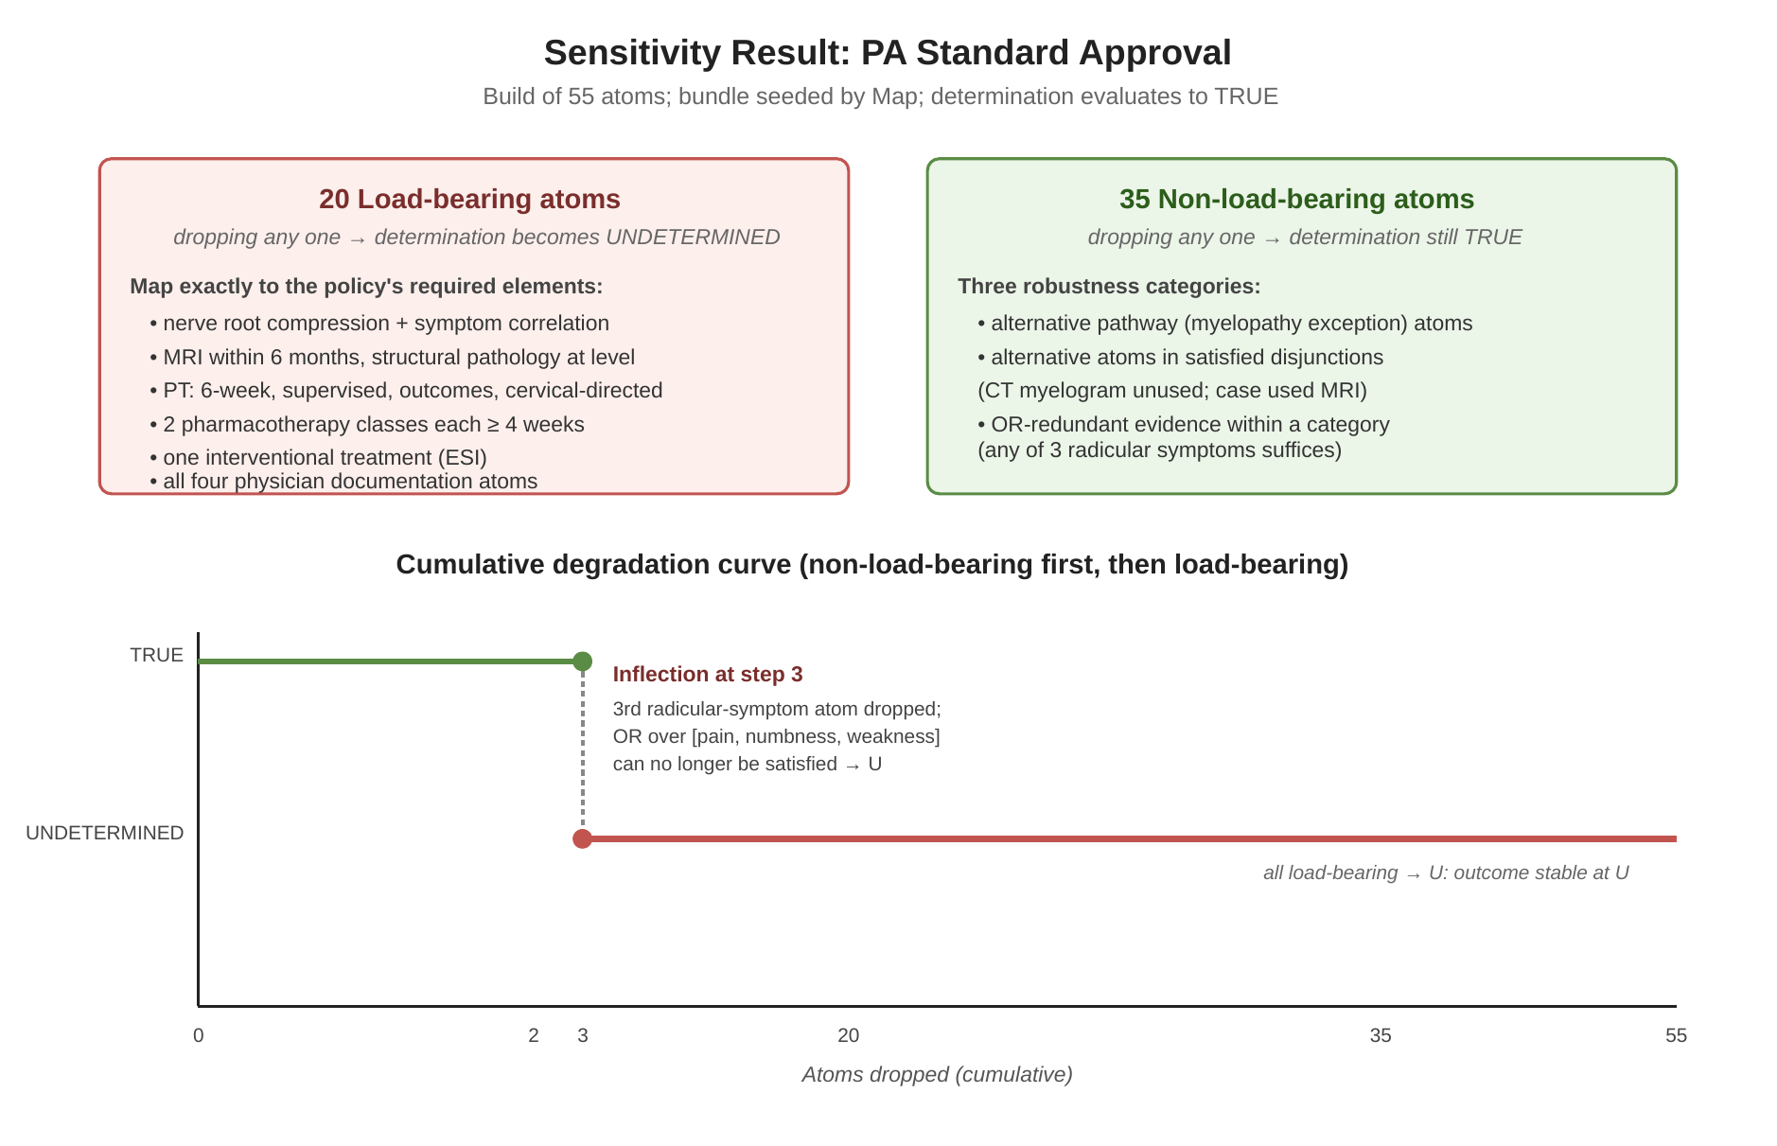
Figure 5. Sensitivity result on PA standard approval. Load-bearing atoms map to policy-required elements; the degradation curve has a sharp inflection at the third radicular-symptom drop.

Current State and Remaining Work
The architecture has been implemented end-to-end. The pipeline runs from a YAML determination spec plus a policy text through the four build stages to a usable DAG, and from a case description plus the DAG through Map + Evaluate to a determination with a trace. Worked policies include the prior-authorization clinical guideline section analyzed above and a federal regulation on credit-card billing errors. Test bundles produce expected determinations on standard, exception, denial, and partial-evidence scenarios.
Remaining work has three substantial dimensions.
Substrate implementations beyond the narrative-LLM baseline.
Real institutional deployments will have structured evidence sources — clinical records, transaction databases, claims systems. A structured substrate that binds atoms to database queries is the next major implementation milestone. The hybrid case follows.
Cross-build validation.
Building the same policy twice and comparing the resulting DAGs surfaces compositional variance the LLM introduces across runs. A cross-validation stage that runs two independent decompositions and diffs them would catch errors that a single build misses.
The Realize primitive.
Beyond producing a determination, an adjudication system should support counterfactual reasoning (what change in evidence would have produced a different determination?), margin analysis (how close was the determination to the opposite outcome?), and binding-constraint identification (which atoms determined the outcome?). The existing trace machinery supports it; the primitive itself is unimplemented.
The architecture is not finished. What is finished is enough to demonstrate that the gap can be bridged: an LLM-assisted policy-to-DAG build pipeline produces auditable, evaluable logical models; the Map primitive bridges evidence to those models; the engine produces explainable determinations under three-valued logic; and the sensitivity tooling exposes structure a reviewer can interpret. The remaining work is engineering depth, not architectural reconception.

A Note on Position
The work reflects a specific position on how LLMs should be integrated into institutional reasoning systems. The position has three commitments.
The LLM is a constrained extractor, not an oracle. It reads natural language and produces structured artifacts within a declared specification. It does not adjudicate.
Institutional knowledge is declarative. Determinations, atom typologies where required, evidence-binding contracts — these are written by the institution and version-controlled alongside the policy. The system does not infer them.
Auditability is non-negotiable. Every determination the system produces must come with a trace a human reviewer can inspect, follow, and challenge. A determination without a trace is not an adjudication; it is an opinion.
The architecture is designed to honor these commitments. Variations of the implementation can be evaluated against them: does this stage preserve auditability? does this primitive over-extend the LLM’s role? does this default infringe on what the institution should declare? The commitments are the test.

