Performance Comparison of Different Machine Learning Classifiers for Diabetes Prediction
Dipayan Ghosh¹, Abhik Ganguly¹, Rounak Chakraborty¹, Pawan Kumar Singh^{1,*[0000-0002-9598-7981]}, Aimin Li^{2 [0000-0002-6983-2310]}

¹Department of Information Technology, Jadavpur University,
Jadavpur University Second Campus, Plot No. 8, Salt Lake Bypass, LB Block, Sector III, Salt Lake City, Kolkata-700106, West Bengal, India
²School of Computer Science and Engineering, Xi'an University of Technology, Xi'an, Shaanxi 710048, P.R China.

{ mail2dipayanghosh@gmail.com, abhik.g2002@gmail.com, rounak.chakraborty02@gmail.com, pawansingh.ju@gmail.com, liaiminmail@gmail.com}
*Corresponding author
Abstract. This paper presents a thorough evaluation of machine learning algorithms for assessing the risk of diabetes using the Pima Indian Diabetes dataset. In light of the global diabetes epidemic, timely and precise risk assessment is imperative. Our study involves an in-depth exploration of the data, uncovering a robust correlation between glucose levels and the likelihood of diabetes. We deploy a diverse set of six machine learning models, encompassing Logistic Regression, Decision Trees, Random Forests, AdaBoost, SVMs, K-Nearest Neighbors, Naive Bayes, XG Boost, and an Artificial Neural Network approach. The Logistic Regression method harnesses the inherent non-linear relationships within the data to enhance prediction accuracy. The results shed light on the strengths and weaknesses of each model, providing valuable insights for potential clinical applications. The Logistic Regression approach, in particular, showcases its ability to capture intricate patterns within the dataset, underscoring its effectiveness in diabetes risk assessment. These findings not only improve the accuracy of diabetes risk assessment but also establish a benchmark for future research in medical diagnosis. Identifying the most effective model assists healthcare practitioners in early intervention and tailored treatment strategies. This research advances the field of healthcare analytics, facilitating more informed decisions in diabetes prevention and management. The integration of a robust Logistic Regression approach broadens the scope of potential applications, marking a significant contribution to the field.
Keywords: Diabetes Prediction, Machine Learning, Classifier, Pima Indian Diabetes dataset.
- Introduction
Diabetes arises from metabolic issues that elevate blood sugar levels, posing a risk to various organs like the heart, blood vessels, and eyes. These adverse effects are directly linked to hyperglycemia, where the body struggles to control blood sugar levels or efficiently use its produced insulin, contributing to the onset of diabetes. A considerable risk exists among adults, with approximately 40% remaining undiagnosed, and a striking 90% of these cases concentrated in middle-income countries. Global spending on diabetes-related healthcare is expected to reach USD 966 billion in 2021, marking a significant 316% increase from the previous decade. Glucose intolerance affects a staggering 541 million adults worldwide [1].

Artificial intelligence (AI), particularly Machine Learning (ML) supervised learning models, proves indispensable in identifying and managing diabetes as a chronic disease. ML models leverage information from a person’s medical history and other risk factors [2], along with their genetic makeup [3], serving as effective predictors of diabetes development. These models extend their utility to analyzing medical images, such as CT scans and retinal scans, enabling the early detection of diabetes and related diseases. ML, at the intersection of computer science and statistics, emerges as a novel discipline addressing problems with breakthroughs that detect and classify gaps in patient care [4]. The primary goal of these ML models is to enhance the quality of patient care and reduce medical costs [5], contributing to identifying risk factors responsible for diabetes development from clinical data and predicting pre-diabetes.

This paper presents a comprehensive comparative analysis of various machine learning classifiers applied to diabetes risk assessment, utilizing the renowned Pima Indian Diabetes dataset [6]. With its inclusion of key clinical and demographic features, this dataset proves to be an ideal resource for training and evaluating predictive models. The study meticulously evaluates the performance of diverse classifiers, including Logistic Regression, Decision Tree, Random Forest, Gradient Boosting, AdaBoost, Support Vector Machine, K-Nearest Neighbor (KNN), Naive Bayes, XG Boost, and Artificial Neural Network (ANN). Each classifier undergoes a rigorous evaluation in terms of accuracy and classification metrics, offering a holistic understanding of their suitability for diabetes risk prediction.

The outcomes of this analysis not only advance our understanding of diabetes risk assessment but also guide healthcare practitioners in selecting the most effective model for early intervention and personalized treatment. Moreover, this research holds far-reaching implications for the application of machine learning in healthcare analytics, enriching the field's knowledge base and fostering improved patient care and public health strategies.
- Literature Review
The literature pertaining to diabetes risk assessment and predictive modeling emphasizes the crucial role of early and precise detection in addressing this global health epidemic. Numerous studies have utilized machine learning (ML) techniques for diabetes detection, often leveraging the Pima Indian dataset, which comprises 9 features and 768 patient records [7]. For example, in [8], Rajni et al. implemented an ML model with cross-validation to predict diabetes, employing four ML models, including their proposed RB-Bayes algorithm. The RB-Bayes classifier outperformed others with a cross-validation metric of 0.7219, while Naïve Bayes exhibited the lowest performance at 67.71%.

In [9], a novel hierarchical approach was proposed, combining Decision Tree (ID3), Logistic Regression, Support Vector Machine (SVM) with an RBF Kernel, Random Forest, and Neural Networks. The model achieved a cross-validation accuracy of 83.08%. Similarly, Sofia et al. [10] suggested a random forest-based ML model for early prediction of diabetes mellitus, achieving an accuracy of 0.79 through various tests by modifying the number of trees. In [11], a retrospective study employing an ML algorithm predicted diabetes within 5 years after diagnosis, reaching an accuracy rate of 82%.

Moreover, the study in [12] conducted a comparative analysis with different classifiers, including Decision Tree, KNN, and Random Forest classifiers. The accuracies obtained were 0.7607, 0.7878, and 0.798, respectively, indicating that the Random Forest model exhibited the best performance in that study. In [13], authors developed a method to classify diabetes using a Gaussian process (GP)-based classification technique, achieving an accuracy of 81.97%. In [14], Dutta et al. proposed an automated knowledge model for identifying diabetes, training two types of neural networks: Deep Learning (DL) and Convolutional Neural Network (CNN). The DL networks did not achieve the expected accuracy rates due to the hidden layer, whereas CNNs significantly improved accuracy by more precisely quantifying the characteristics of different classes.

3 Data Pre-processing

The dataset used in this research, commonly known as the “Pima Indian Diabetes” dataset, comprises several features such as Glucose levels, Blood Pressure, BMI, and Age. The correlation of these features extracted from Pima Indian Diabetes dataset are plotted using scatter plots, as shown in Fig. 1. In the data pre-processing phase, these features are subjected to meticulous handling. The column names are renamed to ensure clarity and consistency in reporting. This step ensures that the dataset is primed for analysis.

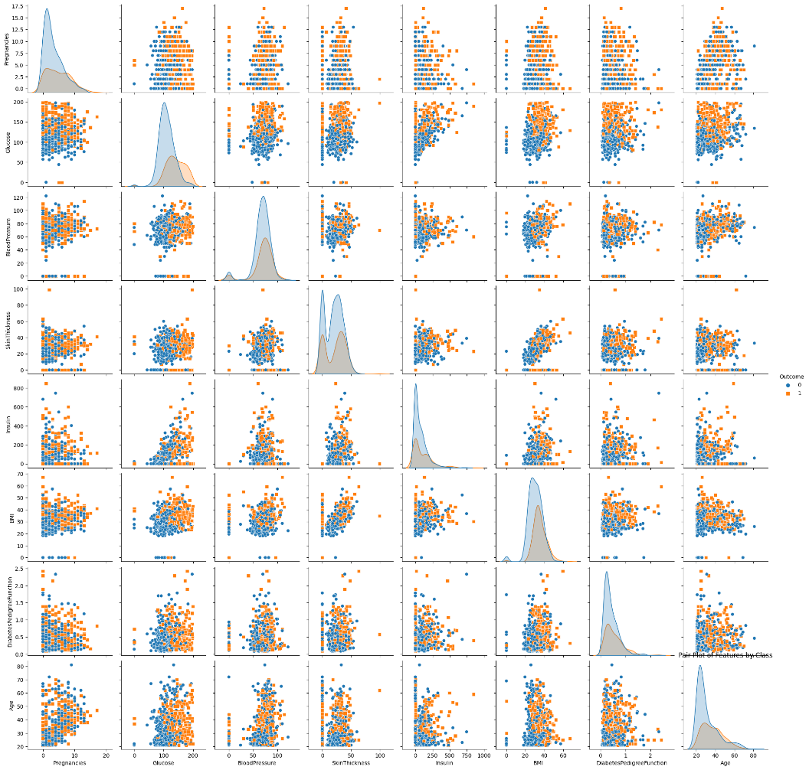

Fig. 1. Correlation of variables using scatter plots measured on Pima Indian Diabetes dataset.
To gain insights into the dataset's characteristics, exploratory data analysis (EDA) is performed. EDA involved data visualization techniques to uncover patterns and distributions. Box plots are used to detect potential outliers, while pair plots offered a holistic view of feature relationships. Fig. 2 shows the box plot visualization of both diabetic and non-diabetic people found in PIMA Indian Diabetes dataset. Additionally, a correlation heatmap, employed to assess the degree of association between variables, is shown in Fig. 3.

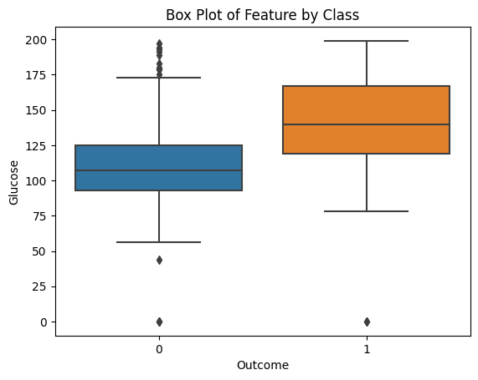

Fig. 2. Box-plot visualization of diabetic and non-diabetic people found in PIMA Indian Diabetes dataset.
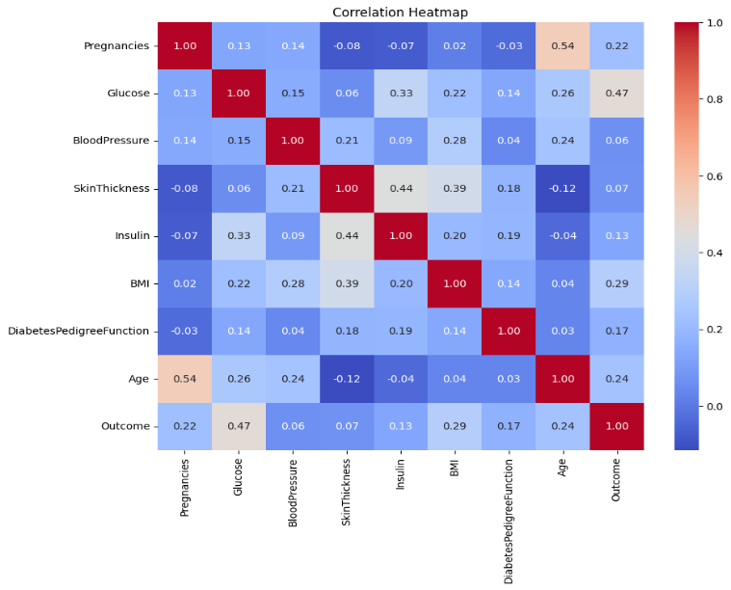
Fig. 3. Correlation matrix of variables in the Pima Indian Diabetes dataset.
A diabetes prediction heatmap is a powerful tool in the field of healthcare and data analysis. It is often used in predictive modeling to visualize the probability of an individual developing diabetes based on a combination of various risk factors and medical indicators. Here is an explanation of what a diabetes prediction heatmap is and how it is used. To create a diabetes prediction heatmap, a dataset is typically collected, which includes information about individuals such as age, gender, family history of diabetes, body mass index (BMI), glucose levels, blood pressure, insulin levels, and other relevant health-related attributes. The dataset usually also includes a binary outcome variable, where '1' indicates the presence of diabetes, and '0' indicates the absence. Machine learning algorithms are applied to the dataset to develop a predictive model for diabetes. These models can be classification algorithms, like logistic regression, decision trees, or more advanced techniques such as neural networks. The model is trained on historical data to learn patterns and relationships between the input features and the diabetes outcome. Once the model is trained, it can predict the probability of an individual having diabetes based on their specific feature values. This probability represents the likelihood of the individual developing diabetes. The heatmap is created to visually represent these probabilities. In this heatmap, rows represent individual cases or patients, and columns represent the different risk factors or features. Each cell in the heatmap is color-coded to indicate the predicted probability for that individual. Typically, warmer colors (e.g., red or orange) represent a higher probability of diabetes, while cooler colors (e.g., blue or green) indicate a lower probability. A healthcare professional or data analyst can interpret the diabetes prediction heatmap to identify high-risk individuals. By looking at the heatmap, they can quickly spot cases with a high probability of developing diabetes, which may require further medical attention or intervention. Diabetes prediction heatmaps can be used as a decision support tool for healthcare providers. They help in identifying individuals who may benefit from early preventive measures, lifestyle changes, or more frequent monitoring to manage their risk of diabetes. It is essential to validate the predictive model and the heatmap's accuracy and reliability to ensure that the predictions are trustworthy and actionable. Diabetes prediction heatmaps are valuable in personalized medicine and population health management. They provide a visually intuitive way to assess diabetes risk on an individual level and can be a critical component of early detection and prevention efforts in healthcare. However, it is important to remember that these predictions are based on statistical models and should not replace clinical diagnosis and medical consultation.

4 Methodology

  - Machine Learning Approaches

The study harnessed a diverse array of ML classifiers, including Logistic Regression, Decision Tree, Random Forest, AdaBoost, Support Vector Machine (SVM), K-Nearest Neighbors, Naive Bayes, XG Boost and ANN. The rationale behind selecting these classifiers varied from the interpretability of decision trees to the ensemble learning capabilities of Random Forest and Gradient Boosting.
For model training and evaluation, the dataset is partitioned into training and testing sets, enabling rigorous assessment of classifier performance. Feature scaling is executed using the Standard Scaler to standardize the features, aligning them with a mean of 0 and a standard deviation of 1. This normalization step optimizes the learning process.
4.1.1 Logistic Regression.
Logistic Regression (LR) serves as a widely employed machine learning model tasked with forecasting the likelihood of an event based on predictor variables, typically binary outcomes like yes/no, true/false, or success/failure [15]. The model utilizes a sigmoid function to gauge the probability of a dependent variable assuming a specific value. As outlined in Ref. [15], the sigmoid function is expressed mathematically as:
$logit(p)=log(p/(1−p)) = β+β1x1+β2x2+…. βpxp$ (1)
LR, being a statistical model, employs the logit function, as shown in Equation (2)
$f\left(x\right)=\frac{1}{1+ⅇ^{−x}}$ (2)
For our investigation, LR implementation has been executed using the Scikit-learn library in the Python programming language. A comprehensive preprocessing of the Pima Indian Diabetes dataset was conducted, involving tasks such as column renaming and feature scaling. Following the data division into training and testing sets, the LR model was trained. The evaluation metrics, including accuracy, precision, recall, and F1-score, were subsequently examined through the generation of a classification report and confusion matrix
4.1.2 Decision Tree. The Decision Tree model is a machine learning (ML) technique employed in predictive analysis [16]. The application of this model involves a series of steps. Firstly, the algorithm identifies the attribute that most effectively divides the data into two distinct groups. Once this attribute is determined by calculating information gain , the dataset is then split into two subsets based on the values of that chosen attribute. This process is iteratively repeated for each subset until a specific level of consistency is achieved.

4.1.3 Bernoulli Naïve Bayes (BNB). The Bernoulli Naive Bayes (BNB) model serves as a classification algorithm in the domain of machine learning, particularly adept at handling features treated as independent binary variables [17]. Its primary application lies in text analysis, where it excels in categorizing items into different classes. The model is trained on discrete data, specifically featuring binary-formatted features. In the training phase, the model computes the probability of each feature within each class. These probabilities are then utilized to predict the class of a new observation. The underlying probability distribution for the Bernoulli Naive Bayes model is encapsulated in Equation (3)

$P\left[X=x\right]=P^{x}{\left(1−P\right)}^{1−x} x=0;x=1$ (3)

4.1.4 Support Vector Machine (SVM). The SVM (Support Vector Machine) model stands out as an algorithm applied to address both classification and regression challenges [18]. Its core objective involves identifying the hyperplane that optimally maximizes the separation between the two closest classes and the distances among samples. In scenarios involving two classes or two dimensions, the hyperplane is mathematically expressed through Equation (4)
$β0+β1x1+β2x2+…. βpxp=0$ (4)
4.1.5 K-Nearest Neighbors (KNN). The K-NN (K-Nearest Neighbors) model is a versatile tool in machine learning, applicable to both classification and regression problems [19]. In the context of classification, the model assesses the distance between a sample and all other samples in the dataset to determine its proximity to the sample requiring classification. By considering the K nearest samples, the model assigns the appropriate class or numerical value to the target sample. Various distance metrics are employed to quantify the closeness between samples, offering flexibility for model optimization by adjusting the value of K. The distance metrics are presented in Equations (5) to (7).

$Euclidian distance d\left(x,y\right)=\sqrt{\sum_{i=1}^{n}{{\left(y_{i}−x_{i}\right)}^{2}}}$ (5)
$Manhattan distance d\left(x,y\right)=\left(\sum_{i=1}^{n}{\left|x_{i}−y_{i}\right|}\right)$ (6)
${ Minkowski distance d\left(x,y\right)=\left(\sum_{i=1}^{n}{\left|x_{i}−y_{i}\right|}\right)}^{1/P}$ (7)

4.1.6 Random Forest. The Random Forest implementation in our project leveraged the scikit-learn library in Python [20]. We conducted a thorough preprocessing of the Pima Indian Diabetes dataset to ensure data consistency. The dataset was then split into training and testing subsets, facilitating the training and evaluation of the Random Forest model. We assessed the predictive prowess of Random Forest through accuracy metrics and an extensive classification report. This evaluation highlights the model's adeptness in handling intricate relationships within the data. Noteworthy features of Random Forest, such as its resilience against overfitting and exceptional performance, contribute to its significance in assessing diabetes risk. This, in turn, supports early intervention and informed healthcare decision-making, ultimately leading to improved patient outcomes.

4.1.7 AdaBoost. AdaBoost, a technique in ensemble learning, shows great potential in the field of diabetes risk assessment. It has garnered attention for its effectiveness in enhancing model performance by combining weak learners to form a robust and accurate predictor [21].
In the context of predicting diabetes, AdaBoost constructs a sequence of weak classifiers. Each classifier is trained iteratively, with a focus on samples that were misclassified by the preceding classifiers. This adaptive approach prioritizes challenging data points, contributing to the continuous refinement of the model's predictive abilities.

4.1.8 XG Boost. XG Boost, an advanced gradient boosting algorithm, plays a leading role in diabetes risk assessment by providing outstanding predictive accuracy and versatility [22]. Its utilization in medical diagnostics, particularly in the context of predicting diabetes, has attracted attention owing to its robust nature and superior performance.

4.1.9 Artificial Neural Network (ANN). The Artificial Neural Network (ANN) is a computational model inspired by the structure and functioning of the human brain [23]. It consists of interconnected nodes, known as neurons, organized into layers, with each layer contributing to the overall information processing. Through iterative learning, ANNs demonstrate the ability to discern intricate patterns, rendering them powerful tools for tasks such as classification and regression in machine learning

  - Model Training and Evaluation
The core of this research revolves around model training and evaluation. Each classifier underwent rigorous training using the training dataset. Subsequently, predictions are made on the testing dataset. The accuracy metric served as the primary performance indicator, but classification reports are also generated. The classification reports presented metrics such as precision, recall, and F1-score for each class (‘0’ for non-diabetic and ‘1’ for diabetic), offering a comprehensive assessment of classifier performance.
The results unveiled a notable variation in classifier performance. Logistic Regression emerged as the top-performing model with an accuracy of 0.84. The model showcased a well-balanced trade-off between precision and recall, making it particularly suited for early diabetes detection.
    - User Input for Diabetes Prediction
In the real-world application of diabetes prediction, users may provide their health parameters for assessment. To simulate this scenario, user input data is standardized using the same scaler as the training data. Predictions are then generated for the user input data using each of the trained classifiers. The most common prediction among the classifiers is determined to classify the user as diabetic or non-diabetic.

4.3 Results
The primary objective of this study is to evaluate the performance of multiple machine learning classifiers in the context of diabetes prediction. The following section presents the results of the analysis, shedding light on the accuracy, precision, recall, and F1-score of each classifier. Fig. 4 illustrates the comparison of accuracies outputted by different machine learning algorithms on Pima Indian Diabetes dataset.
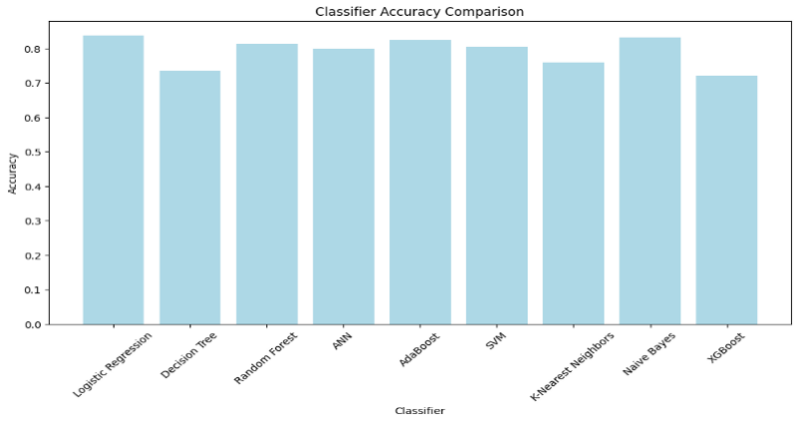
Fig. 4. Accuracies produced by different ML algorithms on Pima Indian Diabetes dataset.
In our analysis of various ML classifiers for diabetes prediction, the Logistic Regression emerged as the top-performing model with an accuracy of 0.8377, showcasing its suitability for this task. For class ‘0’ (non-diabetic individuals), it demonstrated a precision of 0.83, a high recall of 0.94, and an F1-score of 0.88. For class ‘1’ (diabetic individuals), the Logistic Regression exhibited a precision of 0.85, a recall of 0.65, and an F1-score of 0.74. The Decision Tree classifier exhibited moderate performance with an accuracy of 0.7208. For class ‘0’, it had a precision of 0.77, a recall of 0.82, and an F1-score of 0.79, while for class ‘1’, it showed a precision of 0.62, a recall of 0.54, and an F1-score of 0.57. The Random Forest, with an accuracy of 0.8182, positioned itself as a promising classifier. For class ‘0’, it had a precision of 0.82, a recall of 0.93, and an F1-score of 0.87. For class ‘1’, Random Forest demonstrated a precision of 0.82, a recall of 0.61, and an F1-score of 0.70.The ANN classifier achieved competitive performance with an accuracy of 0.7857. The Class ‘0’ exhibited a precision of 0.80, a recall of 0.90, and an F1-score of 0.85, while for class ‘1’, it showed a precision of 0.76, a recall of 0.57, and an F1-score of 0.65. The AdaBoost classifier yielded an accuracy of 0.8247, positioning it as a strong contender. For class ‘0’, it had a precision of 0.84, a recall of 0.90, and an F1-score of 0.87. For class ‘1’, AdaBoost demonstrated a precision of 0.79, a recall of 0.69, and an F1-score of 0.73. The SVM classifier displayed competitive performance with an accuracy of 0.8052. For class ‘0’, it had a precision of 0.81, a recall of 0.91, and an F1-score of 0.86. For class ‘1’, the SVM classifier showed a precision of 0.79, a recall of 0.61, and an F1-score of 0.69. The KNN classifier achieved a moderate performance level with an accuracy of 0.7597. For class ‘0’, it had a precision of 0.79, a recall of 0.86, and an F1-score of 0.82. For class ‘1’, it demonstrated a precision of 0.69, a recall of 0.57, and an F1-score of 0.63. The BNB classifier showcased competitive performance with an accuracy of 0.8312. For class ‘0’, it had a precision of 0.86, a recall of 0.89, and an F1-score of 0.87. For class ‘1’, BNB classifier demonstrated a precision of 0.78, a recall of 0.72, and an F1-score of 0.75. XG Boost exhibited a moderate level of performance with an accuracy of 0.7208. For class ‘0’, it had a precision of 0.77, a recall of 0.82, and an F1-score of 0.79. For class ‘1’, the XG Boost classifier showed a precision of 0.62, a recall of 0.54, and an F1-score of 0.57. These results are given in Table 1 and provide valuable insights into the strengths and weaknesses of different classifiers for diabetes prediction, aiding in informed model selection for this critical healthcare application.

Table 1. Summarized performance of ML models on the Pima Indian Diabetes dataset.
Algorithm | Accuracy | Classification Report
Logistic  Regression | 0.8377
   | precision | recall | F1-score | support
  0 | 0.83 | 0.94 | 0.88 | 100
  1 | 0.85 | 0.65 | 0.74 | 54
  Accuracy |  |  | 0.84 | 154
  Macro average | 0.84 | 0.79 | 0.81 | 154
  Weighted average | 0.84 | 0.84 | 0.83 | 154
Decision Tree | 0.7208
   | precision | recall | F1-score | support
  0 | 0.77 | 0.82 | 0.79 | 100
  1 | 0.62 | 0.54 | 0.57 | 54
  Accuracy |  |  | 0.72 | 154
  Macro average | 0.69 | 0.68 | 0.68 | 154
  Weighted average | 0.71 | 0.72 | 0.72 | 154
Random  Forest | 0.8182
   | precision | recall | F1-score | support
  0 | 0.82 | 0.93 | 0.87 | 100
  1 | 0.82 | 0.61 | 0.70 | 54
  Accuracy |  |  | 0.81 | 154
  Macro average | 0.82 | 0.77 | 0.79 | 154
  Weighted average | 0.82 | 0.82 | 0.81 | 154
ANN | 0.7857
   | precision | recall | F1-score | support
  0 | 0.80 | 0.90 | 0.85 | 100
  1 | 0.76 | 0.57 | 0.65 | 54
  Accuracy |  |  | 0.79 | 154
  Macro average | 0.78 | 0.74 | 0.75 | 154
  Weighted average | 0.78 | 0.79 | 0.78 | 154
AdaBoost | 0.8247
   | precision | recall | F1-score | support
  0 | 0.84 | 0.90 | 0.87 | 100
  1 | 0.79 | 0.69 | 0.73 | 54
  Accuracy |  |  | 0.82 | 154
  Macro average | 0.81 | 0.79 | 0.80 | 154
  Weighted average | 0.82 | 0.82 | 0.82 | 154
SVM | 0.8052
   | precision | recall | F1-score | support
  0 | 0.81 | 0.91 | 0.86 | 100
  1 | 0.79 | 0.61 | 0.69 | 54
  Accuracy |  |  | 0.81 | 154
  Macro average | 0.80 | 0.76 | 0.77 | 154
  Weighted average | 0.80 | 0.81 | 0.80 | 154
KNN | 0.7597
   | precision | recall | F1-score | support
  0 | 0.79 | 0.86 | 0.82 | 100
  1 | 0.69 | 0.57 | 0.63 | 54
  Accuracy |  |  | 0.76 | 154
  Macro average | 0.74 | 0.72 | 0.72 | 154
  Weighted average | 0.75 | 0.76 | 0.75 | 154
BNB | 0.8312
   | precision | recall | F1-score | support
  0 | 0.86 | 0.89 | 0.87 | 100
  1 | 0.78 | 0.72 | 0.75 | 54
  Accuracy |  |  | 0.83 | 154
  Macro average | 0.82 | 0.81 | 0.81 | 154
  Weighted average | 0.83 | 0.83 | 0.83 | 154
XGBoost | 0.7208
   | precision | recall | F1-score | support
  0 | 0.77 | 0.82 | 0.79 | 100
  1 | 0.62 | 0.54 | 0.57 | 54
  Accuracy |  |  | 0.72 | 154
  Macro average | 0.69 | 0.68 | 0.68 | 154
  Weighted average | 0.71 | 0.72 | 0.72 | 154

In this study, a binary classification model is developed using a neural network architecture implemented in Python with the help of the Scikit-learn and TensorFlow libraries. The dataset is preprocessed using the Standard Scaler from Scikit-learn to standardize the features. This ensures that the data has zero mean and unit variance, which is a common preprocessing step for many machine learning algorithms.
The ANN model consists of three dense layers. The first layer has 64 units with the rectified linear unit (ReLU) activation function, which is a standard choice for hidden layers in neural networks. The input shape of the data is determined by the number of features in the training set. The second hidden layer contains 32 units also with ReLU activation. The final layer is a single unit with a sigmoid activation function, suitable for binary classification tasks.
The model is compiled using the Adam optimizer and binary cross-entropy loss function, which is appropriate for binary classification problems. The training process consisted of 75 epochs, with a batch size of 27, and a validation split of 20% to monitor the model's performance. After training, the model is evaluated on a separate test set, yielding an accuracy of 81.17%. This result suggests that the model exhibits promising performance in classifying the data. The use of a neural network in this context demonstrates its potential as a powerful tool for binary classification tasks.
The best-performing model in this study is Logistic Regression, with an accuracy of 0.84. It demonstrated a balanced trade-off between precision and recall, making it particularly well-suited for early diabetes detection.
These results underscore the potential of machine learning in diabetes prediction and emphasize the importance of selecting an appropriate classifier for the task. Logistic Regression's exceptional performance positions it as a leading candidate for early detection, with applications in public health and healthcare systems. Further research should focus on enhancing data quality and exploring advanced machine learning techniques to improve the accuracy of diabetes prediction models.
To gauge the classifiers' performance more comprehensively, Receiver Operating Characteristic (ROC) curves are utilized. These curves are instrumental in assessing a model's ability to discriminate between the classes. The Area Under the Curve (AUC) is calculated for each classifier, offering a numerical measure of its discriminative power. ROC curves also provide insights into the trade-off between true positive rate and false positive rate, aiding in the selection of suitable classifiers. Fig. 5 shows the ROC curves produced by applying different machine learning algorithms on the Pima Indian Diabetes dataset
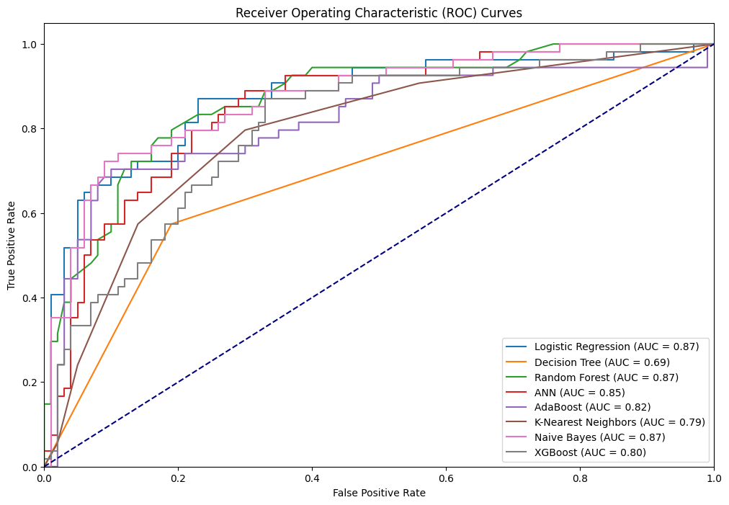
Fig. 5. ROC curves for different ML algorithms on the Pima Indian Diabetes dataset.
  - Discussion
The results obtained in this research illuminate the potential of machine learning in diabetes prediction, particularly for early detection. Logistic Regression emerged as the most promising model, with its balanced precision and recall. The implications of these findings for public health are substantial, as early detection can lead to timely intervention and improved outcomes for individuals at risk of diabetes.
However, it is important to acknowledge the study's limitations. Data quality remains a challenge, and further research efforts should focus on refining data sources and exploring advanced machine learning techniques to enhance prediction accuracy. Additionally, considerations for model interpretability and clinical relevance are paramount in the integration of these models into healthcare settings.
Table 2. Previous work on Pima Indian Diabetes dataset
Author | Year | Model | Accuracy
Rajni et al. | 2019 | RB-Bayes | 72.9
Mani et al. | 2020 | Ensemble of Decision Tree,  Logistic Regression and Neural Network | 83.08
Sofia et al. | 2019 | Random Forests | 79
Allen et al. | 2022 | Machine Learning Algorithm (MLA) | 82
Saxena et al. | 2022 | Random Forest | 79.8
Maniruzzaman et al. | 2017 | Gaussian process (GP) | 81.97

Table 3. Our work on Pima Indian Diabetes dataset
Classifier | Accuracy
Logistic Regression | 83.77
Decision Tree | 72.08
Random Forest | 81.82
ANN | 78.57
AdaBoost | 82.47
SVM | 80.52
KNN | 75.97
BNB | 83.12
XGBoost | 72.08

- Conclusion and Future work
In conclusion, this research sheds light on the potential of machine learning in diabetes prediction. The study highlights Logistic Regression as the most accurate model for this purpose, but other classifiers also exhibit promise. Early detection is a cornerstone of diabetes management, and machine learning models have the potential to make significant contributions to public health.
Looking forward, there is a need for continuous refinement of data quality and exploration of more advanced techniques. The integration of machine learning models into clinical practice holds the promise of proactive healthcare intervention, ultimately improving the lives of individuals at risk of diabetes.
Transitioning from conventional ML to the integration of deep learning with image processing represents a forward-looking and transformative step in diabetes prediction. While current machine learning models offer valuable insights based on structured data, embracing deep learning and image analysis introduces a new dimension of comprehensive health assessment. This forward-thinking approach enables the incorporation of visual information, such as retinal images and skin conditions, allowing for early detection of diabetic complications. By utilizing non-invasive glucose monitoring through image data, personalized nutritional assessments, and real-time telemedicine applications, the future of diabetes prediction holds the promise of enhanced accuracy and proactive healthcare management. As this innovative fusion of deep learning and image processing takes center stage, it not only aims to refine predictive capabilities but also seeks to redefine the way we understand and address the complexities of diabetes, ultimately improving the well-being of individuals living with the condition.

References
- PAHO PAHO/WHO|Pan American Health Organization. Available online: https://www.paho.org/en
- El-Attar, N.E.; Moustafa, B.M.; Awad, W.A. Deep Learning Model to Detect Diabetes Mellitus Based on DNA Sequence. Intell. Autom. Soft Comput. 2022, 31, 325–338.
- Mohamed, A.T.; Santhoshkumar, S. Deep Learning Based Process Analytics Model for Predicting Type 2 Diabetes Mellitus. Comput. Syst. Sci. Eng. 2022, 40, 191–205.
- American Diabetes Association. Classification and Diagnosis of Diabetes: Standards of Medical Care in Diabetes—2018. Diabetes Care 2018, 41, S13–S27.
- Thotad, P.N.; Bharamagoudar, G.R.; Anami, B.S. Diabetes Disease Detection and Classification on Indian Demographic and Health Survey Data Using Machine Learning Methods. Diabetes Metab. Syndr. Clin. Res. Rev. 2023, 17, 102690.
- https://www.kaggle.com/datasets/uciml/pima-indians-diabetes-database Accessed on 2023-08-05.
- Aggarwal, S.; Pandey, K. Early Identification of PCOS with Commonly Known Diseases: Obesity, Diabetes, High Blood Pressure and Heart Disease Using Machine Learning Techniques. Expert Syst. Appl. 2023, 217, 119532.
- Bagga, A .; Bhalla, R. RB Bayes algorithm for the prediction of diabetic in “Pima Indian dataset”.2019,9(6),6.
- Abedini, M.; Banirostam,T. ;Bijari, A.Classification of Pima Indian Diabetes Dataset using Ensemble of Decision Tree,Logistic Regression,Neural Network.2020, 9(7),4.
- Baghdad, A.; Benbelkacem, S.Random Forest for diabetes Diagnosis.2019,3.
- Allen, A.; Iqbal, Z.; Green-Saxena, A.; Hurtado, M.; Hoffman, J.; Mao, Q.; Das, R. Prediction of Diabetic Kidney Disease with Machine Learning Algorithms, upon the Initial Diagnosis of Type 2 Diabetes Mellitus. BMJ Open Diabetes Res. Care 2022, 10, e002560
- Saxena, R.; Sharma, S.K.; Gupta, M.; Sampada, G.C. A Novel Approach for Feature Selection and Classification of Diabetes Mellitus: Machine Learning Methods. Comput. Intell. Neurosci. 2022, 2022, 3820360.
- Maniruzzaman, M.; Kumar, N.; Menhazul Abedin, M.; Shaykhul Islam, M.; Suri, H.S.; El-Baz, A.S.; Suri, J.S. Comparative Approaches for Classification of Diabetes Mellitus Data: Machine Learning Paradigm. Comput. Methods Programs Biomed. 2017, 152, 23–34.
- Dutta, S.; S Manideep, B.C.; Basha, M.; Manideep, B.C.; Muzamil Basha, S.; Caytiles, R.D.; Ch N Iyengar, N.S. Classification of Diabetic Retinopathy Images by Using Deep Learning Models a Comparative Study of Deep Learning Models for Medical Image Classification View Project Bigdata Predictive Analytics View Project Classification of Diabetic Retinopathy Images by Using Deep Learning Models. Int. J. Grid Distrib. Comput. 2018, 11, 89–106
- Vasu, V.N.; Surendran, R.; Saravanan, M.S.; Madhusundar, N. Prediction of Defective Products Using Logistic Regression Algorithm against Linear Regression Algorithm for Better Accuracy. In Proceedings of the 2022 International Conference on Innovation and Intelligence for Informatics, Computing, and Technologies, 3ICT, Sakheer, Bahrain, 20–21 November 2022; pp. 161–166
- Abdelhalim, A.; Traore, I. A New Method for Learning Decision Trees from Rules. In Proceedings of the 8th International Conference on Machine Learning and Applications, ICMLA 2009, Miami, FL, USA, 20–21 November 2022; pp. 693–698
- Ye, F.; Chen, G.; Liu, Q.; Zhang, L.; Qi, Q.; Hu, B.; Fan, X. A Spam Classification Method Based on Naive Bayes. In Proceedings of the IEEE 6th Information Technology and Mechatronics Engineering Conference, ITOEC 2022, Chongqing, China, 4–6 March 2022; pp. 1856–1861.
- Tanveer, M.; Rajani, T.; Rastogi, R.; Shao, Y.H.; Ganaie, M.A. Comprehensive Review on Twin Support Vector Machines. Ann. Oper. Res. 2022, 3, 1–46.
- Fathabadi, A.; Seyedian, S.M.; Malekian, A. Comparison of Bayesian, k-Nearest Neighbor and Gaussian Process Regression Methods for Quantifying Uncertainty of Suspended Sediment Concentration Prediction. Sci. Total Environ. 2022, 818, 151760
- https://en.wikipedia.org/wiki/Random_forest
- https://scikit-learn.org/stable/modules/generated/sklearn.ensemble.AdaBoostClassifier.html
- https://scikit-learn.org/stable/modules/generated/sklearn.ensemble.GradientBoostingClassifier.html
- Ian, G., Yoshua, B., & Aaron, C. (2017). Deep learning: Adaptive computation and machine learning.

