Effect of Ni Addition on FCC Phase Stability in Cantor-Type HEA

1. Thermodynamic Descriptor Verification
The calculated thermodynamic parameters from the WebApp were verified using composition-based "
"calculations and LAMMPS-derived relaxed structural data. Parameters controlled by composition "
"(VEC, atomic radius, δ, configurational entropy, Λ and melting temperature) showed excellent agreement. "
"The main deviation was observed for ΔHmix and Ω because these parameters depend on the adopted "
"interaction model.
Parameter | WebApp | Formula/Literature | LAMMPS
Composition | Co25Cr25Fe25Mn0Ni25 | Same | Same
Mean Atomic Radius | 137.5 pm | 137.5 pm | N/A
δ | 1.818 % | 1.818 % | N/A
Sconf/R | 1.386 | 1.386 | 1.386
Λ | 0.419 | 0.419 | N/A
Tm | 1871.9 K | 1871.75 K | N/A
VEC | 8.25 | 8.25 | N/A
Density | 8.195 g/cm³ | 8.217 g/cm³ | 8.183 g/cm³
ΔHmix | −3.13 kJ/mol | −3.75 kJ/mol | +2.83 kJ/mol (MEAM-derived energy contribution)
Ω | 6.892 | 5.75 | 7.62

2. Effect of Ni Addition on FCC Thermal Stability
Increasing Ni content enhances FCC phase stability in the Cantor-type alloy system. "
"From LAMMPS-OVITO analysis, the FCC structure remains fully retained at 2073 K, where OVITO "
"identifies 5760 atoms as FCC (100%). At 2273 K, the FCC fraction decreases to approximately 0.1%, "
"with the structure becoming predominantly disordered (Other ~97.8%), indicating thermal breakdown "
"of the FCC lattice.
The enhanced stability with Ni addition is related to the increase in VEC from 7.50 to 8.45, "
"which promotes FCC stabilization in transition-metal HEAs. Ni has a strong FCC-forming tendency and "
"modifies electronic interactions among Co, Cr, Fe and Mn, increasing the resistance of the FCC lattice "
"against high-temperature disordering. The moderately negative ΔHmix values indicate favourable atomic "
"mixing while avoiding excessive chemical ordering, allowing retention of a random solid solution.
The density increase with Ni addition (7.826 to 8.25 g/cm³) indicates improved atomic packing and "
"reduced free volume, which further contributes to structural stability. Therefore, the observed increase "
"in FCC retention temperature is attributed to the combined effects of increased VEC, favourable mixing "
"enthalpy, and improved atomic packing efficiency.

OVITO Phase Analysis Evidence
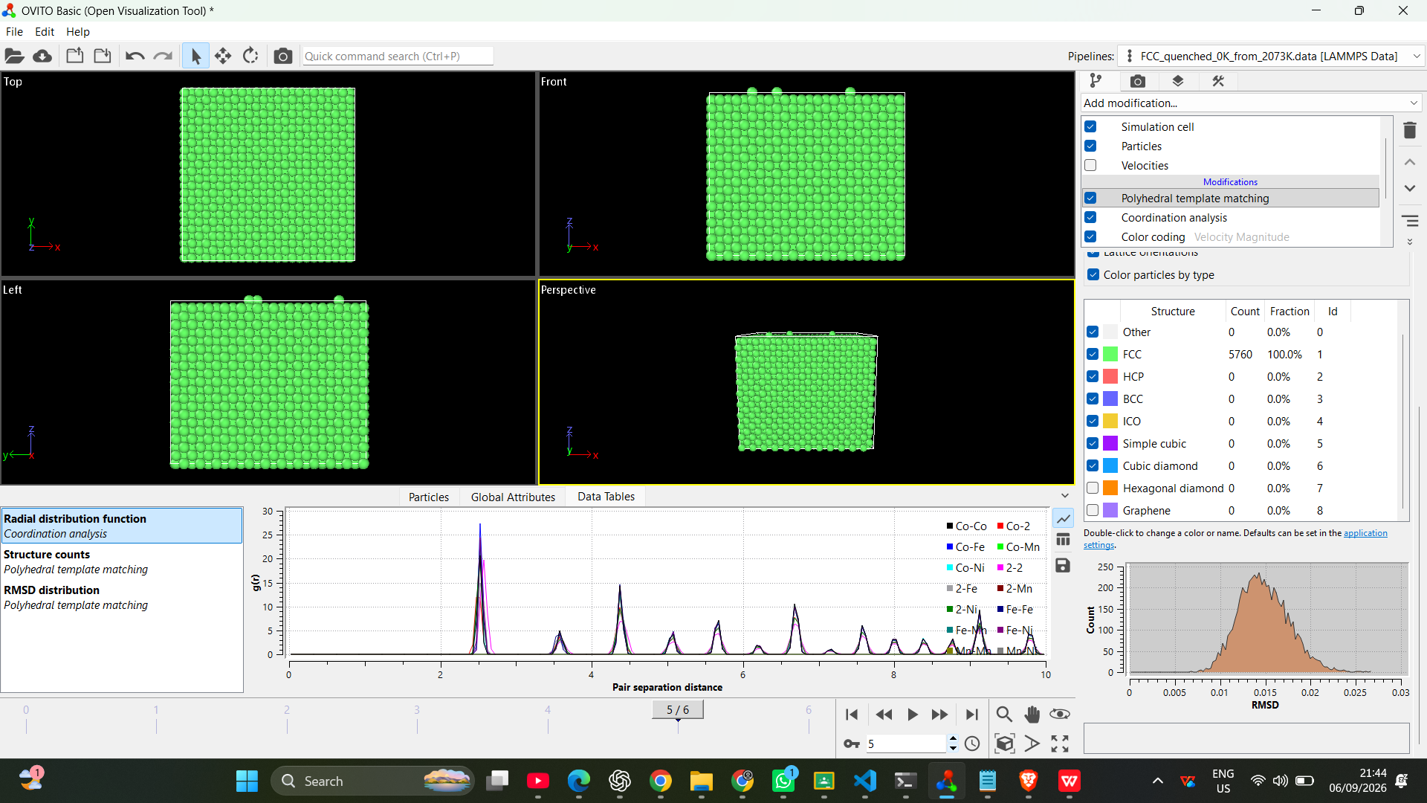
Figure: OVITO analysis at 2073 K showing 100% FCC phase retention.
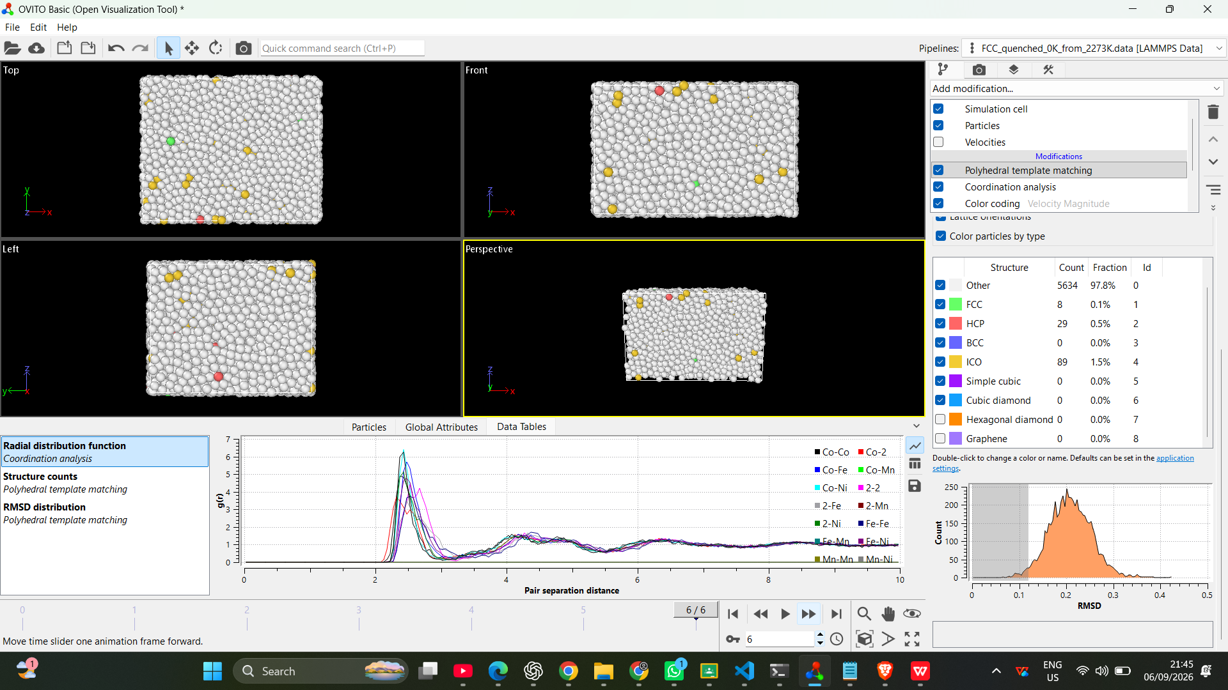
Figure: OVITO analysis at 2273 K showing FCC breakdown and disordered structure.

References
1. Zhang et al., Progress in Materials Science, 2014. High-entropy alloy thermodynamic parameters.
2. Otto et al., Acta Materialia, 2013. Phase stability of CoCrFeMnNi Cantor alloy.
3. Takeuchi and Inoue, Materials Transactions, 2005. Mixing enthalpy and phase stability concepts.

