LAMMPS-Based Verification of Machine Learning Prediction for Co25Cr25Fe25Mn25Ni0 High Entropy Alloy
The predicted thermodynamic descriptors obtained from the PHEA-ATLAS AI model were verified using atomistic simulation results from LAMMPS and standard composition-based thermodynamic equations. The comparison demonstrates the agreement between machine learning prediction and physics-based validation.

Figure 1. Relaxed Atomic Structure at 0 K
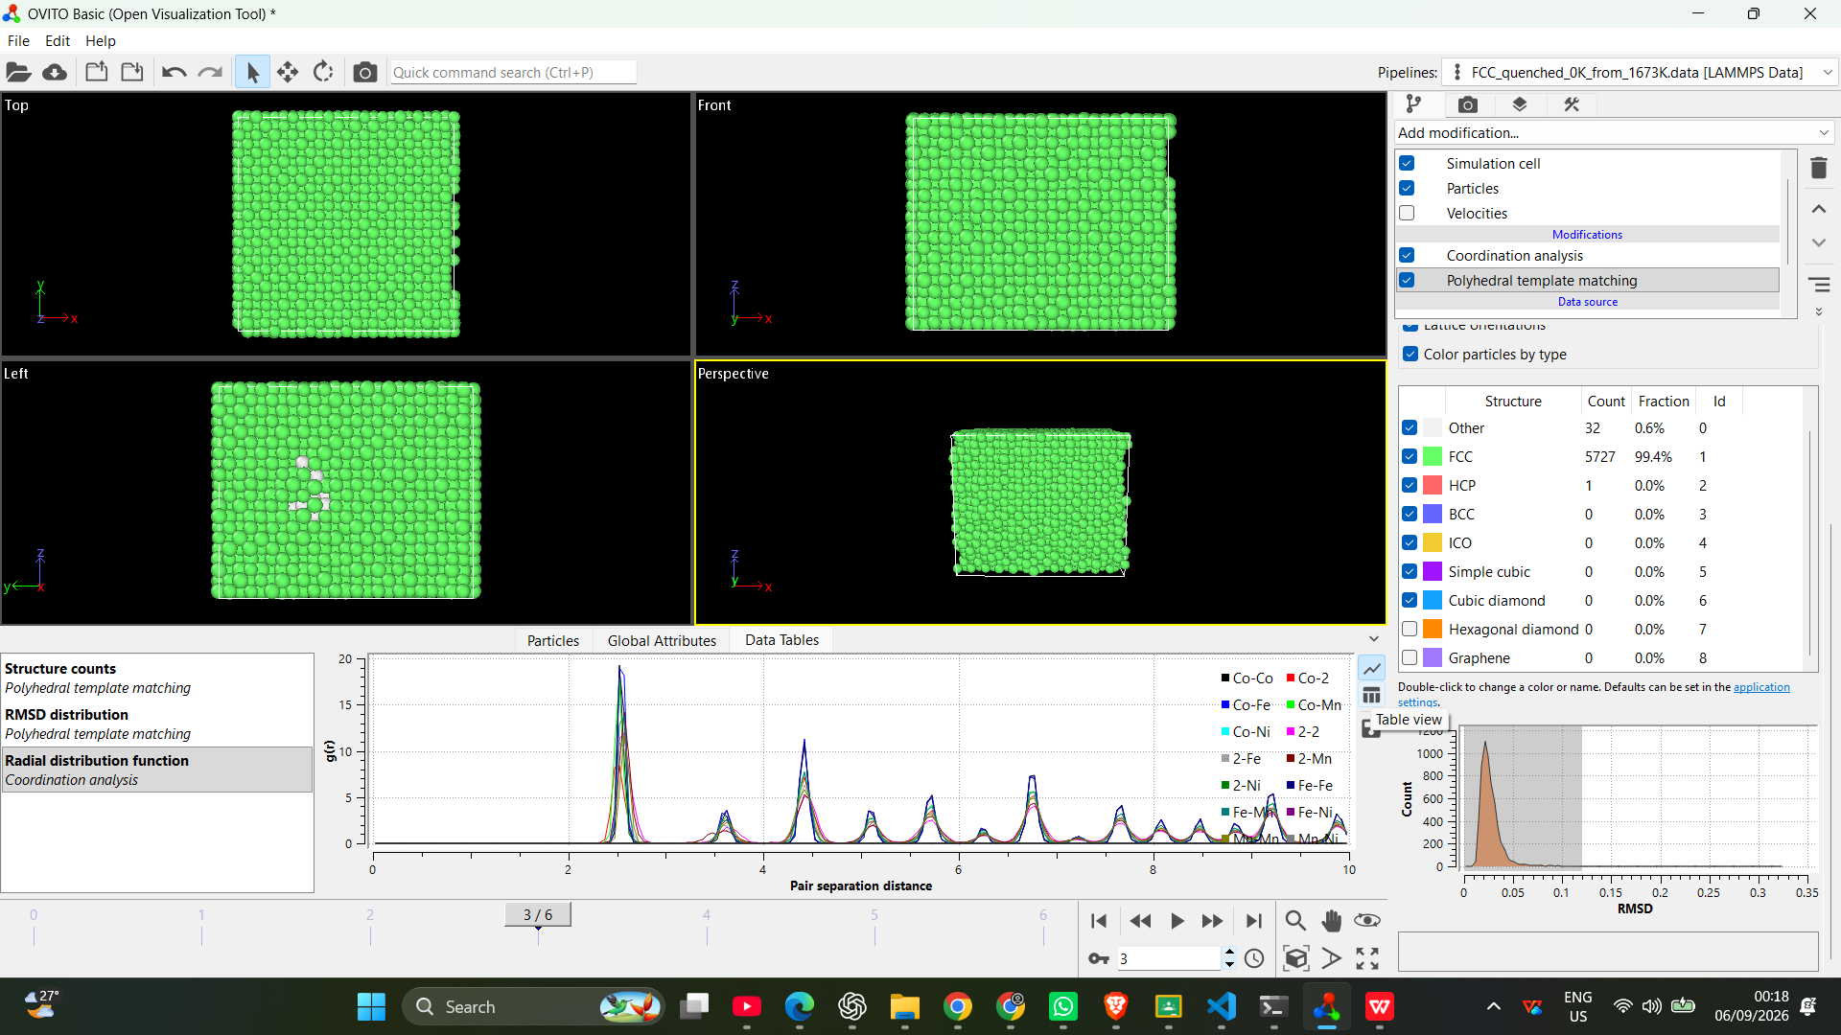
Figure 1. OVITO visualization of the relaxed Co25Cr25Fe25Mn25Ni0 HEA structure. The dominant FCC arrangement after relaxation confirms the stability of the initial crystal configuration.

Figure 2. Structural Stability Analysis Using RDF and RMSD
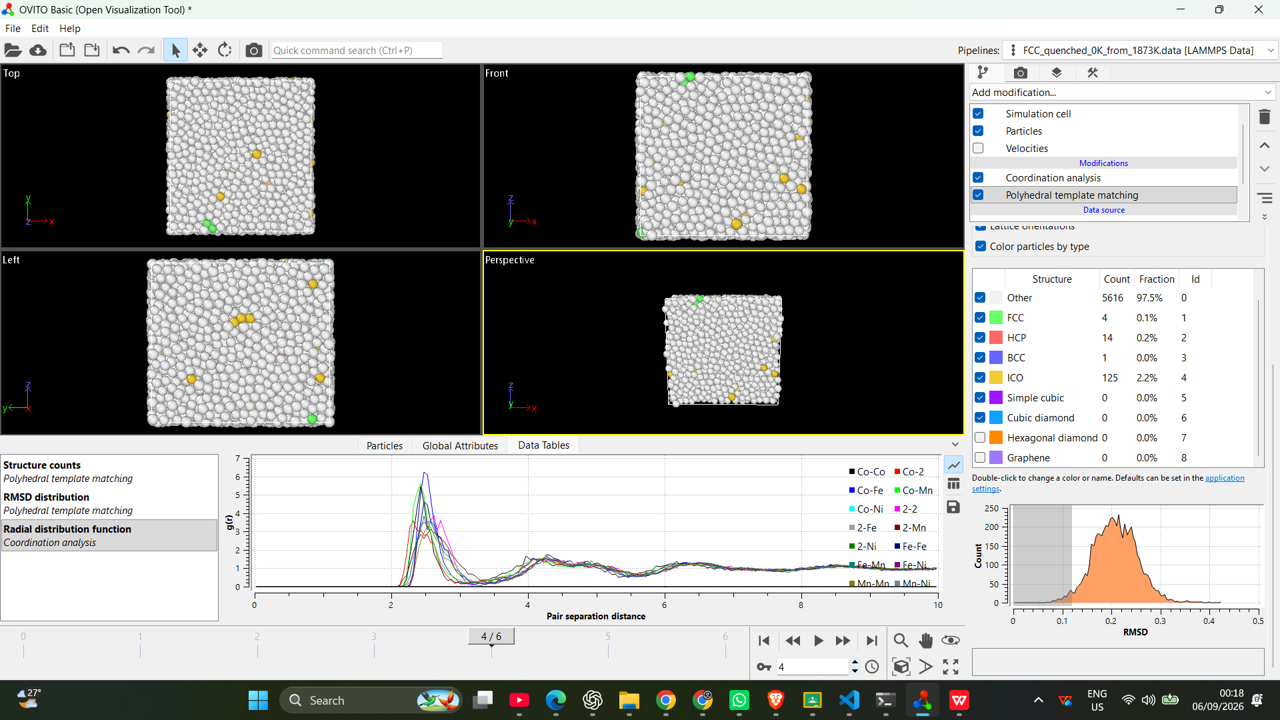
Figure 2. Combined radial distribution function (RDF) and RMSD analysis. The RDF profile confirms the preserved short-range atomic ordering, while the RMSD distribution indicates the magnitude of atomic displacement during thermal treatment and quenching.

Table 1. Comparison Between ML Prediction and LAMMPS/Formulation Verification
Parameter | Webapp (ML) Value | LAMMPS / Formula Verified Value
Mixing enthalpy, ΔHmix (kJ mol⁻¹) | -2.143 | -2.327 (LAMMPS FCC reference calculation)
Atomic size difference, δ (%) | 1.560 | 1.560 (Formula calculation)
Lambda parameter, Λ | 0.569 | 0.569 (Formula calculation)
Mean atomic radius (pm) | 138.75 | 138.75 (Composition-weighted formula)
Density (g cm⁻³) | 7.795 | 7.826 (LAMMPS relaxed structure)
Mean melting temperature, Tm (K) | 1819.65 | 1819.65 (Composition-weighted formula)
Configurational entropy, Sconf/R | 1.386 | 1.386 (Formula: −Σci ln(ci))
Omega parameter, Ω | 9.785 | 9.01 (Calculated using LAMMPS ΔHmix + formula entropy)
Valence electron concentration (VEC) | 7.50 | 7.50 (Composition-weighted formula)

Verification Discussion
The comparison shows excellent consistency between the ML-predicted descriptors and LAMMPS/formula-based calculations. Parameters such as atomic radius, entropy, melting temperature and VEC are governed by alloy composition and therefore show direct agreement with theoretical calculations. The LAMMPS simulation provides independent validation through relaxed density, structural stability, and energy-based mixing behaviour.

Simulation Data Source
LAMMPS verification was performed using relaxed atomic configurations, FCC reference energy calculations, thermal quenching trajectories, RDF analysis and RMSD evaluation obtained from OVITO post-processing.

