**Swing**

* **Difference Between AWT and Swing:-**

There are many differences between java awt and swing that are given below :

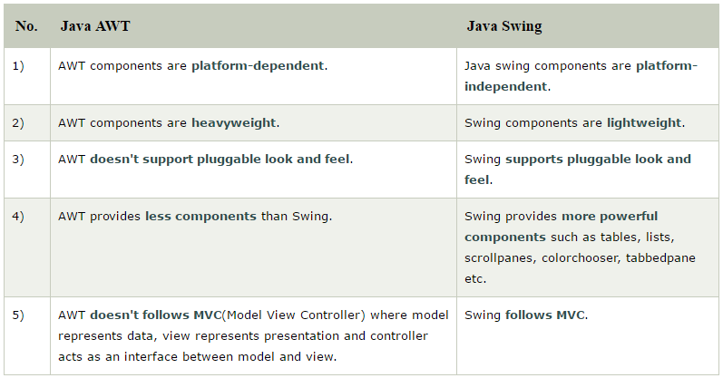

* **What is Swing? :-**

Java Swing is a part of Java Foundation Classes (JFC) that is used to create window-based applications. It is built on the top of AWT (Abstract Window Toolkit) API and entirely written in java. Swing classes are located under javax.swing package.

Unlike AWT, Java Swing provides platform-independent and lightweight components.

The javax.swing package provides classes for java swing API such as JButton, JTextField, JTextArea, JRadioButton, JCheckbox, JMenu, JColorChooser etc.

**What is JFC?**

The Java Foundation Classes (JFC) are a set of GUI components which simplify the development of desktop applications.

**Hierarchy Of Swing Class :**

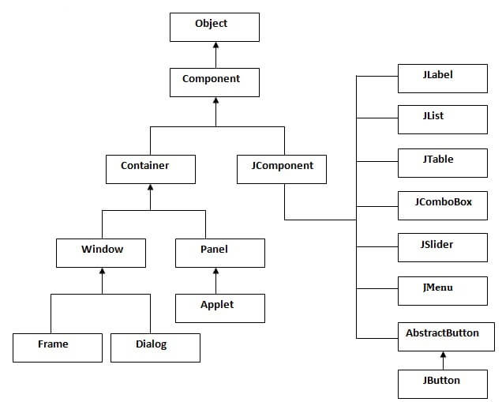

**Methods of Component class :**

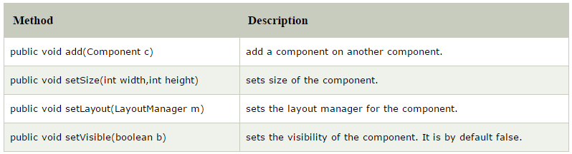

**Example :-**

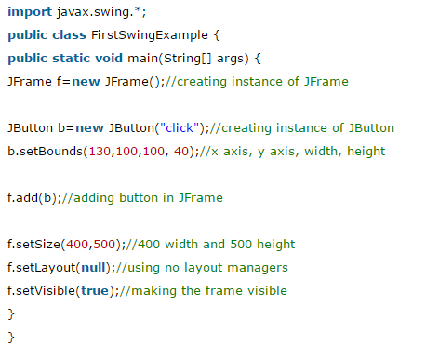

**Output :-**

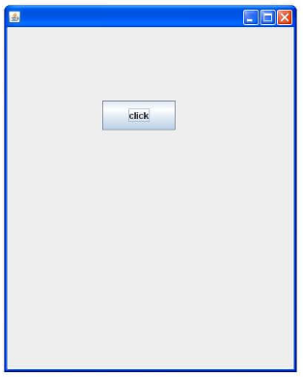

* **Swing Components :-**

There are following Swing components :

* **JLabel:-**

The object of JLabel class is a component for placing text in a container. It is used to display a single line of read only text. The text can be changed by an application but a user cannot edit it directly. It inherits JComponent class.

**Methods Of JLabel:**

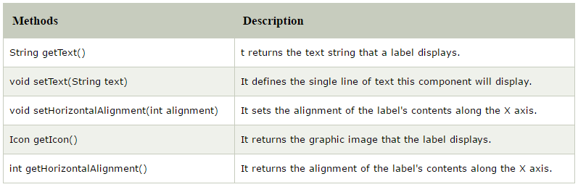

**Example :-**

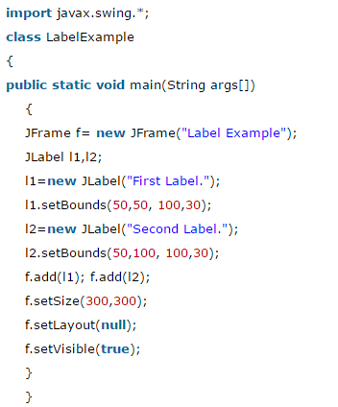

**Output :-**

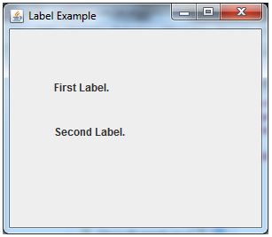

* **JTextField:-**

The object of a JTextField class is a text component that allows the editing of a single line text.

**Methods Of JTextField:**

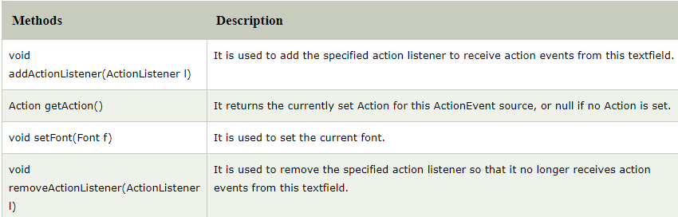

**Example :-**

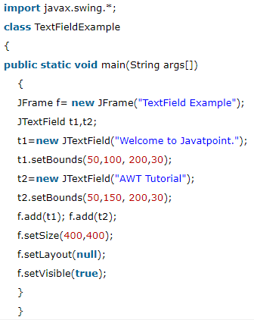

**Output :-**

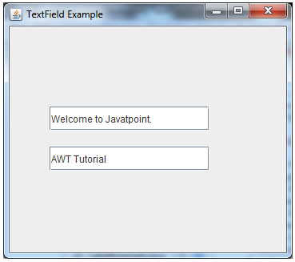

* **JButton:-**

The JButton class is used to create a labeled button that has platform independent implementation. The application result in some action when the button is pushed.

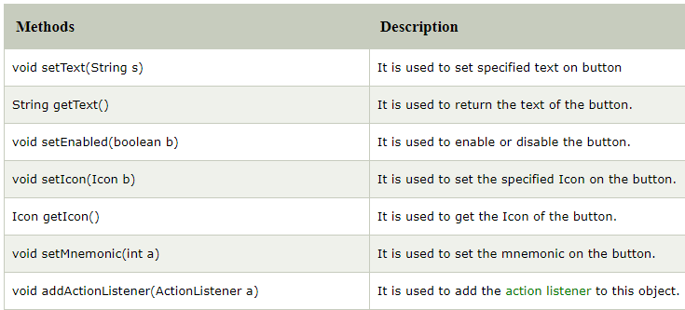

**Example :-**

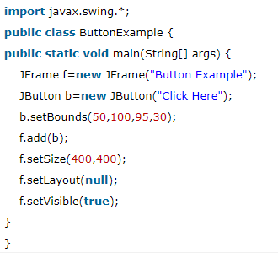

**Output :-**

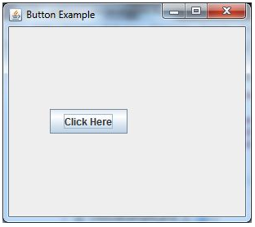

* **JComboBox:-**

The object of Choice class is used to show popup menu of choices. Choice selected by user is shown on the top of a [menu](https://www.javatpoint.com/java-jmenuitem-and-jmenu).

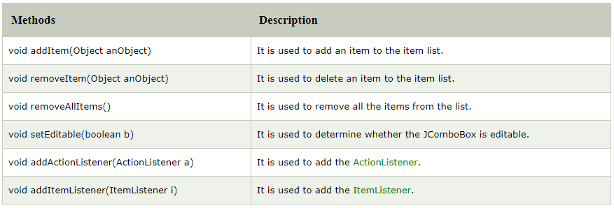

**Example :-**

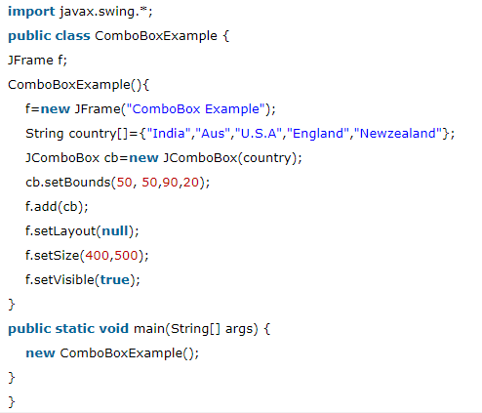

**Output :-**

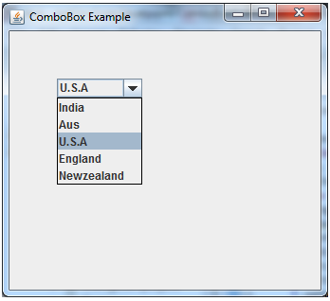

* **JList:-**

The object of JList class represents a list of text items. The list of text items can be set up so that the user can choose either one item or multiple items.

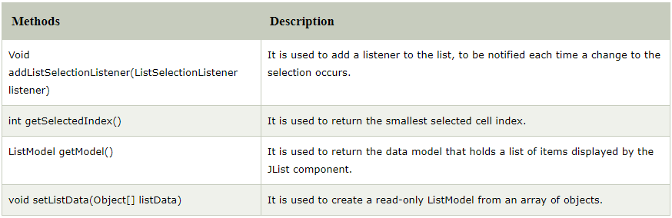

**Example :-**

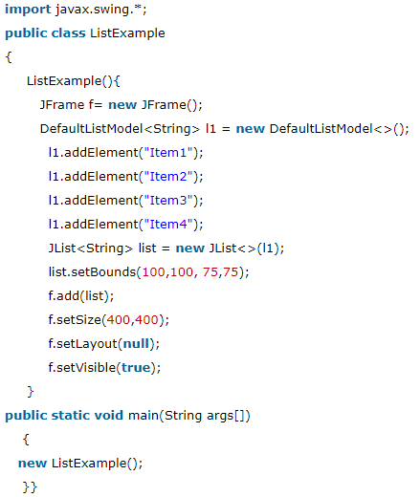

**Output :-**

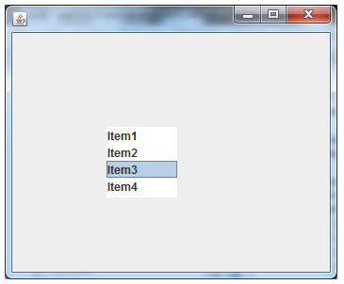

* **JTable:-**

The JTable class is used to display data in tabular form. It is composed of rows and columns.

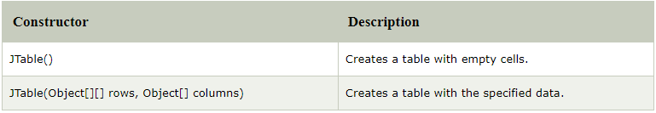

**Example :-**

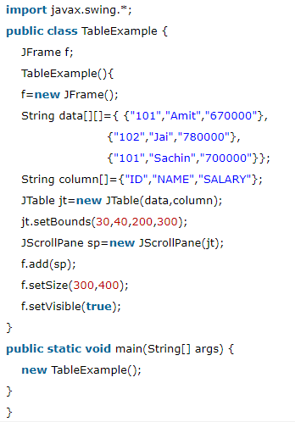

**Output :-**

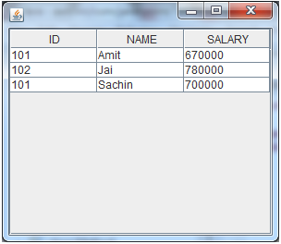

* **Java ActionListener Interface :-**

The Java ActionListener is notified whenever you click on the button or menu item. It is notified against ActionEvent. The ActionListener interface is found in java.awt.event [package](https://www.javatpoint.com/package). It has only one method: actionPerformed().

## actionPerformed() method :-

The actionPerformed() method is invoked automatically whenever you click on the registered component.

**Example :-**

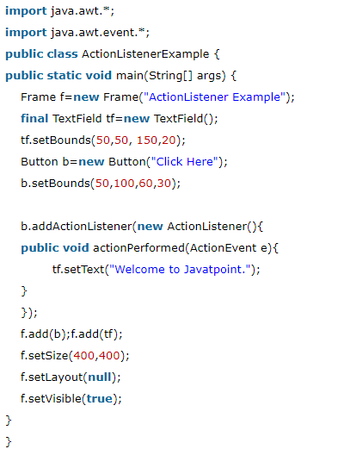

**Output :-**

