MODULE: 3.1 (C Language Fundamental)

(1) Display This Information using printf
1. Your Name
2. Your Birth date
3. Your Age
4. Your Address

Code….
#include<stdio.h>
int main()
{
printf("\nMY INFORMATION :");

printf("\nname : Dipak Chaudhari");
printf("\nBODy : 14/04/2001");
printf("\nage : 22");
printf("\naddress : at-isar,ta-mandvi,di-surat");
}
Output :
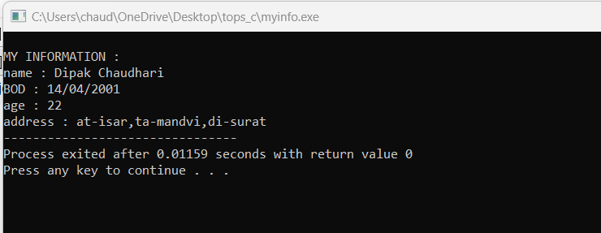
(2) Write a program to make Simple calculator (to make addition, subtraction, multiplication, division and modulo)

Code…
#include<stdio.h>
int main()
{
int a,b,c;

printf("please enter value of a:");
scanf("%d",&a);

printf("please enter value of b:");
scanf("%d",&b);

c=a+b;
printf("sum of two value :%d",c);

c=a-b;
printf("\nsub of two value :%d",c);

c=a*b;
printf("\nmultiplication of two value:%d",c);

c=a/b;
printf("\ndiv of two value:%f",c);
}

Output :
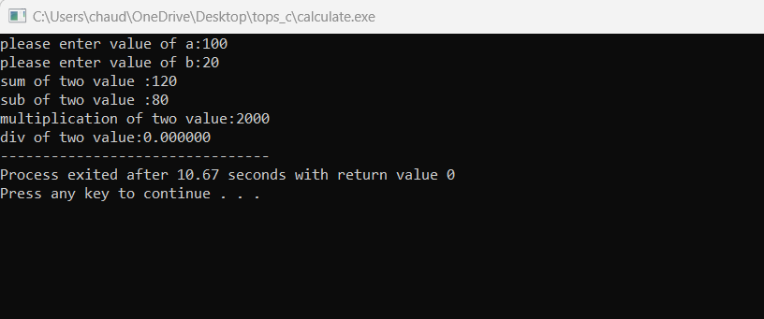

(3)WAP to find area of circle, rectangle and triangle.

Code…
#include <stdio.h>
void main()
{
int fig_code;
float side, base, length, breadth, height, area, radius;
printf("-------------------------\n");
printf(" 1 --> Circle\n");
printf(" 2 --> Rectangle\n");
printf(" 3 --> Triangle\n");

printf("-------------------------\n");
printf("Enter the Figure code\n");
scanf("%d", & fig_code);
switch (fig_code) {

case 1:
printf("Enter the radius\n");
scanf("%f", & radius);
area = 3.142 * radius * radius;
printf("Area of a circle=%f\n", area); /* find the area of circle */
break;

case 2:
printf("Enter the breadth and length\n");
scanf("%f %f", & breadth, & length);
area = breadth * length;
printf("Area of a Rectangle=%f\n", area); /* find area of the rectangle */
break;

case 3:
printf("Enter the base and height\n");
scanf("%f %f", & base, & height);
area = 0.5 * base * height;
printf("Area of a Triangle=%f\n", area); /* find the area of the triangle */
break;

default:
printf("please select given nomber\n");
break;
}
}

Output :
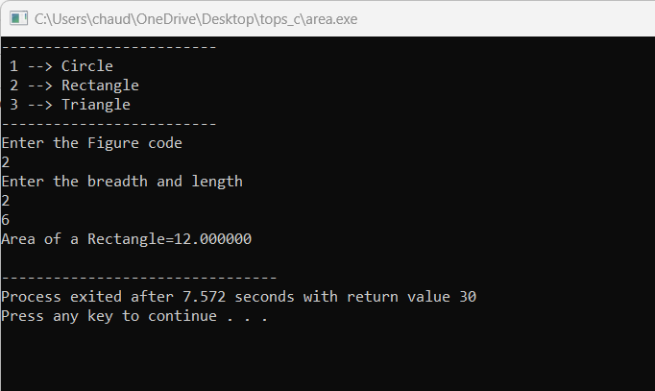

(4)WAP to find simple interest.

Code…
# include <conio.h>
# include <stdio.h>
# include <stdlib.h>

int main(){

//Simple interset program
int principal, rate, time, interest;

printf("Enter the principal: ");
scanf("%d", &principal);

printf("Enter the rate: ");
scanf("%d", &rate);

printf("Enter the time: ");
scanf("%d", &time);

interest = principal * rate * time / 100;
printf("The Simple interest is %d", interest);

return 0;

}
Output :
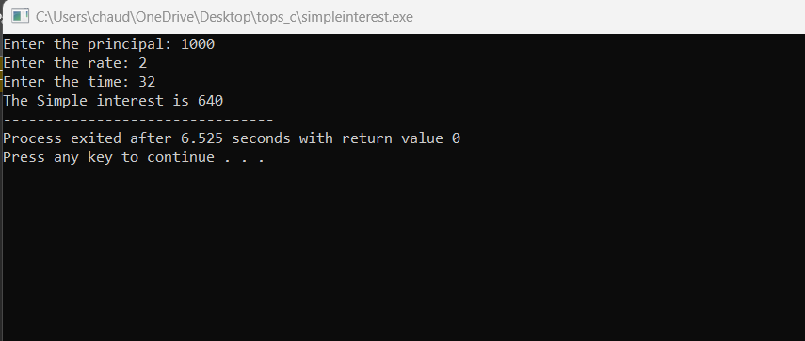

(5)WAP to check if the given year is a leap year or not.
Code…
#include <stdio.h>
int main()
{
int year;
printf("Enter a year: ");
scanf("%d", &year);

// leap year if perfectly divisible by 400
if (year % 400 == 0) {
printf("%d is a leap year.", year);
}
// not a leap year if divisible by 100
// but not divisible by 400
else if (year % 100 == 0) {
printf("%d is not a leap year.", year);
}
// leap year if not divisible by 100
// but divisible by 4
else if (year % 4 == 0) {
printf("%d is a leap year.", year);
}
// all other years are not leap years
else {
printf("%d is not a leap year.", year);
}

return 0;
}
Output :
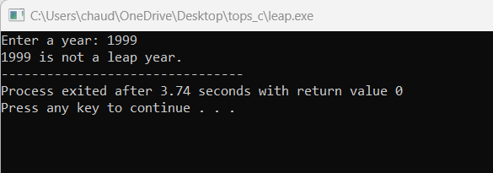

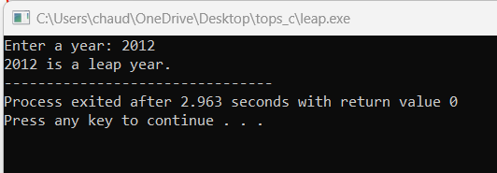

(6)WAP to convert years into days and days into years.

Code…
#include <stdio.h>
int main()
{
int days, years, weeks;

//user to input number of days
printf("Enter days: ");
scanf("%d", &days);

// Ignoring leap year
years = (days / 365);
weeks = (days % 365) / 7;
days = (days % 365) %7;

//Print the result
printf("YEARS: %d\n", years);
printf("WEEKS: %d\n", weeks);
printf("DAYS: %d", days);

return 0;
}
Output :
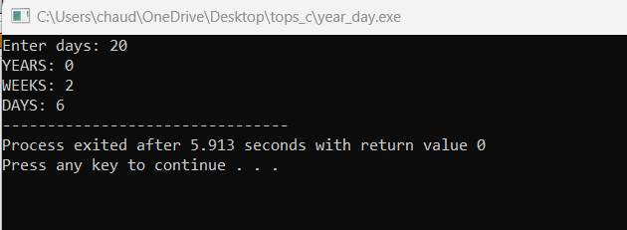
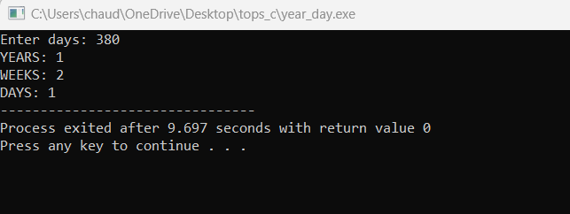

MODULE: 3.2
(C Language Programing with C)

• WAP to make simple calculator (operation include Addition, Subtraction, Multiplication, Division, modulo)
Code :
#include<stdio.h>
int main()
{
int a,b,c;

printf("please enter value of a:");
scanf("%d",&a);

printf("please enter value of b:");
scanf("%d",&b);

c=a+b;
printf("sum of two value :%d",c);

c=a-b;
printf("\nsub of two value :%d",c);

c=a*b;
printf("\nmultiplication of two value:%d",c);

c=a/b;
printf("\ndiv of two value:%f",c);
}
Output :
• WAP to swap two numbers without using third variable .
Code :
#include<stdio.h>
int main()
{
int a,b;
printf("please enter value of a :");
scanf("%d",&a);

printf("please enter value of b :");
scanf("%d",&b);

a=a+b;
b=a-b;
a=a-b;
printf("swapping the value.....\n");
printf("value of a %d \n",a);
printf("value of b %d",b);
}

Output :
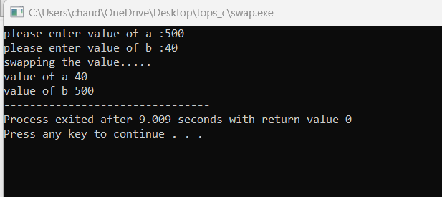

• WAP to find number is even or odd using ternary operator.
Code :
#include<stdio.h >
int main()
{
int n;

printf("Enter an integer number\n");
scanf("%d", &n);

(n % 2 == 0) ?
(printf("%d is Even number\n", n)) :
(printf("%d is Odd number\n", n));

return 0;
}
Output :
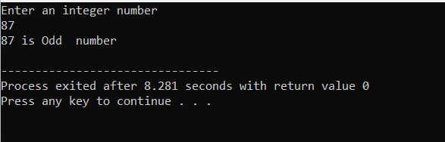
• WAP to show
- to Sunday Monday using switch case

#include<stdio.h>
int main()
{
int wk;

/* Input week number from user */
printf("Enter week number(1-7): ");
scanf("%d", &wk);

switch(wk)
{
case 1:
printf("Monday");
break;
case 2:
printf("Tuesday");
break;
case 3:
printf("Wednesday");
break;
case 4:
printf("Thursday");
break;
case 5:
printf("Friday");
break;
case 6:
printf("Saturday");
break;
case 7:
printf("Sunday");
break;
default:
printf("Invalid input! Please enter week number between 1-7.");
}

}

Output :
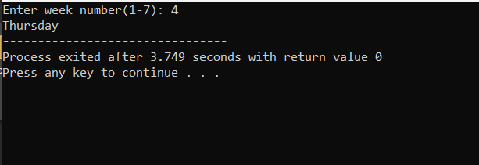

2. Vowel or Consonant using switch case
#include <stdio.h>
int main()
{
char vc;

/* Input an alphabet from user */
printf("Please enter any alphabet: ");
scanf("%c", &vc);

/* Switch value of vc */
switch(vc)
{
case 'a':
printf("Vowel");
break;
case 'e':
printf("Vowel");
break;
case 'i':
printf("Vowel");
break;
case 'o':
printf("Vowel");
break;
case 'u':
printf("Vowel");
break;
case 'A':
printf("Vowel");
break;
case 'E':
printf("Vowel");
break;
case 'I':
printf("Vowel");
break;
case 'O':
printf("Vowel");
break;
case 'U':
printf("Vowel");
break;
default:
printf("Consonant");
}

return 0;
}
Output :
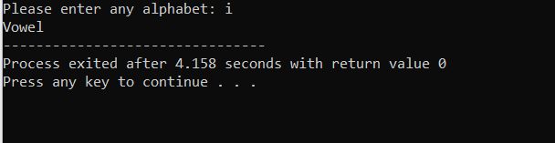
• Looping programs:
- WAP to print 972 to 897 using for loop
#include <stdio.h>

int main() {
int i;
for (i = 972; i >= 897; i--) {
printf("%d ", i);
}
return 0;
}
Output :
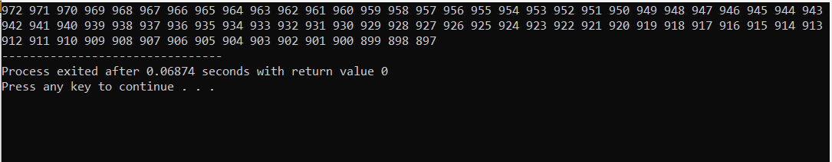

- WAP to take 10 no. Input from user and find out …

- How many Even numbers are there

- How many odd numbers are there

- Sum of even numbers

- Sum of odd numbers WAP to print table up to given numbers

#include <stdio.h>

int main() {
int numbers[10];
int countEven = 0, countOdd = 0, sumEven = 0, sumOdd = 0;

// Input 10 numbers from the user
printf("Enter 10 numbers:\n");
for (int i = 0; i < 10; i++) {
scanf("%d", &numbers[i]);
}

// Calculate count and sum of even and odd numbers
for (int i = 0; i < 10; i++) {
if (numbers[i] % 2 == 0) {
countEven++;
sumEven += numbers[i];
} else {
countOdd++;
sumOdd += numbers[i];
}
}

// Output results
printf("Number of even numbers: %d\n", countEven);
printf("Number of odd numbers: %d\n", countOdd);
printf("Sum of even numbers: %d\n", sumEven);
printf("Sum of odd numbers: %d\n", sumOdd);

// Printing the table of numbers
int num;
printf("Enter a number to print its table: ");
scanf("%d", &num);
printf("Table of %d:\n", num);
for (int i = 1; i <= 10; i++) {
printf("%d x %d = %d\n", num, i, num * i);
}

return 0;
}

Output :
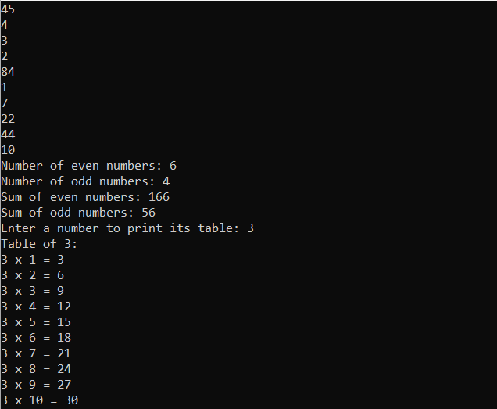
• WAP to print factorial of given number.

#include <stdio.h>
void main(){
int i,f=1,num;

printf("Input the number : ");
scanf("%d",&num);

for(i=1;i<=num;i++)
f=f*i;

printf("The Factorial of %d is: %d\n",num,f);
}
Output :
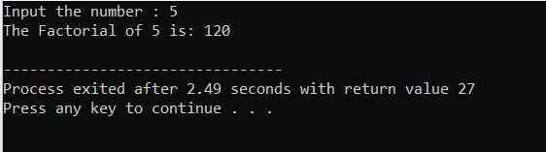

• WAP to print Fibonacci series up to given numbers
#include <stdio.h>
int main() {

int i, n;

// first and second terms
int t1 = 0, t2 = 1;

// next term (3rd term)
int Term = t1 + t2;

// get no. of terms from user
printf("Enter the number of terms: ");
scanf("%d", &n);

// print the first two terms t1 and t2
printf("Fibonacci Series: %d, %d, ", t1, t2);

// print 3rd to nth terms
for (i = 3; i <= n; ++i) {
printf("%d, ", Term);
t1 = t2;
t2 = Term;
Term = t1 + t2;
}

return 0;
}
Output :
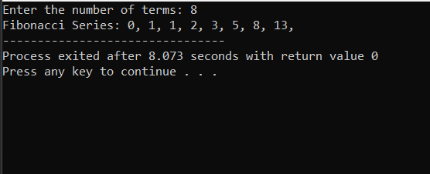

• WAP to print number in reverse order e.g.: number = 64728 ---> reverse = 82746

#include <stdio.h>
int main() {
int number, reverse = 0, remainder;

printf("Enter a number: ");
scanf("%d", &number);

while (number != 0) {
remainder = number % 10;
reverse = reverse * 10 + remainder;
number /= 10;
}

printf("Reverse of the number: %d\n", reverse);

return 0;
}
Output :
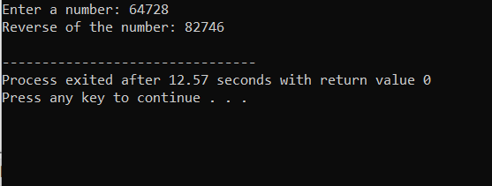

• Write a program to find out the max from given number (E.g., No: -1562 Max number is 6)
#include <stdio.h>
int main() {
double a, b, c;

printf("Enter three numbers: ");
scanf("%lf %lf %lf", &a, &b, &c);

if (a >= b && a >= c)
printf("%.2lf is the largest number.", a);

else if (b >= a && b >= c)
printf("%.2lf is the largest number.", b);

else
printf("%.2lf is the largest number.", c);

return 0;
}
Output:
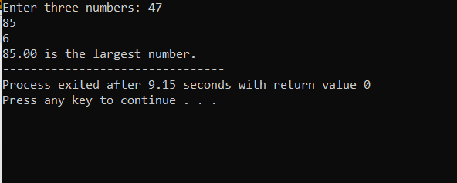

• Write a program make a summation of given number (E.g., 1523 Ans: -11)
#include <stdio.h>

int main() {
int number, sum = 0, digit;

printf("Enter a number: ");
scanf("%d", &number);

// Calculate the sum of digits
while (number != 0) {
digit = number % 10; // Get the last digit
sum += digit; // Add the digit to the sum
number /= 10; // Remove the last digit
}

printf("Sum of digits: %d\n", sum);

return 0;
}
Output :
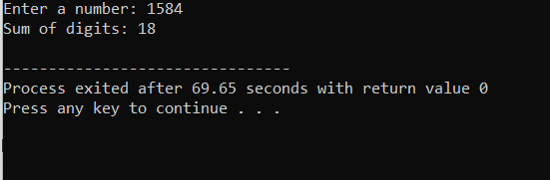

• Write a program you have to make a summation of first and last Digit. (E.g., 1234 Ans: -5)
#include <stdio.h>

int main() {
int number, fDigit, lDigit, sum;

printf("Enter a number: ");
scanf("%d", &number);

fDigit = number;
while (fDigit >= 10) {
fDigit /= 10;
}

// Extract last digit
lDigit = number % 10;

// Calculate the sum of first and last digits
sum = fDigit + lDigit;

printf("Sum of first and last digits: %d\n", sum);

return 0;
}
Output :
