Curriculum-vitae

Hemant
Address: H.No. 726, Sector 29, Faridabad, Haryana +91 7015351887, 9802555070.
Mail id: gaurhemant555@gmail.com

Objective: To attain Self-Actualization to Personal and Professional growth. Open to challenges to constantly deliver result. My Strength is my commitment, sincerity and motivation. I am self-driven, Customer conscious, possesses, good interpersonal skills and ability to work as a team.

Total work Experience 1 Year

Year from | Year to | Designation | Company | Domain
March, 2018 | April, 2019 | Associate | Inter Globe Technologies Gurgaon | Airways

Profile in a Glance:

• Dealt with Business to Business Clients located across PAN India.
• Dealt with Business to Customer Clients located across PAN India.

Technologies Stack:
Technologies used Windows, Outlook, Office 365, Word, Excel, Power point.

Academic Qualification
Standard | University/Board | Year of Passing | Marks
B.Sc. | MDU Rohtak, Haryana | 2018 | 63%
12th | HBSE Bhiwani, Haryana | 2015 | 82%
10th | HBSE Bhiwani, Haryana | 2013 | 85%

JOB PROFILE at IGT Technologies Gurgaon

1. Project Details:
Project: Galileo Helpdesk
Role Process Associate
Client Make My Trip.
Duration 13 Months
Team Size 2 Architect + 9 Developers

Project Description
This is a project for make my trip. Make my trip provide various offers to its agents and customers time to time. Galilio is a product which was used by different -2 agents. ITQ was another product which was used by IGT customer and internal agents.
Roles and Responsibility: Requirement gathering and preparing meeting notes. Following up with customers for any further details. Suggesting resolution if any conflict arise.
PERSONAL DETAILS
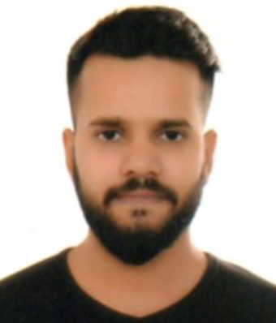
Name Hemant
Father’s Name Mr. Rakesh Kumar
Permanent Add 227, Jhabar Nagar Near Old Post Office, Palwal, Haryana.
Marital Status Unmarried
Corres. Address H.No. 726, Sector 29, Faridabad
Strength Excellent Communication and interpersonal skills.
Weakness Can not say No to any assignment without putting efforts.

