Tip Calculator

Requirement: Calculate tip on original bill amount

Enhancement:

1. Can split the bill amount with tips into multiple part, if no. of contributors is more than one.
2. Shows tips of 10, 15 and 20 by default. If Tip (%) different then use slider to change it.

UI

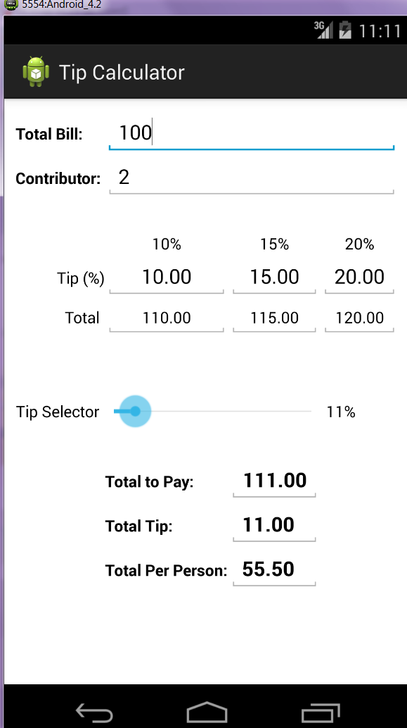

# Video URL

https://github.com/dipTech/AndroidDev/blob/master/DipTipsCalculator/DipTipCalculator.gif