***Types of Error***

A number of different authors have classified errors from a range of perspectives for a range of purposes. These are some of the best known systems; none is complete.

**Slips versus Mistakes**

* A **mistake** is making the wrong decision about what to do
* A **slip** is a failure to execute a decision correctly
  + An **execution slip** is a failure to correctly perform the action to achieve a goal
  + An **evaluation slip** is a failure to see or understand the situation correctly – what you’ve done, or what an interactive system has done, or what is happening in the situation

**Types of Unsafe Acts (Reason)**

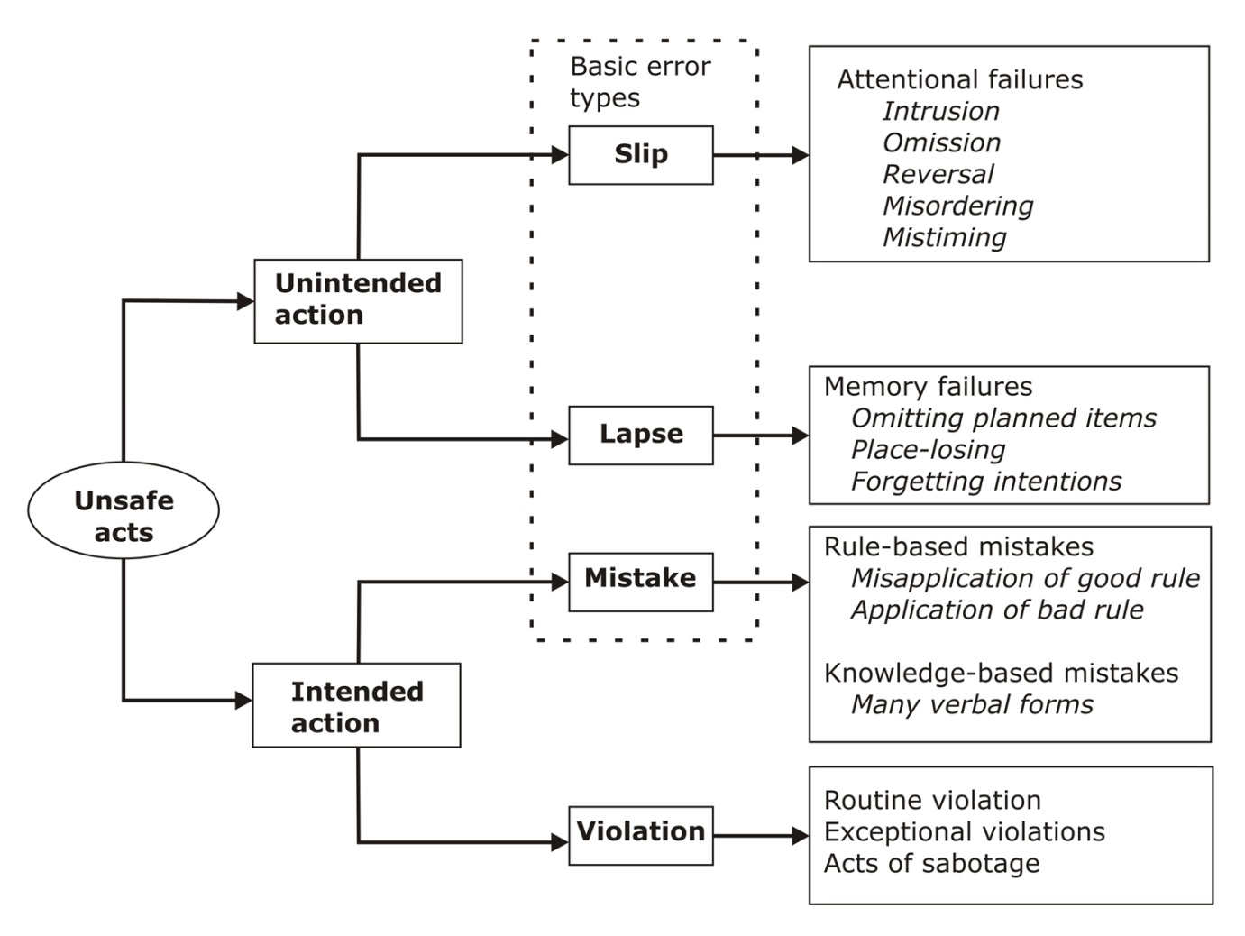

Adapted from **James Reason**, *Human Error*, Cambridge University Press, 1991.

**Skills, Rules and Knowledge (Rasmussen)**

From **Jens Rasmussen**, Skills, Rules and Knowledge: Signals, Signs and Symbols, and Other Distinctions in Human Performance Models*, IEEE Transactions on Systems, Man and Cybernetics*, 13, 257-266, 1983.

Rasmussen (1983) classifies errors according to how much knowledge-based thinking they involve. Note that the levels of behaviour are complementary, not alternatives, and interact.

* **Skill-Based Behaviour**: Very well learned highly automated preconscious procedures for perceiving features in the environment and performing actions.
* **Rule-Based Behaviour**: Learned recognition of situations, association of situations with tasks, application of stored rules for actions and problem-solving steps in particular situations.
* **Knowledge-Based Behaviour**: Thinking using knowledge to identify situations, set goals and make decisions, and plan actions.

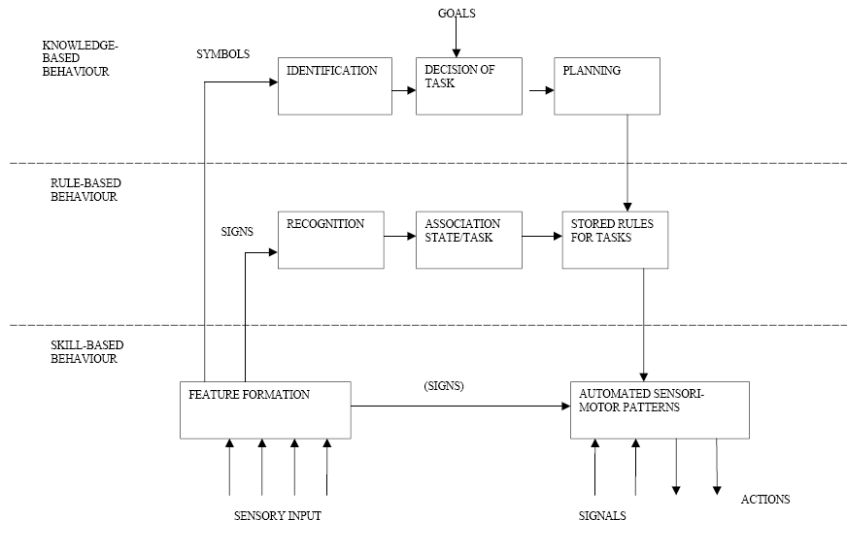

Diagram from Rasmussen (1983)

**Categorization of Action Slips (Norman)**

From **Donald A. Norman**, Categorization of Action Slips, *Psychological Review*, 88, 1-15, 1983.

Norman (1981) was interested in making sense of why people make errors in terms of cognitive processes, as well as in how to prevent them. Norman’s error classification is based on a model of how *action schemas* are activated and performed, and then monitored and evaluated – errors can occur at each step. *Execution slips* come from failures in the mental processes on the left side of the diagram, and *evaluation slips* come from failures in the mental processes on the right side of the diagram.

*User Activities*

*System Activities*

Physical System

Evaluation

Goal

Intention

Action Specification

Execution

Interpretation

Perception

Diagram redrawn from a PowerPoint presentation for a lecture by Anna L Cox of University College London.

* **Capture Slip**. [Failure of execution] Automatic activation of a well-learned routine that overrides the current intended activity. *(#804 Colleague forgot her suitcase on the train! Non-routine having suitcase with her, but she followed normal routine on exiting.)*
* **Double Capture Slip**. [Failure of execution] Unintended activation of a related strong action schema. *(“I intended only to take my shoes off, but took my socks off as well”)*
* **Omission Slip**. [Failure of transition from action specification to execution] Action specification lost before triggering action; due to interruptions. *(#786 Filled in a postgraduate application form and then forgot to actually click submit! Realised two days after the deadline :-/)*
* **Loss of Activation Slip**. [Failure of intention] Goal is lost before generation of action specification. *(#650 Forgot to tweet my error to* [*#errordiary*](http://search.twitter.com/search?q=) *& then couldn’t remember what the error was.)*
* **Description Slip**. [Failure of action specification] Incomplete or ambiguous specification of intention that is similar to a familiar intention. *(#850. Oyster card will not grant you entry through the college gates.)*
* **Associative Activation Slip**. [Failure of action specification] Activation of similar but incorrect action schema. *(#810 Having tapped the screen of my phone to cancel the alarm I nearly tapped the screen of my desktop to cancel it there)*
* **Perceptual Confusion Slip**. [Failure of execution] *(#842 - Realise I just moisturised my face with hair cream. My eyebrows look fab.)*
* **Reverse Schema Slip**. [Failure of intention] Reverse action schema overwrites forward action schema. *(“I got the correct fare out of my purse to give to the bus conductor. A few moments later I put the coins back into the purse before the conductor had come to collect them.”)*
* **Repetition of Action Slip**. [Failure of evaluation] Repetition of correctly performed action. *(A nurse repeated radiation therapy to a patient three times in a row, due to poor feedback. The patient died three months later.)*
* **Crosstalk Slip (Concurrent)**. [Failure of action specification] Action components are exchanged between two or more concurrent actions. *(#736. Started writing a message in English, then interleaved to look at a website in Dutch, and then continued my message in Dutch.)*
* **Crosstalk Slip (Sequential)**. [Failure of action specification] Action components are exchanged between two or more sequential actions. *(“I had just finished talking on the phone when my secretary ushered in some visitors. I got up from behind the desk and walked to greet them with my hand outstretched saying ‘Smith speaking’.”)*

Descriptions based on teaching materials by Anna L Cox of University College, London.

**Human Factors Analysis and Classification System (Shappell and Wiegmann)**

From **Scott A. Shappell & Douglas A. Weigmann**, *The Human Factors Analysis and Classification System – HFACS*, Office of Aviation Medicine, 2000.

A larger scale perspective intended for accident investigations. 4 *levels* of errors.

* **Unsafe Acts**
  + Errors
    - Skill based errors – checklist error
    - Decision errors – exceeded ability
    - Perceptual errors – not paying attention
  + Violations
    - Routine – habitual bad practice but turning a blind eye
    - Exceptional – non typical behaviour and not condoned
* **Preconditions for Unsafe Acts**
  + Environmental Factors
    - Physical environment
    - Technological environment
  + Condition of Operators
    - Mental state
    - Physical/mental limitations
  + Personnel Factors
    - Teamwork
    - Drugs, Alcohol
* **Unsafe Supervision**
  + Inadequate supervision
  + Inappropriate plan for operation and skill level
  + Fail to correct known problem
  + Supervisory violation – don’t follow the rules
* **Organizational Influences**
  + Resource Management – resources, equipment
  + Organisational climate – working atmosphere
  + Operational process – rules, procedures

**The Dirty Dozen (Dupont)**

The Dirty Dozen refers to twelve of the most common human error preconditions, or conditions that can act as **precursors, to accidents or incidents**. These twelve elements influence people to make mistakes. The Dirty Dozen is a concept developed by Gordon Dupont, in 1993, whilst he was working for Transport Canada, and formed part of an elementary training programme for Human Performance in Maintenance.

|  |  |  |
| --- | --- | --- |
| 1. Lack of communication | 5. Complacency | 9. Lack of knowledge |
| 2. Distraction | 6. Lack of teamwork | 10. Fatigue |
| 3. Lack of resources | 7. Pressure | 11. Lack of assertiveness |
| 4. Stress | 8. Lack of awareness | 12. Norms |

From ***Skybrary*** (a website for aviation safety knowledge): <http://www.skybrary.aero/index.php/The_Human_Factors_%22Dirty_Dozen%22> which explains each of these in more detail.