**City table :**

CREATE TABLE city ( id INT PRIMARY KEY,city_name VARCHAR(255),lat DOUBLE,`long` DOUBLE,country_id INT, FOREIGN KEY (country_id) REFERENCES country(id));

insert into city values(1,'Berlin',52.520008,13.404954,1),

(2,'Belgrade',44.787197,20.457273,2),

(3,'Zagreb',45.815399,15.966568,3),

(4,'Ney York',40.730610,-73.935242,4),

(5,'los Angeles',34.052235,-118.243683,4),

(6,'Warsaw',52.237049,21.017532,5);

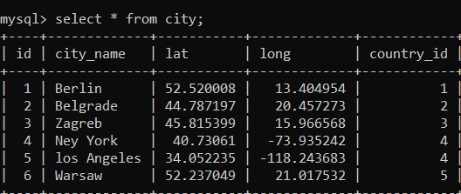

**Customer table:**

**CREATE TABLE customer (id INT PRIMARY KEY,customer_name VARCHAR(255),city_id INT,customer_address VARCHAR(255),next_call_date DATE,**

**ts_inserted TIMESTAMP DEFAULT CURRENT_TIMESTAMP,**

**FOREIGN KEY (city_id) REFERENCES city(id));**

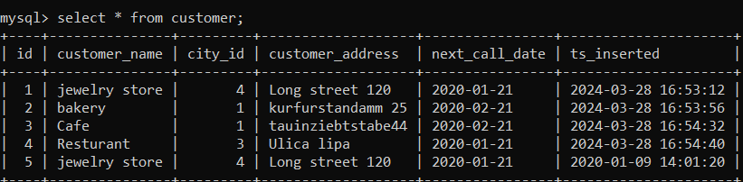

**Country table :**

create table country(id int, country_name varchar(150),country_eng varchar(100),country_code varchar(100));

insert into country values(1,Deutschland,Germany,DEU),

s (2,'Serbia','Serbia','SRB'),

(3,'Hrvatska','Croatia','HRV'),

(4,'united State America','United state','USA'),

(5,'polska','Poland','POL'),

(6,'Espana','spain','ESP'),

(7,'Rossiya','Russiya','RUS');

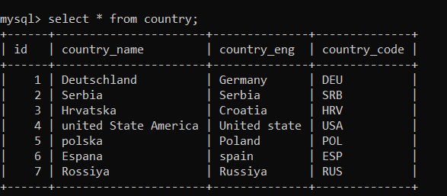

Task : 1 (join multiple tables using left join)

SELECT customer.id AS customer_id,customer.customer_name,city.id AS city_id,city.city_name,country.id AS country_id,country.country_name

-> FROM customer

-> LEFT JOIN city ON customer.city_id = city.id

-> LEFT JOIN country ON city.country_id = country.id;

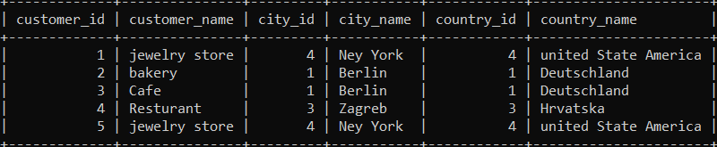

List all Countries and customers related to these countries.

SELECTcountry.id AS country_id,country.country_name,customer.id AS customer_id,customer.customer_name

-> FROM country

-> LEFT JOIN city ON country.id = city.country_id

-> LEFT JOIN customer ON city.id = customer.city_id;

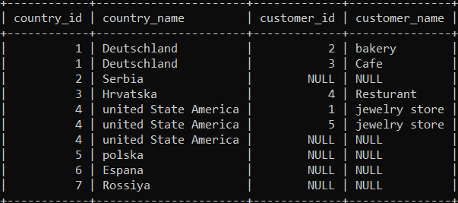

For each country displaying its name in English, the name of the city customer is located in as well as the name of the customer.

SELECT

-> country.country_name AS country_name,city.city_name,customer.customer_name

-> FROM customer

-> LEFT JOIN city ON customer.city_id = city.id

-> LEFT JOIN country ON city.country_id = country.id;

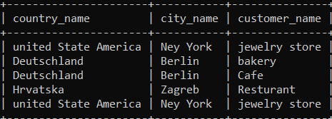

Return even countries without related cities and customers.

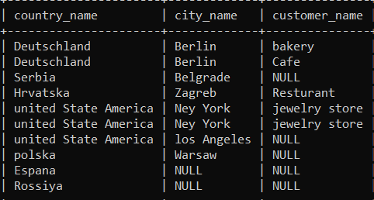

Task : 2 (join multiple tables using both left and inner join)

SELECT

-> country.country_name AS country_name,city.city_name,customer.customer_name

-> FROM country

-> LEFT JOIN city ON country.id = city.country_id

-> INNER JOIN customer ON city.id = customer.city_id;

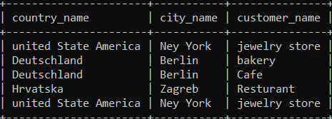

Return the list of all countries that have pairs(exclude countries which are not referenced by any city). For such pairs return all customers.

SELECT

country.country_name AS country_name,

city.city_name,

customer.customer_name

FROM

country

INNER JOIN

city ON country.id = city.country_id

INNER JOIN

customer ON city.id = customer.city_id;

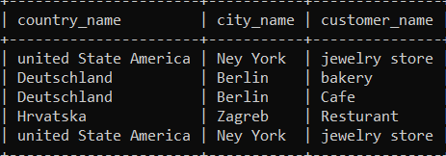

Return even pairs of not having a single customer

SELECT country.country_name AS country_name,city.city_name,customer.customer_name

-> FROM country

-> LEFT JOIN city ON country.id = city.country_id

-> LEFT JOIN customer ON city.id = customer.city_id;

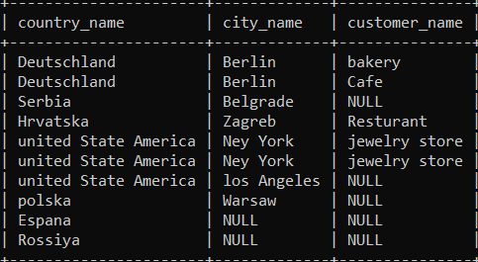

s