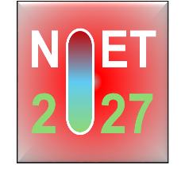 | Two-day national Conference On Net-zero Emission Technologies for  Sustainable Development: Challenges and Opportunities (N0ET-2027)  JANUARY 29-30, 2027 | 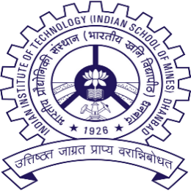

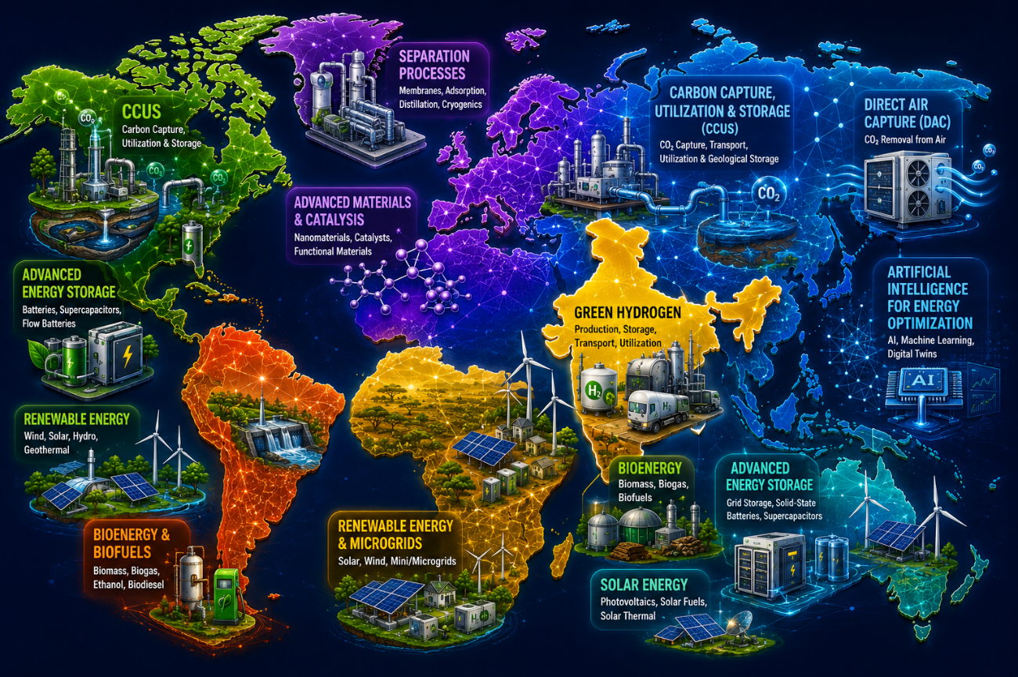

Organized by
Department of Chemical Engineering
IIT (ISM) Dhanbad

About the Conference:
Net-zero emissions refer to balancing anthropogenic greenhouse gas (GHG) emissions with their removal from the atmosphere. Achieving this balance is essential for sustainable development and limiting global warming. The transition to a net-zero future requires transformative technologies that decarbonize energy, industrial, and transportation systems while minimizing carbon dioxide (CO₂) emissions. Emerging technologies such as carbon capture, utilization, and storage (CCUS), direct air capture (DAC), green hydrogen, renewable energy, bioenergy, advanced energy storage, separation processes, and artificial intelligence for energy optimization are expected to play a crucial role in this transition. However, significant technical, economic, and policy challenges remain, necessitating interdisciplinary research and strong collaboration among academia, industry, and government. The Two-Day National Conference on Net-Zero Emission Technologies for Sustainable Development: Challenges and Opportunities (N0ET–2027) provides a platform for researchers, academicians, industry professionals, policymakers, and students to exchange ideas, present cutting-edge research, and explore innovative solutions for a low-carbon future. The conference aims to promote scientific collaboration and technological advancements that support India's Net-zero 2070 commitment and contribute to achieving the Paris Agreement goal of limiting the global temperature rise to 1.5 °C.
About the Department
Since its inception in 2010, the department aimed to instill in all the students the essential skills of critical thinking, and creative problem-solving for their success in the practice of chemical engineering. The department offers academic and research programs leading to B.Tech, M.Tech, and PhD degrees. Many of the graduated students are placed in reputed national and multinational organizations such as IOCL, BPCL, ONGC, GAIL, Reliance Industries Ltd, L&T, Vedanta, Haldia Petrochemicals Ltd, and Aditya Birla. A substantial number of the students are also engaged in higher studies and research in reputed institutes in India and abroad. The department has been actively involved in different collaborative and multidisciplinary research projects sponsored by CIL, DST, DST FIST, ANRF, SAIL, TATA Steel, NJB, TEXMiN, etc., thereby maintaining and modernizing its research infrastructure. The department strongly emphasizes developing and maintaining strong collaborative and cooperative links with private and public sector industries, R&D houses, government user departments as well as premier academic and research institutions within the country and abroad for the advancement of knowledge and the benefit of society.
Major Themes
Clean Energy Innovation
Carbon Capture, Utilization & Storage (CCUS)
Green Hydrogen
Renewable Energy
Energy Storage Systems
Materials Science & Nanotechnology
Electro, Chemical, Bio & Photo-catalysis
Circular Economy
Other Relevant Areas
Programs:
- Keynote Talks
- Invited Talks
- Oral/Poster Presentations

Call for Abstract
The conference invites abstracts from faculty members, students, scientists, researchers, and industry professionals. The abstract should be limited within to 200-250 words. The abstract should report original research on any of the topics in the highlighted major themes/relevant areas, but not limited to the major themes.
Official Email ID for all correspondence and submission of registration: n0et@iitism.ac.in
For detailed guidelines on the abstract submission, please visit the following link:
N0ET-2027
All the submitted abstracts would be subject to peer review.
Important Dates:
Commencement of Abstract Submission | 5 September 2026
Abstract Submission Deadline | 27 November 2026
Acceptance of Abstract | 7 December 2026
Submission Deadline of Full-length Manuscript | 4 January 2027
Commencement of Registration | 8 December 2026
Online Registration Deadline | 20 January 2027
Conference Date | 29 - 30 January 2027

Registration Fees:
Type of Participant | Regular
Industrial Personnel | INR 12,000
Faculty Member and Scientist | INR 8,000
Student and Research Scholars | INR 3,000
Others | INR 8,000

For further details on registration and payment, please visit the following link:
N0ET-27 Payment
Sponsorship:
For sponsorship rates, please visit at this link: N0ET-27 Sponsorship

Chief Patron: Prof. Prem Vrat, Chairman, IIT (ISM) Dhanbad
Patron: Prof. Sukumar Misra, Director, IIT (ISM) Dhanbad
Co-Patron: Prof. Sarat Kumar Das, Dy. Director, IIT(ISM) Dhanbad
Chairman: Prof. Aditya Kumar, Head, Chemical Engineering
Local Organizing Committee
Convener: Prof. Paidinaidu Paluri
Co-Convener: Prof. Arunkumar Samanta and Prof. Lutukurthi D N V V Konda

Advisory Committee:
Shri. Anand Mohan — Director (Technical / R&D & T, BD), CMPDIL, Ranchi
Prof. Arvind Rajendran — University of Alberta, Canada
Prof. Bishnupada Mandal — IIT Guwahati
Shri Dinesh Kumar Gangwal — Chief – O&M Services, MPL, Dhanbad
Prof. Goutam Deo — IIT Kanpur
Prof. Kishalay Mitra — IIT Hyderabad
Dr. (Mrs.) Malti Goel — President, Climate Change Research Institute, Delhi
Dr. Pinaki Sarkar — Senior Scientist, CSIR-CIMFR, Dhanbad
Dr. Pratik Swarup Dash — Chief, Sustainability Research Group, R&D, Tata Steel, Jamshedpur
Prof. Preeti Aghalayam — IIT Madras
Prof. Rajender Gupta — University of Alberta, Canada
Prof. Sankar Bhattacharya, — Monash University, Australia
Prof. Sarma V. Pisupati — The Pennsylvania State University, USA
Prof. Srinivasakannan Chandrasekar — Khalifa University, Abu Dhabi, UAE
Prof. Suddhasatwa Basu — IIT Delhi
Dr. Vinay Amte — Reliance Industries Limited (RIL)

Core Committee:
Prof. Aritra Santra
Prof. Bidhan Chandra
Prof. Ejaz Ahmad
Prof. Khantesh Agrawal
Prof. Krishna Sandilya Durbha
Prof. Mahendra N Nandanwar
Prof. Pantula D Priyanka
Prof. Sandip Mandal
Prof. Siddhartha Sengupta
Prof. Soubhik Kumar Bhaumik
Prof. Soumyajit Sen Gupta
Prof. Sourav Sengupta
Prof. Suman Dutta
Prof. Suresh Kumar Yatirajula

Local Advisory Committee
Prof. Sarat Kumar Das, Dy.Director, IIT(ISM) Dhanbad

Contact Us:
Prof. Paidinaidu Paluri  Convener  naidu@iitism.ac.in  +91-9471192195 | Prof. Arunkumar Samanta  Co-Convener  asamanta@iitism.ac.in  +91- 9471192213 | Prof. Lutukurthi D N V V Konda  Co-Convener  dnvvkonda@iitism.ac.in  +91- 9471192194

Registration Form
Two-day National Conference
On
Net-zero Emission Technologies for Sustainable Development: Challenges and Opportunities (N0ET-2027)
January 29-30, 2027
Name
Qualification
Designation
Department
Institution/
Organisation
Official Address | Pin
Phone
Email
Accommodation | Yes/No
Payment Details (Please tick the mode of payment)
DD | Payee Check
Amount Paid
Date of payment
Cheque no./DD/
Transaction ID
Registration fees and other payments can be done using the following details:
Name of the Account | IIT ISM CEP ACCOUNT | 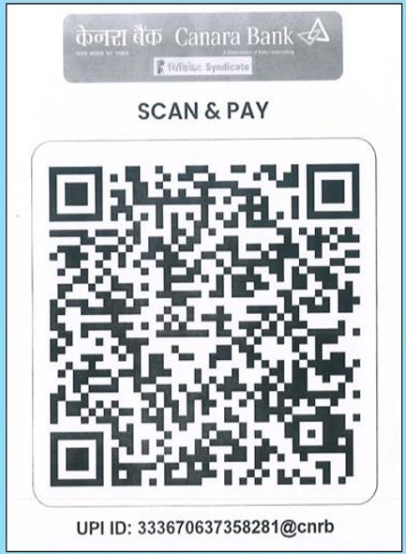 | Please mention  "OCEP 0137 O &  N0ET-2027" while  making the transaction
Account Number | 110261358281
Name of the Bank | CANARA BANK
IFS Code | CNRB0000986
SWIFT CODE | CNRBINBBFD

For further details on registration and payment, please visit the following link: N0ET-27 Payment
Date: Signature of the applicant

