

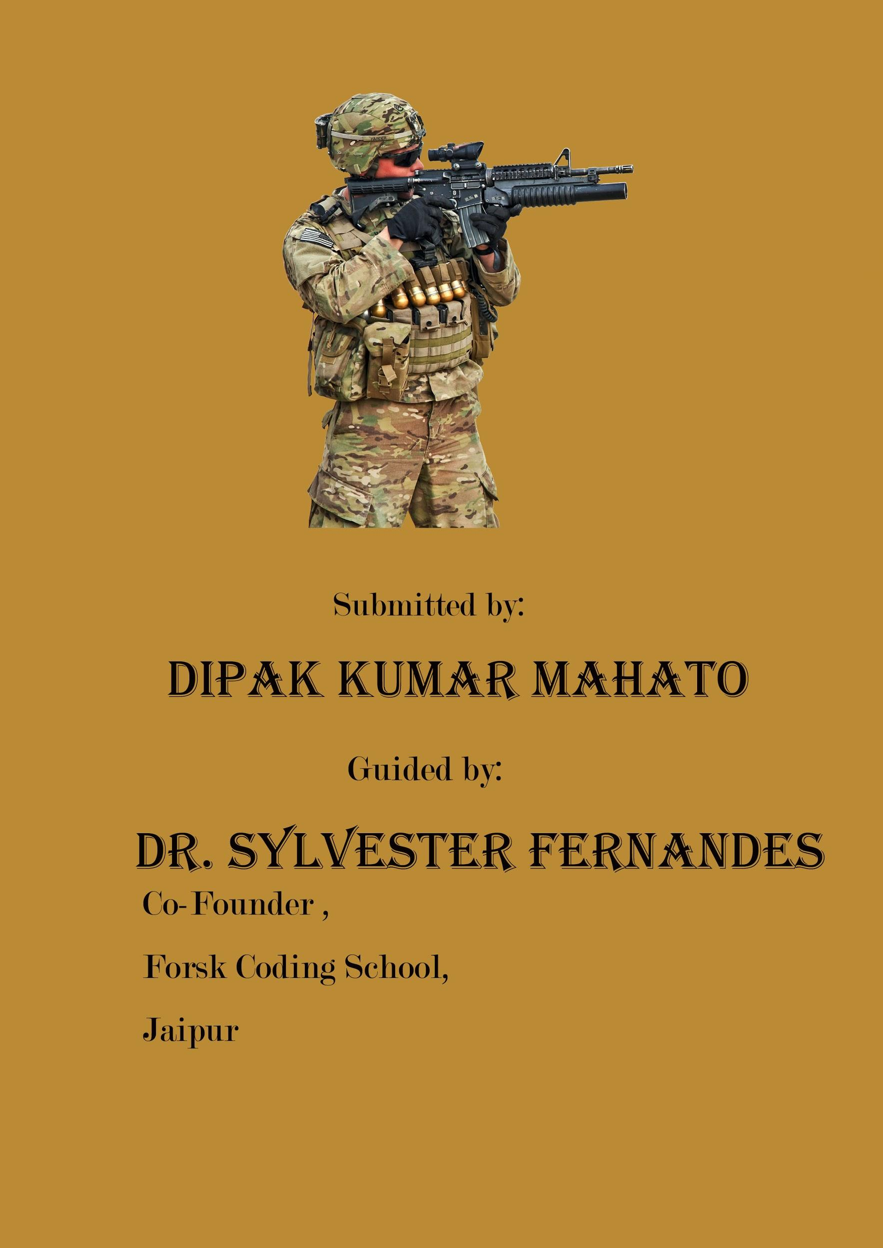

**Table of Content**

1. Introduction
2. Related Work
3. My Work
4. Implementation
5. Results
6. Conclusion and Future Work
7. References
8. Biography

**Introduction**

The project is basically a Data Visualization and Analysis tool . A huge dataset is filtered , visualized and analysed through this tool. The User Interface Application is developed using a powerful UI library and framework named ‘Dash’ in Python. The dataset contains the terrorism data from year 1970 to 2018. Dash framework allows a developer to build high level UI applications that contains extensively integrated user components to gain the benefits of dynamicity . Moreover, it is best to use library to make good visualizations via time series plots and maps , and helps in inclusion of effective UI components as it uses html, javascript , and css internally, therefore building a fast and robust UI application is a lot more easier with this framework.

**Related Work:**

For this project we are using a python framework named Dash , which uses many other libraries like , plotly , pandas , webbrowser etc , for displaying data of global terrorism dataset that has 1,90,000 records. Here , the client’s requirements are thoroughly understood and then the data is visualized and filtered accordingly, and records are displayed using maps and charts.

**My Work:**

In this project , I have developed a graphical user interface using a python framework **Dash**. The interface is mainly divided into two tabs i.e., **Map Tools** and **Chart Tools** . The Map Tools tab is further divided into two subtabs i.e., **World Map Tool** and **India Map Tool.**  The World Map Tool considers the data of the entire world and shows the result on the map according to the filters applied . Whereas , India Map Tool considers only the data of India and shows the result on map . For filtering the data there are 7 drop-downs provided . These drop-downs are :

1. Month
2. Day
3. Region
4. Country
5. Province\State
6. City
7. Attack_types

For filtering out the data according to year there is also a range-slider that allows the user to filter the data for a particular range of years.

The Chart Tool tab is also divided into two sub-tabs i.e., **World Chart Tool** and **India Chart Tool .** The World Chart Tool displays the Chart for the entire World data whereas India Chart Tool displays chart only for India Data. For displaying the charts there is a drop-down , that displays the chart only for the desired Features like :

1. Region(defaul)
2. Terrorist Organization
3. Target Nationality
4. Target Type
5. Weapon Type

There is also a search box that is used to search the data. According to the features selected , the chart is displayed.

**Implementation:**

Python Libraries used in the projects are:

* Pandas - Library used for data analysis and filtering .
* webbowser - Library used for opening the web page in default browser.
* dash - Library used for creating the local server and dummy app.
* dash_html_components - Library used for designing the webpage.
* dash_dependencies - Library used in callbacks for taking the inputs and giving the modified outputs.
* plotly.graph_objects - Library used for creating the figures of map and graphs.
* plotly.express - Library used for creating the charts .
* dash_core_components - Library used for drawing the elements of the webpage.
* dash.exceptions - Library used for preventing the exceptions error.

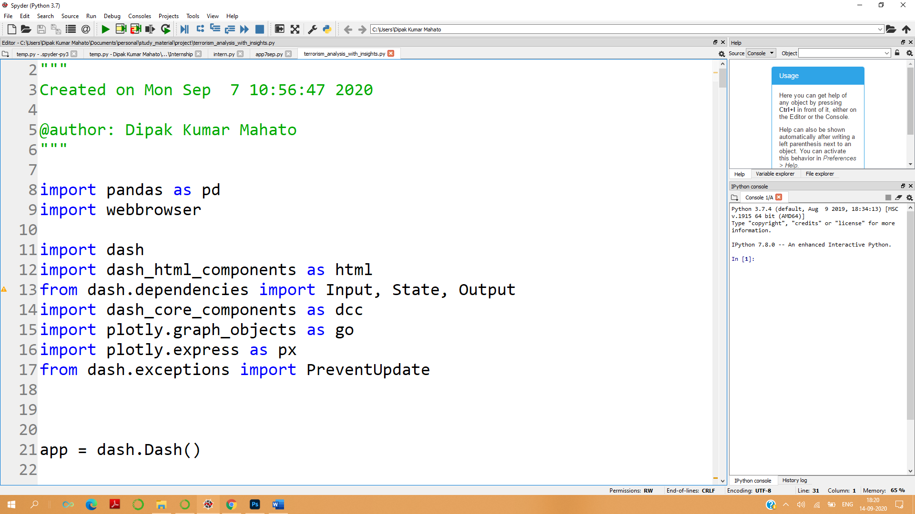

**Results:**

* **Web Application Overview**

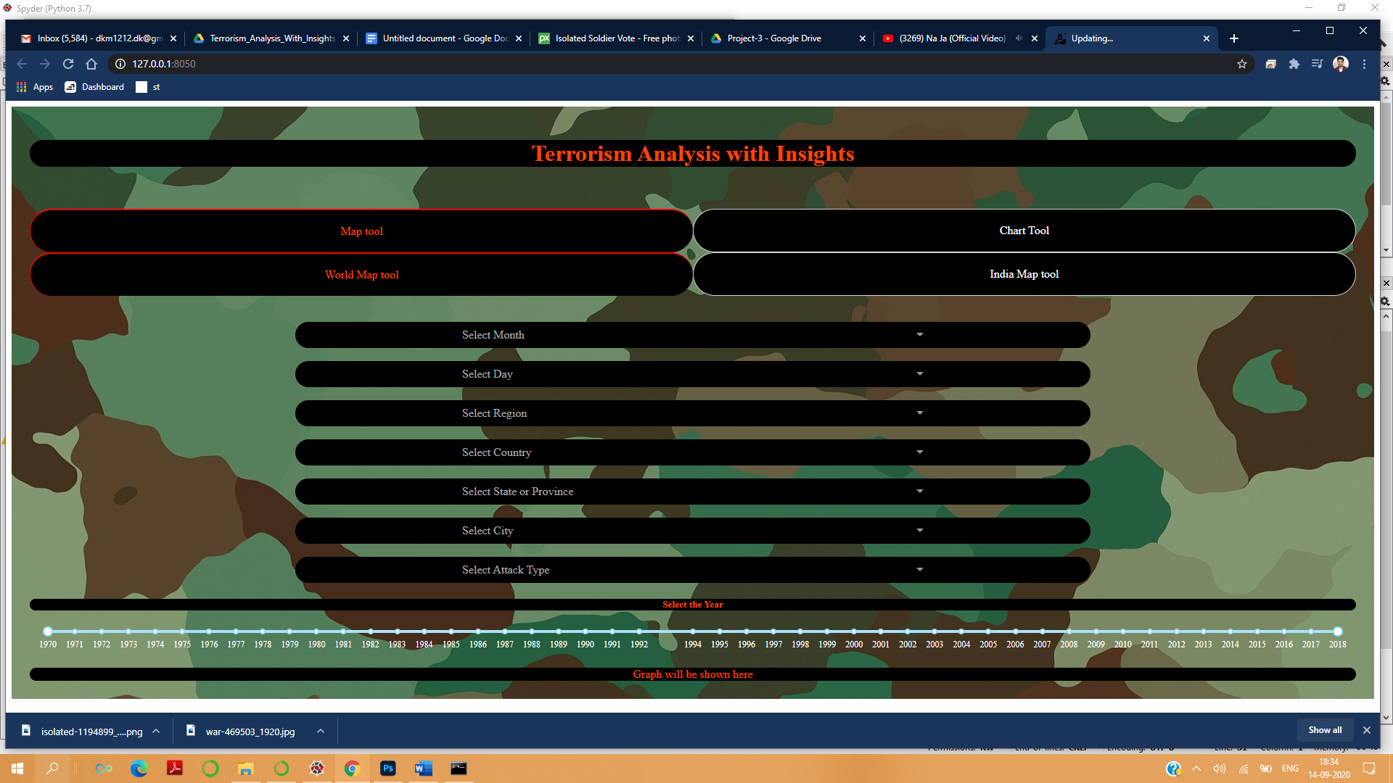

* **Filtering using Drop-downs and year-slider**

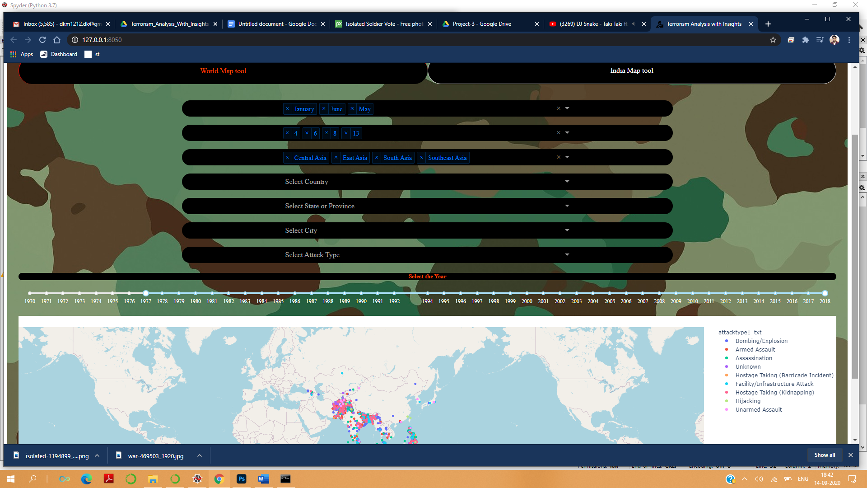

* **Map is Updated According to the filters applied**

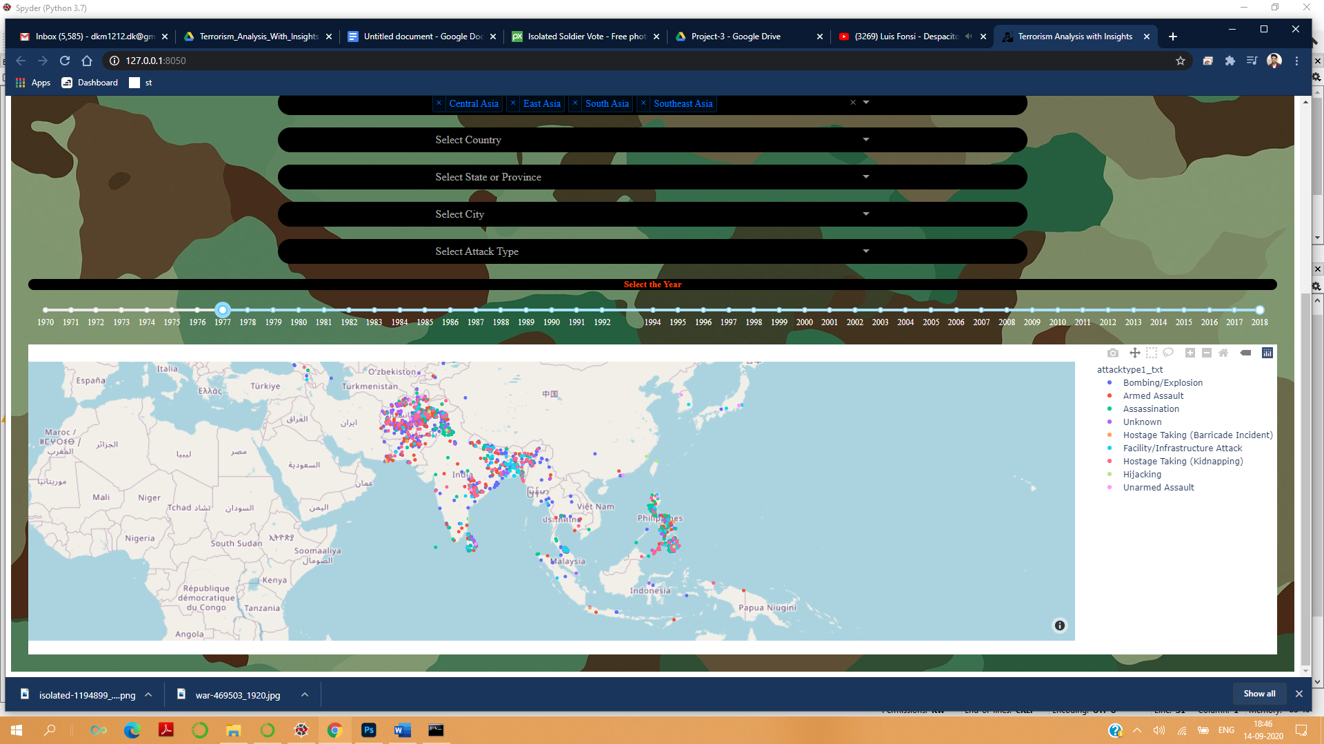

* **Chart for Attack-type**

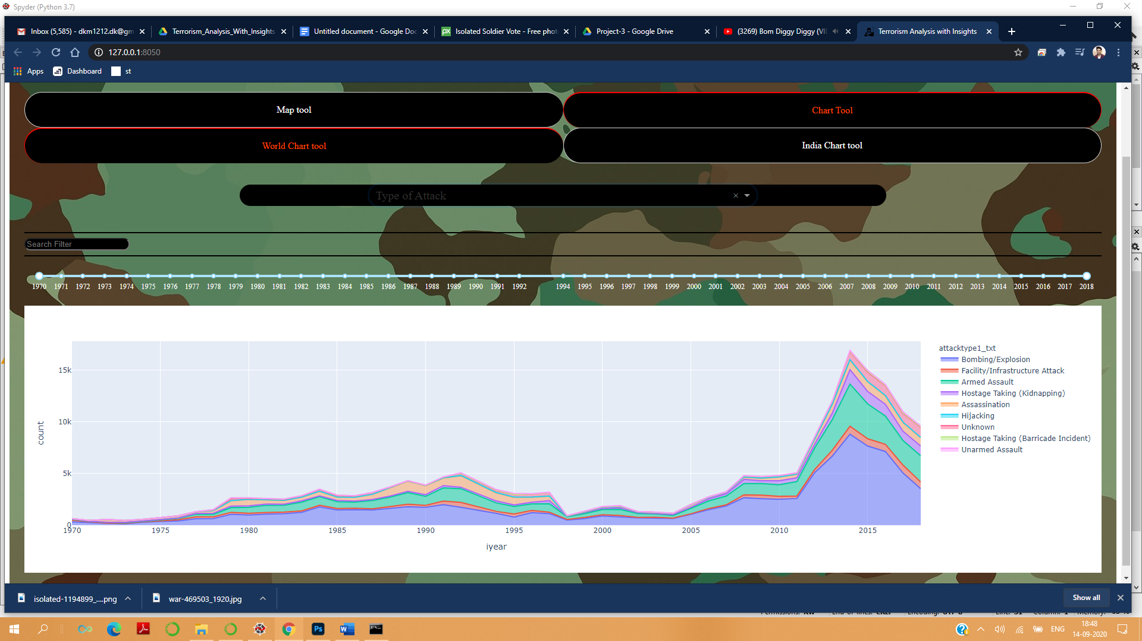

* **Chart for Region of India**

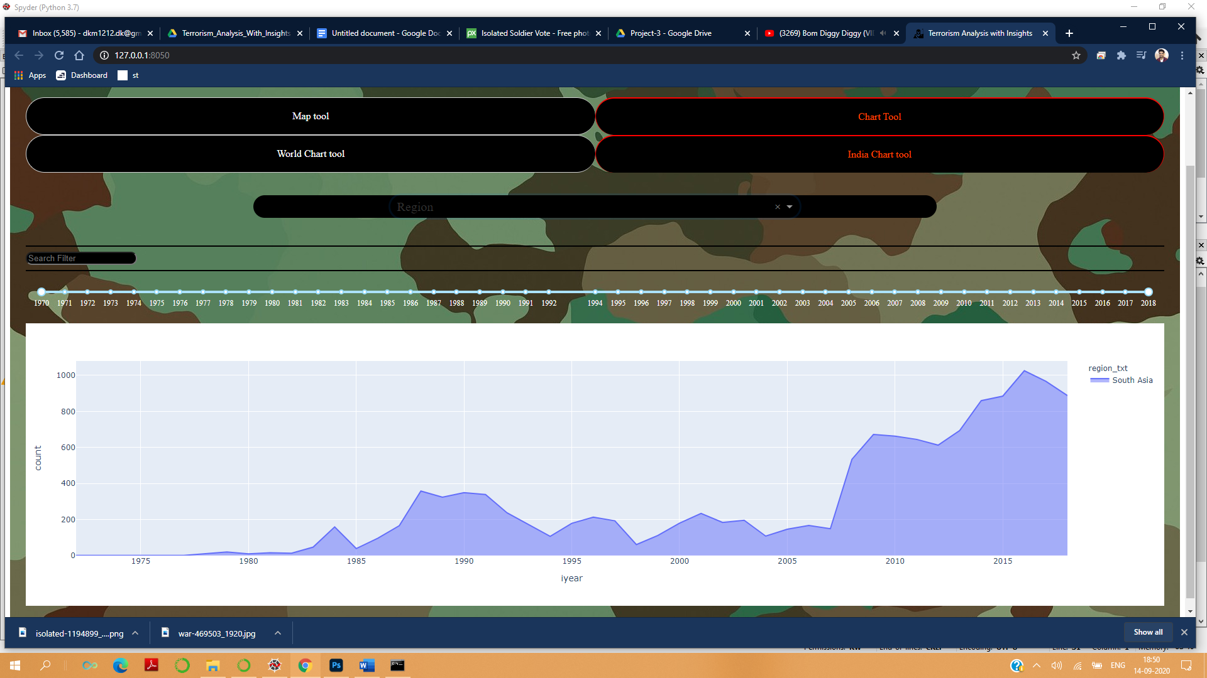

**Conclusion and Future Work:**

The project was able to meet the client’s need . The UI designed was robust and easy to use. The UI was able to display the Map tool and Chart Tool separately . From the charts we can easily conclude that the number of terrorist activities have been gradually increasing .

The Scope of Future Work in the project is that we can use Machine Learning Algorithms and build a predictive model and thus we can easily predict the terrorist activities going to happen and thus prevent it .

**Acknowledgement:**

I would like to express my heartfelt and sincere thanks to my project guide **Dr. Sylvaster Fernandes** and **Mr. Yogesh Singh** and also the entire team of **Forsk Coding School.** Their guidance and supervision was much needed for this project to be completed . They also provided the required information and also supported me in the entire journey and kept me motivated throughout.

I would also like to express my gratitude and sincere thanks to my Parents for their cooperation and providing me the requirements need for completing this project.

**References:**

* <http://dash.plotly.com/>
* <https://towardsdatascience.com/how-to-build-a-web-based-app-in-50-lines-of-code-using-plotly-and-dash-3953f039b217>
* <https://www.youtube.com/watch?v=yfWJXkySfe0&feature=youtu.be>
* <https://www.youtube.com/watch?v=i4yJi-cpwWk&feature=youtu.be>
* www.google.com

**Biography**

I am **Dipak Kumar Mahato** . I am from DurgaPur, West Bengal . I am pursuing my B.tech in Electrical Engineering from Lakshmi Narain College of Technology ,Bhopal. I am in final year of my graduation.

I believing in learning and performing my best . Although , I am from Electrical Engineering background , I have a lot of interest in learning new technologies and coding .

I have special interest for Data Science and Machine Learning . Before attempting this project , I had the knowledge of Basic Python programming and python libraries like Pandas and Matplot. As i have not made any project in python before , I had to face a lot of challenges during this journey . This project gave me an opportunity to learn new things like Data Analysis and Dash . It also gave me an opportunity to do my first Client-based Project .

While doing this project , I also learnt to face and overcome challenges which boosted up my confidence .

Thanking You,

Dipak Kumar Mahato