PUQWGA02_DVNTD_sfDB2jccdatasource.props.ear_PUQWG_AgencyUserDB2JCC.png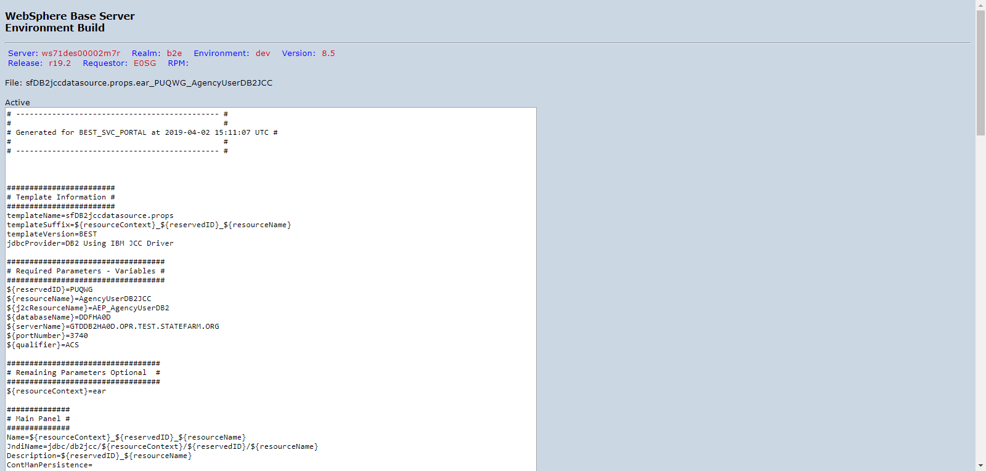

PUQWGA02_DVNTD_sfDB2jccdatasource.props.ear_PUQWG_ValidateAgentDB2JCC.png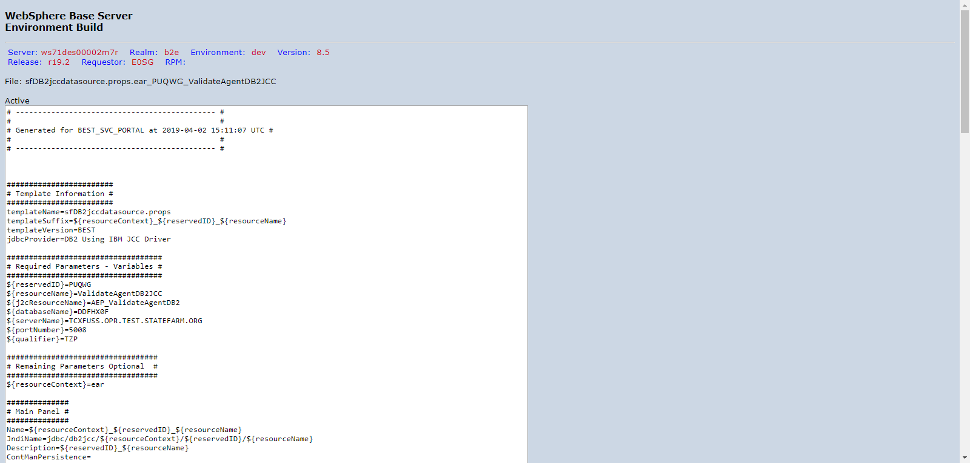

PUQWGA02_DVNTD_sfDB2jccdatasource.props.ear_PUQWG_AgencyUserDB2JCC.png

PUQWGA02_DVNTD_sfDB2jccdatasource.props.ear_PUQWG_ValidateAgentDB2JCC.png

PUQWGA02_DVNTD_sfDB2jccdatasource.props.ear_PUQWG_AgencyUserDB2JCC.png

PUQWGA02_DVNTD_sfDB2jccdatasource.props.ear_PUQWG_AgencyUserDB2JCC.png

PUQWGA02_DVNTD_sfDB2jccdatasource.props.ear_PUQWG_AgencyUserDB2JCC.png

PUQWGA02_DVNTD_sfDB2jccdatasource.props.ear_PUQWG_AgencyUserDB2JCC.png

PUQWGA02_DVNTD_sfDB2jccdatasource.props.ear_PUQWG_AgencyUserDB2JCC.png

PUQWGA02_DVNTD_sfDB2jccdatasource.props.ear_PUQWG_AgencyUserDB2JCC.png

PUQWGA02_DVNTD_sfDB2jccdatasource.props.ear_PUQWG_AgencyUserDB2JCC.png

PUQWGA02_DVNTD_sfDB2jccdatasource.props.ear_PUQWG_AgencyUserDB2JCC.png

PUQWGA02_DVNTD_sfDB2jccdatasource.props.ear_PUQWG_AgencyUserDB2JCC.png

PUQWGA02_DVNTD_sfDB2jccdatasource.props.ear_PUQWG_ValidateAgentDB2JCC.png

PUQWGA02_DVNTD_sfJ2C.props.ear_PUQWG_AEP_AgencyUserDB2.png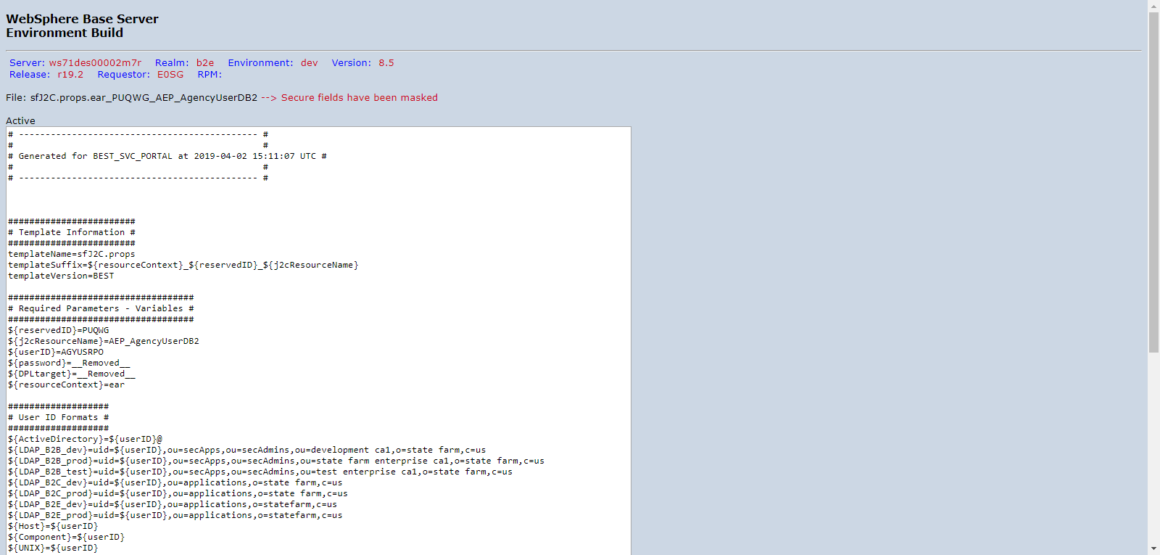

PUQWGA02_DVNTD_sfDB2jccdatasource.props.ear_PUQWG_AgencyUserDB2JCC.png

PUQWGA02_DVNTD_sfDB2jccdatasource.props.ear_PUQWG_ValidateAgentDB2JCC.png

PUQWGA02_DVNTD_sfJ2C.props.ear_PUQWG_AEP_AgencyUserDB2.png

PUQWGA02_DVNTD_sfDB2jccdatasource.props.ear_PUQWG_AgencyUserDB2JCC.png

PUQWGA02_DVNTD_sfDB2jccdatasource.props.ear_PUQWG_ValidateAgentDB2JCC.png

PUQWGA02_DVNTD_sfJ2C.props.ear_PUQWG_AEP_AgencyUserDB2.png

PUQWGA02_DVNTD_sfJ2C.props.ear_PUQWG_AEP_ValidateAgentDB2.png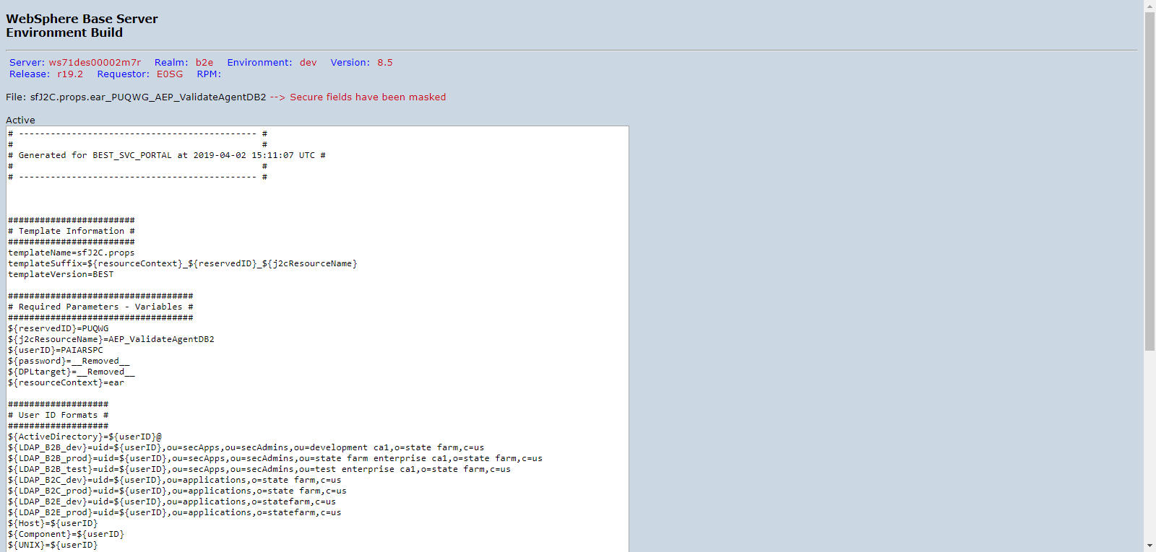

PUQWGA02_DVNTD_sfappserver.props.server1.png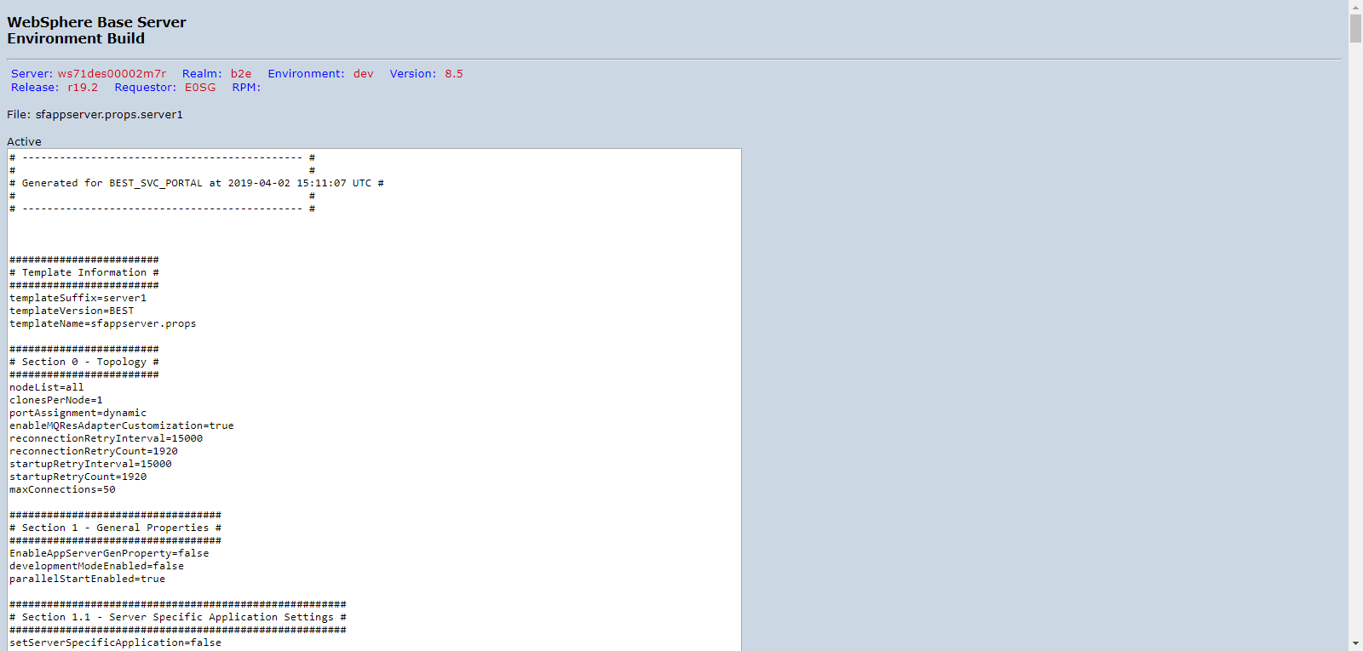

PUQWGA02_DVNTD_sfDB2jccdatasource.props.ear_PUQWG_AgencyUserDB2JCC.png

PUQWGA02_DVNTD_sfDB2jccdatasource.props.ear_PUQWG_ValidateAgentDB2JCC.png

PUQWGA02_DVNTD_sfJ2C.props.ear_PUQWG_AEP_AgencyUserDB2.png

PUQWGA02_DVNTD_sfJ2C.props.ear_PUQWG_AEP_ValidateAgentDB2.png

PUQWGA02_DVNTD_sfappserver.props.server1.png

PUQWGA02_DVNTD_sfDB2jccdatasource.props.ear_PUQWG_AgencyUserDB2JCC.png

PUQWGA02_DVNTD_sfDB2jccdatasource.props.ear_PUQWG_ValidateAgentDB2JCC.png

PUQWGA02_DVNTD_sfJ2C.props.ear_PUQWG_AEP_AgencyUserDB2.png

PUQWGA02_DVNTD_sfJ2C.props.ear_PUQWG_AEP_ValidateAgentDB2.png

PUQWGA02_DVNTD_sfappserver.props.server1.png

PUQWGA02_DVNTD_roleToUser.png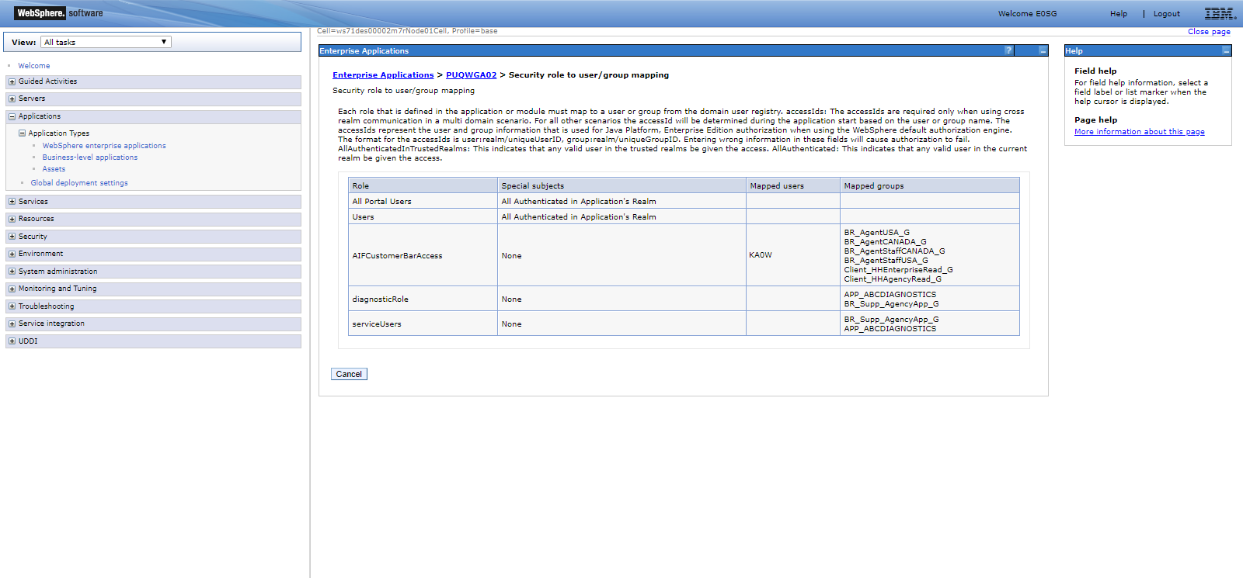

PUQWGA02_DVNTD_sfDB2jccdatasource.props.ear_PUQWG_AgencyUserDB2JCC.png