PUQWGA02_SYSTG_sfDB2jccdatasource.props.ear_PUQWG_AgencyUserDB2JCC.png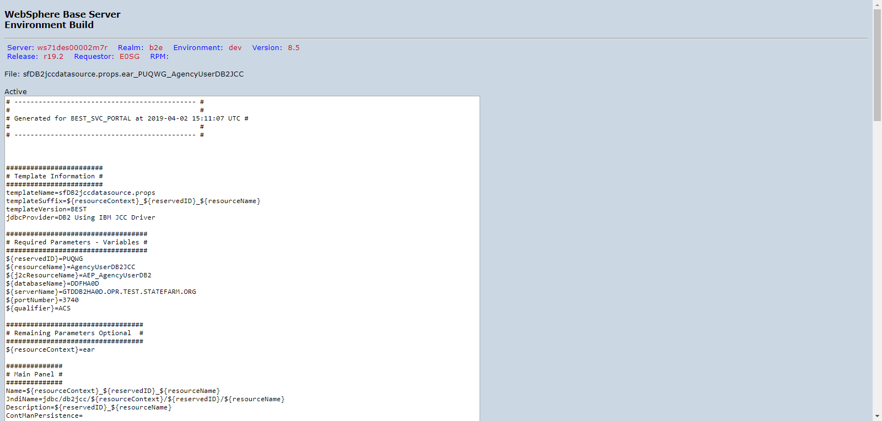

PUQWGA02_SYSTG_sfDB2jccdatasource.props.ear_PUQWG_ValidateAgentDB2JCC.png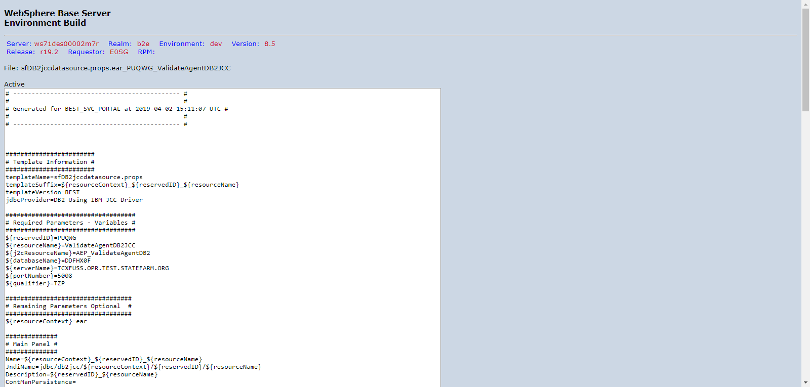

PUQWGA02_SYSTG_sfJ2C.props.ear_PUQWG_AEP_AgencyUserDB2.png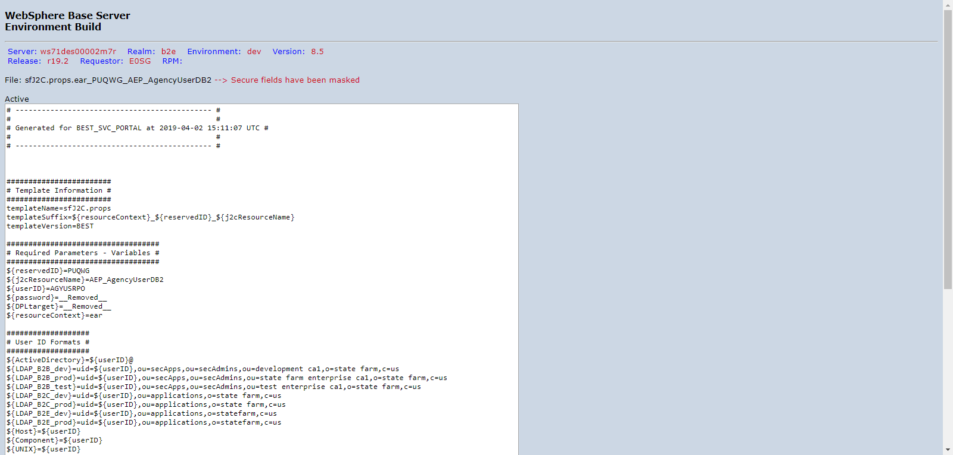

PUQWGA02_SYSTG_sfJ2C.props.ear_PUQWG_AEP_ValidateAgentDB2.png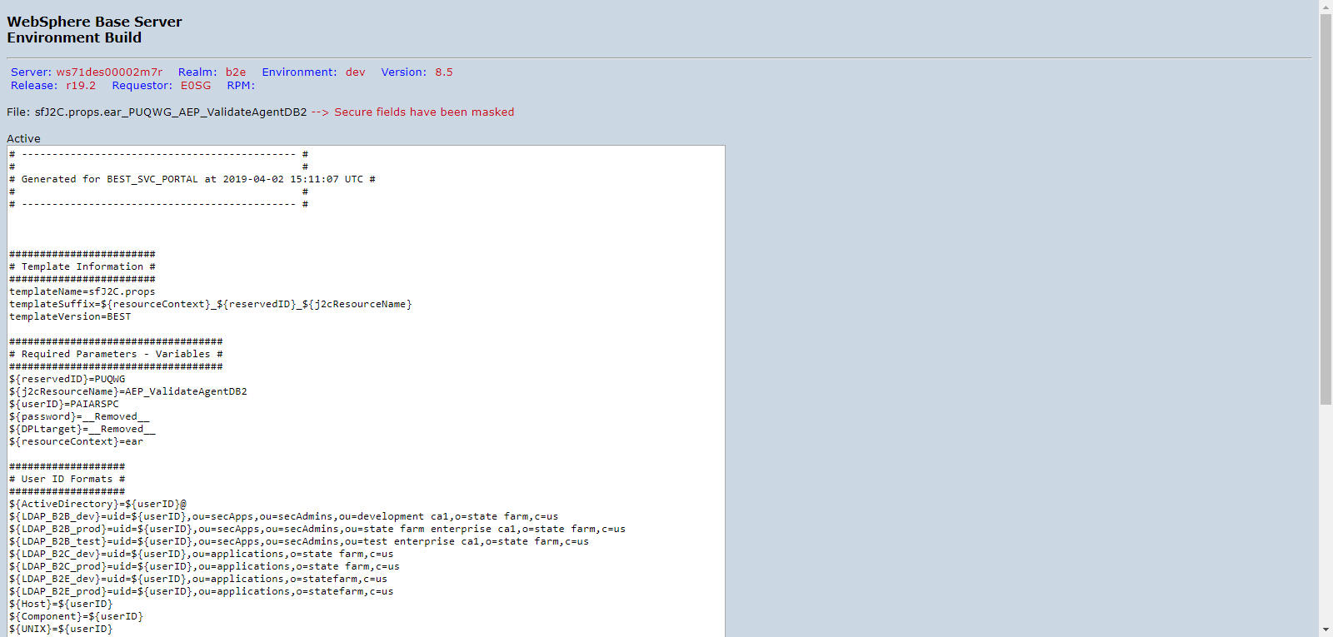

PUQWGA02_SYSTG_sfappserver.props.server1.png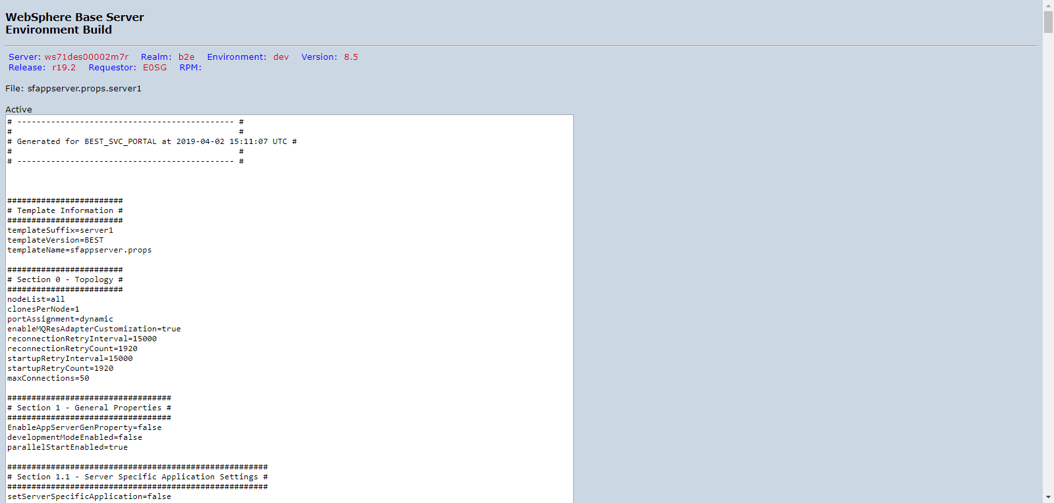

PUQWGA02_SYSTG_roleToUser.png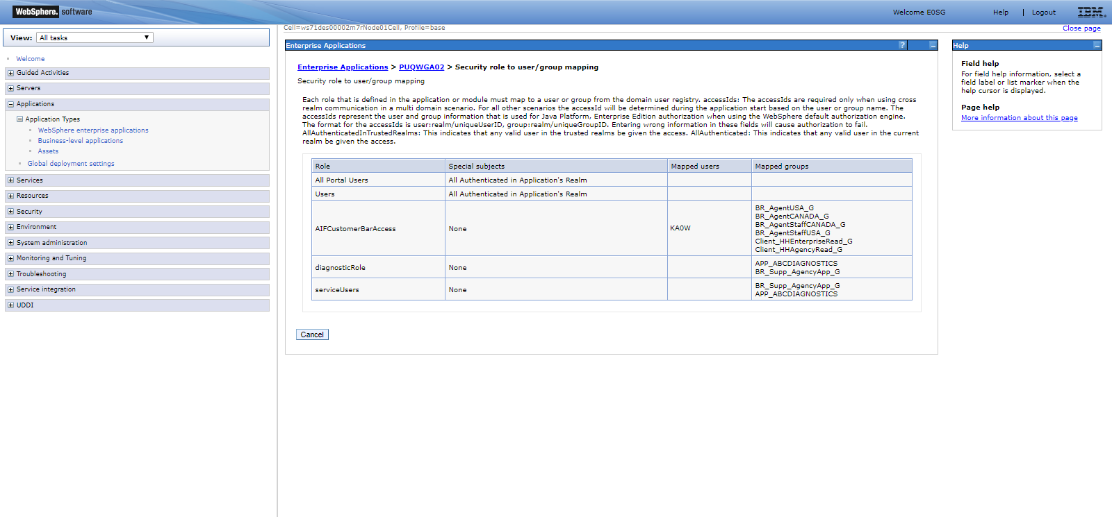

PUQWGA02_SYSTG_webservices.png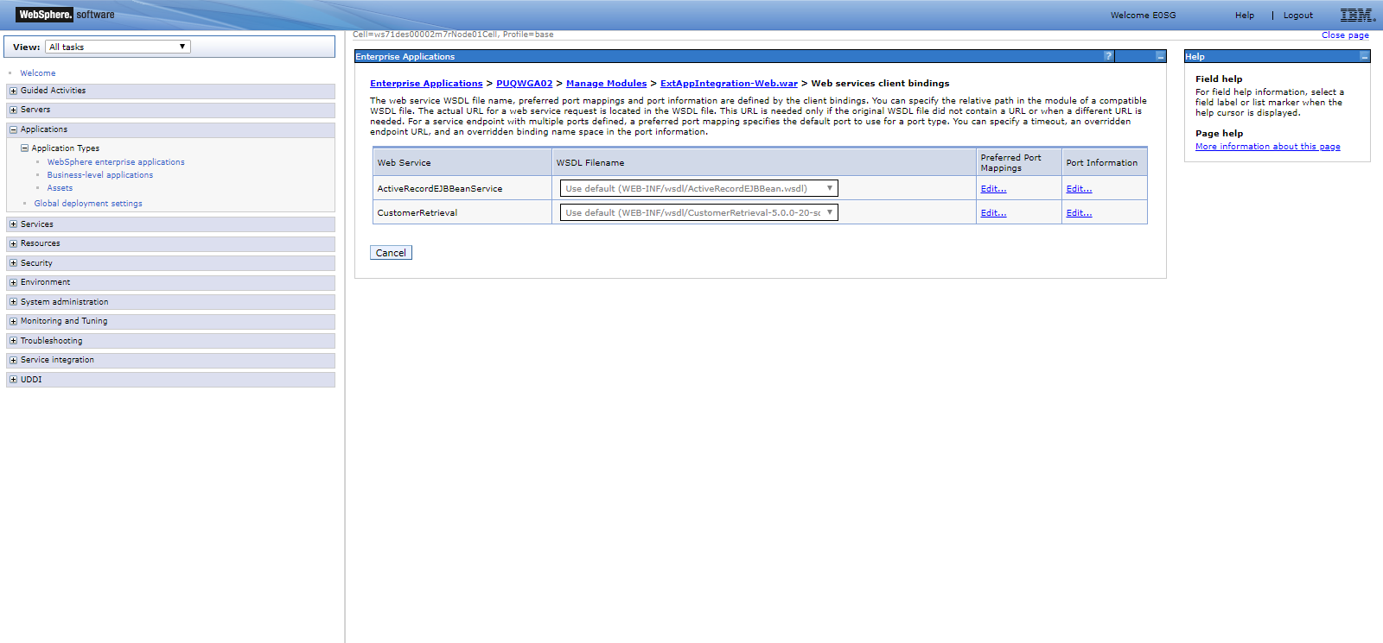

https://sfesb-dev.opr.test.statefarm.org/B2E/ActRecService/services/ActiveRecordEJBean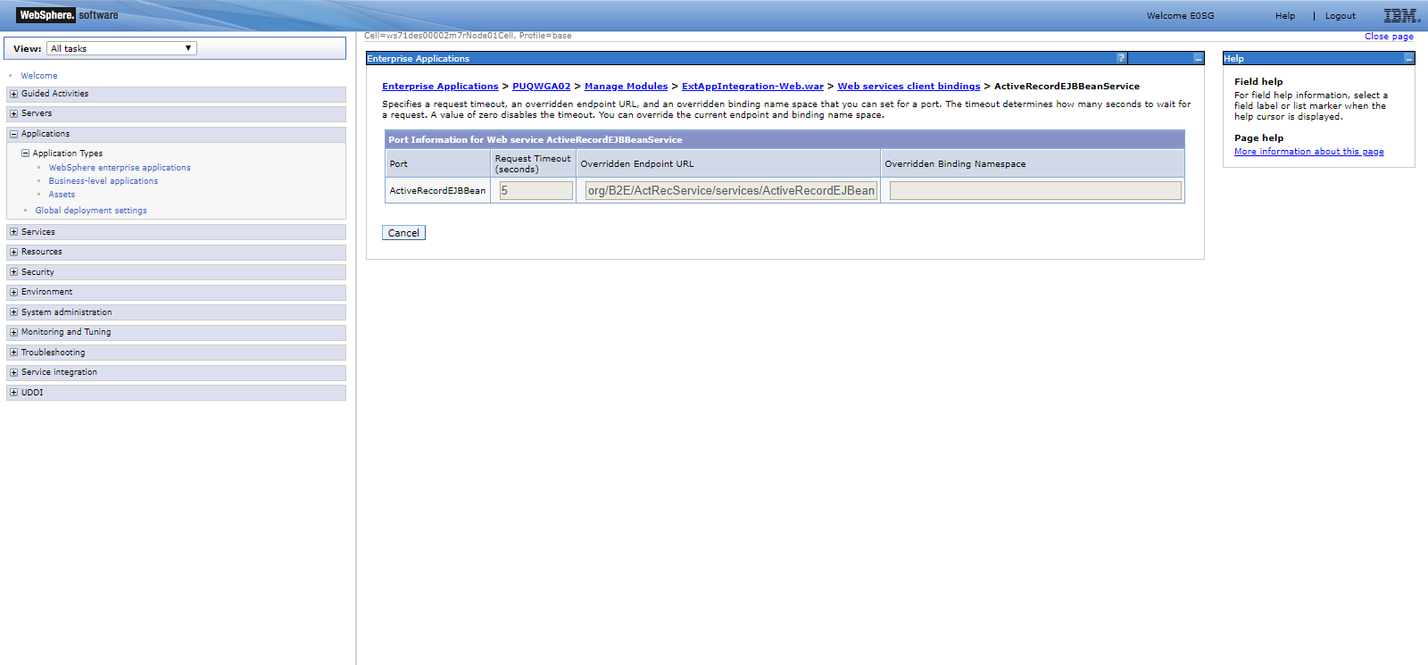

https://sfesb-sys.opr.test.statefarm.org/ICP/agentexternal/icpbridge/customerretrieval/systg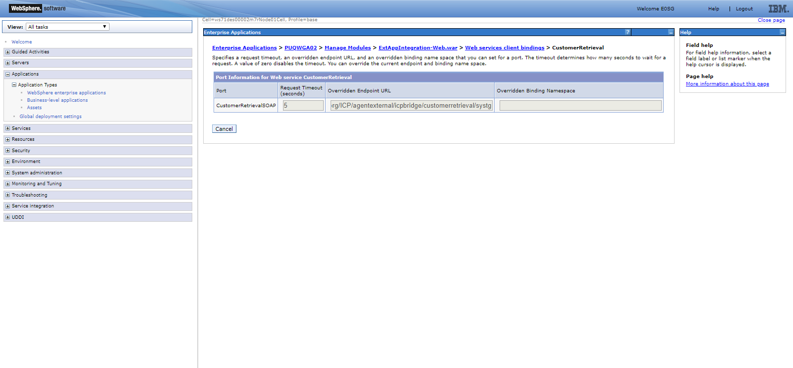

PUQWGA02_SYSTG_sfDB2jccdatasource.props.ear_PUQWG_AgencyUserDB2JCC.png

PUQWGA02_SYSTG_sfDB2jccdatasource.props.ear_PUQWG_ValidateAgentDB2JCC.png

PUQWGA02_SYSTG_sfJ2C.props.ear_PUQWG_AEP_AgencyUserDB2.png

PUQWGA02_SYSTG_sfJ2C.props.ear_PUQWG_AEP_ValidateAgentDB2.png

PUQWGA02_SYSTG_sfappserver.props.server1.png

PUQWGA02_SYSTG_roleToUser.png

PUQWGA02_SYSTG_webservices.png

https://sfesb-dev.opr.test.statefarm.org/B2E/ActRecService/services/ActiveRecordEJBean

https://sfesb-sys.opr.test.statefarm.org/ICP/agentexternal/icpbridge/customerretrieval/systg