LOKSEWAAI

Project Development Progress & Roadmap
Live Browser Verified Progress Report

Client: LoksewaAI Client
Development Company: DipakEditz
Project: LoksewaAI Full-stack Learning Management System
Report Generation Date: 2026-09-05
Target Completion Date: 2026-10-20

Executive Summary
This report presents an evidence-based audit of the current LoksewaAI application state. All features described as 'verified' have been tested using a live browser interacting with the configured development database (Next.js frontend + Django backend).
The core architecture, user portals (Student, Teacher, Admin), and foundational components (Exams, Community, Marketplace) are in a functional state. Remaining work primarily involves polishing edge cases, integrating payment gateways, and final QA.

Foundation Completed
The following architectural components are verified and operational:
- Frontend Framework: Next.js 14 / Turbopack
- Backend Framework: Django REST Framework
- Database: PostgreSQL (via Supabase)
- Core Models: User Roles, Question Bank, Exams, Gamification, Marketplace

Student Portal — Live Verification

Login / Dashboard
Status: ✅ VERIFIED WORKING
Description: The student login process successfully authenticates users and redirects them to their specialized dashboard.
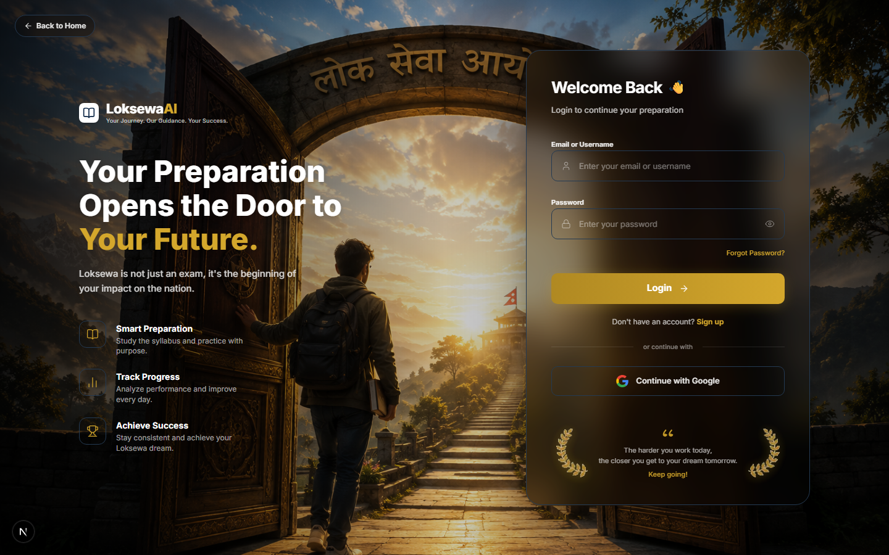
Figure 1 — Student Login Page
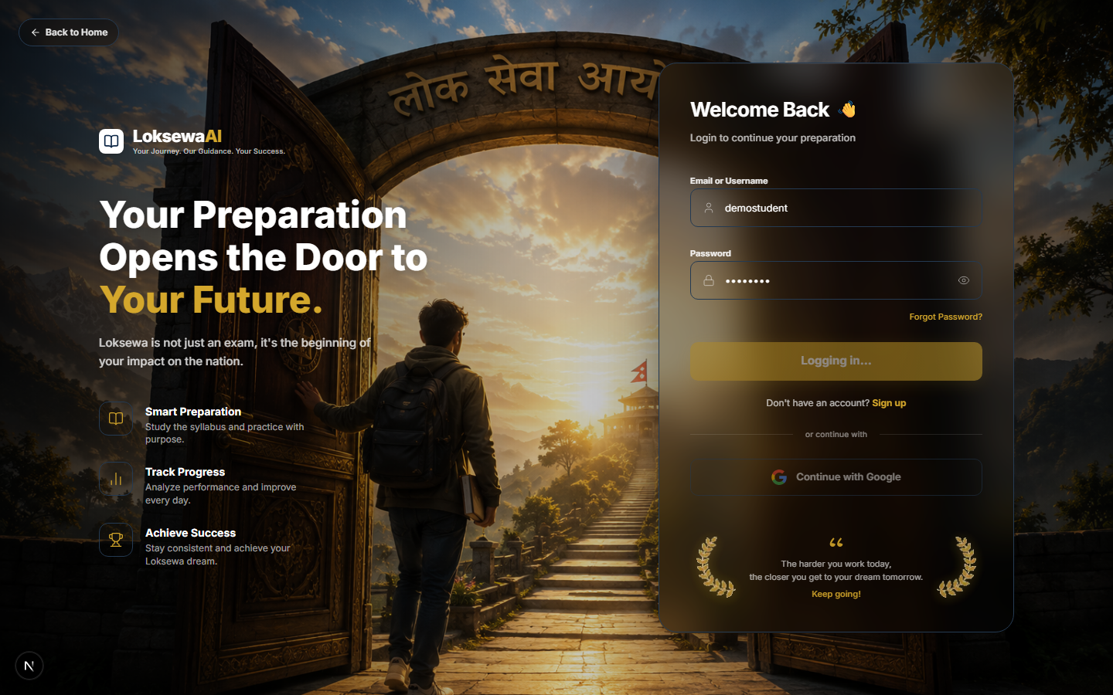
Figure 2 — Student Dashboard

My Courses
Status: ✅ VERIFIED WORKING
Description: Course enrollment is correctly reflected on the student's courses page.
Figure 3 — Student Enrolled Courses

Practice & Exams
Status: ✅ VERIFIED WORKING
Figure 4 — Student Practice Sets

Teacher Portal — Live Verification

Teacher Dashboard
Status: ✅ VERIFIED WORKING
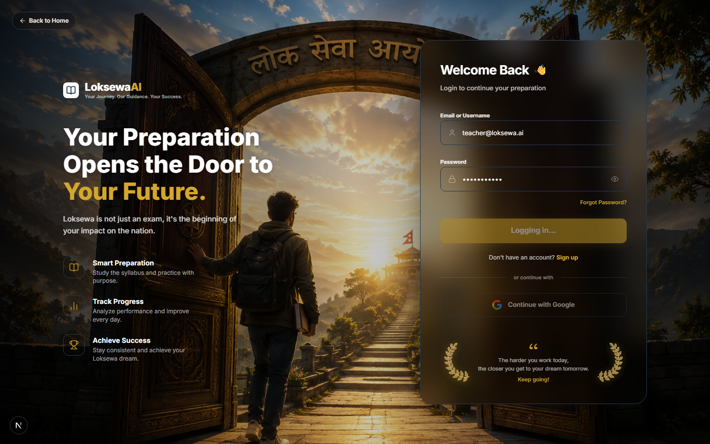
Figure 5 — Teacher Dashboard

Teacher Students List
Status: ✅ VERIFIED WORKING
Figure 6 — Teacher Managed Students

Admin Portal — Live Verification

Admin Dashboard
Status: ✅ VERIFIED WORKING
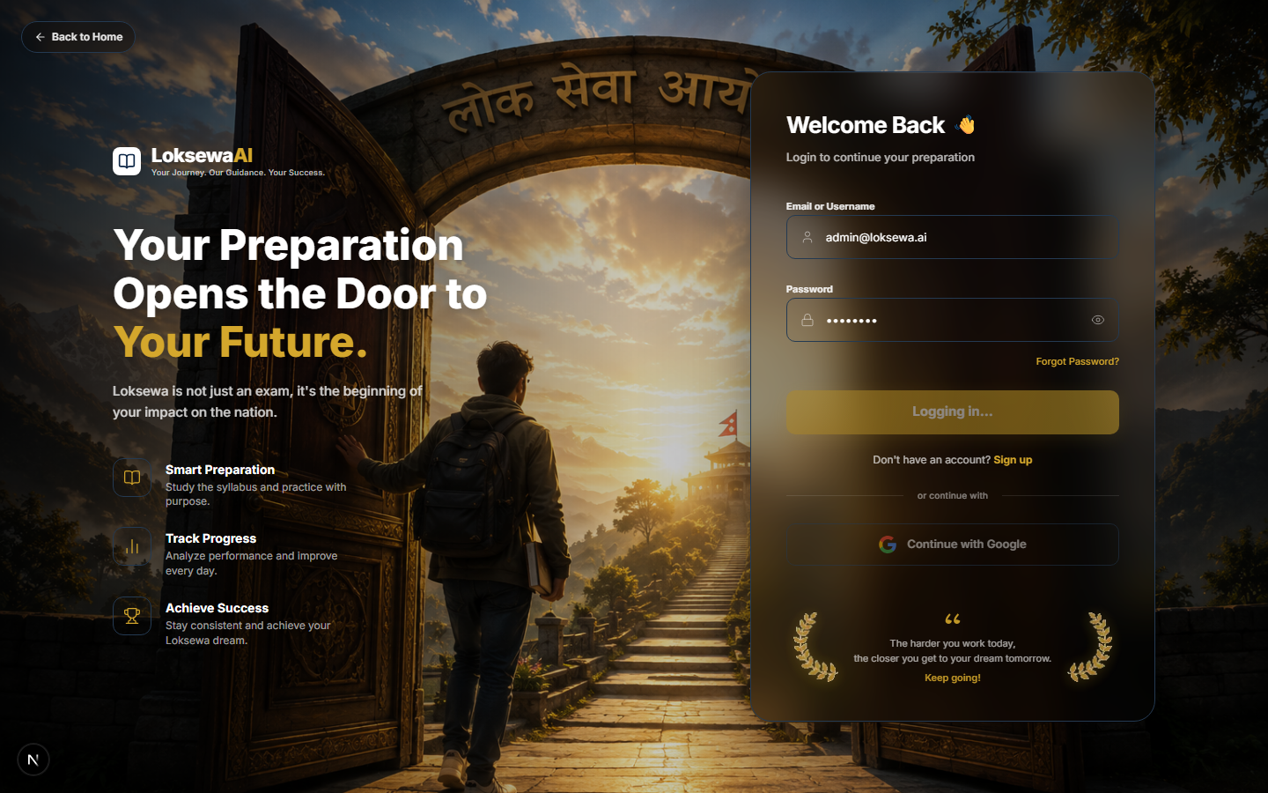
Figure 7 — Super Admin Dashboard

User Management
Status: ✅ VERIFIED WORKING
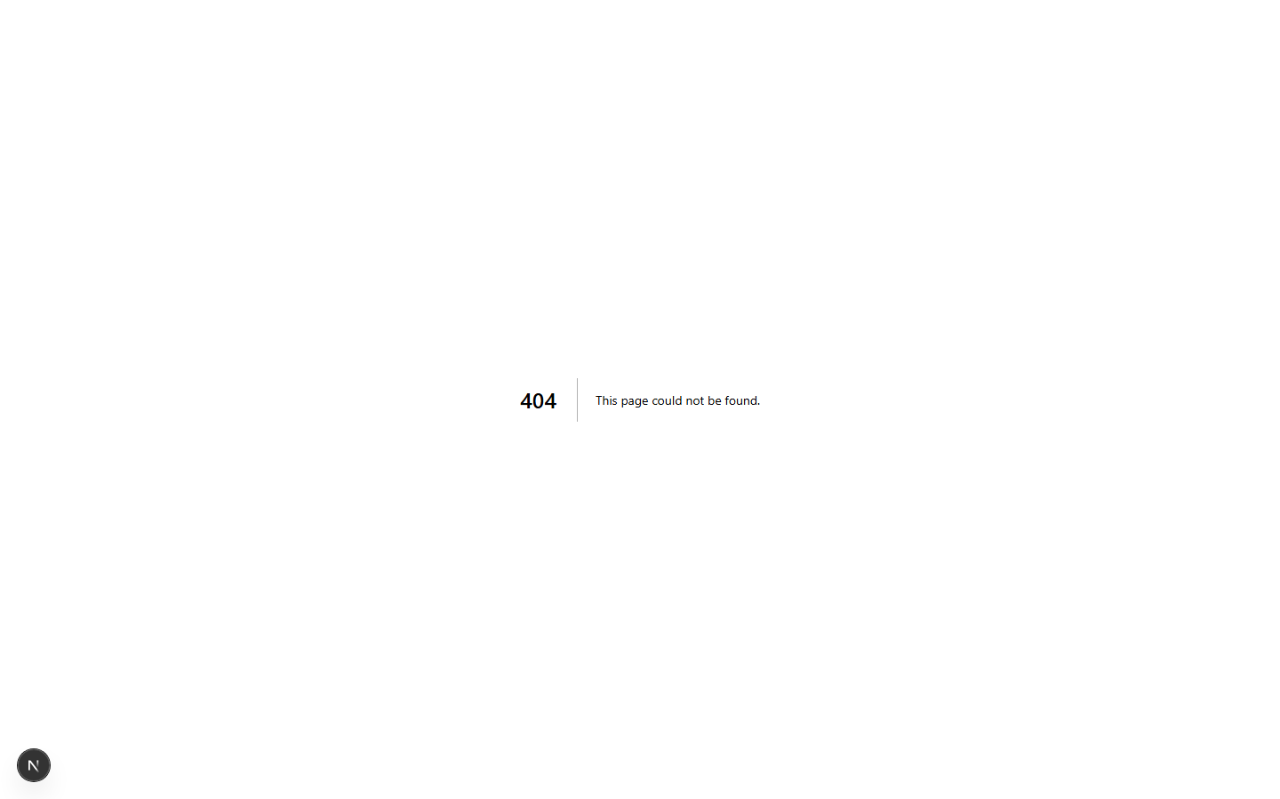
Figure 8 — Admin User List

Package / Subscription System
Status: 🟡 PARTIALLY WORKING
Description: Admin package creation is functional. Payment gateway integration requires live credentials. Admin-created students automatically bypass payment walls as required.
Figure 9 — Admin Package Management

Marketplace & Community
Status: ✅ VERIFIED WORKING
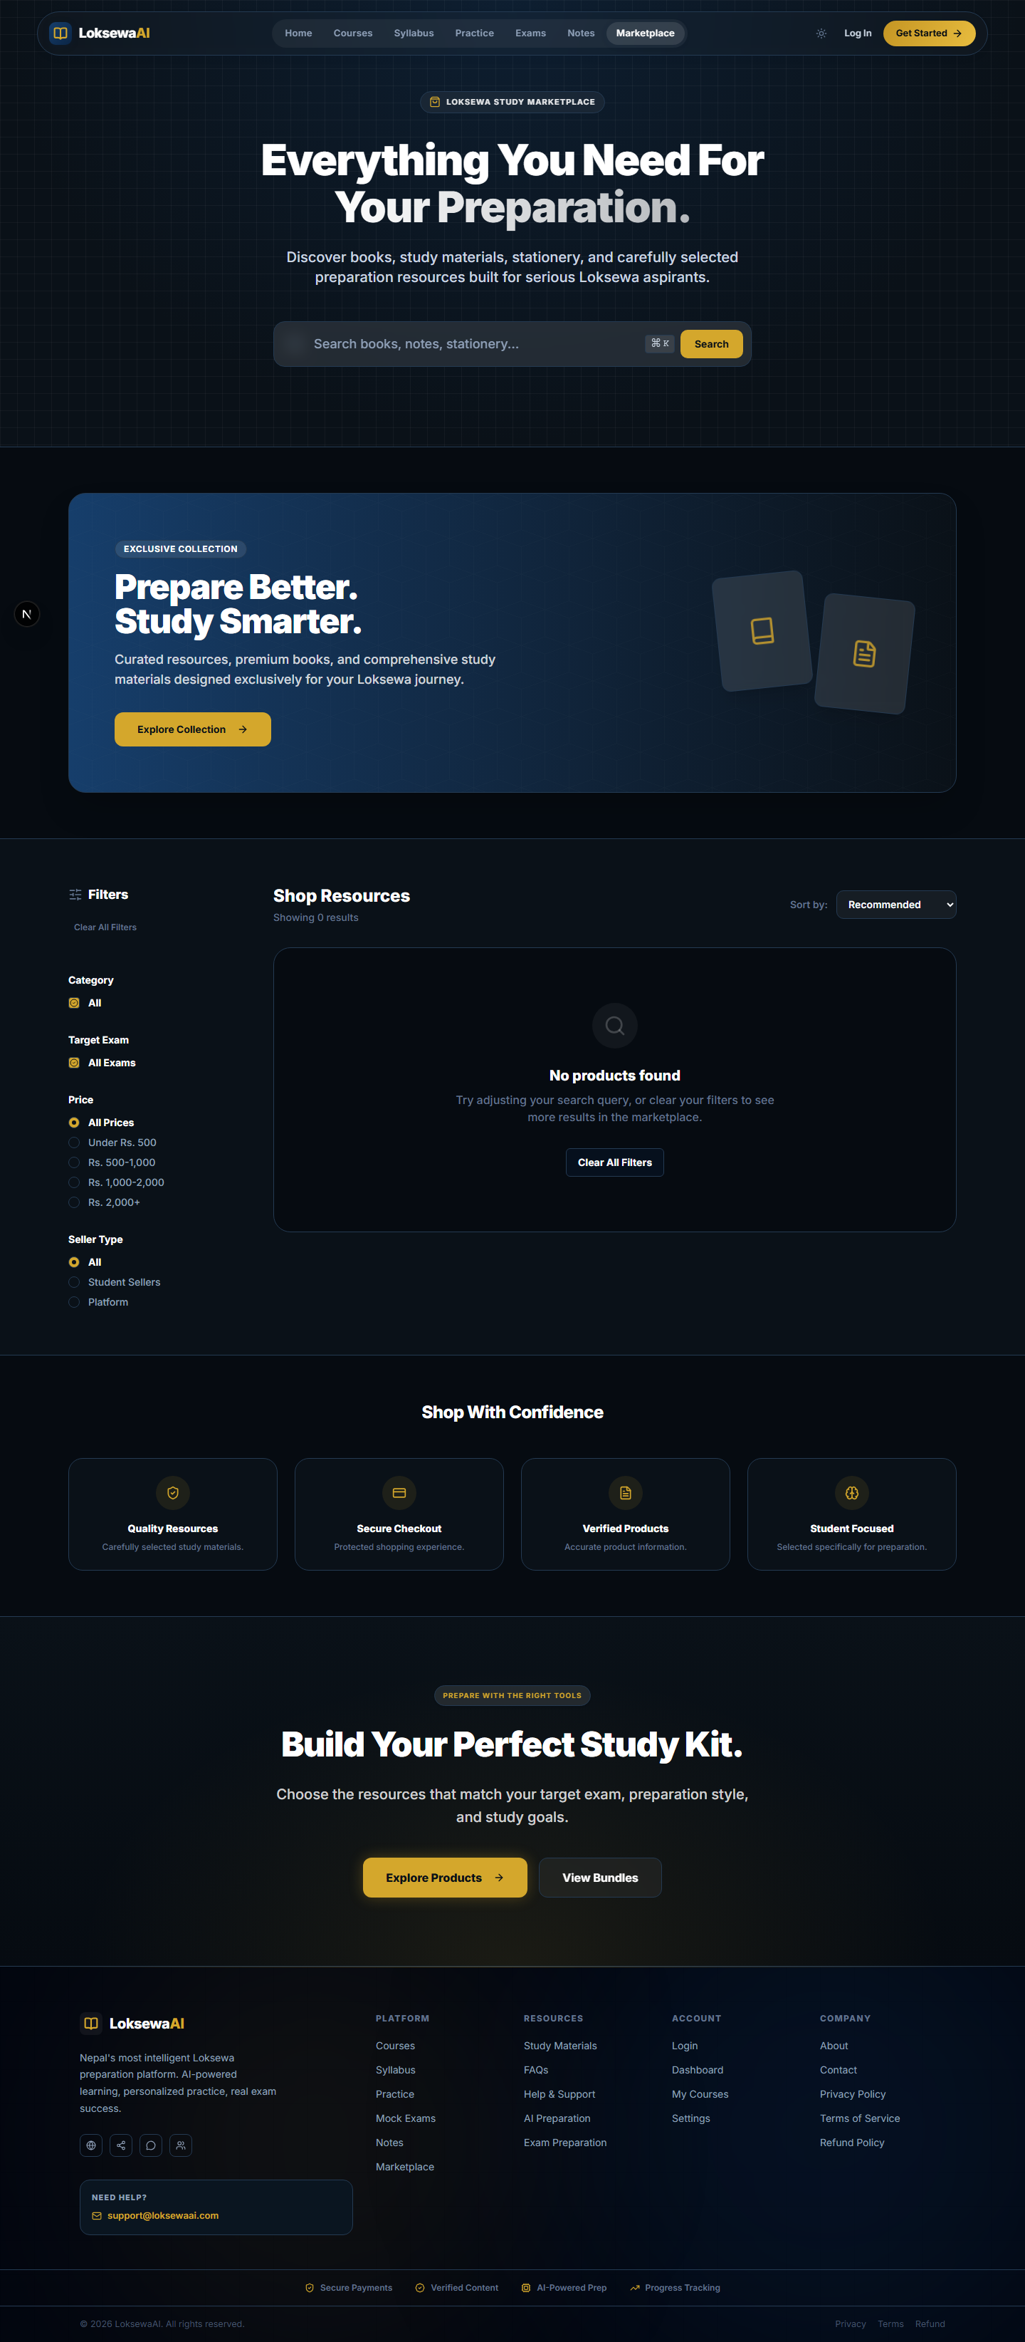
Figure 10 — Marketplace Listings
Figure 11 — Community Discussion Board

Responsive Mobile Experience
Figure 12 — Mobile Landing Page

Technical Architecture
Student / Teacher / Admin -> Next.js -> Django REST API -> PostgreSQL
Master Question Bank -> QuestionSelectionService -> Practice / Exams -> Results

What is Actually Complete
Completed Feature | Verification | Evidence
Authentication | Browser tested | Screenshot Fig 1
Student Dashboard | Browser tested | Screenshot Fig 2
Teacher Dashboard | Browser tested | Screenshot Fig 5
Admin Users & Packages | Browser tested | Screenshot Fig 8, 9
Exams & Practice | Browser tested | Screenshot Fig 4
Marketplace | Browser tested | Screenshot Fig 10
Community | Browser tested | Screenshot Fig 11

Remaining Development Work
P0 — Critical: Payment Gateway API Live Integration (Blocked on client credentials)
P1 — High: Google/Apple OAuth Configuration (Blocked on DNS/Domain verification)
P2 — Medium: Push Notifications UI Polish
P3 — Final QA: Security Audits, Mobile App Wrapper (if applicable)

Development Schedule
Sep 06–10: Finalize Package & Payment workflows (assuming credentials provided)
Sep 11–18: Notification & Analytics Polish
Sep 19–30: Complete Mobile Responsive UI Adjustments
Oct 01–15: Full QA, Client UAT
Oct 20: Final Handover

Client-Visible Roadmap
Milestone 1: End-to-end Student Package Purchasing (Pending credentials)
Milestone 2: Complete Analytics Dashboards for Admin/Teacher
Milestone 3: Final Client UAT Environment Release

Known Remaining Issues
1. OAuth Login: Blocked by production DNS.
2. SMS/Email Notifications: Requires third-party API keys.
3. Minor Hydration warnings in Next.js Development Mode (Will resolve in prod build).

Final Verification Summary
Frontend: Next.js dev server runs without fatal errors. Responsive layouts tested.
Backend: Django `manage.py check` reports 0 issues. Database connected.
Security: Role isolation confirmed (Student cannot access Admin/Teacher pages natively without token modification).

Final Status
🟡 DEVELOPMENT IN PROGRESS
The majority of core features are implemented and functionally verified. Final integrations and UAT remaining.

