**Task- Creating a snapshot and sharing it in different region**

**Go to EC2 service -> Snpashot -> click on create snapshot**

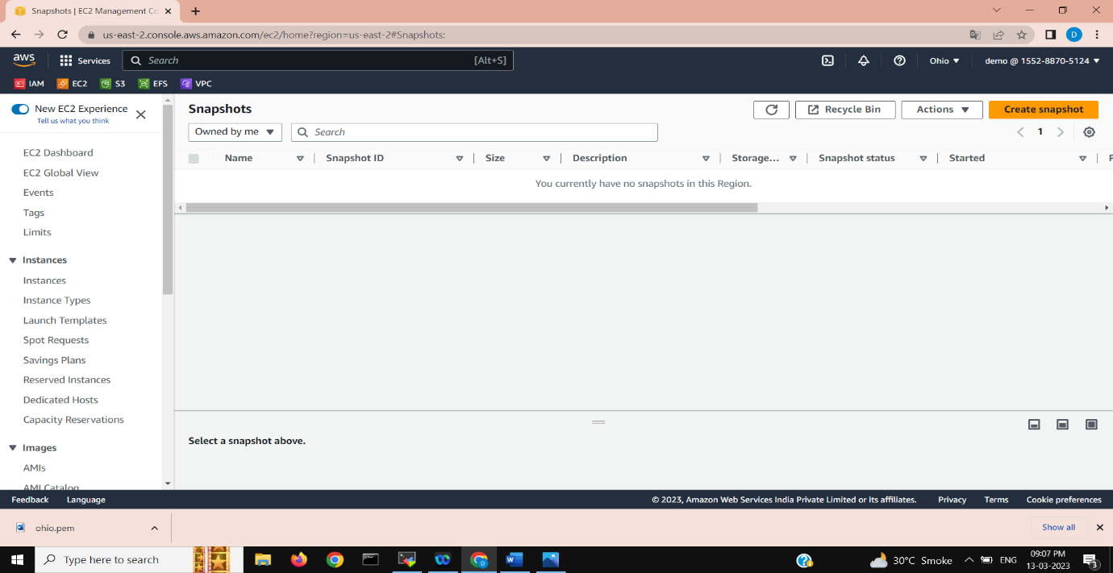

**Select of which we want to create snapshot-**

**Whether volume or instance**

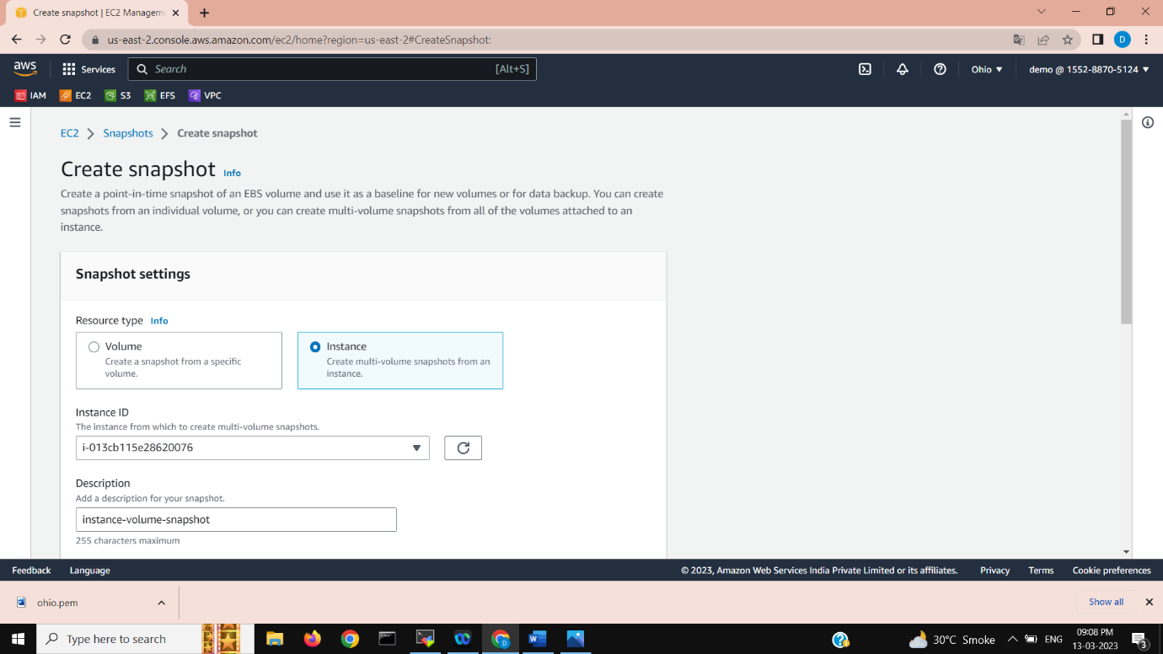

**Exclude any volume if required and then click create snapshot**

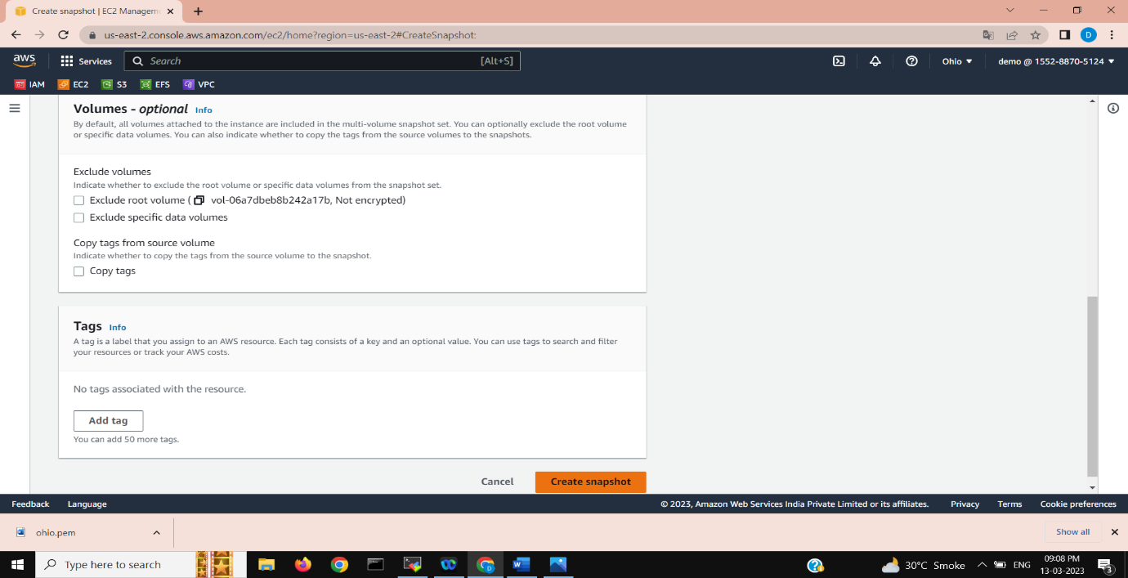

**Select created snapshot ,click on action -> copy snapshot**

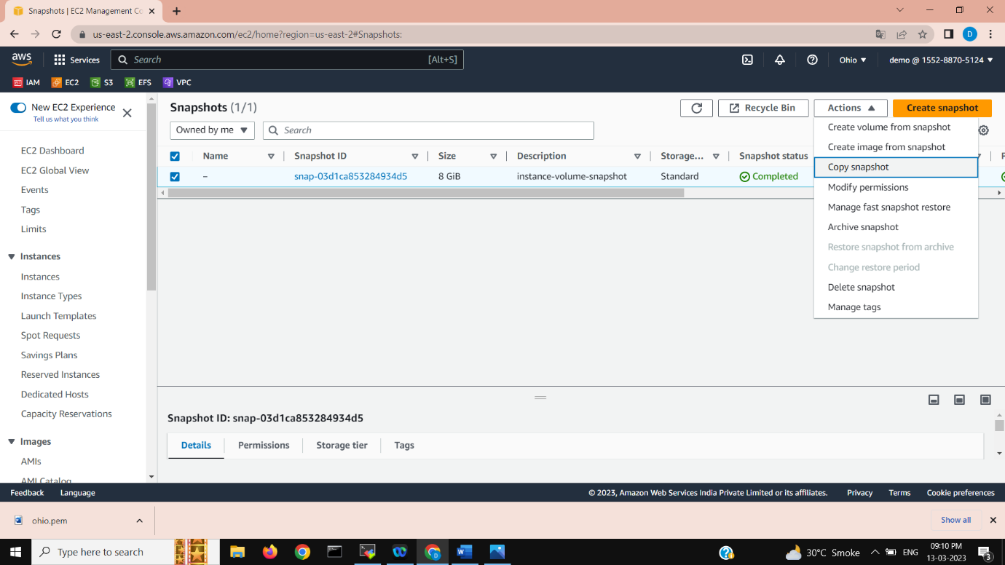

**Select snapshot and destination region**

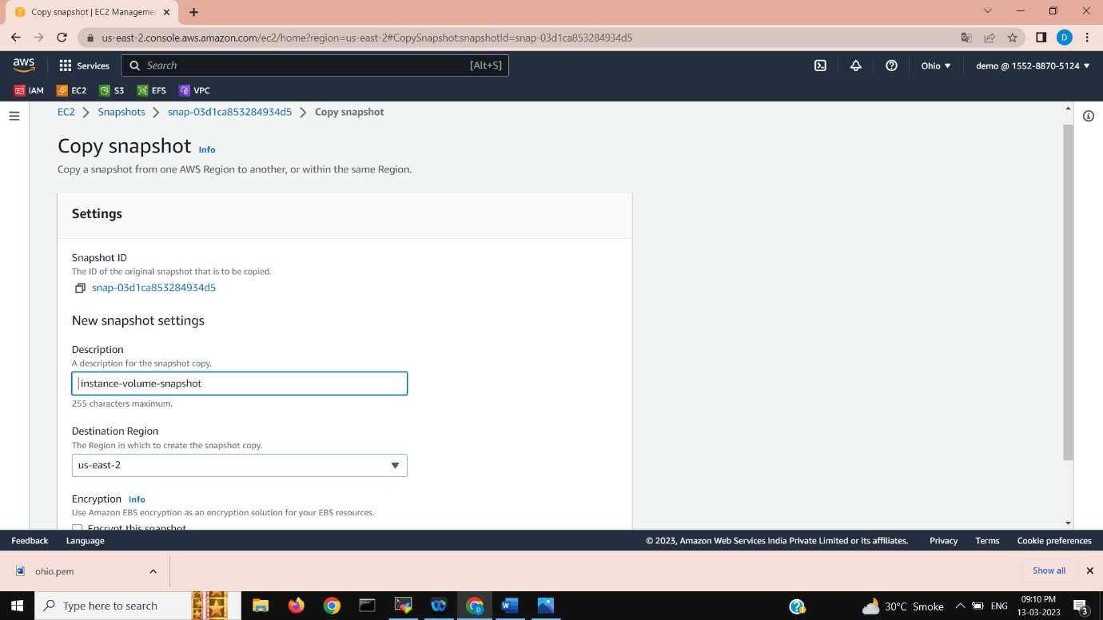

**Check destination region, snapshot copied.**

