//Program to implement data fragmentation used in DBMS:

create table employee(id integer, first_name varchar(100), last_name varchar(100), address varchar(100),age integer, location varchar(100),deptid integer, projid interger);

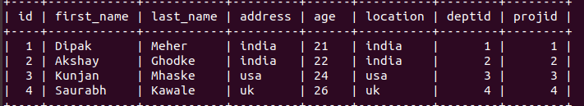
Horizontal Fragmentation:
select * from employee where location="india";
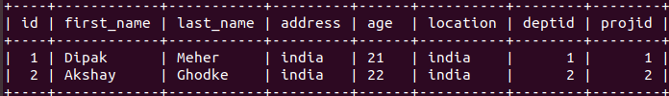
Vertical Fragmentation:
select first_name, last_name, location from employee;
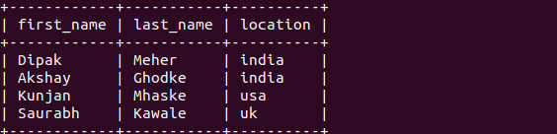
Hybrid Fragmentation:
select first_name,last_name,location from employee where location="india";
