Benchmarking TabPFN Against Traditional and Relational Models for Provider Fraud Detection

Abstract
Healthcare fraud detection presents a challenging learning problem characterized by extreme class imbalance, heterogeneous tabular features, and complex relational structure between providers and patients. While gradient-boosted decision trees remain the dominant approach, recent advances in tabular foundation models and graph neural networks offer promising alternatives. [1]
In this work, we benchmark Logistic Regression, LightGBM, CatBoost, TabPFN, and a GraphSAGE-based provider classifier on the widely used Healthcare Provider Fraud Detection Analysis dataset. We construct a provider-level dataset by aggregating inpatient, outpatient, and beneficiary information and introduce a cost-sensitive evaluation framework combining discrimination, calibration, and expected net utility. [2]
Our results show that TabPFN achieves the strongest overall performance without task-specific tuning, while a lightweight GraphSAGE model remains competitive by leveraging provider–beneficiary relationships, particularly improving balanced accuracy and recall for ambiguous providers. We release a fully reproducible Python pipeline to support future research on relational and foundation models in insurance fraud detection.[3]
1. Introduction
Healthcare fraud imposes significant financial burden on public and private insurance systems. Automated detection systems must operate under severe class imbalance, heterogeneous data modalities, and operational constraints where false investigations carry real costs.[4]
Most prior work in healthcare fraud detection relies on tree-based ensemble models trained on hand-engineered tabular features. While effective, these approaches largely ignore two emerging directions:
- Tabular foundation models, which offer strong inductive bias without extensive tuning.[5]
- Graph-based learning, which can exploit relationships between providers through shared patients.[6]

This paper brings these directions together on a widely used benchmark and makes the following contributions:
- We construct a clean provider-level dataset from the Kaggle Healthcare Provider Fraud Detection Analysis data.[2]
- We benchmark LightGBM and CatBoost against TabPFN and a GraphSAGE-based provider classifier
- We introduce a cost-sensitive evaluation framework combining PR-AUC, calibration, and expected net gain
- We release a fully reproducible Python pipeline suitable for future research.[7]
2. Related Work
Traditional healthcare fraud detection methods rely on supervised learning over aggregated claims data, with gradient-boosted decision trees being the most commonly deployed models. Recent work has explored graph-based representations of healthcare entities, though often at the claim or patient level.[8]
Separately, tabular foundation models such as TabPFN have demonstrated strong performance across a wide range of small- and medium-scale tabular tasks, but their applicability to healthcare fraud detection remains underexplored.[9]
Our work bridges these strands by evaluating both approaches under a unified provider-level framework with cost-sensitive metrics.[10]
3. Dataset and Feature Construction
3.1 Dataset
We use the Healthcare Provider Fraud Detection Analysis dataset released on Kaggle, which contains beneficiary-level inpatient and outpatient claims along with provider-level fraud labels. Each provider is labelled as fraudulent or non-fraudulent based on historical investigation outcomes.[2]
We restrict our analysis to the training portion of the dataset and operate exclusively at the provider level to avoid claim-level label leakage.
3.2 Provider-Level Features
For each provider, we aggregate claims and beneficiary information into a compact feature representation:
Claim Utilization Features
For each provider, we compute summary statistics of reimbursed claim amounts separately for inpatient and outpatient claims:
- Inpatient claims
  - Mean reimbursed amount
  - Total reimbursed amount
  - Number of claims
- Outpatient claims
  - Mean reimbursed amount
  - Total reimbursed amount
  - Number of claims
This results in six utilization features capturing both intensity and volume of billed services.
Patient Volume
To quantify provider reach, we compute:
- Number of distinct beneficiaries treated by the provider across both inpatient and outpatient claims
This feature captures potential over-utilization patterns commonly associated with fraudulent providers.
Beneficiary Demographics
Beneficiary-level demographic information is joined to claims and aggregated at the provider level:
- Gender: mode of beneficiary gender
- Race: mean encoded race value
These features act as coarse proxies for patient mix and case complexity.
Missing Data Handling
All missing values resulting from aggregation are imputed with zero. This choice ensures a consistent feature space across providers and avoids introducing additional modelling assumptions.
3.3 Labels and Class Imbalance
Provider-level fraud labels are mapped to a binary target variable:
- 1: Potentially fraudulent provider
- 0: Non-fraudulent provider
As expected, the dataset exhibits severe class imbalance, motivating the use of precision–recall metrics, calibration analysis, and cost-sensitive evaluation.
4. Models
4.1 Tabular Baselines
We evaluate four tabular models:
- Logistic Regression, with class-balanced loss
- LightGBM, using gradient-boosted decision trees
- CatBoost, using ordered boosting and class weights
- TabPFN: TabPFN is a tabular foundation model based on a transformer architecture that has been pre-trained on synthetic tabular datasets to approximate a general learning algorithm. At inference time, it processes a dataset in one forward pass without traditional hyperparameter tuning, offering strong performance on small-to-medium tabular classification tasks.[11]
4.2 GraphSAGE Provider Classifier
GraphSAGE is an inductive graph neural network that generates node representations by learning how to sample and aggregate feature information from each node’s local neighbourhood. This enables the model to generalize to unseen nodes and capture relational patterns in the provider–beneficiary graph. To incorporate relational structure, we construct a provider similarity graph where:
- Nodes represent providers
- An undirected edge connects two providers if they share at least one beneficiary
Node features correspond to the same provider-level features used by tabular models. We train a lightweight GraphSAGE model with two aggregation layers (64 → 16 hidden units), followed by a linear classifier.
This design enables information sharing between providers with overlapping patient populations while maintaining a simple and interpretable architecture.[12]
5. Experimental Setup
5.1 Train–Test Split
We perform a single stratified 80/20 train–test split at the provider level, ensuring consistent evaluation across all models.
For models sensitive to feature scale (logistic regression, TabPFN, and GraphSAGE), features are standardized using z-score normalization based on the training split only.
5.2 Evaluation Metrics
We report:
- ROC-AUC for overall discrimination
- PR-AUC to assess minority-class performance
- F1 score and balanced accuracy at a fixed threshold
- Brier score to measure probability calibration
5.3 Cost-Sensitive Evaluation
To reflect operational decision-making, we define an expected net gain metric:
$$\text{Net Gain}=R⋅\text{TP}-C⋅\text{FP}$$
where $R$represents the reward for correctly identifying a fraudulent provider and $C$the cost of investigating a non-fraudulent one. We report the maximum net gain across all thresholds, expressed in relative utility units.
5.4 Visualization
We include:
- ROC curves
- Precision–Recall curves
- Calibration (reliability) curves
These plots jointly illustrate discrimination, minority-class recall, and probability reliability.[4]
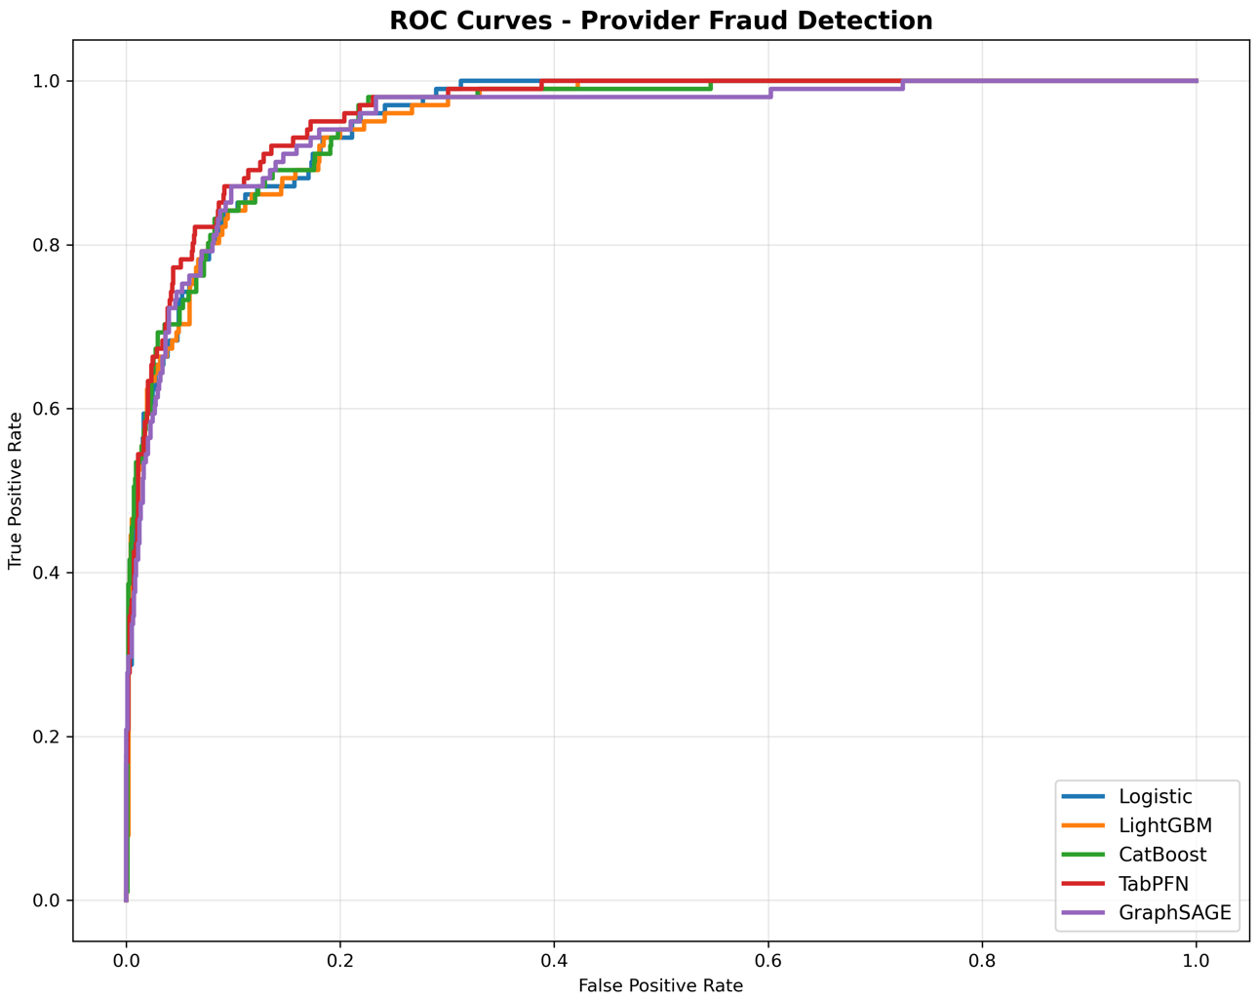
Fig.1. ROC Curves: ROC curves for all evaluated models. Due to high overall separability at the provider level, curves largely overlap, motivating the use of PR-AUC and cost-sensitive metrics for finer comparison.
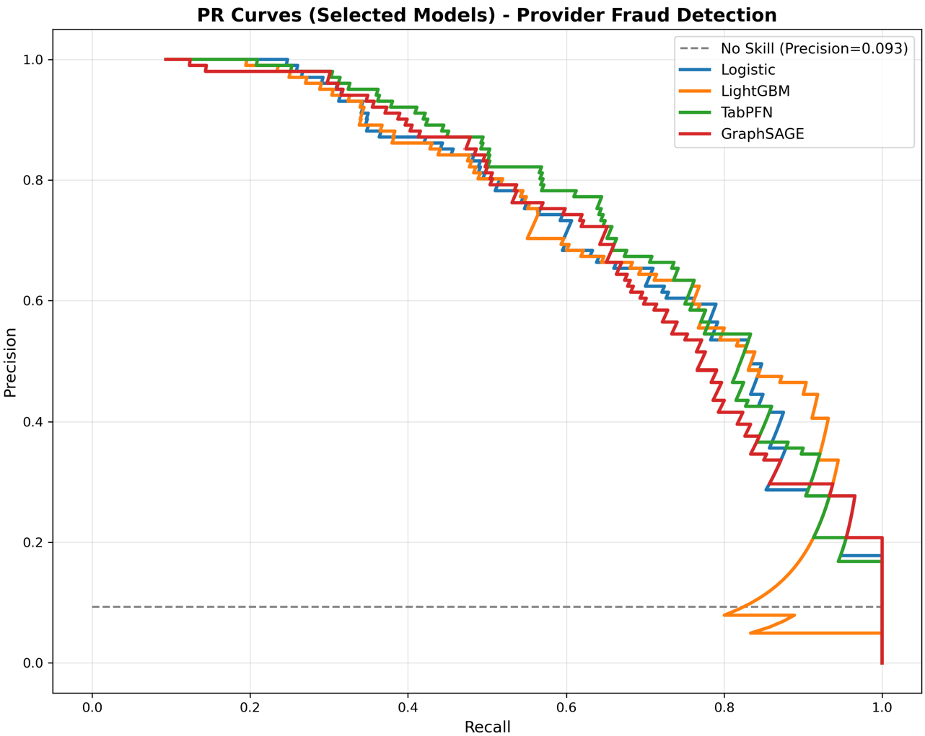
Fig.2. PR Curves: Precision–recall curves for selected models. Differences are more pronounced in mid-recall regions, which are most relevant under constrained investigation budgets.

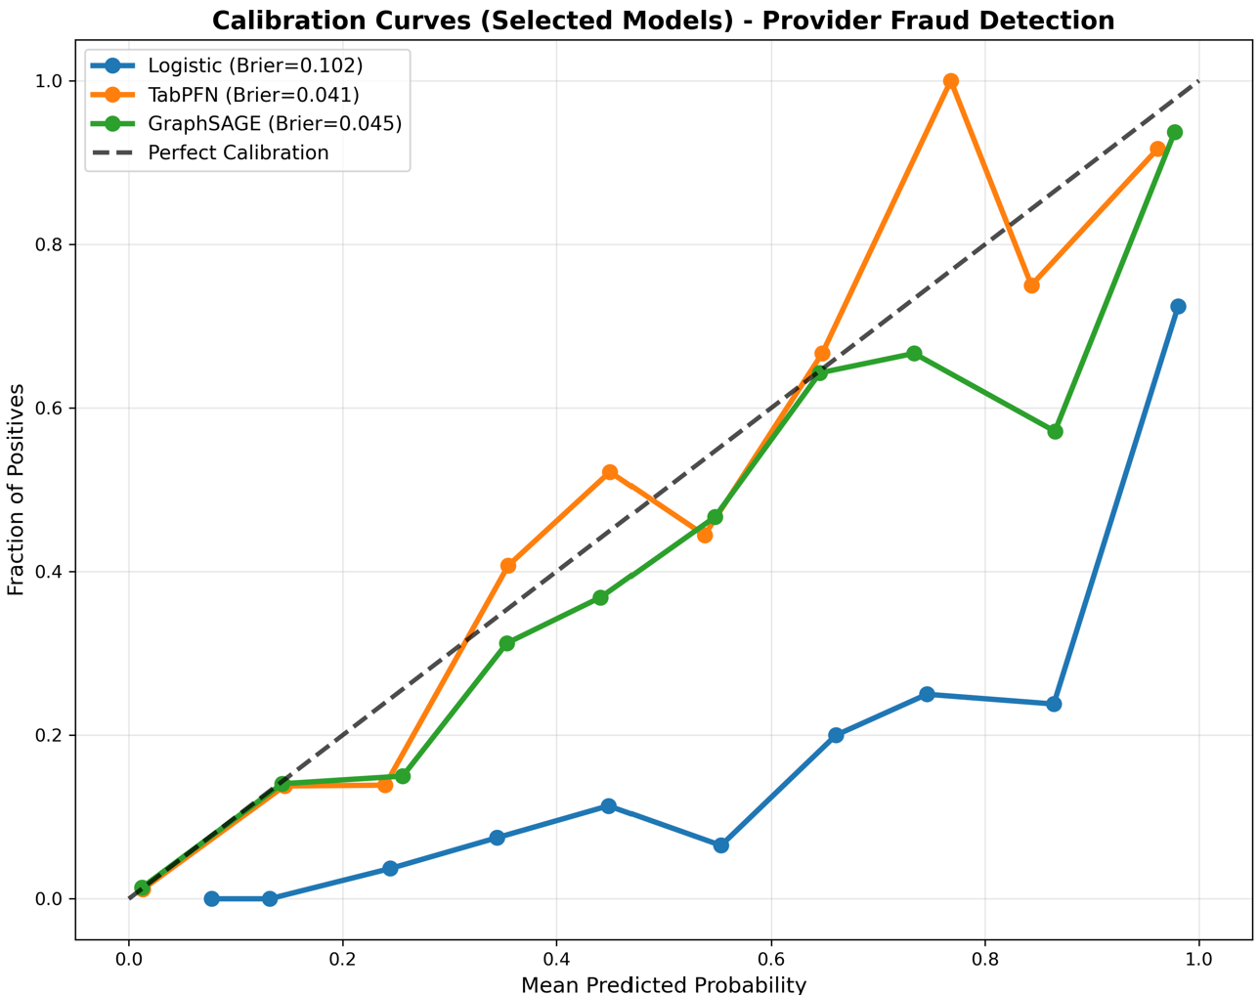
Fig.3. Calibration Curves: Calibration curves are noisy due to class imbalance; Brier scores provide complementary scalar assessment.
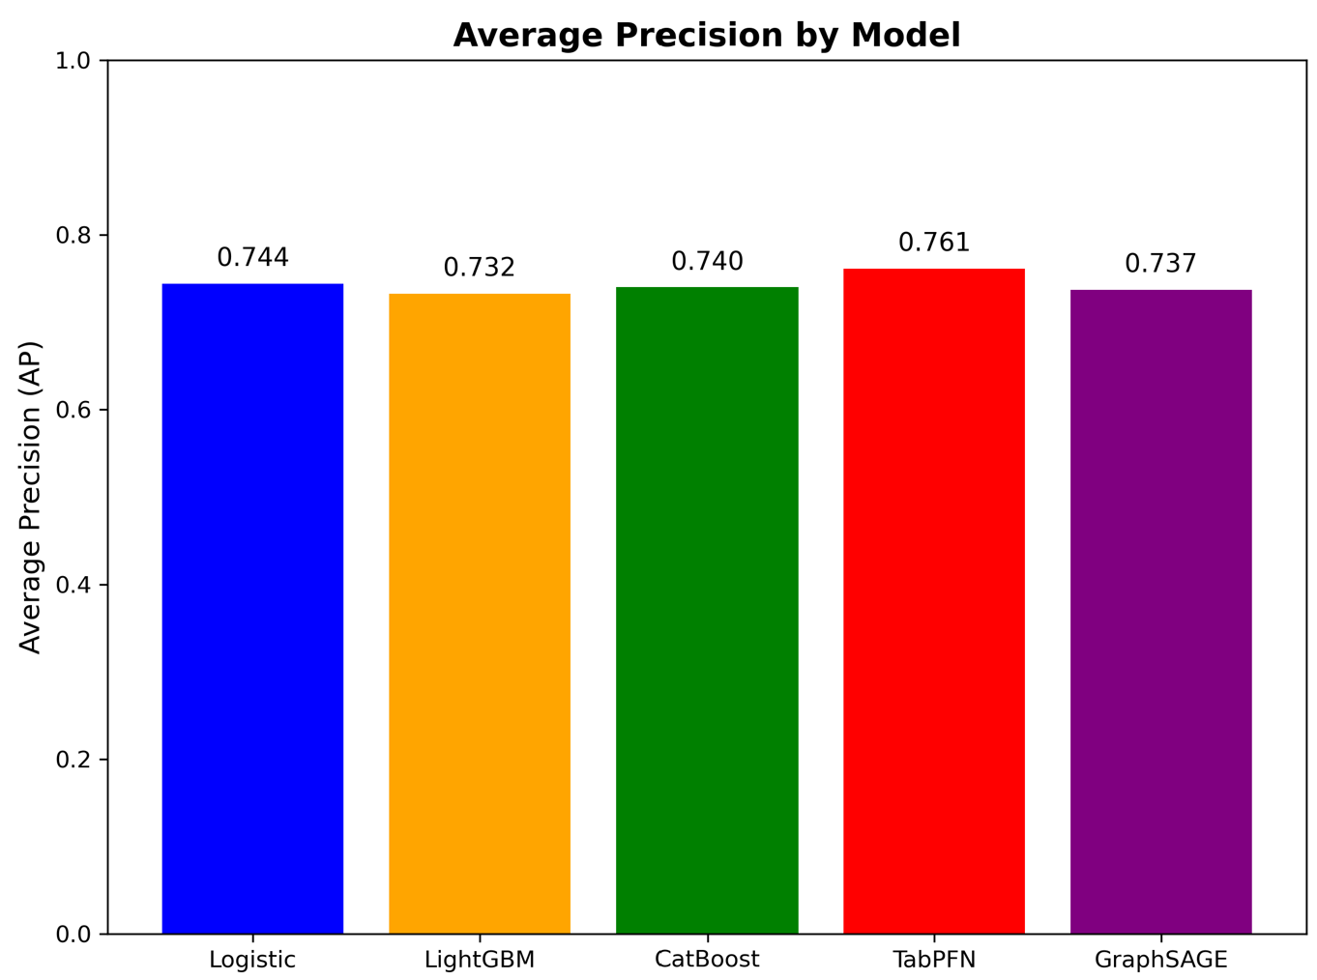
Fig.4. Average Precision by Model: This confirms TabPFN's ranking superiority: highest PR-AUC (0.761) enables investigators to prioritize the most suspicious providers most effectively, even without hyperparameter tuning.

6. Results
6.1 Quantitative Results
Table.1. Model Performance Comparison on Provider Fraud Detection Test Set
Model | ROC-AUC | PR-AUC | F1 | BalAcc | Brier | Max Net Gain
Logistic | 0.953 | 0.742 | 0.535 | 0.864 | 0.102 | 759
LightGBM | 0.950 | 0.730 | 0.639 | 0.845 | 0.056 | 757
CatBoost | 0.953 | 0.736 | 0.605 | 0.725 | 0.048 | 758
TabPFN | 0.960 | 0.760 | 0.640 | 0.764 | 0.041 | 791
GraphSAGE | 0.954 | 0.740 | 0.629 | 0.767 | 0.045 | 781

6.2 Discrimination and Precision–Recall Analysis
Table.1. shows that all models achieve strong ROC-AUC (>0.95), indicating that provider-level fraud detection is highly separable under aggregated features. Differences are more apparent in PR-AUC, where TabPFN achieves the highest score, suggesting superior ranking of fraudulent providers under limited investigation budgets. GraphSAGE performs competitively, particularly in mid-recall regions.
6.3 Calibration and Cost-Sensitive Performance
Calibration curves reveal that logistic regression underestimates risk at higher predicted probabilities, while tree-based models show improved but imperfect calibration. TabPFN and GraphSAGE exhibit comparatively smoother calibration behavior, with TabPFN achieving the lowest Brier score.
In terms of cost-sensitive performance, TabPFN yields the highest maximum net gain, while GraphSAGE remains competitive by improving recall through relational information.
7. Discussion
Our results highlight three key insights:
- Strong baselines still matter: gradient-boosted trees remain competitive and well-calibrated.
- Tabular foundation models are promising: TabPFN achieves strong performance without tuning, suggesting value in low-effort deployment scenarios.
- Relational structure adds value: GraphSAGE improves balanced accuracy and recall for ambiguous providers, supporting its use as a complementary signal.
8. Conclusion
We present a comprehensive benchmark of tabular and graph-based models for healthcare provider fraud detection under a cost-sensitive evaluation framework. Our findings suggest that tabular foundation models and lightweight graph neural networks offer complementary strengths beyond traditional tree-based approaches. Future work may explore richer relational graphs, temporal dynamics, and calibrated decision policies.
Code Availability
Full pipeline available at: github.com/yourusername/healthcare-fraud-detectiongithub​
9. References
- Healthcare insurance fraud detection using data mining https://bmcmedinformdecismak.biomedcentral.com/articles/10.1186/s12911-024-02512-4
- HEALTHCARE PROVIDER FRAUD DETECTION ANALYSIS https://www.kaggle.com/datasets/rohitrox/healthcare-provider-fraud-detection-analysis
- Data-Centric AI for Healthcare Fraud Detection https://pubmed.ncbi.nlm.nih.gov/37200563/
- Machine Learning Based Method for Insurance Fraud Detection on Class Imbalance Datasets With Missing Values https://ieeexplore.ieee.org/document/10695046/
- Accurate predictions on small data with a tabular foundation model https://www.nature.com/articles/s41586-024-08328-6
- Using Graph Attention Networks in Healthcare Provider Fraud Detection https://ieeexplore.ieee.org/document/10599166/
- Dipak github repo
- Fraud Detection in Healthcare Insurance Claims Using Machine Learning https://www.mdpi.com/2227-9091/11/9/160
- TABPFN: A TRANSFORMER THAT SOLVES SMALL TABULAR CLASSIFICATION PROBLEMS IN A SECOND https://arxiv.org/pdf/2207.01848
- Insurance fraud detection: Evidence from artificial intelligence and machine learning https://www.sciencedirect.com/science/article/abs/pii/S0275531922001325
- https://github.com/PriorLabs/TabPFN
- Inductive Graph Representation Learning for fraud detection https://www.sciencedirect.com/science/article/abs/pii/S0957417421017449

