Detection Report #1
SMB Enumeration Detection — Home SOC Lab

Summary
Field | Value
Date | July 29, 2026
Analyst | Dipak Poudel
Attacker host | Kali Linux — 192.168.50.20
Target host | Windows 11 (window11) — 192.168.50.11
SIEM | Wazuh manager — 192.168.50.10
Technique tested | SMB service/share enumeration

This exercise simulated an unauthenticated SMB reconnaissance scan from an attacker-controlled Kali Linux host against a Windows 11 target, and validated that the Wazuh SIEM captured and alerted on the resulting authentication activity.

1. Objective
Confirm that a Wazuh agent deployed on a Windows 11 endpoint generates usable telemetry when the host is scanned for open SMB shares, and validate that the Wazuh manager's default ruleset produces an alert an analyst can investigate.

2. Environment
- Attacker: Kali Linux, 192.168.50.20, isolated VMnet3 lab network
- Target: Windows 11, hostname window11, 192.168.50.11, Wazuh agent enrolled (agent.id 001)
- SIEM: Wazuh 4.14.6 all-in-one (manager, indexer, dashboard), Ubuntu Server, 192.168.50.10
- Network: isolated host-only segment (VMnet3); no attack traffic crossed onto the real host network or internet

3. Attack Steps
Windows Firewall initially blocked inbound SMB (port 445 showed filtered). File and Printer Sharing was enabled and the VMnet3 adapter's network profile was set to Private to allow the traffic through, matching a realistic scenario where a workstation has file sharing enabled on its local network.
Command run from Kali:
nmap -p445 --script smb-os-discovery,smb-enum-shares,smb-enum-users 192.168.50.11
Result: port 445 open; the enumeration scripts returned no share/user data because Windows 11 blocks anonymous enumeration of that detail by default. The connection attempt itself, however, was logged by Windows as an anonymous NTLM network logon.
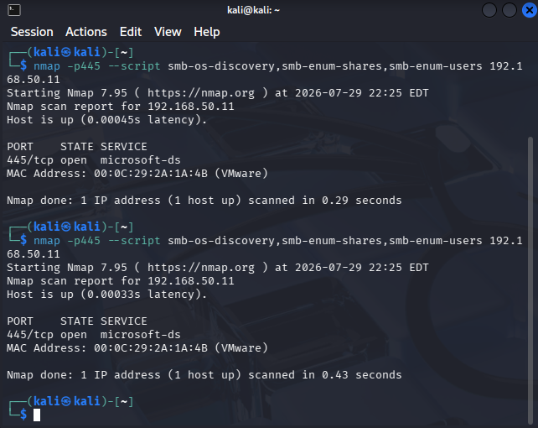
Figure 1 — Nmap SMB scan executed from Kali against the Windows 11 target (192.168.50.11).

4. Detection
The Wazuh dashboard (Events, agent window11, DQL: data.win.system.eventID: (5140 or 5145 or 4624 or 4625)) surfaced one matching event:
- Windows Event ID: 4624 (An account was successfully logged on)
- Logon Type: 3 (Network)
- Account: ANONYMOUS LOGON / WORKGROUP
- Authentication Package: NTLM (NTLM V1)
- Source: 192.168.50.20, Workstation Name: KALI
- Wazuh Rule: 92657, level 6, group win_evt_channel/windows/authentication_success
- Rule description: "Successful Remote Logon Detected - User:\ANONYMOUS LOGON - NTLM authentication, possible pass-the-hash attack - Possible RDP connection..."
The source IP and workstation name in the log (192.168.50.20 / KALI) confirm this event corresponds directly to the Nmap scan, not unrelated background activity.
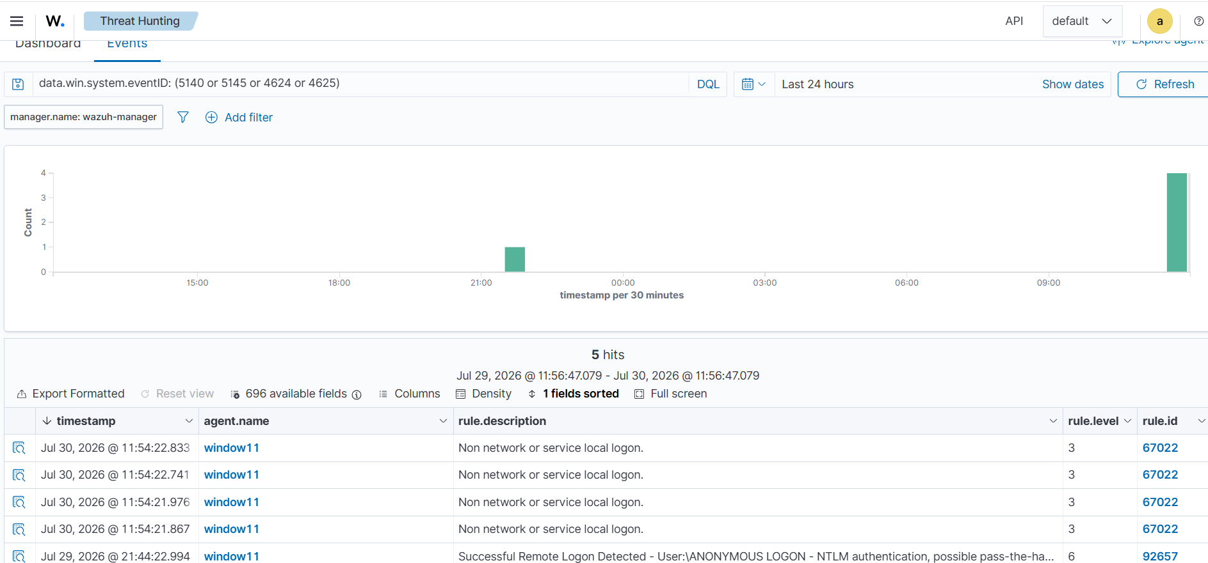
Figure 2 — Wazuh Events view for agent window11, filtered to logon/share-access event IDs, showing the matching alert.
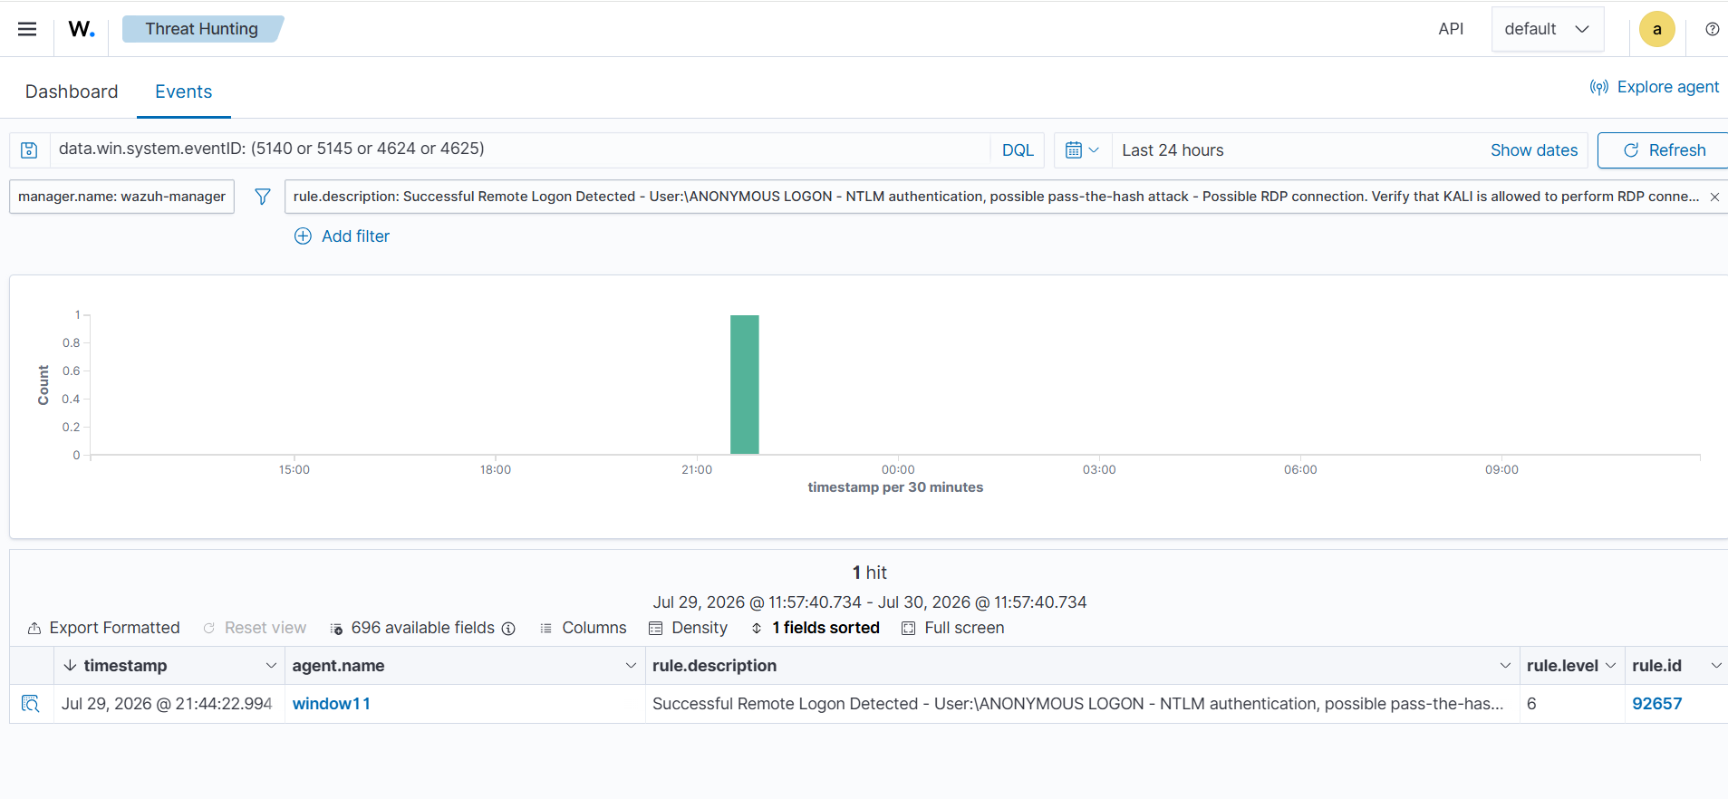
Figure 3 — Same alert filtered directly by rule description, confirming a single, isolated hit at 21:44:22.

5. Analysis — Correcting the Automated MITRE Mapping
Wazuh's rule 92657 auto-tags this event with MITRE ATT&CK techniques T1550.002 (Pass the Hash) and T1021.001 (Remote Desktop Protocol). Neither matches what actually occurred. Rule 92657 is a generic detector for any anonymous NTLM network logon, and its canned MITRE mapping reflects a common scenario (RDP relay / pass-the-hash) rather than the specific technique used in this exercise.
Based on the actual attack performed, the correct mapping is:
- T1046 — Network Service Discovery (the Nmap port/service scan itself)
- T1135 — Network Share Discovery (the smb-enum-shares/smb-enum-users script attempt)
This distinction matters operationally: an analyst who accepts the tool's default tag at face value would misclassify this as a credential-theft/lateral-movement event (pass-the-hash) rather than reconnaissance, which would change the severity and response. Verifying automated tags against the known attack timeline, rather than trusting them by default, is a core analyst skill this exercise demonstrates.

6. Conclusion
The lab successfully demonstrated a full detection loop: an attack was executed from a known-hostile machine, the target logged the resulting authentication activity, the SIEM ingested and alerted on it, and the alert was traced back to its source and correctly re-classified against MITRE ATT&CK. This confirms the Windows 11 agent, Wazuh manager, and the isolated lab network are all functioning correctly end to end.

