Detection Report #2
RDP Brute-Force Detection — Home SOC Lab

Summary
Field | Value
Date | July 30-31, 2026
Analyst | Dipak Poudel
Attacker host | Kali Linux — 192.168.50.20
Target host | Windows 11 (window11) — 192.168.50.11
SIEM | Wazuh manager — 192.168.50.10
Technique tested | RDP credential brute-force (Hydra)

This exercise simulated a credential brute-force attack against RDP on a Windows 11 target using Hydra from Kali Linux, and validated that Wazuh's built-in correlation ruleset detects the attack pattern — not just the individual failed logins — without any custom rule authoring.

1. Objective
Confirm that repeated failed RDP authentication attempts are captured by the Windows 11 Wazuh agent, and that Wazuh's out-of-box detection logic distinguishes a sustained brute-force pattern from an isolated failed login, contrasting with Detection Report #1's single-event detection.

2. Environment
- Attacker: Kali Linux, 192.168.50.20
- Target: Windows 11, hostname window11, 192.168.50.11, Wazuh agent enrolled (agent.id 001)
- Test account: local user "pentest" created specifically for this exercise (not a real account), added to the Remote Desktop Users group
- SIEM: Wazuh 4.14.6, 192.168.50.10

3. Attack Steps
RDP was not reachable by default: Nmap showed port 3389 as filtered until the Remote Desktop feature was explicitly enabled at the OS level (fDenyTSConnections registry value corrected from 1 to 0) and the associated firewall rule group was enabled. A test account ("pentest") was created with a known password and added to the Remote Desktop Users group, since Windows does not permit RDP logins for standard accounts by default even with correct credentials.
A small custom wordlist was used (rather than a large dictionary) so the exercise completed in a reasonable time against a single known-format password.
Command run from Kali:
hydra -l pentest -P /tmp/passlist.txt -t 1 -W 3 rdp://192.168.50.11
(-t 1 -W 3: one connection at a time, 3-second delay between attempts — Hydra's own RDP module warns that aggressive parallel connection attempts are unreliable against RDP targets.)
Result: 4 incorrect passwords attempted and rejected, then a successful authentication with the correct password.
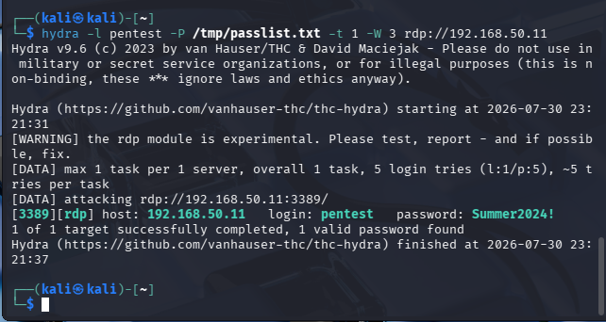
Figure 1 — Hydra successfully brute-forcing the "pentest" account's RDP credential from Kali.

4. Detection
The Wazuh dashboard (Events, agent window11, DQL: data.win.system.eventID: (4625 or 4624)) returned 18 hits in the attack window, including:
- Rule 60122, level 5, "Logon Failure - Unknown user or bad password" — fired once per incorrect password attempt
- Rule 60204, level 10, "Multiple Windows Logon Failures" — a correlation rule that fired automatically once the repeated-failure pattern was recognized, independent of any single event
- Rule 92657, level 6, "Successful Remote Logon Detected" — fired on the final, successful authentication
Rule 60204 is the key result of this exercise: it is a pattern-based detection built into Wazuh's default ruleset, and it fired without any custom rule configuration, correctly distinguishing sustained brute-force behavior from an isolated failed login.
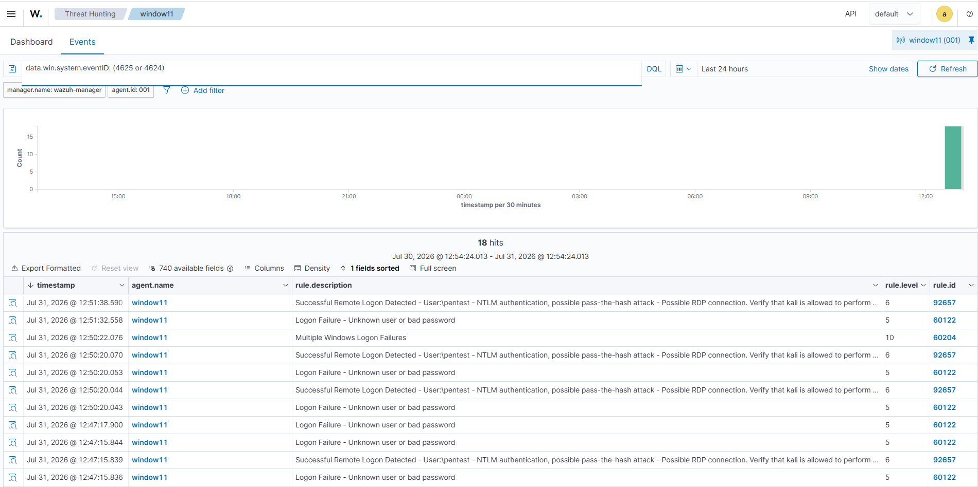
Figure 2 — Wazuh Events view for agent window11 showing the full sequence: repeated failures, the correlation alert (rule 60204), and the eventual successful logon.

5. Analysis — MITRE Mapping and the Recurring Rule 92657 Caveat
The correct MITRE ATT&CK mapping for this exercise is T1110.001 (Brute Force: Password Guessing) — one account, many candidate passwords, tried sequentially against a live service.
Rule 92657 fired again on the successful logon, the same generic anonymous/NTLM-logon rule seen in Detection Report #1. Its description references both pass-the-hash and RDP; the RDP framing happens to be accurate this time, since this attack genuinely was an RDP logon, but the pass-the-hash framing still does not apply — this was straightforward password guessing over the wire, not reuse of a captured hash. This is a second confirmed instance of the same finding from Report #1: rule 92657's canned MITRE/description text should not be trusted as an automatic diagnosis of technique, only as a signal that an anonymous or unusual authentication event occurred and needs manual classification.
Separately, Windows itself demonstrated a legitimate defensive behavior during this exercise: RDP connection throttling caused Hydra's first full-speed attempt (4 parallel threads) to fail with connection errors, and only succeeded once the attack was slowed to one connection at a time. This is a real anti-brute-force control working as intended, independent of Wazuh, and worth noting as a secondary finding.

6. Conclusion
Unlike Detection Report #1, where the SIEM caught a single anomalous event, this exercise confirmed Wazuh's out-of-box correlation logic (rule 60204) detecting a sustained attack pattern automatically. Combined with the repeated, confirmed mis-framing of rule 92657's canned MITRE tag, this reinforces a consistent finding across both exercises: individual-event rules require analyst verification against the real MITRE technique, while frequency/pattern-based correlation rules provide a stronger, lower-noise signal for this class of attack.

