Author : Dipak Ghodake

Date of creation: 04-03-2022

**Introduction to the Application** :

This is Automate E-Commerce website where user can buy product by creating an account using respective credentials.

**Below is the testcases to be automated** :

1. Invoke browser chrome/firefox

2. Open URL <http://automationpractice.com/index.php>

3. Hover over Women tab.

4.Click on sub menu ‘T-shirts’.

5.Hover on first product

6. Click More button

7. Increase quantity to 2.

8. Select size ‘L’

9. Select different color.

10. Click ‘Add to Cart’ button.

11. Click ‘Proceed to checkout’ button

12. Click next button to proceed further.

13. Create an account using valid EmailID

14. Select Radio button.

15. Enter First name.

16. Enter Last name.

17. Enter Password.

18. Select Date from Dropdown button.

19. Select Month from Dropdown button.

20. Select Year from Dropdown.

21. Select Checkboxes.

22. Enter First name.

23. Enter Last name.

24. Enter Company.

25. Enter Address.

26. Enter Address2.

27. Enter City.

28. Select State from Dropdown.

29. Enter Zipcode.

30. Select Country from dropdown.

31. Enter Text in Additional information.

32. Enter only numbers in Home phone & Mobile phone.

33. Enter address in ‘Assign an address alias for future reference and Click on ‘Register’.

34. Enter text in text-box & click on ‘Proceed to Checkout’.

35. Select checkbox and click on ‘Proceed to Checkout’.

36. Click on ‘Pay by bank wire’.

37. Click on ‘I Confirm Order’.

38. Close the Browser.

**Here to automate the same we used the below framework** :

We used Selenium WebDriver 3.141.59 , Java, Maven Project to complete the automation for the case study.

**Project Framework :**

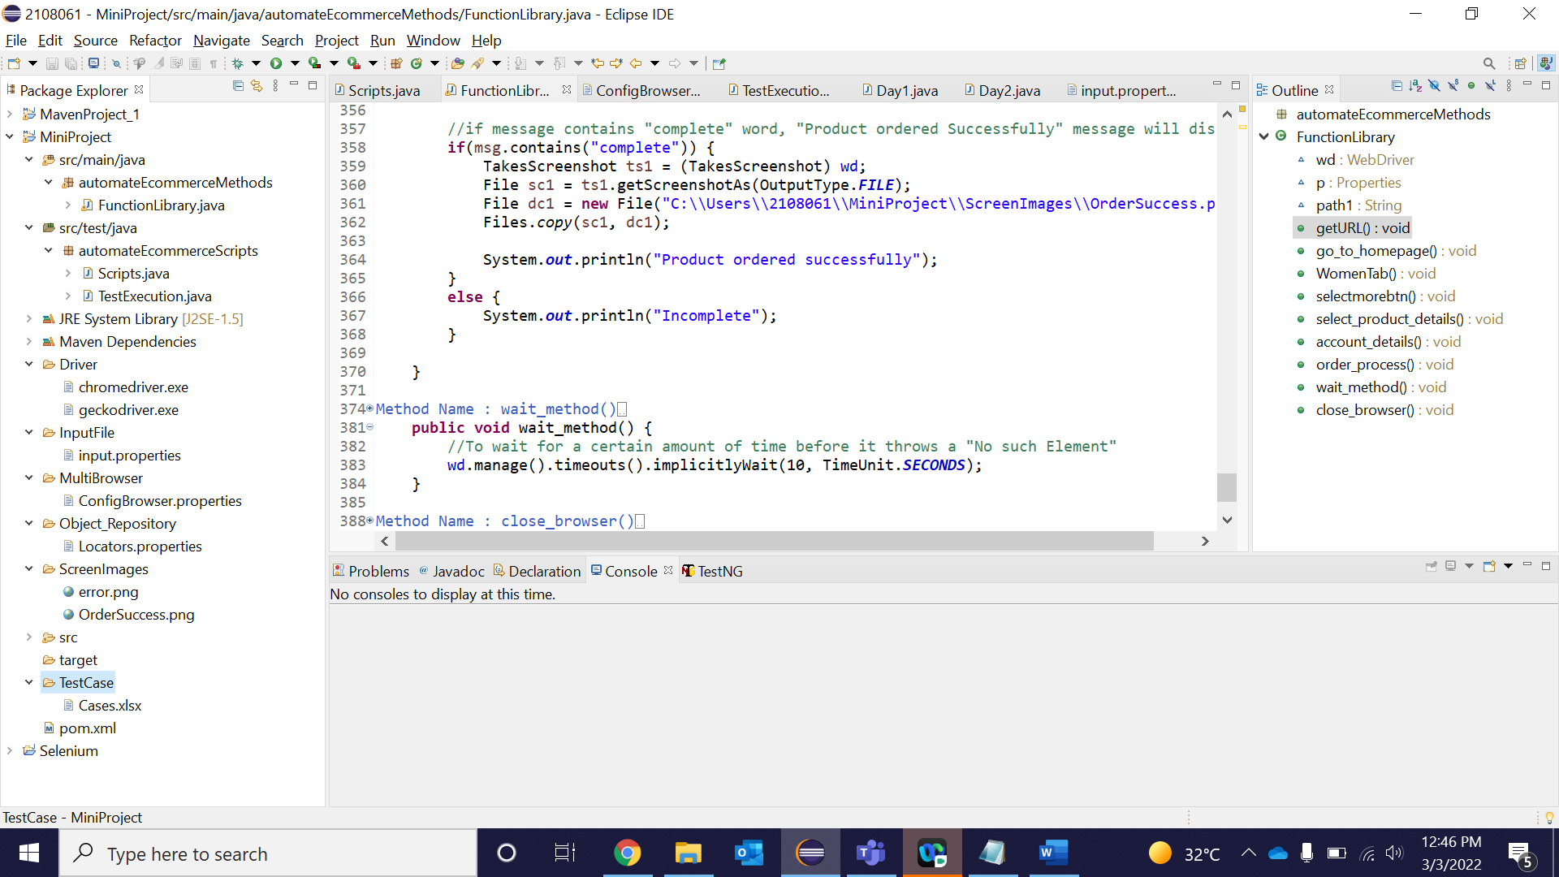

**Folder Structure in framework** :

The maven project is “MiniProject”.

Which is having different repositories for different components in framework.

1. Src/main/java :

automateEcommerceMethods is the package which includes all the libraries.

1. Src/test/java:

automateEcommerceScripts is the package which includes all the scripts and will execute for automation.

1. List of source folders in the framework are:

* TestCase :

This folder contains the test case in excel file.(./TestData/testcase.xlsx)

* InputFile :

This folder contains all the inputs which are to be enter.

* Drivers:

This folder contains respective drivers for different browser

* Multibrowser:

It contains properties file for invoke required browser.

* Object_Repository:

It includes all locators inside properties file.

* ScreenImages:

It contains Snapshot of Error message as well as Successful order.

**Steps to execute the scripts in side framework** :

Below are the steps which we need to follow while executing.

Step-1:

Open POM.xml, check the required dependencies.

POM.xml is the last file inside the framework.

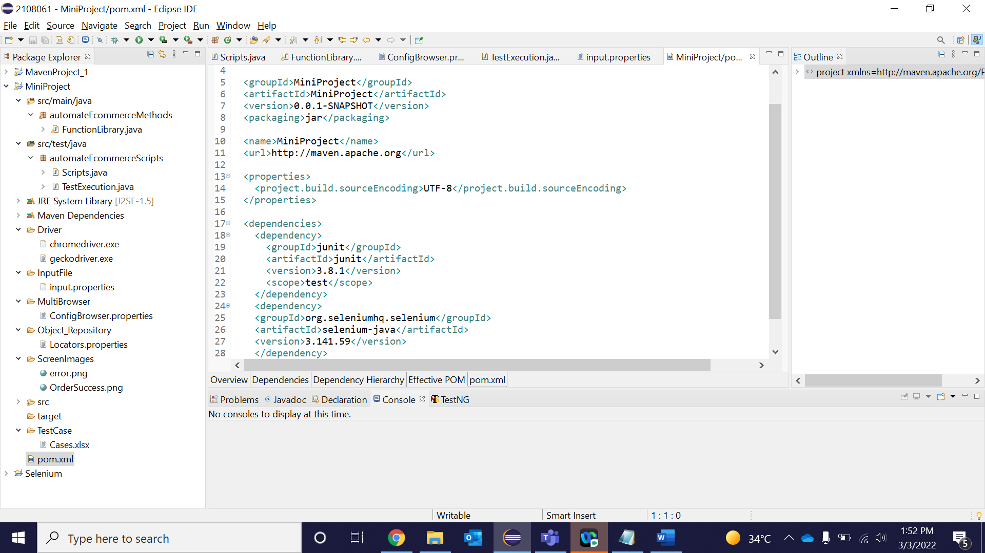

Crosscheck the content of the jars in “Maven Dependencies” folder.

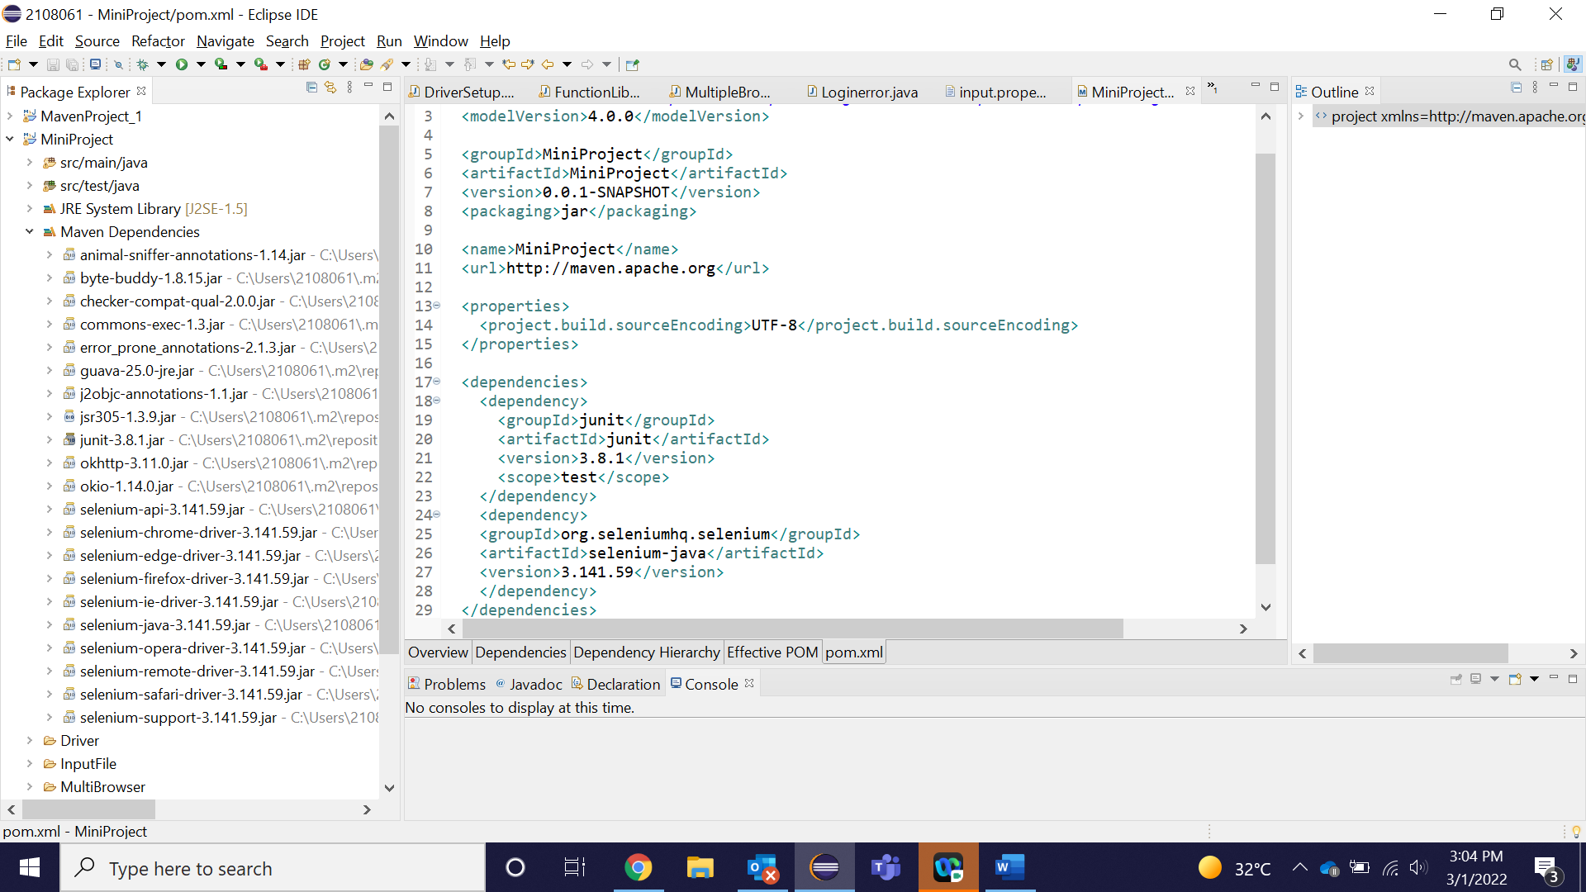

Step-2 :

Refresh the entire project.

Steps-3:

Identify the main script to execute from below path.

C:\Users\2108061\MiniProject\src\test\java\automateEcommerceScripts\TestExecution.java

Execute the file or run the java program.

**The below is the console report attached**:

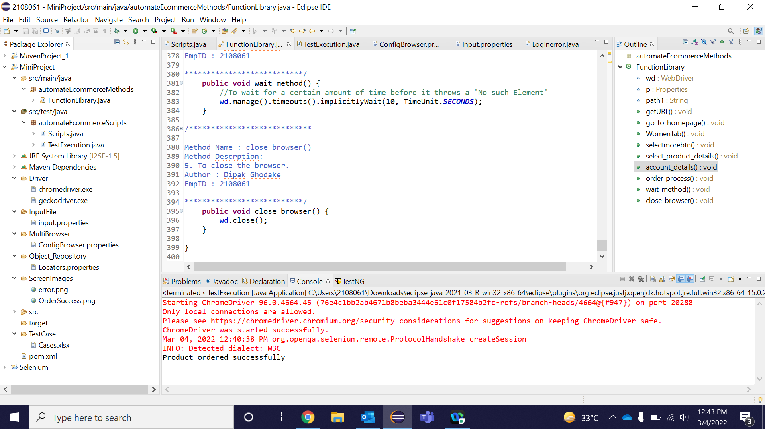

**Note** :

Execute program in Chrome browser.

We used both keyword driven and data driven framework using properties file in the above case study automation.

To execute the same in other environment, we need to import the project in eclipse and build the POM.xml file.