RELEASE 0

* Find all files inside the Desktop folder that have a name of "learn."

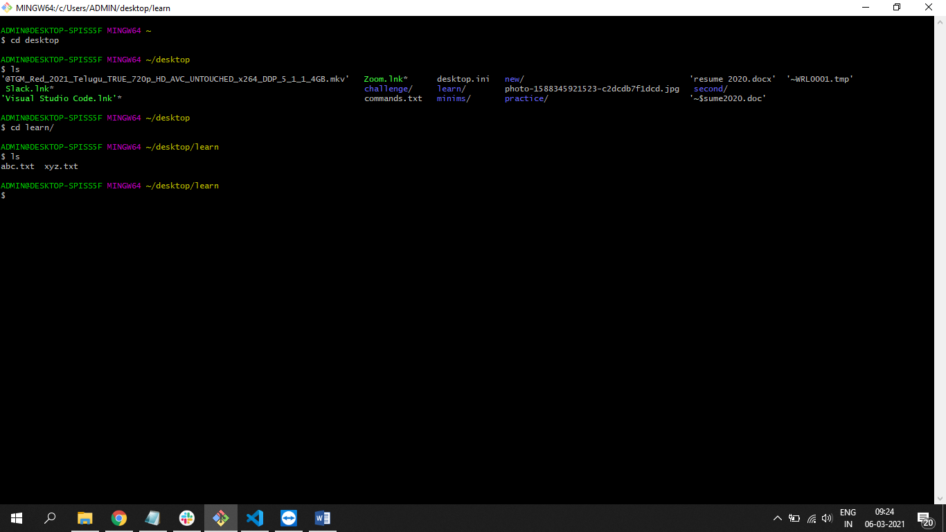

Find all files inside the Desktop folder that start with a "P.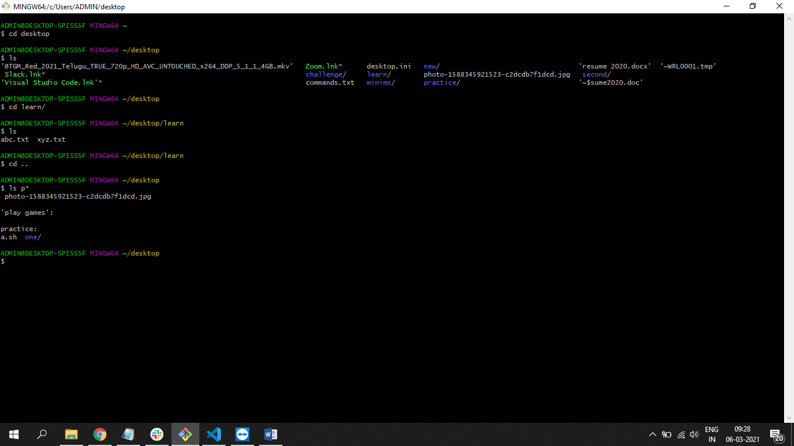

Find all files inside the Desktop folder that end with .txt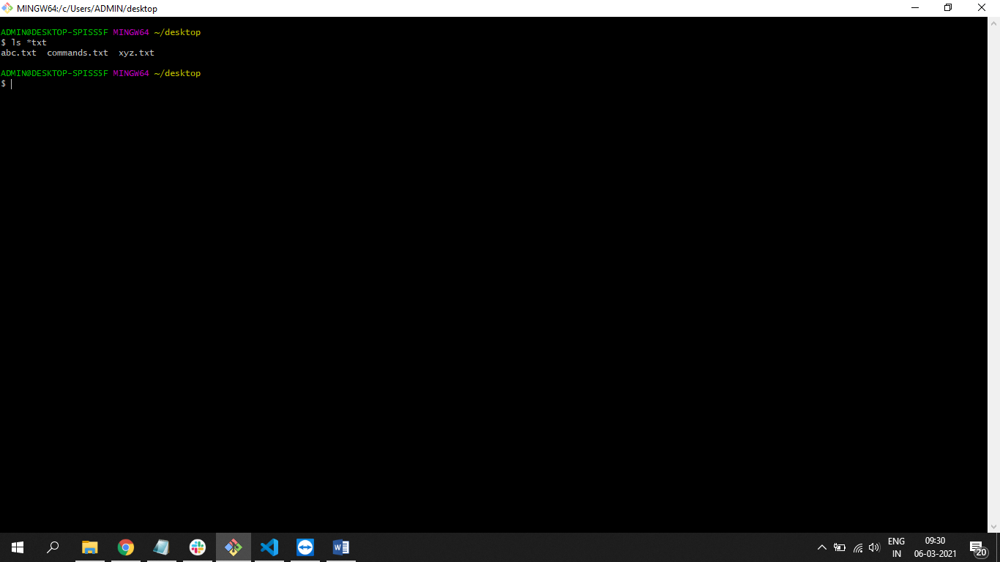

* Find all files inside the Desktop/views folder that have the name data somewhere in their filename.

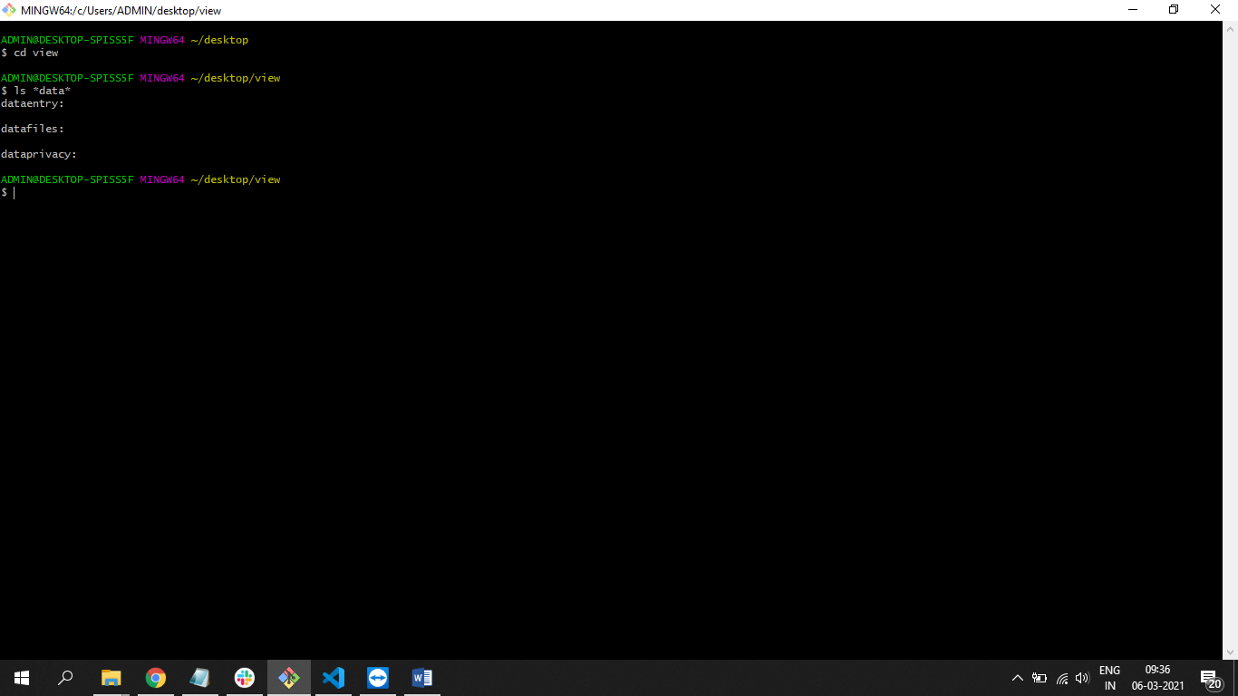

RELEASE 1

Create file named instructors.txt with the following content.

Mark

Elie

Beth

Tim

Elizabeth

Tom

Matt

Liza

Shana

Write the terminal commands for the following.

* Inside of the instructors.txt file, output the number of times the word "Elie" appears.
* Inside of the instructors.txt file, list all matches for any full word that starts with a capital "P."
* Inside of the instructors.txt file, list all the line numbers for any full word that starts with a "z" (it should match regardless of upper or lower case).

