1.Query the list of *CITY* names from **STATION** that either do not start with vowels or do not end with vowels. Your result cannot contain duplicates.

**Input Format**

The **STATION** table is described as follows:

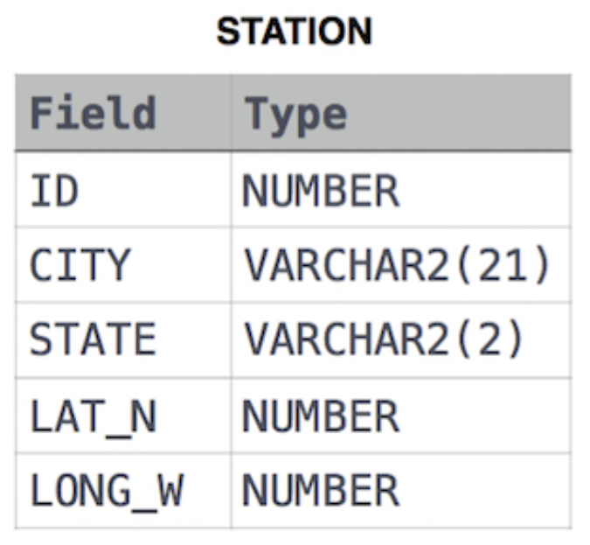

Ans:

select distinct customer_name from customer where customer_name ~*'^[bcdfghjklmnpqrstvwxyz]' and customer_name ~*'[bcdfghjklmnpqrstvwxyz]$';

2. Query the *Name* of any student in **STUDENTS** who scored higher than  *Marks*. Order your output by the *last three characters* of each name. If two or more students both have names ending in the same last three characters (i.e.: Bobby, Robby, etc.), secondary sort them by ascending *ID*.

**Input Format**

The **STUDENTS** table is described as follows:

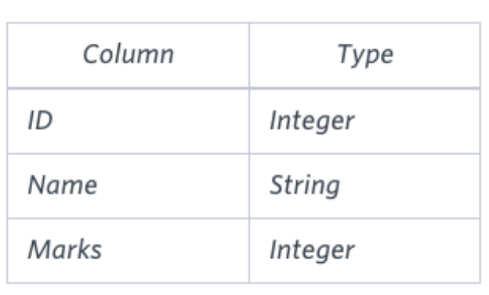

Ans:

Select name from students where marks>75 order by right(name,3), ID asc

3. Write a query that prints a list of employee names (i.e.: the *name* attribute) from the **Employee** table in alphabetical order.

**Input Format**

The **Employee** table containing employee data for a company is described as follows:

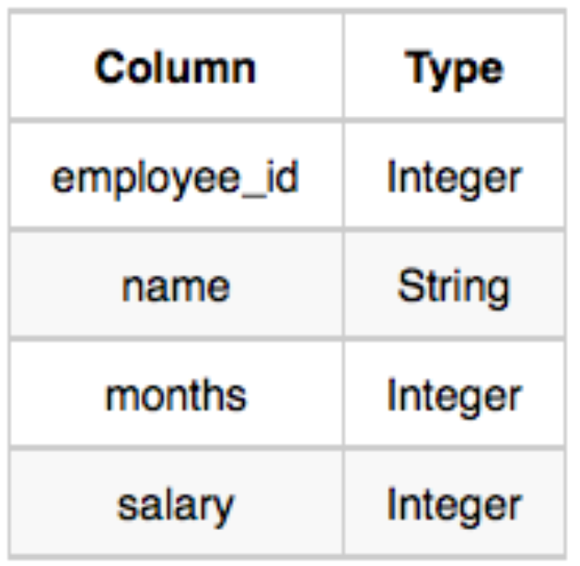

Ans:

select name from employee order by name asc

---------------------------------------------------------------------------------------------------------------------------

4. Write a query that prints a list of employee names (i.e.: the *name* attribute) for employees in **Employee** having a salary greater than  per month who have been employees for less than  months. Sort your result by ascending *employee_id*.

**Input Format**

The **Employee** table containing employee data for a company is described as follows:



Ans:

select name from employee where salary>2000 and months<10 order by employee_id asc