1.Query the *Western Longitude* (*LONG_W*) for the largest *Northern Latitude* (*LAT_N*) in **STATION** that is less than . Round your answer to  decimal places.

**Input Format**

The **STATION** table is described as follows:

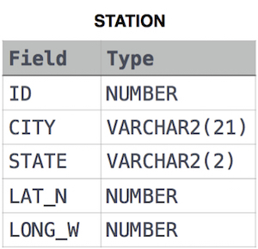

Ans:

SELECT ROUND(LONG_W,4) FROM STATION WHERE LAT_N<137.2345 ORDER BY LAT_N DESC LIMIT 1;

2. Query the smallest *Northern Latitude* (*LAT_N*) from **STATION** that is greater than . Round your answer to  decimal places.

**Input Format**

The **STATION** table is described as follows:



Ans:

SELECT ROUND(LAT_N,4) FROM STATION WHERE LAT_N>38.7780 ORDER BY LAT_N ASC LIMIT 1;

3. Query the *Western Longitude* (*LONG_W*)where the smallest *Northern Latitude* (*LAT_N*) in **STATION** is greater than . Round your answer to  decimal places.

**Input Format**

The **STATION** table is described as follows:



Ans:

SELECT ROUND(LONG_W,4) FROM STATION WHERE LAT_N>38.7780 ORDER BY LAT_N ASC LIMIT 1;

4. Consider  and  to be two points on a *2D* plane.

* happens to equal the minimum value in *Northern Latitude* (*LAT_N* in **STATION**).
* happens to equal the minimum value in *Western Longitude* (*LONG_W* in **STATION**).
* happens to equal the maximum value in *Northern Latitude* (*LAT_N* in **STATION**).
* happens to equal the maximum value in *Western Longitude* (*LONG_W* in **STATION**).

Query the [Manhattan Distance](https://xlinux.nist.gov/dads/HTML/manhattanDistance.html) between points  and  and round it to a scale of  decimal places.

**Input Format**

The **STATION** table is described as follows:



Ans:

SELECT ROUND((MAX(LAT_N)-MIN(LAT_N))+(MAX(LONG_W)-MIN(LONG_W)),4)FROM STATION;