1. Consider  and  to be two points on a 2D plane where  are the respective minimum and maximum values of *Northern Latitude* (*LAT_N*) and  are the respective minimum and maximum values of *Western Longitude* (*LONG_W*) in **STATION**.

Query the [Euclidean Distance](https://en.wikipedia.org/wiki/Euclidean_distance) between points  and  and *format your answer* to display  decimal digits.

**Input Format**

The **STATION** table is described as follows:

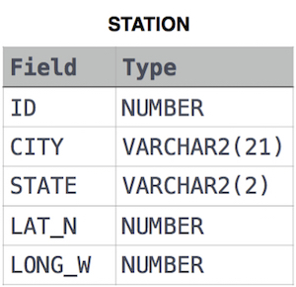

Ans:

SELECT ROUND(SQRT(POWER((MIN(LAT_N)-MAX(LAT_N)),2) + POWER((MIN(LONG_W)-MAX(LONG_W)),2)),4) FROM STATION;

2. A [*median*](https://en.wikipedia.org/wiki/Median) is defined as a number separating the higher half of a data set from the lower half. Query the *median* of the *Northern Latitudes* (*LAT_N*) from **STATION** and round your answer to  decimal places.

**Input Format**

The **STATION** table is described as follows:



Ans:

SELECT ROUND(MEDIAN(LAT_N), 4)FROM STATION;

3. Query a *count* of the number of cities in **CITY** having a *Population* larger than .

**Input Format**

The **CITY** table is described as follows:

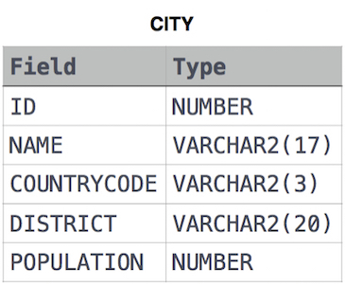

Ans:

SELECT COUNT(DISTRICT) FROM CITY WHERE POPULATION>100000;

4. Query the total population of all cities in **CITY** where *District* is **California**.

**Input Format**

The **CITY** table is described as follows:



Ans:

SELECT SUM(POPULATION) FROM CITY WHERE DISTRICT='CALIFORNIA';